Brandon Timok

CS 422 Machine Learning

Junggab Son

Homework 4

Used libraries and their purposes:

sklearn: Used for implementing SVM with multiple kernels and computing accuracy using 5-fold CV.

Screenshots:

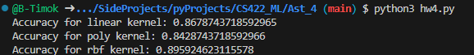

What I learned from this assignment:

I learned how to use SVMs with different kernels (linear, poly, rbf) for multi-class classification and computing accuracy.