SOTRAL INDUSTRIE SAS
p.riviere@sotral-industrie.fr
Tel. 04 78 55 44 33

Service report
21/09/2026

Your contact:
Julien DURAND
Technicien SAV
j.durand@bfr-systems.fr
Tel. 06 12 34 56 78
Accompanied by : Thomas BERNARD

SOTRAL INDUSTRIE SAS
45 av. des Frères Lumière, 69120 Vaulx-en-Velin

In Blyes, on 21/09/2026,
For the attention of M. Pascal Rivière,
Service call
Customer | SOTRAL INDUSTRIE SAS | Machine | Presse hydraulique 120 T ; Convoyeur d'évacuation C40
Location | Atelier 2 — ligne d'emboutissage 4 | Model | PH-120/4D ; C40-MOD
Customer address | 45 av. des Frères Lumière, 69120 Vaulx-en-Velin | Serial number | PH1204D-2011-0387 ; SN-CONV-0492
On-site contact | M. Pascal Rivière — Responsable maintenance | On-site technicians | Julien DURAND · Thomas BERNARD
Phone / e-mail | 04 78 55 44 33 / p.riviere@sotral-industrie.fr | On-site times | 2 Service days
Time on site | 15 h 00

Inspected machines
Machine | Model | Serial number
Presse hydraulique 120 T | PH-120/4D | PH1204D-2011-0387
Convoyeur d'évacuation C40 | C40-MOD | SN-CONV-0492

Service days breakdown
Date | On-site times | Break | Time on site | Activity / Work
21/09/2026 | 08:15 - 17:00 | 45 min | 8 h 00 (8,00 h) | Mechanical audit of hydraulic power unit and electrical cabinet inspection
22/09/2026 | 08:00 - 15:45 | 45 min | 7 h 00 (7,00 h) | Belt replacement, oil change, tuning and load testing
Cumulative total |  |  | 15 h 00 (15,00 h)

1. Summary of the service call
Category | Number
Safety issue | 1
Urgent | 1
High priority | 1
Low priority | 2
Informational | 1

Mechanical : 3 • Electrical : 2 • Automation : 1
Hours spent on site: 15 h 00 (15,00 h) • Photos : 5
Technician's summary
Full audit of the hydraulic power unit as requested. The loss of output is explained by slippage of the slack belt (estimated slip 8 to 10%) and by the thermal drift of the oil (68 C), which lowers the volumetric efficiency of the pump. The noise and vibration come from the main shaft bearing at end of life. After the work, the machine returned to its rated output; two outstanding items remain: the main bearing and the leak at the discharge fitting.
Customer's subject / request
Full mechanical audit requested by maintenance: abnormal noise and increasing vibration on the hydraulic power unit, output down by about 15%.
2. Safety and emergencies
🔧 Mechanical [⚙️ Presse hydraulique 120 T] [URGENT] 09:20
Main shaft bearing at end of life: axial play measured with a dial gauge 0.18 mm (0.05 mm max.), temperature rise recorded at 81 C and characteristic noise at 1,450 rpm. Replacement to be scheduled within 48 h - risk of seizure within 250 production hours.
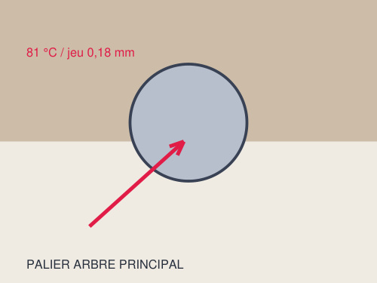
Photo 1
⚡ Electrical [SAFETY ISSUE] 14:30
No drip tray under the hydraulic power unit and oil marks on the floor in front of the cabinet: slip risk reported to the maintenance manager, area cordoned off pending compliance work. To be addressed before production resumes on 3 shifts.
3. High-priority points
🔧 Mechanical [⚙️ Presse hydraulique 120 T] [HIGH PRIORITY] 10:05
Pump drive V-belt slack: measured deflection 12 mm against a maximum of 8 mm. Visible cracking and rubber deposits in the pulley groove. Belt replaced (XPB 2360) and tension set to 7 mm.
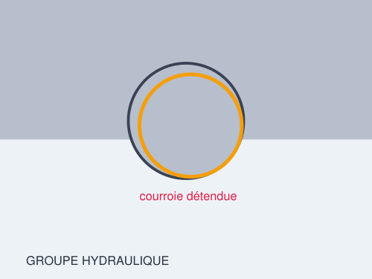
Photo 2
4. Low-priority points
⚡ Electrical [⚙️ Convoyeur d'évacuation C40] [LOW PRIORITY] 11:10
Electrical cabinet: ventilation filter clogged with dust and two cable glands loose at the bottom. Filter vacuumed, glands retightened. No insulation fault found on the motor and control circuits.
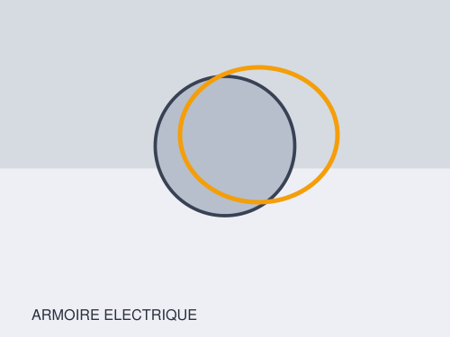
Photo 3
🔧 Mechanical [LOW PRIORITY] 13:40
Four cracked motor mounting bushes (visible deformation) and two bearing lubrication points not done for over 6 months. Full lubrication completed, bushes to be replaced within 1 month.
5. Additional information
🤖 Automation [⚙️ Convoyeur d'évacuation C40] [INFORMATIONAL] 14:05
S7-300 PLC: HMI parameters correct, program backup verified on the memory card. Cycle counter reads 1,942,000 cycles against a recommended preventive maintenance at 2,000,000: to be scheduled at the next shutdown.
6. Work performed
Replacement of the V-belt and cleaning of the pulley groove; tension set to 7 mm. Full lubrication of the bearings and the connecting-rod head. Torque retightening of the frame bolts and motor mountings. Cleaning of the oil cooler core and of the cabinet filter. Check and refurbishment of the cartridge filtration. No-load then on-load test: rated output restored, oil temperature stabilised at 61 C.
7. Work to be planned
1) Replace the main shaft bearing within 48 h (part ref. 63-2216-C3) - estimated labour 4 h, machine downtime 1 day.
2) Replace the 4 motor bushes within 1 month.
3) Fit a drip tray and an absorbent mat under the hydraulic power unit (safety).
4) Schedule replacement of the hydraulic power unit at 2,000,000 cycles.
5) Set up a periodic lubrication schedule and a monthly vibration reading.
8. Spare parts
Description | Part number | Quantity
V-belt XPB 2360 | BFR-8820-XPB | 1
Hydraulic filter cartridge 10 µm | HYD-FILT-010 | 2

The customer's signature constitutes acceptance of the final quote and validation of the spare parts listed above.
9. Additional photos
Overall view of the hydraulic power unit
Electrical cabinet - general condition
10. Validation
The customer acknowledges having read this report, having received the technician's explanations, and accepts the findings and the work described. The customer's signature constitutes acceptance of the final quote and validation of the spare parts listed above.
The customer (approved) | The technician
Pascal RIVIÈRE | Julien DURAND
Responsable maintenance | Technicien SAV — 06 12 34 56 78 · j.durand@bfr-systems.fr
 | Accompanied by : Thomas BERNARD
Date: 21/09/2026 at 15:35 | Date: 21/09/2026 at 15:40

