Figure 1; [Kuskokwim Isoscape, include inset and bounding box values in the figure description]

Figure 2; Management Unit Map

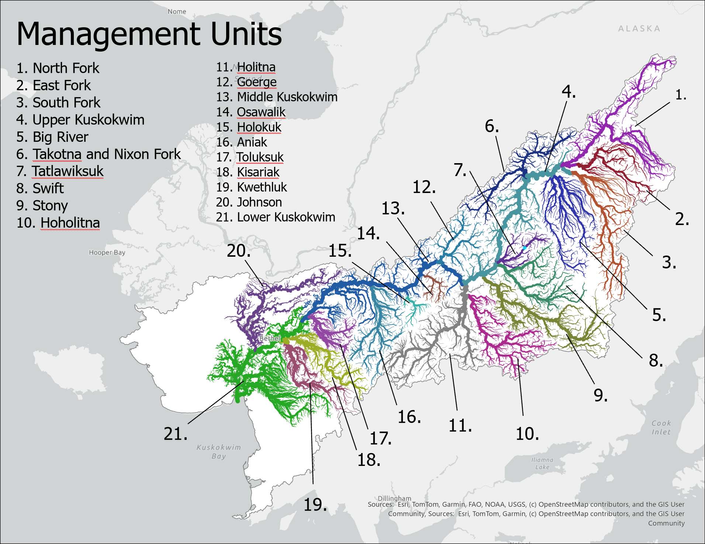

Figure 3; 8 Panel map of average production