Figure 1: Isoscape of the Kuskokwim river basin showing distribution of estimated Sr87/Sr86 values across the landscape.

Figure 2: A map showing the final distribution of management units after collection of all upstream segments.

Figure 3: Timeseries of proportional contribution for each management unit. Each datapoint is a quartile for all 5 years of the dataset (2017-2021).

Figure 4: Trend 1 (66.8% of Variance). Increase in mean contribution from tributaries such as the Aniak, Takotna, and Nixon Fork with an increase in contribution from the 3rd and 4th run quartile. Opposite pattern of decreasing contribution from these quartiles in the upper Kuskokwim units.

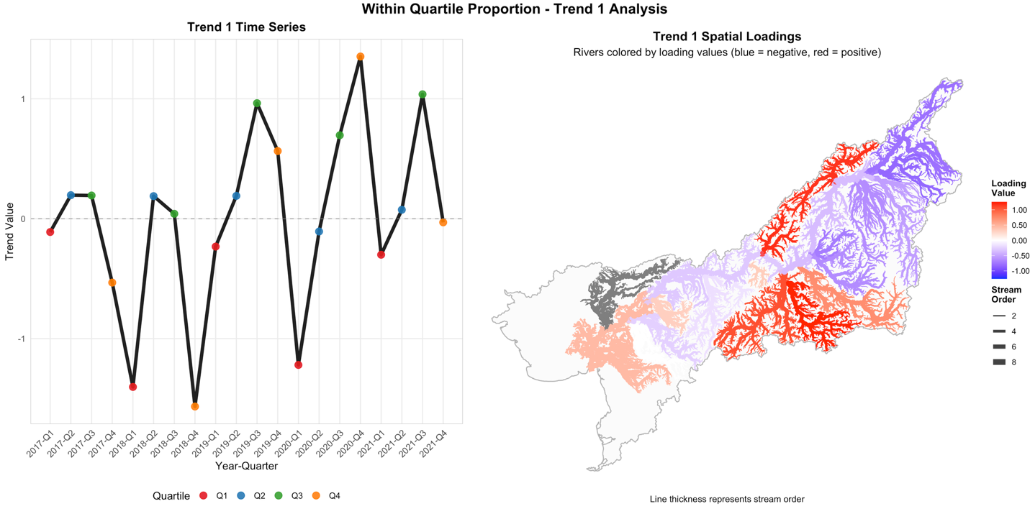

Figure 5: Trend 2 (22.8% of Variance). Slight increase in mean contribution over time, but a marked consolidation into the 1st quartile for tributaries in the upper Kuskokwim.

