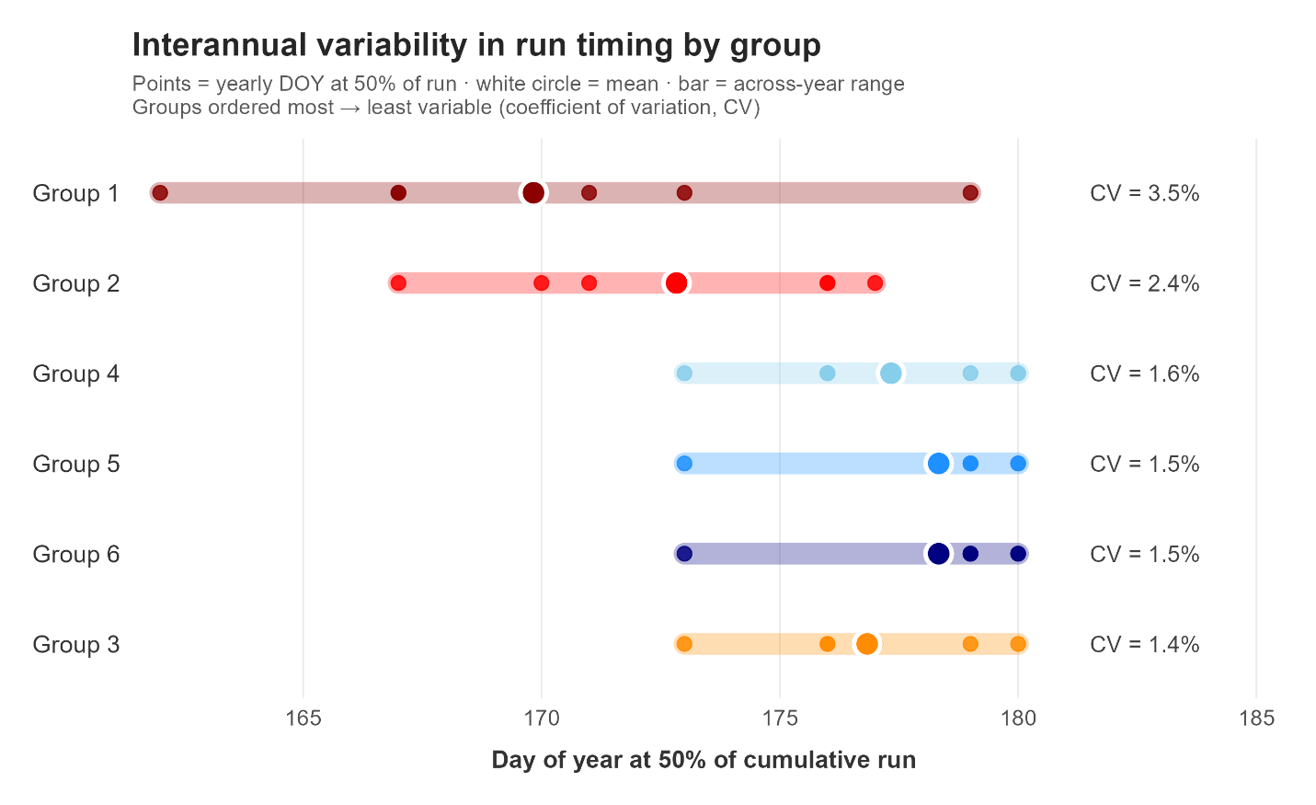
Supplemental Figure 1: Interannual variability in return timing among groups, quantified as the day of the year that at least 50% of the total group’s contribution that has been assigned. Coefficient of variation (CV) for upper watershed groups is higher than for others in the basin.

