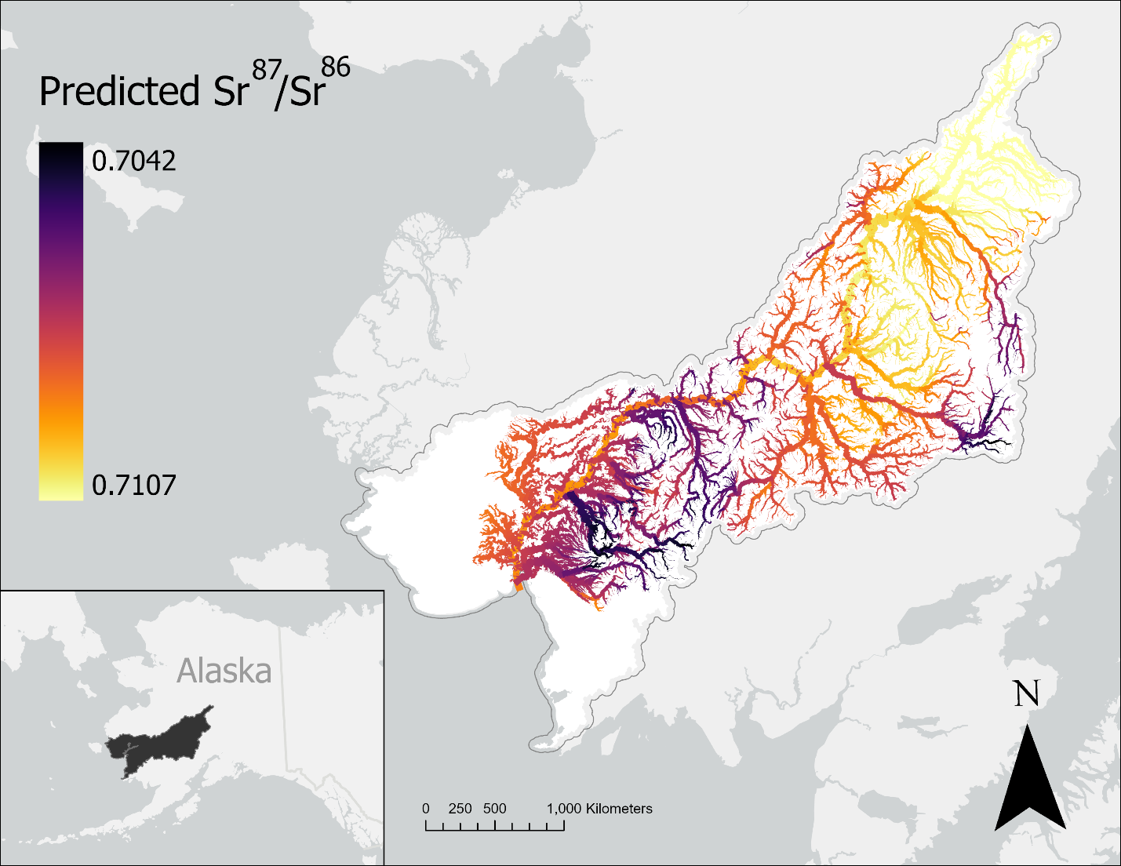
Figure 1: Strontium isoscape of the Kuskokwim River Basin (French et al., 2020) displaying the spatial variation in Sr⁸⁷/Sr⁸⁶ ratios. Darker colors indicate lower relative isotope ratios, whereas lighter colors indicate higher values. Isotope ratios across the basin range from 0.7042 to 0.7107, with a general trend toward higher values at the top of the watershed.

