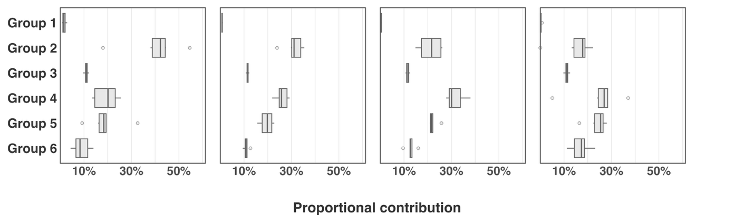
D.
B.
C.
A.
Figure 3: Median proportional contribution of regional groups to each seasonal quartile across all years of the dataset. Boxplots illustrate the range in proportional contribution to each quartile for each stock group across all years of the dataset.

