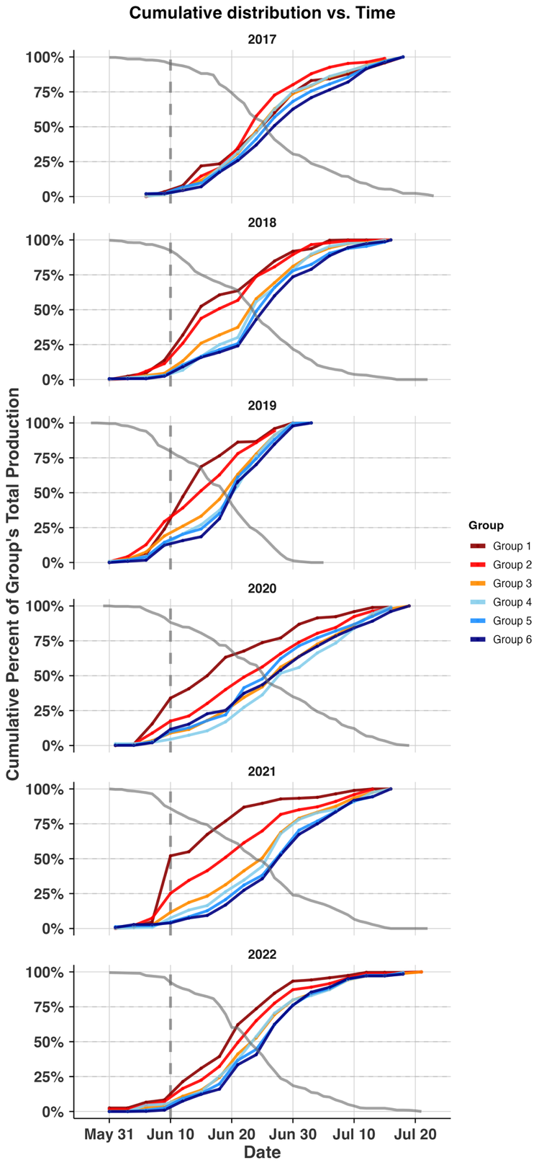
Figure 4: Cumulative distribution plots of returning regional groups to the Bethel Test Fishery in June and July 2017-2022. Lines are colored in order of their watershed position, with the furthest upstream groups in red transitioning toward downstream groups in blue. Gray dashed vertical line illustrates the end of the front-end closure. Gray solid line illustrates the remaining proportion of the total CPUE at each day.

