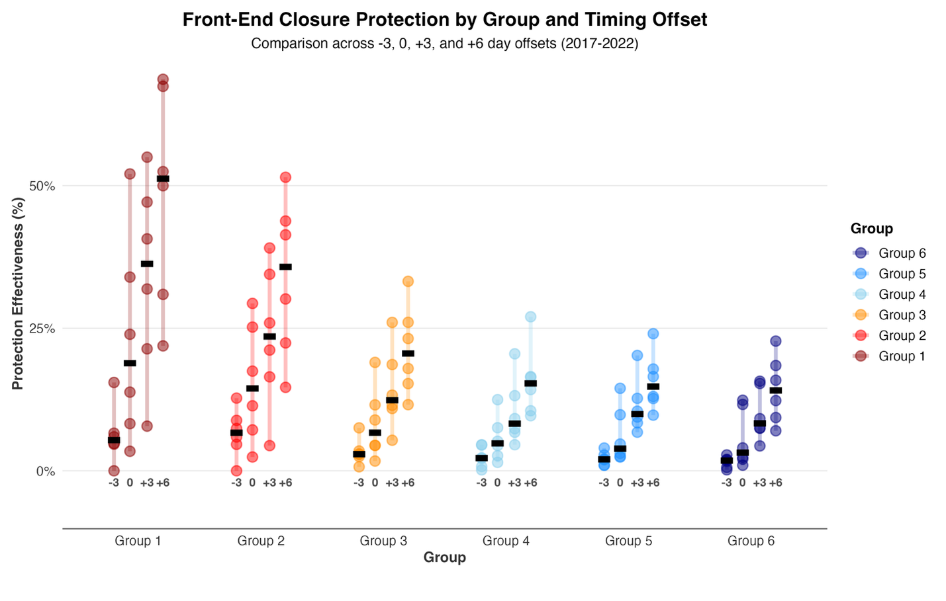
Figure 5: The proportion of each regional group’s total return protected under several simulated front-end closure scenarios, including the current closure. X-axis labels show the number of days the simulated closure end date differs from the current end date (−3 = June 8, 0 = June 11, +3 = June 14, +6 = June 17). Each point represents a single year, colored bars show the year-to-year range, and black lines denote the median across all years. Colors reflect watershed position, with upstream groups shown in red and downstream groups in blue.

