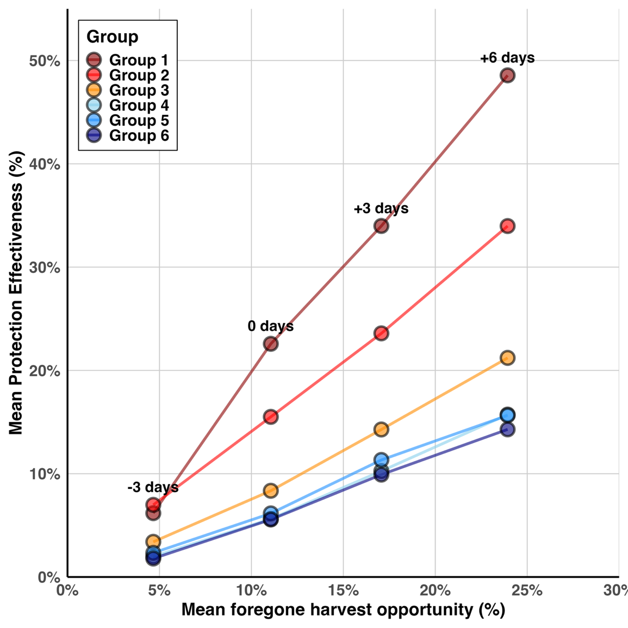
Figure 6: Comparison of the mean protection afforded to each group across all years with the mean foregone potential harvest. Potential foregone harvest is calculated as 1- (cumulative daily CPUE at each closure date/ total summed daily CPUE in that year). Each column of points illustrates a different closure end date scenario.

