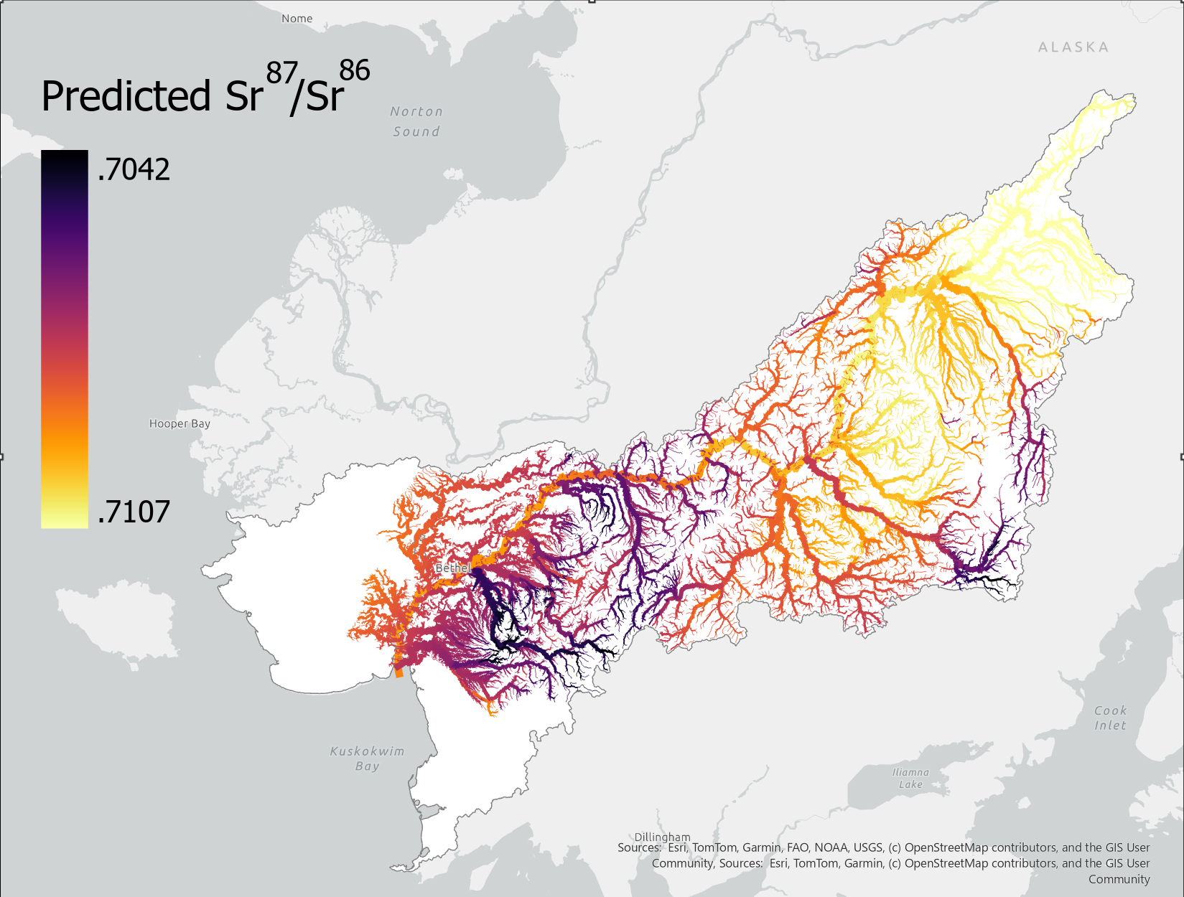
Figure 1: Strontium isoscape of the Kuskokwim River basin displaying the spatial variation in Sr⁸⁷/Sr⁸⁶ ratios. Darker colors indicate lower relative isotope ratios whereas lighter colors indicate higher values. Isotope ratios across the basin range from .7042 to .7107, with a general trend towards higher values at the top of the watershed.

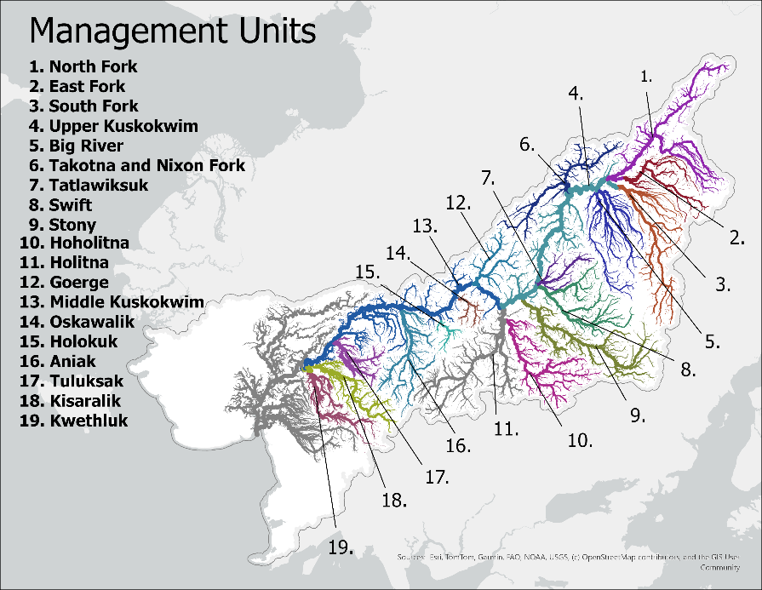

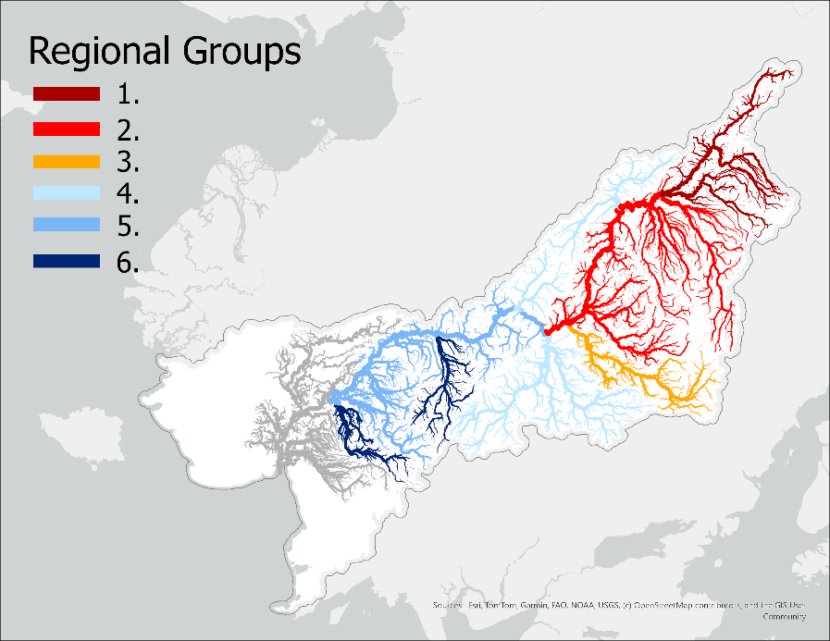

Figure 2: A) 19 Management units selected by collecting the upstream reaches of notable tributaries in the basin. Regions not associated with a tributary (e.g. Lower Kuskokwim) were manually selected to ensure full coverage of the basin. B) Regional isotopic groupings based on k-means clustering and evaluation of elbow method and silhouette score.

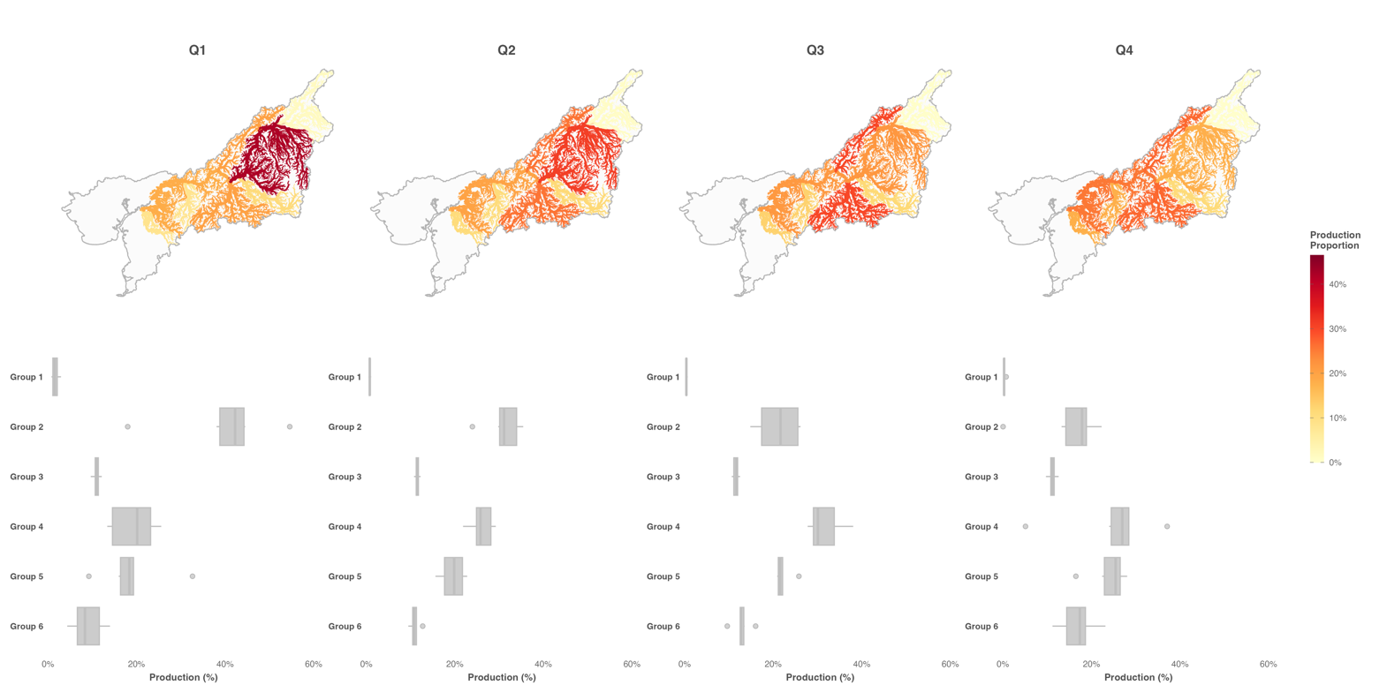
Figure 3: A) Median proportion contribution of regional stock groups to each seasonal quartile across all years of the dataset. Tributaries with darker colors (closer to red) indicate relatively higher proportional contribution to quartile returns. B) Boxplots illustrating the range in proportional contribution to each quartile for each stock group across the dataset.

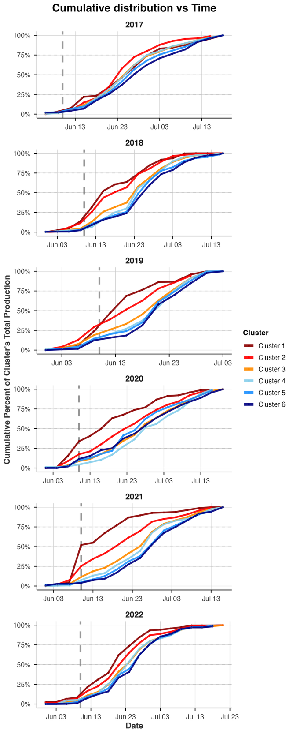
Figure 4: Cumulative distribution plots of returning stock grouping to the Bethel Test Fishery in June and July 2017-2022. Lines are colored in order of their watershed position, with the furthest upstream groups in red transitioning towards downstream groups in blue. Grey dashed vertical line illustrates the end of the front-end closure (June 11th).

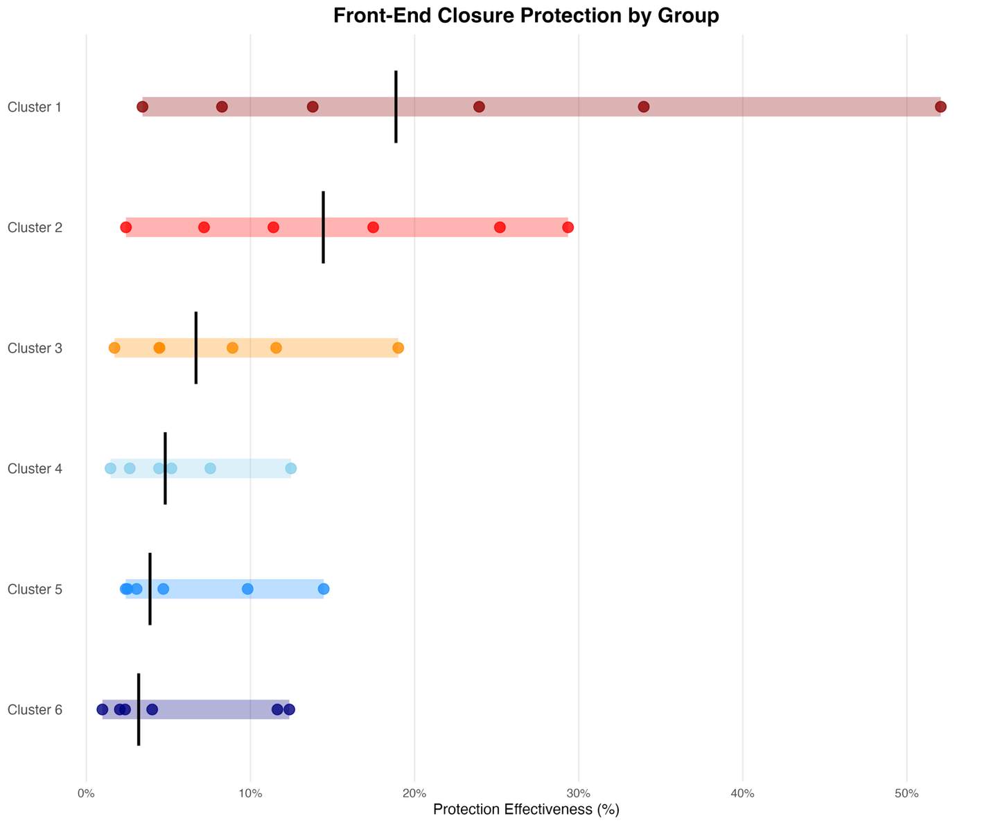
Figure 6: The proportion of each regional group’s total contribution protected by the front end closure window (before June 11th) across all years the dataset. Each point represents a year of data, colored bars indicate the range, and solid black lines indicate the median value across all years. Watershed position is indicated by color with furthest upstream groups in red and furthest downstream groups in blue.

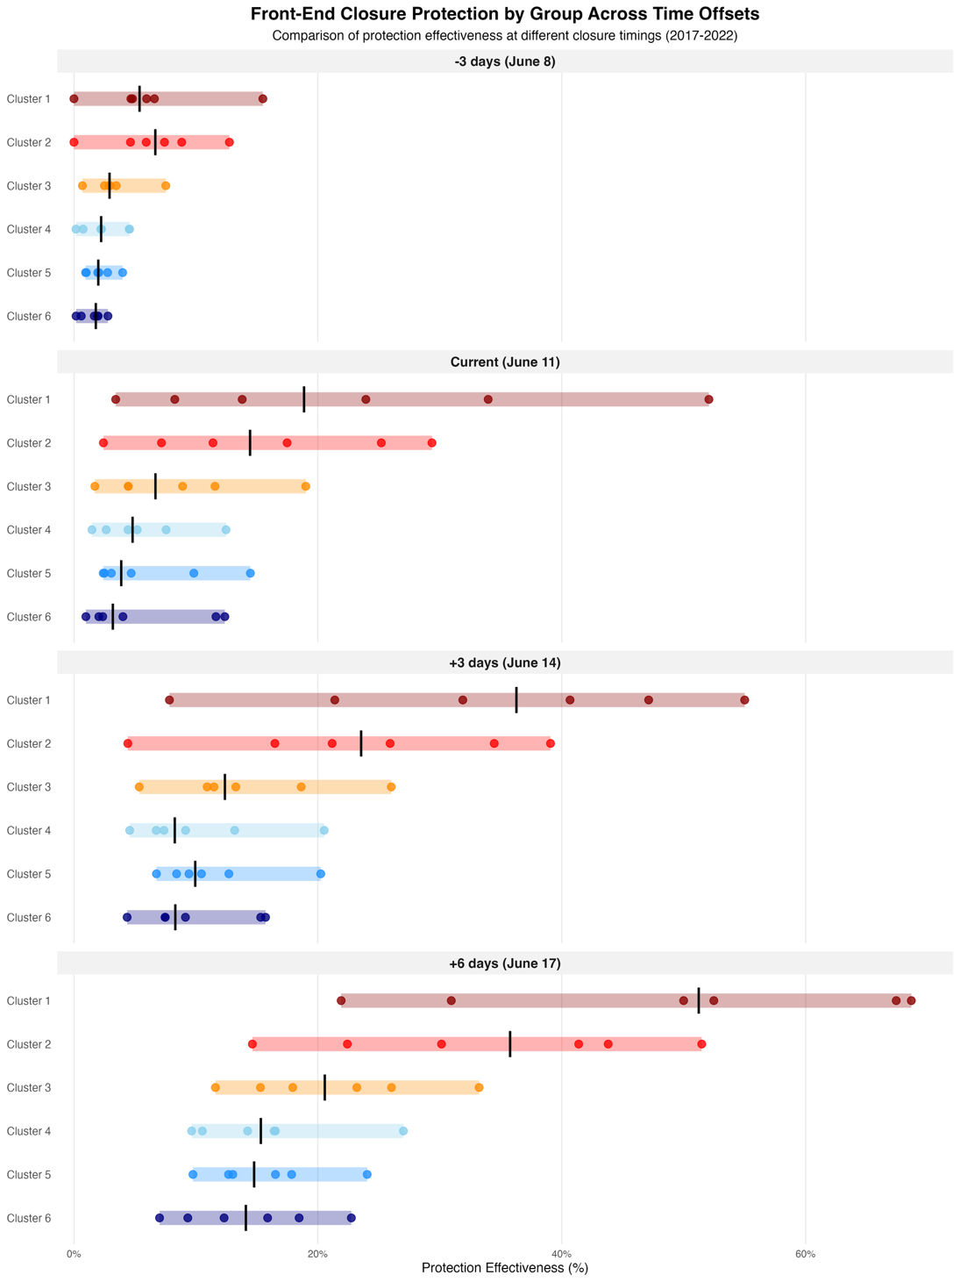
Figure 7 (6?) : Proportional returns within the front-end closure with adjusted end dates across our dataset. Each panel represents a different end date for the closure. Each point is a year of data for that group. Colored bars represent the range, and vertical black lines indicate the median value across all years for that group.
