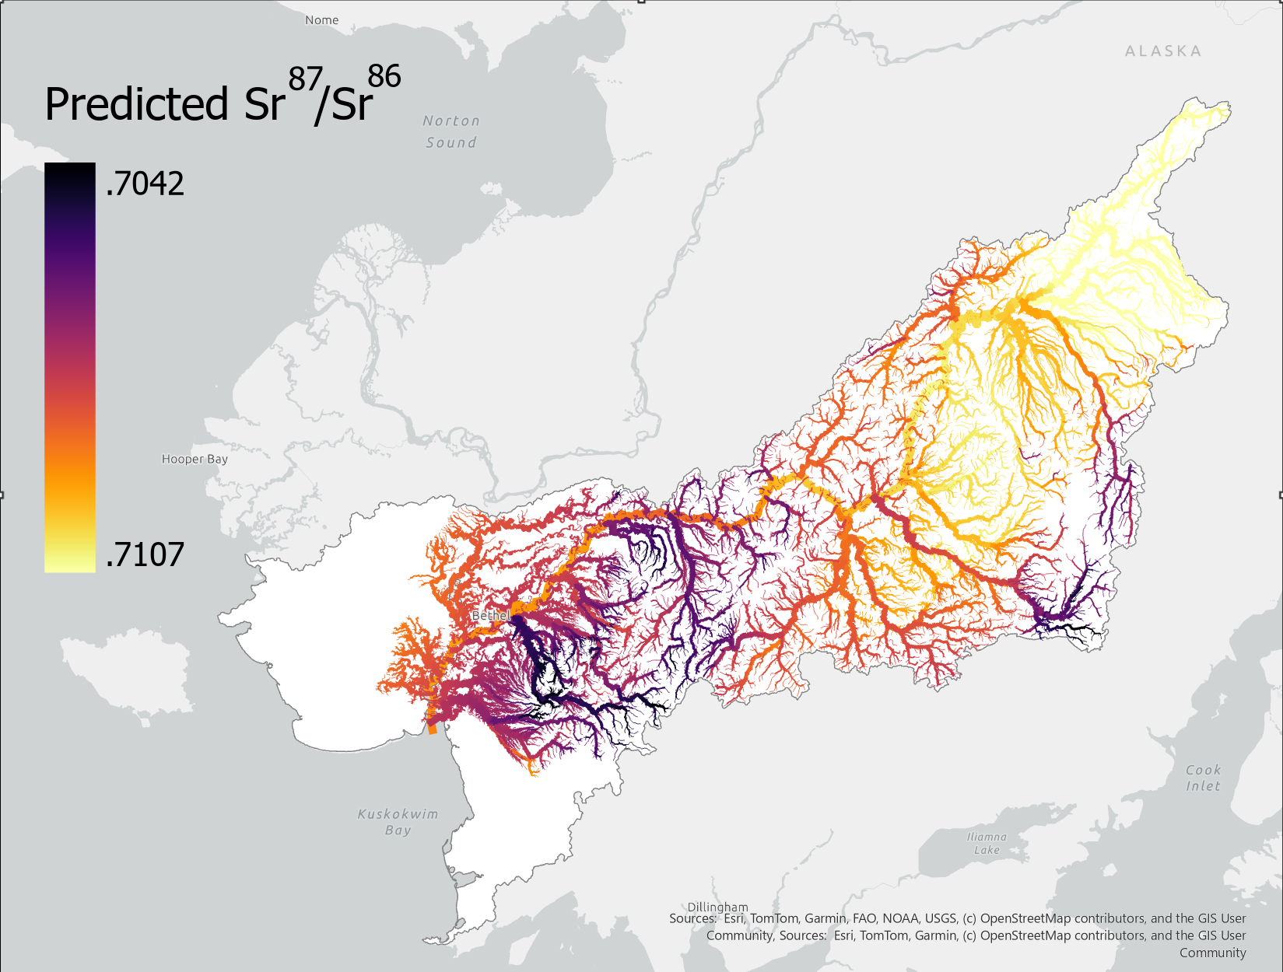
Figure 1: Strontium isoscape of the Kuskokwim River basin displaying the spatial variation in modeled Sr⁸⁷/Sr⁸⁶ ratios. Darker colors indicate lower relative isotope ratios whereas lighter colors indicate more enriched values. Isotope ratios across the basin range from .7042 to .7107, with a general trend towards more enriched values at the top of the watershed.

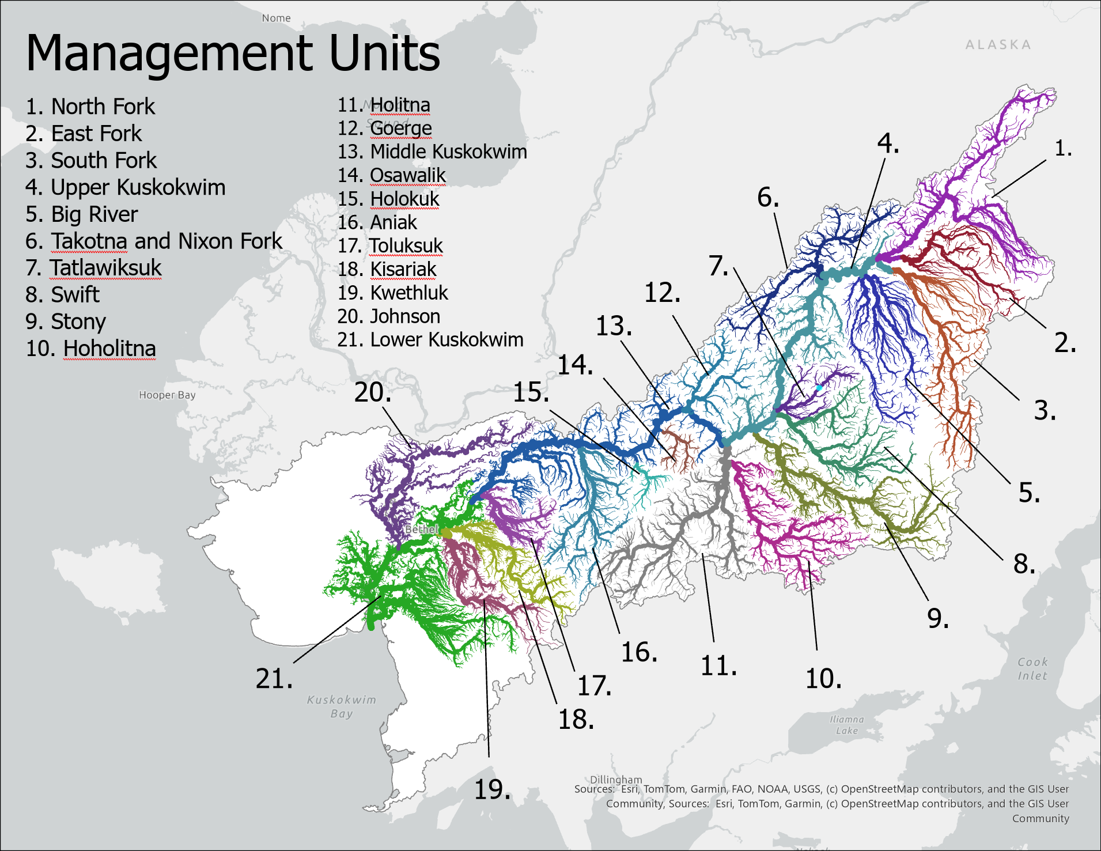
Figure 2: Tributaries included in each management unit, derived by selecting the upstream reaches of several identified rivers of management interest and manually selected units of similar size.

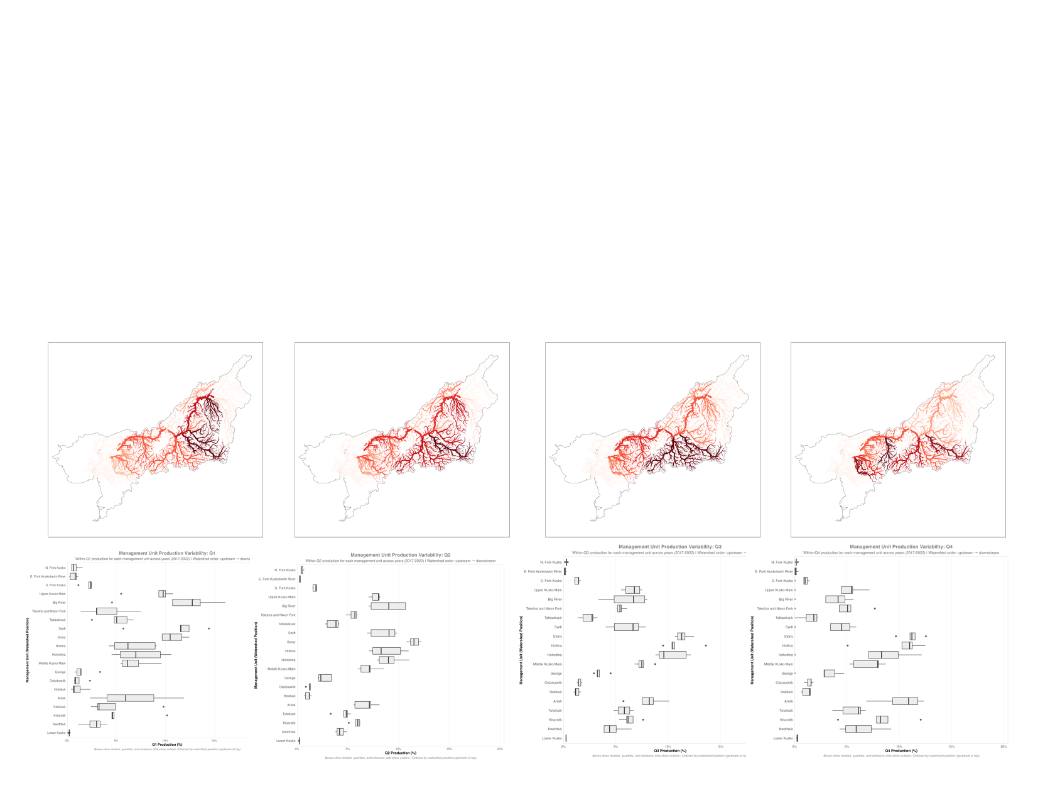Figure 3: A) Mean contribution of management units for each seasonal quartile of the salmon run. Tributaries with darker colors (closer to red) indicate relatively higher mean proportional contribution to quartile returns. B) boxplots illustrate the range in mean values across all years of the dataset.

Figure 4: Cumulative Distribution Plots
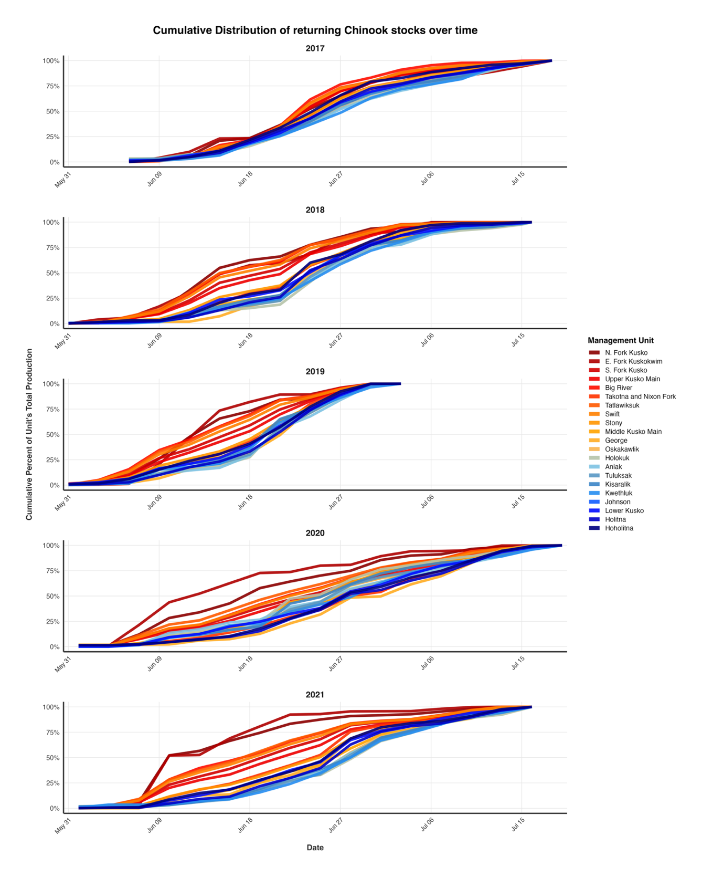
Figure 4: Cumulative distributions of returning stocks for each three-day period of the run. Stocks are colored in order of their watershed position, with the furthest upstream stocks in red transitioning towards downstream stocks in blue.

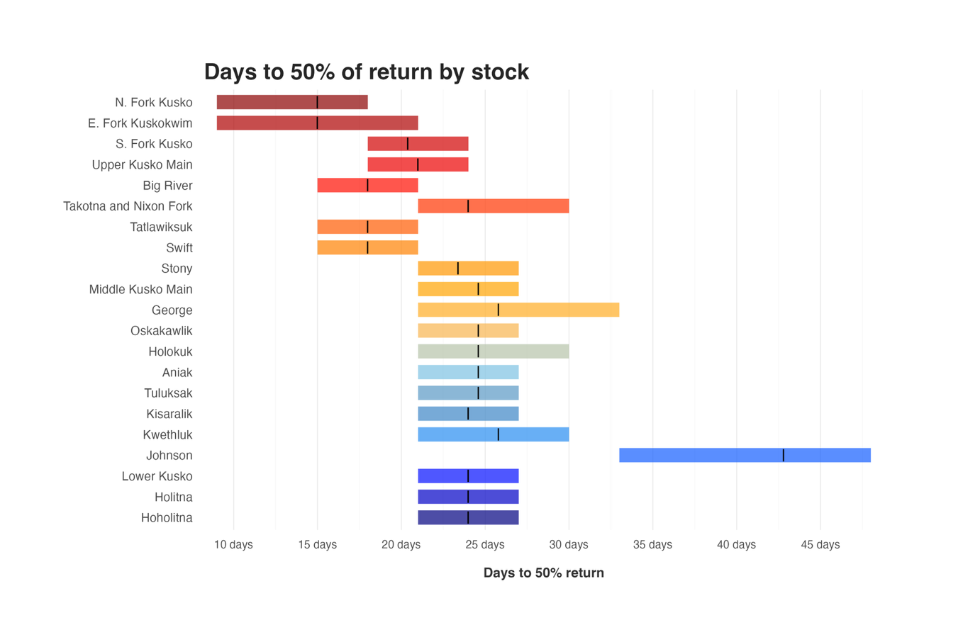
Figure 5: Range and mean number of days from the beginning of the run to 50% of total returns by stock. The width of the bar represents the range of values, and the black vertical line represents the mean. Bars are colored by their watershed position, with upstream stocks in red and downstream stocks in blue.

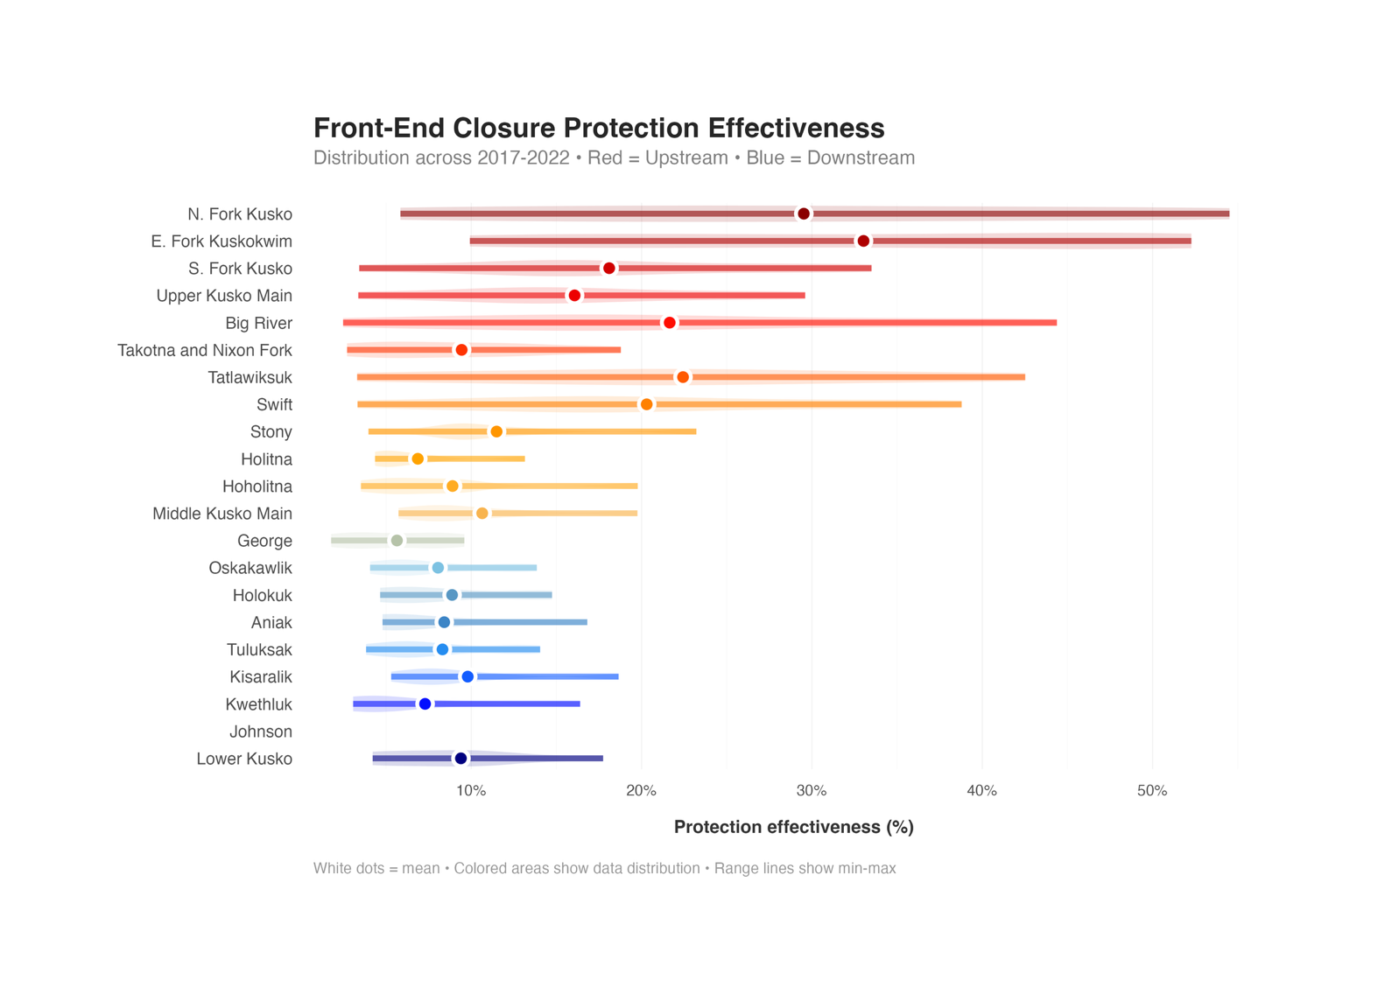
Figure 6: The range of proportional protection offered by the front-end closure ending on June 11th. White circles indicate the mean. Violin plots illustrate the range of values across all years by stock. Watershed position is indicated by color with furthest upstream stocks in red and furthest downstream stocks in blue.

