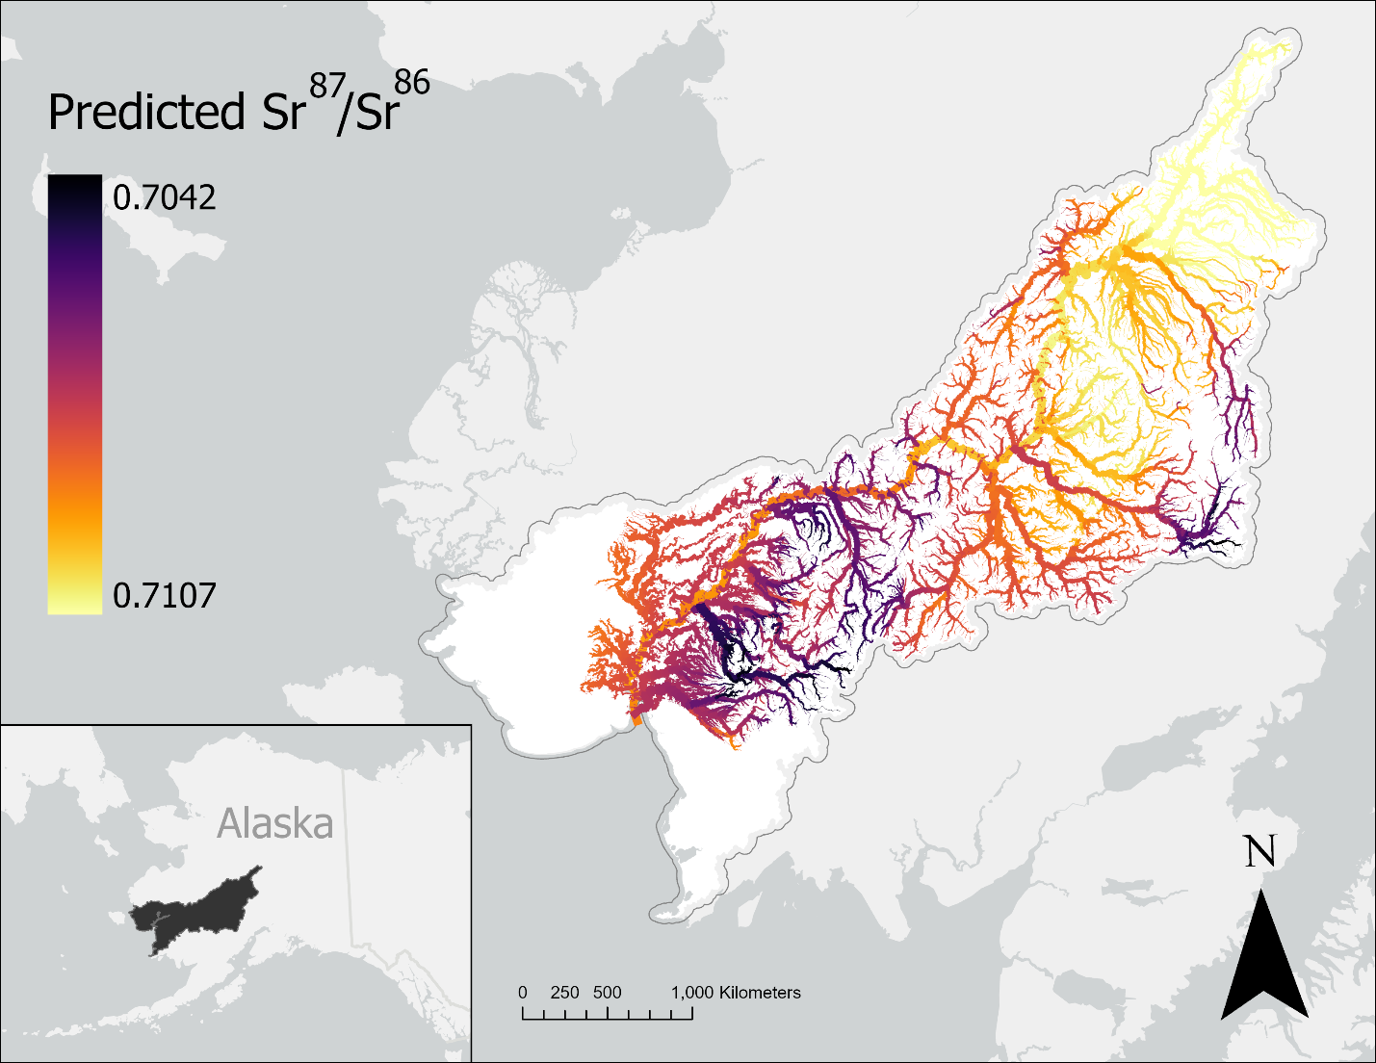
Figure 1: Strontium isoscape of the Kuskokwim River Basin (French et al., 2020) displaying the spatial variation in Sr⁸⁷/Sr⁸⁶ ratios. Darker colors indicate lower relative isotope ratios, whereas lighter colors indicate higher values. Isotope ratios across the basin range from 0.7042 to 0.7107, with a general trend toward higher values at the top of the watershed.

Figure 2:
A) 19 tributary groups selected by collecting the upstream reaches of notable tributaries in the basin. Regions not associated with a tributary (e.g. Lower Kuskokwim) were manually selected to ensure full coverage of the basin.
B) Six regional groupings based on k-means clustering and evaluation of silhouette score.
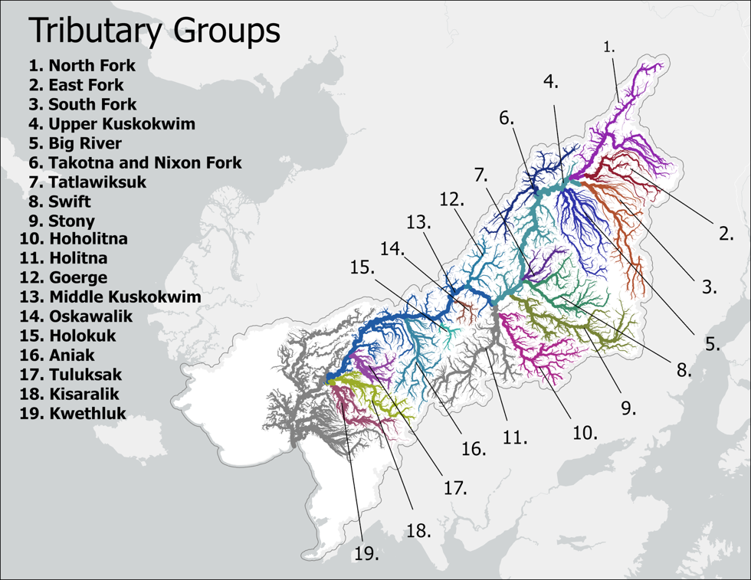
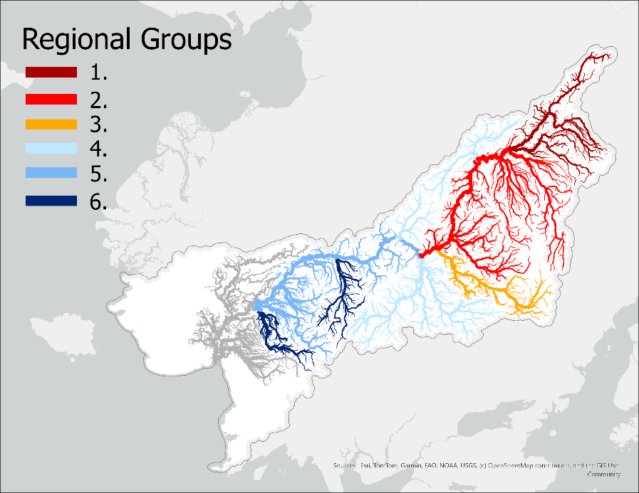

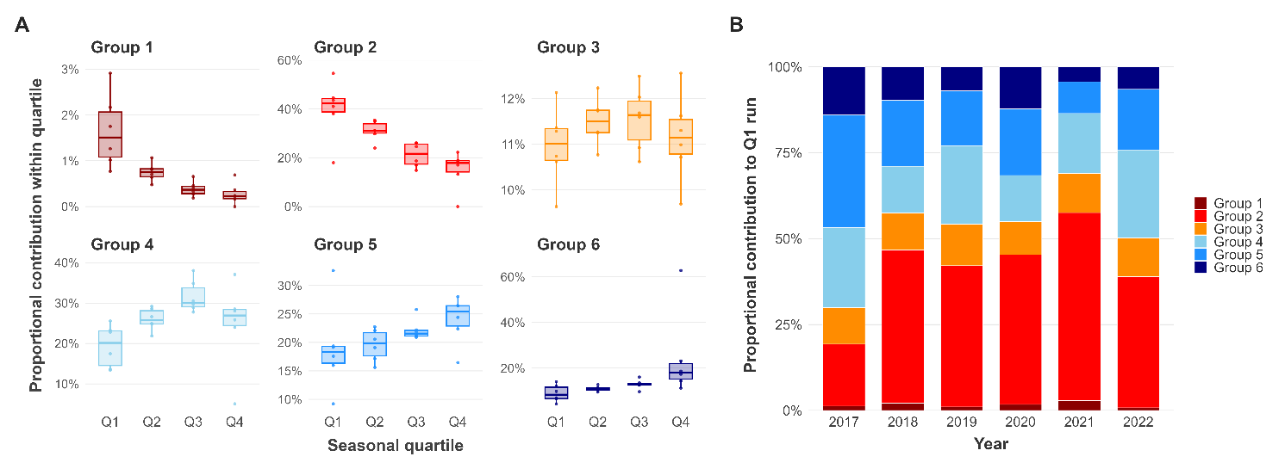
Figure 3: A) Median proportional contribution of regional groups to each seasonal quartile across all years of the dataset. Q1 ranged from the start of the season through June 11th, Q2 ranged from June 12th- 21st, Q3 ranged from June 22nd – July 1st, and Q4 ranged from July 2nd onwards. Boxplots illustrate the range in proportional contribution to each quartile for each stock group across all years of the dataset. B) Relative contribution of each regional group to Q1, which includes the duration of the front-end closure.

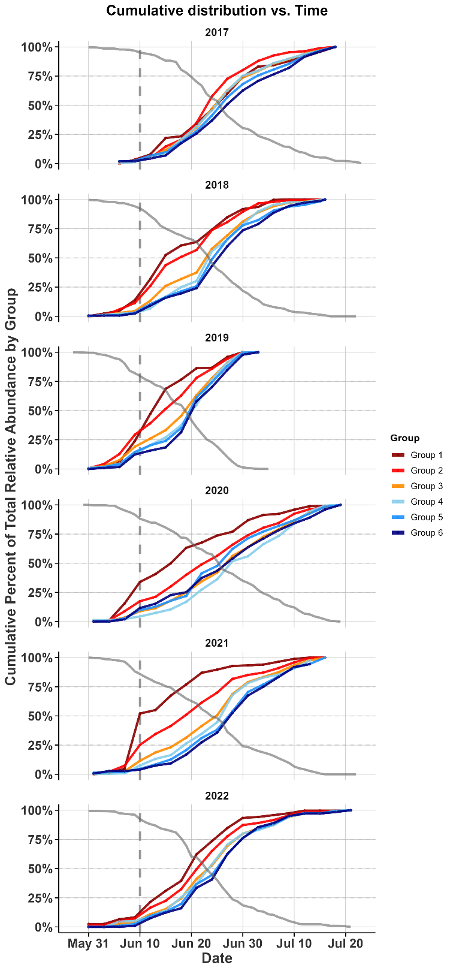
Figure 4: Cumulative distribution plots of returning regional groups to the Bethel Test Fishery in June and July 2017-2022. Lines are colored in order of their watershed position, with the furthest upstream groups in red transitioning toward downstream groups in blue. Gray dashed vertical line illustrates the end of the front-end closure. Gray solid line illustrates the remaining proportion of the total CPUE at each day.

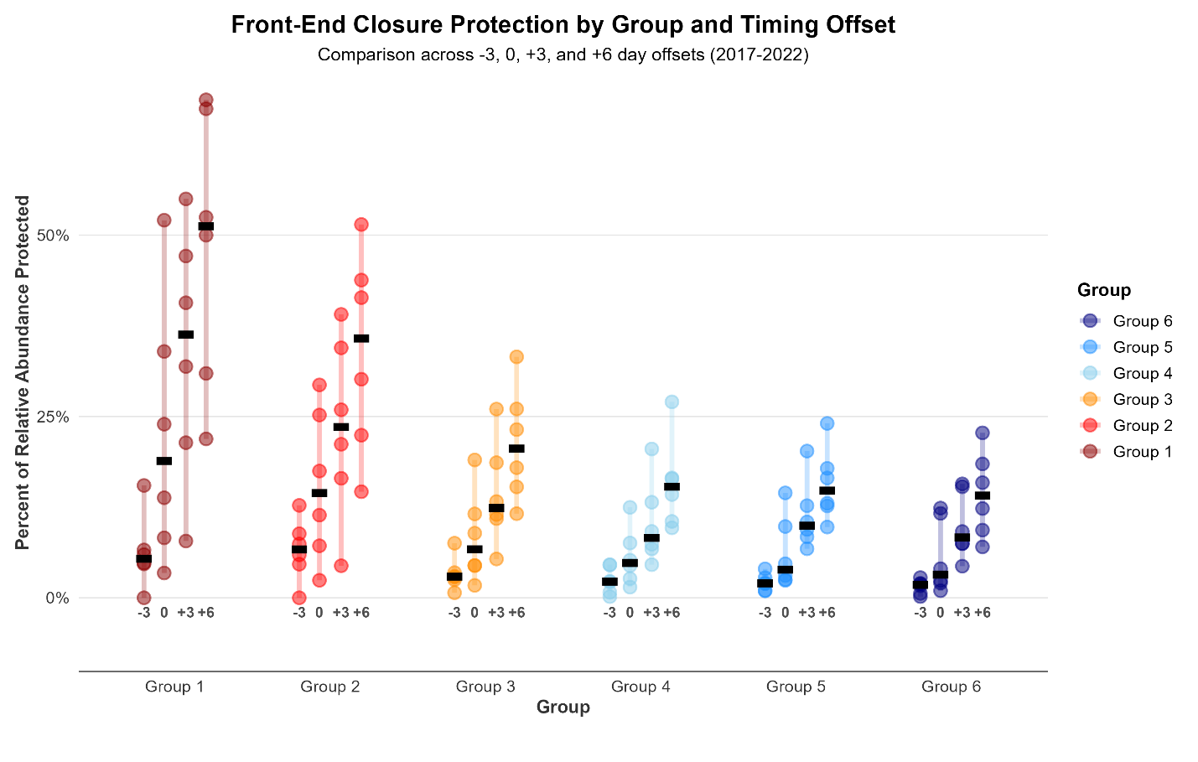
Figure 5: The proportion of each regional group’s total return protected under several simulated front-end closure scenarios, including the current closure. X-axis labels show the number of days the simulated closure end date differs from the current end date (−3 = June 8, 0 = June 11, +3 = June 14, +6 = June 17). Each point represents a single year, colored bars show the year-to-year range, and black lines denote the median across all years. Colors reflect watershed position, with upstream groups shown in red and downstream groups in blue.

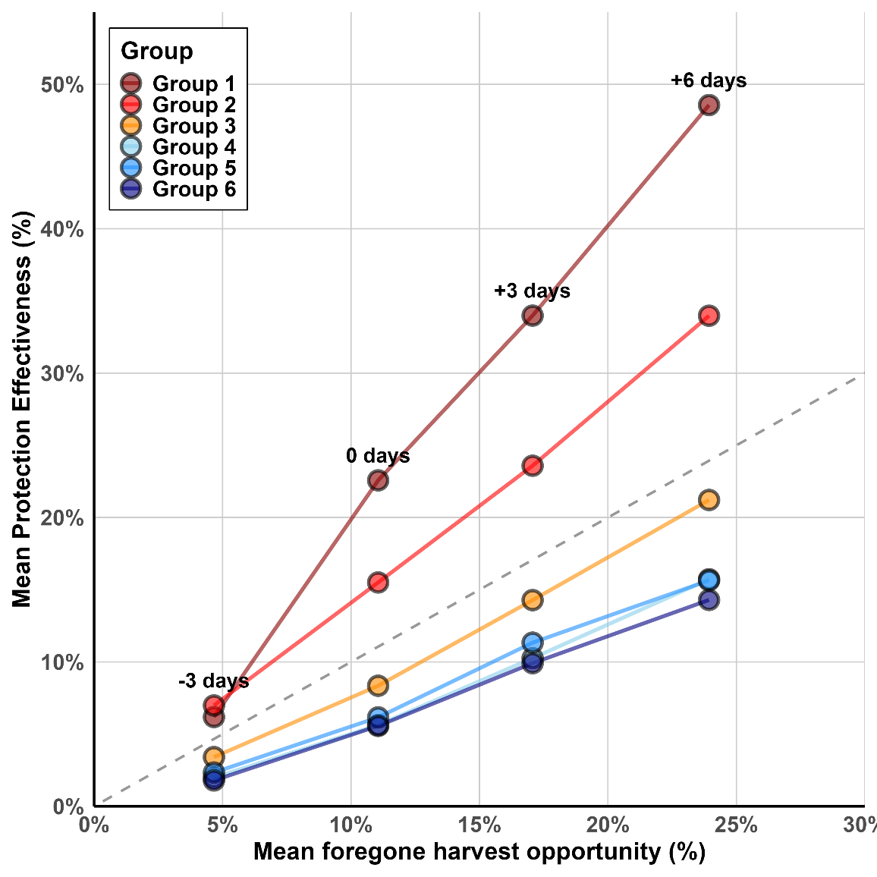
Figure 6: Comparison of the mean protection afforded to each group across all years with the mean foregone potential harvest. Potential foregone harvest is calculated as 1- (cumulative daily CPUE at each closure date/ total summed daily CPUE in that year). Each column of points illustrates a different closure end date scenario. The dashed grey line illustrates the 1:1 relationship.

