AI Career Mentor Web App – Frontend Development

Week 1 Report: Homepage interface
Author: Jagadeesh A
Date: 24 september 2025

1. Introduction
AI Career Mentor is a web application that seeks to offer customized career counseling through resume analysis, skill gap detection, identification of relevant learning material, and practice tests.
In Week 1, the frontend groundwork was focused on. Major deliverables are:
Homepage (index page): Welcomes the platform, showcases key features, and establishes the visual identity.
This report documents the step-by-step frontend implementation, design considerations, and file organization. The project remains under active development, and AI integrations, dashboards, and backend connectivity are scheduled for later weeks.

2. Project Structure
Current Project Structure (Frontend Focus):

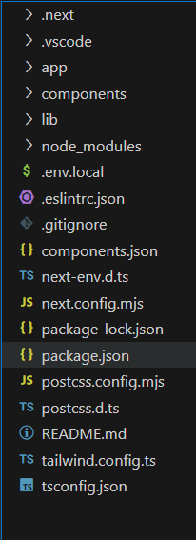
Structure Notes:
- app/components: UI components that can be reused to ensure modularity and scalability.
- pages: Main routes; index page implemented.
- globals.css: Contains Tailwind directives, theme variables, and glassmorphism effects.

3. Frontend Implementation
3.1 Homepage (index.tsx)
Goal: Design a visually engaging entry page that showcases platform features and invites user interaction.
Step-by-Step Implementation:
- Navigation Bar (Navbar.tsx)
- Comprises logo, links (Home, Dashboard, Contact), and theme toggle.
- Hero Section (HeroSection.tsx)
- Catchy tagline highlighting career guidance.
- Applied glassmorphism effects for semi-transparent background.
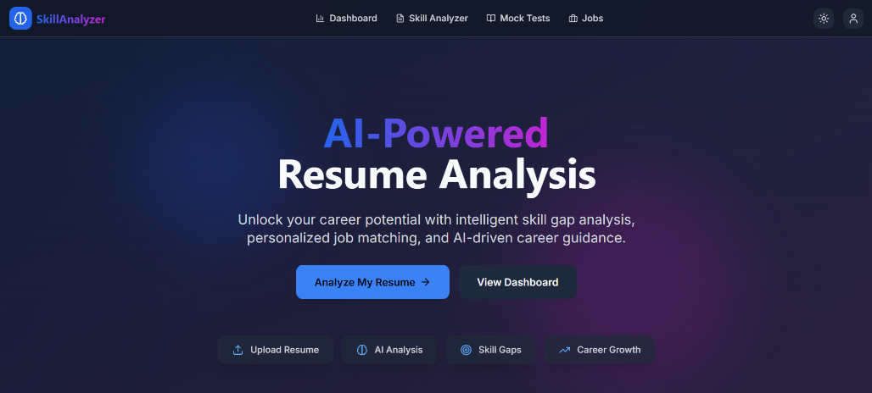

3.2 Responsiveness & Layout :
- Used Tailwind responsive utilities for mobile, tablet, and desktop screens.
- Hero section and feature cards dynamically adjust to varying screen widths.
- Theme Support dark class toggled for dark mode support.
- CSS variables set in globals.css for primary, secondary, and accent colors.

3.3 UI Design :
- Glassmorphism card with blur effect and semi-transparent background.
- Hover and focus effects for user interaction.
- Future Integration Placeholder
- Skill extraction and gap analysis modules will handle uploaded content in upcoming weeks

4. Tools and Technologies Used:
- Frontend Framework : Next.js (TypeScript)
- Styling : Tailwind CSS, Glassmorphism, CSS Variables
- Development Environment : VS Code, Node.js
- Version Control : Git
- Package Management : npm
- Design Reference : Figma mockups, Chrome DevTools

5. Work-in-Progress Notes:
- Feature card implementation for representing the features.
- Backend integration for resume parsing and AI modules is to be done later.
- Dashboards, mock tests, and personalized learning paths will be executed in future weeks.
- Current frontend is prepared for modular integration, ensuring easy shift to full-stack development.

6. Next Week Plan
- Backend Integration: Integrate resume upload page to FastAPI endpoints.
- Skill Extraction Modules: Enforce AI-based parsing of uploaded resumes.
- Dashboard Framework: Ready user dashboard design with dummy charts and progress trackers.
- Theme & UX Enhancements: Enhance animations, responsiveness, and accessibility features.
- Unit & Integration Testing: Test UI elements and ready for API integration.

7. Conclusion
- Homepage successfully implemented with professional UI.
- Frontend is modular, responsive, and good-looking, with light/dark mode support.
- The project is still work-in-progress, pending backend and AI integration for completeness.
- Provided a scalable base for additional development of AI Career Mentor's interactive functionalities.

8. Compliance Statement
I attest that all frontend code and interface layouts for Week 1 were coded by me independently. No unauthorized AI tools were applied, and all outputs represent my own development and design work.

