Assignment 1

Name:Shital Digambar Bhadre
PRN:260740150022

Q1.Types of Cable?

Cables are groups of wires or fibers covered by plastic or metal. The main types are twisted pair, coaxial, fiber optic, ribbon, and shielded cables. They are used to send power, phone calls, and computer data.
Common Types of Cables
Twisted Pair Cable
- Structure: Two copper wires twisted together and wrapped in color-coded plastic. Types include Unshielded (UTP) and Shielded (STP).
- Use: Telephone lines and local computer networks (LAN).
- How it works: Twisting the wires stops outside electrical noise from messing up the signal.
Coaxial Cable
- Structure: A central copper wire core surrounded by a plastic insulator, a metal foil or braid shield, and an outer plastic jacket.
- Use: Cable television and internet modems.
- How it works: The inner core and outer shield share the same axis, which blocks radio frequency interference.
Fiber Optic Cable
- Structure: Thin strands of glass or plastic fibers inside a protective outer tube.
- Use: High-speed internet and long-distance telecommunications.
- How it works: It sends data as pulses of light instead of electricity, allowing very fast speeds with zero signal loss over long distances.
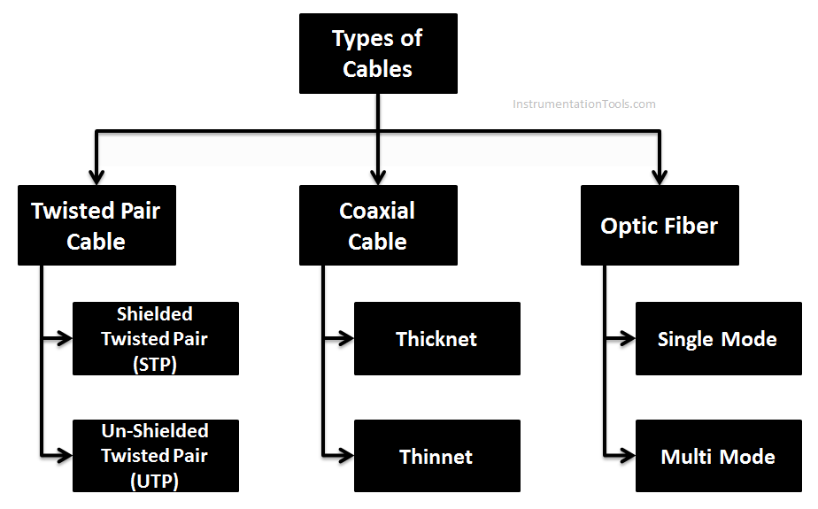

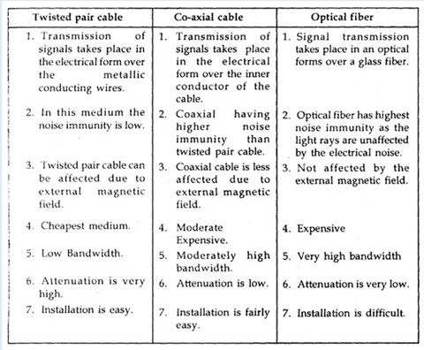

Q2.Difference Between TCP and UDP?

TCP (Transmission Control Protocol) and UDP (User Datagram Protocol) are two core protocols of the Transport Layer of the OSI and TCP/IP models. Both are responsible for end-to-end communication between applications, but they differ significantly in terms of reliability, speed, and use cases. Understanding the difference between TCP and UDP is essential for designing efficient and reliable networked systems.
Transmission Control Protocol (TCP)
TCP is a reliable, connection-oriented transport protocol that ensures accurate and ordered data delivery. It uses control mechanisms to guarantee data correctness, which makes it slower but dependable.
- Connection-oriented protocol
- Reliable and ordered data delivery
- Higher overhead but high accuracy
User Datagram Protocol (UDP)
UDP is a fast, connectionless transport protocol that sends data without reliability guarantees. It is efficient for applications where speed is more important than accuracy.
- Connectionless and lightweight
- No guarantee of delivery or order
- Low overhead and high speed

TCP (Transmission Control Protocol) | UDP (User Datagram Protocol)
Connection-oriented; uses a three-way handshake | Connectionless; no handshake
Guarantees reliable data delivery | Does not guarantee delivery
Uses acknowledgements (ACKs) | No acknowledgements
Supports retransmission of lost packets | No retransmission support
Ensures packets are delivered in order | Does not ensure ordering
Provides flow control and congestion control | No flow or congestion control
Slower due to higher overhead | Faster with minimal overhead
Variable header size (20–60 bytes) | Fixed header size (8 bytes)
Treats data as a continuous byte stream | Treats data as independent messages
Does not support broadcasting or multicasting | Supports broadcasting and multicasting
Used by HTTP, HTTPS, FTP, SMTP | Used by DNS, DHCP, VoIP, Streaming

