Name:Shital Digambar Bhadre

PRN:260740150022

Assignemnt 2 (IP Addressing)

- What is IP Addressing?
An IP Address is a unique numerical label assigned to each device connected to a computer network that uses the Internet Protocol for communication.
Example: IP 192.168.1.10

Types of IP Address
- Public IP Addresses
A Public IP address is assigned to every device that directly accesses the internet. This address is unique across the entire internet. Uniqueness & Accessibility are its key characteristics & are assigned by Internet Service Providers. When you connect to the internet through an ISP, your device or router receives a public IP address. These addresses can be static or dynamic.
Example Use: If you host a website on your own server at home, your ISP must assign a public IP address to your server so users around the world can access your site.ives a public IP address. These addresses can be static or dynamic.

- Private IP Addresses
Private IP addresses are used within private networks and are not routable on the internet. This means that devices with private IP addresses cannot directly communicate with devices on the internet without a translating mechanism like a router performing Network Address Translation (NAT). These are only required to be unique within their own network & are used for communication between devices within the same network
Example Use: In a typical home network, the router assigns private IP addresses to each device (like smartphones, laptops, smart TVs) from the reserved ranges. These devices use their private IPs to communicate with each other and with the router. The router uses NAT to allow these devices to access the internet using its public IP address.

- What are the Different Versions of IP Addresses?

- IPv4: Uses four numbers (octets) ranging from 0 to 255 separated by periods. Because the rapid growth of connected devices exhausted the ~4.3 billion available IPv4 addresses, workarounds like Network Address Translation (NAT) were deployed to prolong its lifespan.

- IPv6: Uses eight groups of four hexadecimal digits separated by colons. It provides virtually unlimited address space—enough to assign millions of IP addresses to every single square meter on Earth—eliminating the need for complex address-sharing mechanisms.

- Describe IPv4 in Detail.
  - What is IPv4?
  - How is it structured (bit length, dotted decimal format)?

IPv4 (Internet Protocol Version 4) is the fourth iteration of the Internet Protocol and the core communication technology that powers the majority of global internet traffic. Defined in 1981 by the Internet Engineering Task Force (IETF) under RFC 791, IPv4 provides a connectionless, best-effort packet delivery service operating at the Network Layer (Layer 3) of the OSI model.
It assigns a unique numerical identifier to every network interface, allowing routers to locate, route, and deliver data packets across interconnected networks worldwide.
An IPv4 address is built around a simple mathematical structure designed to balance machine processing speed with human readability:
- Bit Length & Total Capacity: An IPv4 address is 32 bits (4 bytes) long. This total length provides a theoretical maximum address space of 2^{32} or 4,294,967,296 unique addresses.
- Four Octets: The 32-bit binary string is divided into four equal 8-bit sections called octets (or bytes). Since an 8-bit binary number ranges from 00000000 (0) to 11111111 (255), each individual octet can hold a value between 0 and 255.
- Dotted-Decimal Format: Because raw binary (11000000101010000000000100000001) is difficult for humans to read, IPv4 uses dotted-decimal notation. Each octet is converted into a base-10 decimal number, separated by dots:

- Explain the Classes of IPv4 Addressing (Class A, B, C, D, E) with the help of the following parameters for each class:
  - High Order Bit(s)
  - Network ID Bits
  - Host ID Bits
  - Number of Networks
  - Addresses per Network
  - Starting Address
  - Ending Address1`s
  - Default Subnet Mask
  - Reserved For (purpose or use case)

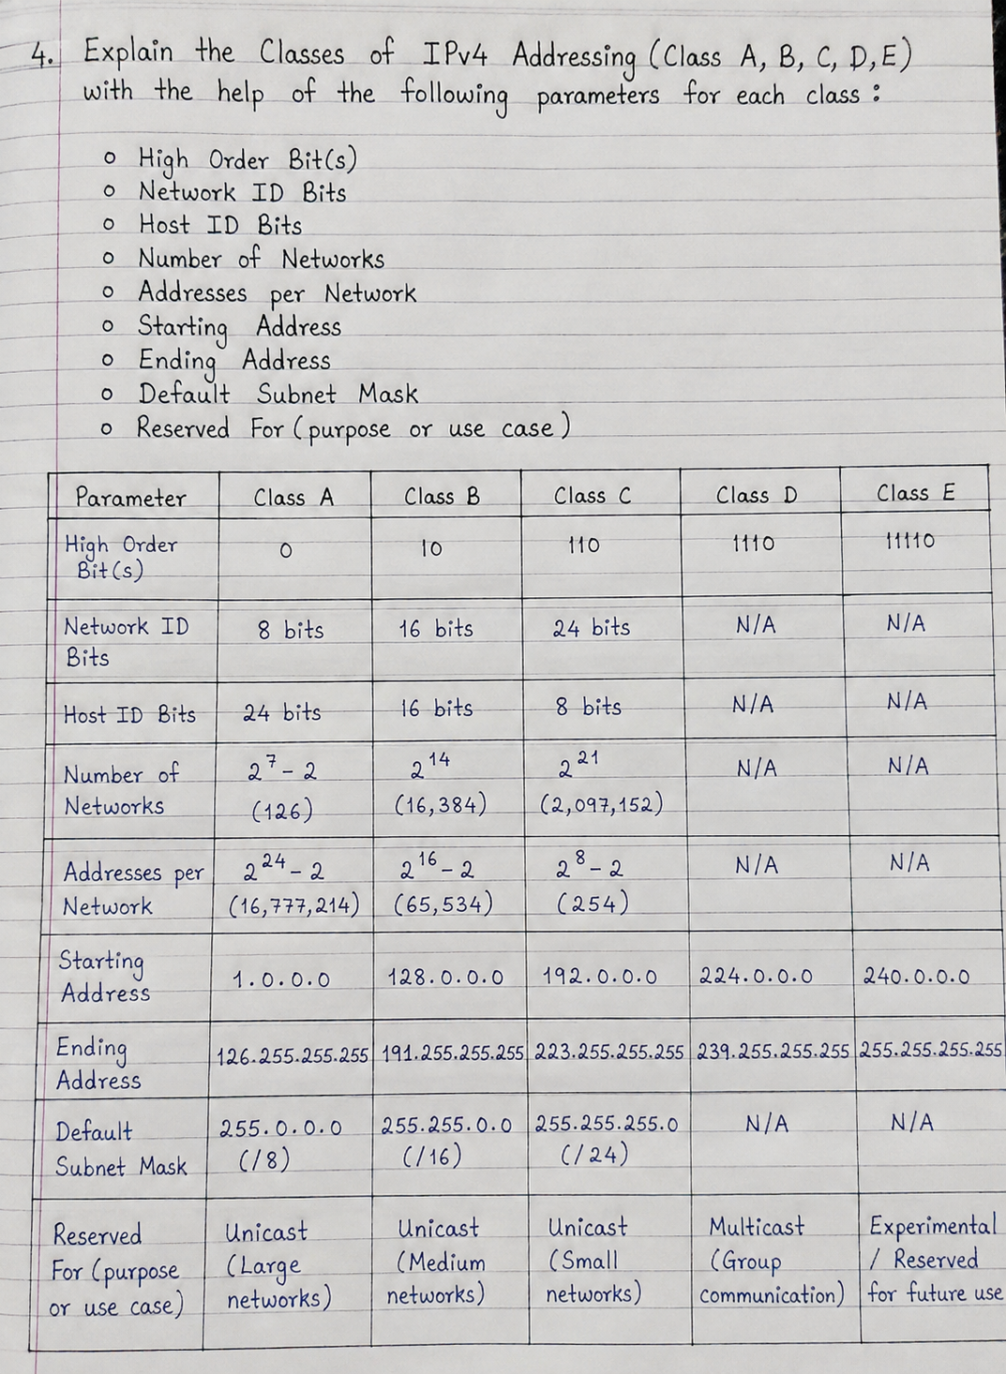

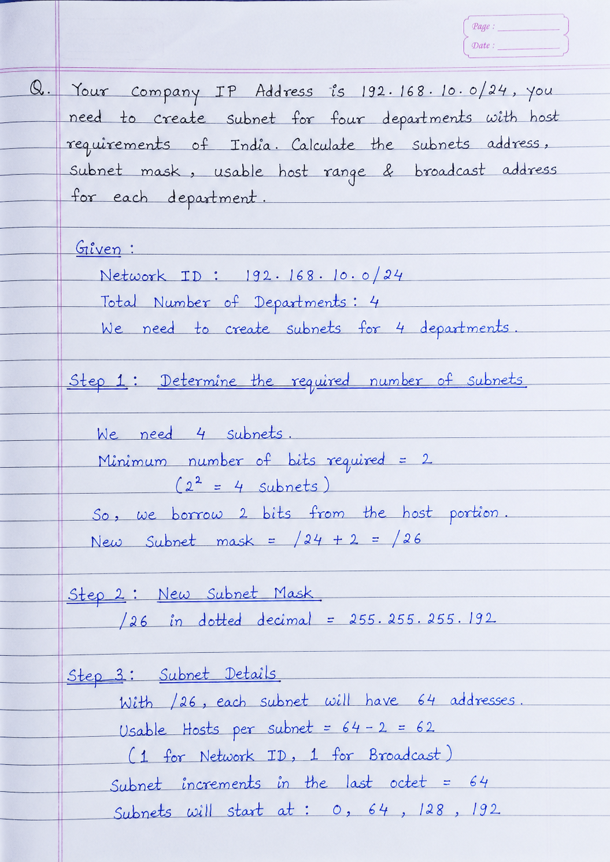

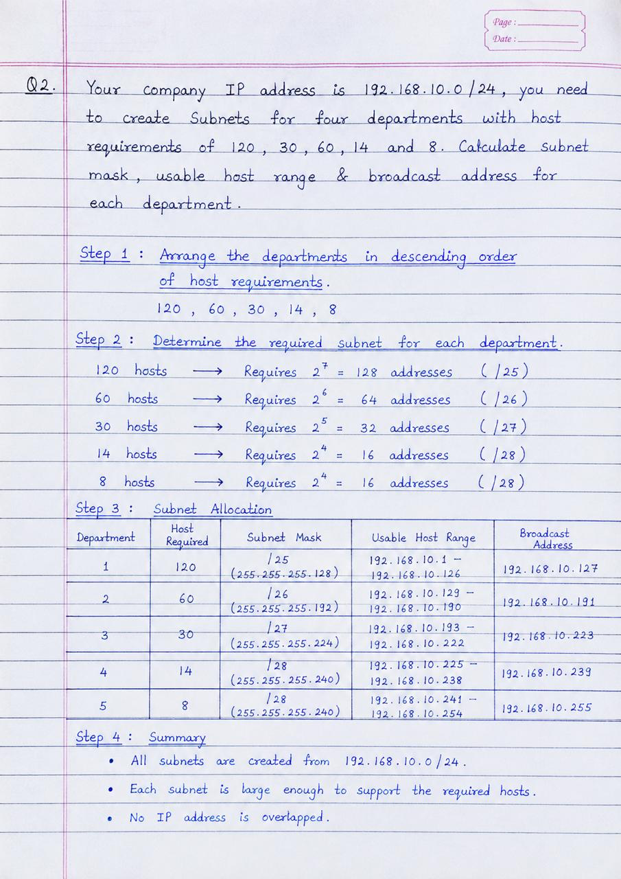

Assignemnt 2 (Broadcasting)

1. What is Broadcasting?
Broadcasting is a communication method in which one device sends data to all devices connected to the same network. The message is delivered to every device, but only the intended device processes it.

2. Where is Broadcasting commonly used?
Broadcasting is commonly used in:
- Computer networks for sending information to all devices.
- ARP (Address Resolution Protocol) to find the MAC address of a device.
- DHCP when a device is trying to obtain an IP address.
- Network discovery and service discovery.

3. What are the drawbacks of Broadcasting?
The main drawbacks are:
- It creates extra network traffic.
- It can reduce network performance when many broadcast messages are sent.
- Every device receives the message, which may waste bandwidth and processing power.
- Too much broadcasting can cause a broadcast storm and slow down the network.

