Assignment 3
PNR: 260740150022
Name: Shital Digambar Bhadre
1. IPv4 Address Classes
1.1. What is the Class C address range in decimal and in binary?
1.2. What is the valid range of a Class A network address?
1.3. What is the Class A private IP address space?
1.4. What is the Class B private IP address space?
1.5. What is the Class C private IP address space?
2. Multiple Choice Questions
2.1. Which Class of IP addresses uses the pattern shown here?
Network Network Network Host
A. Class A
B. Class B
C. Class C
D. Class D
2.2. Which of the following is an example of a multicast address?
A. 10.6.9.1
B. 192.168.10.6
C. 224.0.0.10
D. 172.16.9.5
2.3. Which two of the following are private IP addresses?
A. 12.0.0.1
B. 168.172.19.39
C. 172.20.14.36
D. 172.33.194.30
E. 192.168.24.43
2.4. What is the address range of a Class B network address in binary?
A. 01xxxxxxx
B. 0xxxxxxx
C. 10xxxxxx
D. 110xxxxxx
3. Find the Network and Broadcast Address
Tip: Network address is the first address of the subnet, and broadcast address is the last address of the subnet.
3.1. Find the network and broadcast address for 192.168.10.0/24.
3.2. Find the network and broadcast address for 10.0.0.0/8.
3.3. Find the network and broadcast address for 150.150.150.150/16.
3.4. Find the network and broadcast address for 200.200.200.200/24.
3.5. Find the network and broadcast address for 100.100.100.0/8.
3.6. Find the network and broadcast address for 100.100.255.0/8.
3.7. Find the network and broadcast address for 172.172.150.150/16.

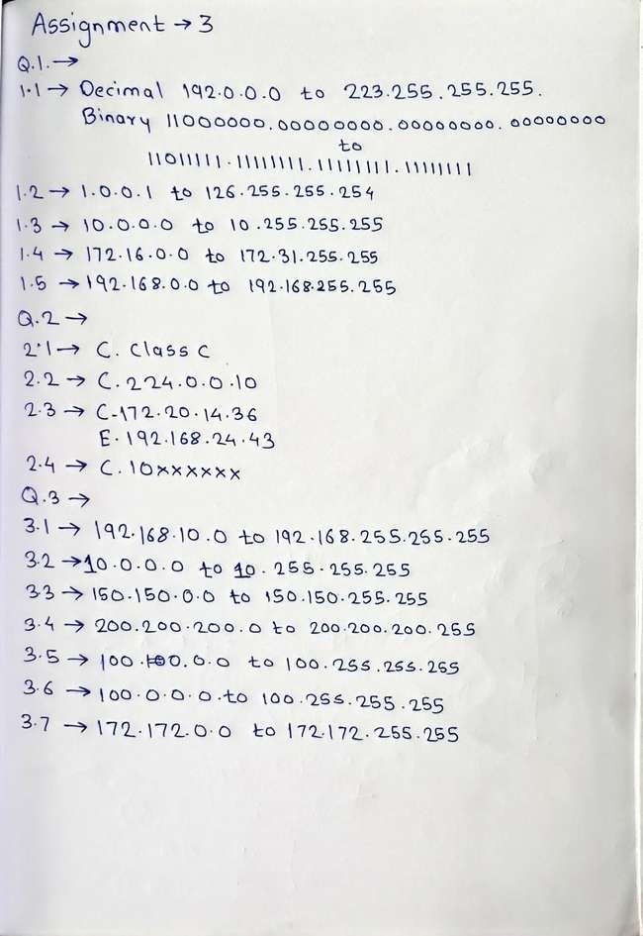
4. Network, Host Range and Subnet Mask
4.1. All N/w and Host Range subnet mask
4.1.1. Example 2: 192.168.10.0 — In this, we need 8 networks.
4.1.2. Example 3: 200.200.200.0 — In this, we need 10 networks.
4.1.3. Example 4: 220.200.200.0 — In this, we need 6 networks.
4.1.4. Example 5: 192.168.10.0 — In this, we need 60 networks.

4.2 N/w and host range subnet mask
4.2.1. Example 6: 192.168.10.0/25 — Find the network, host range, and subnet mask.
4.2.2. Example 7: 192.168.10.0/27 — Find the network, host range, and subnet mask.
4.2.3. Example 8: 192.168.10.0/31 — Find the network, host range, and subnet mask.
4.2.4. Example 9: 220.200.200.0/29 — Find the network, host range, and subnet mask.

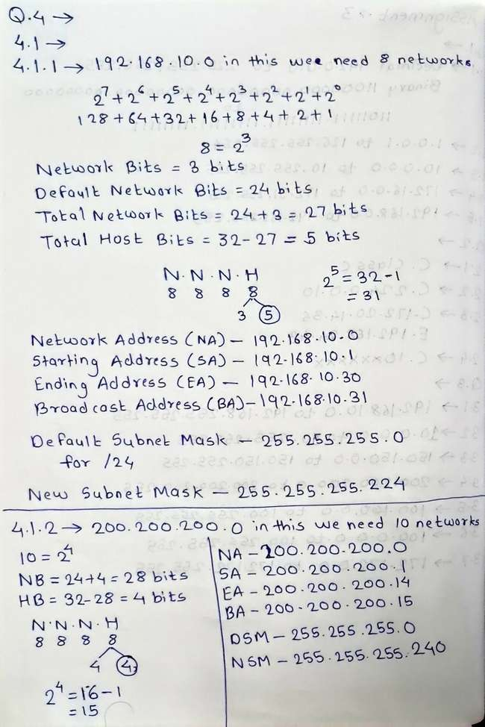
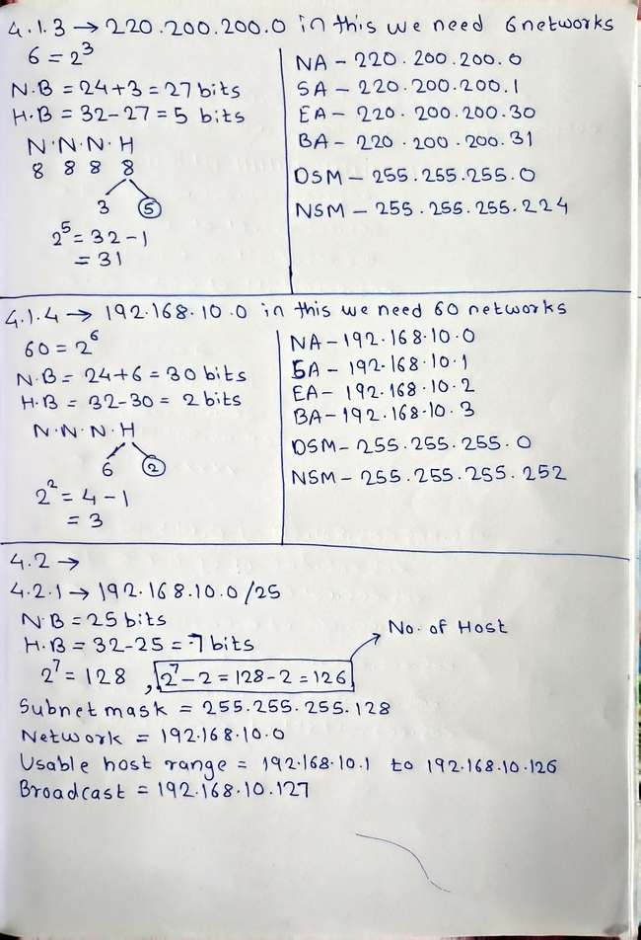
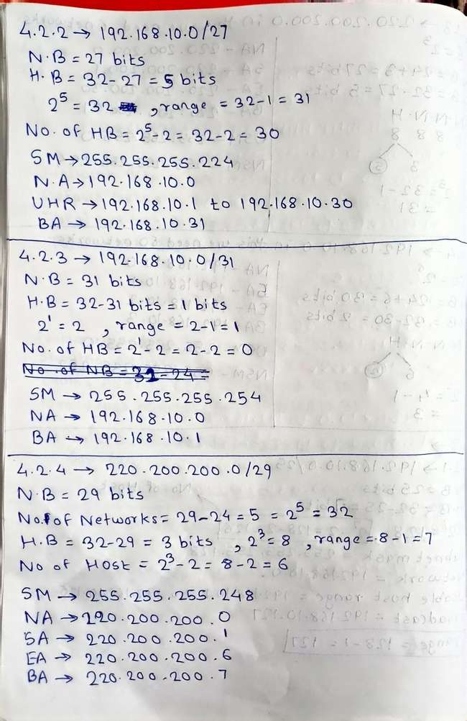
5. Finding Network Address from an IP Address and Subnet Mask
5.1. Find the network address:
. IP Address: 192.168.10.198
. Subnet Mask: 255.255.255.247
6. Write the Subnet, Broadcast Address and Valid Host Range
6.1. 192.168.100.25/30
6.2. 192.168.100.37/28
6.3. 192.168.100.66/27
6.4. 192.168.100.17/29
6.5. 192.168.100.99/26

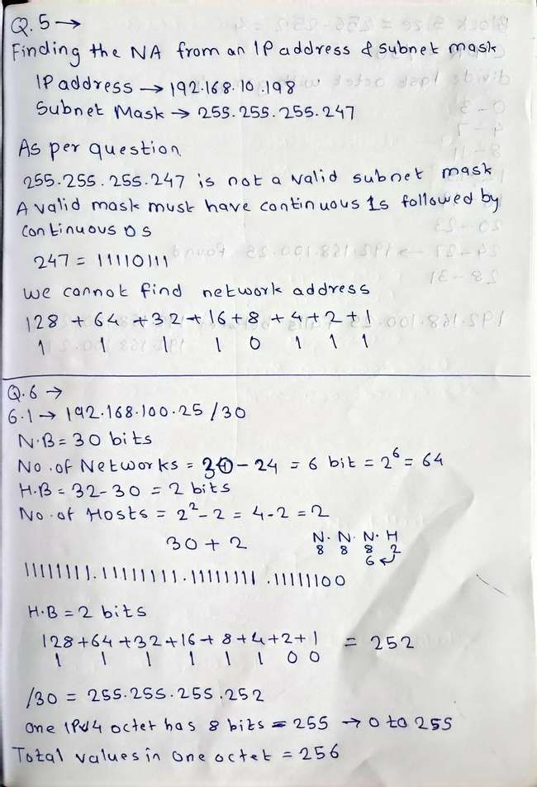
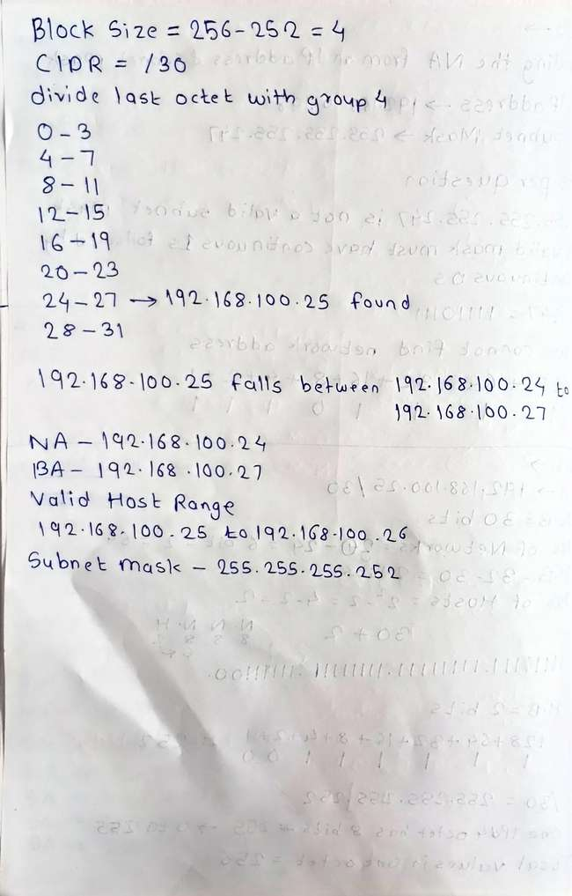
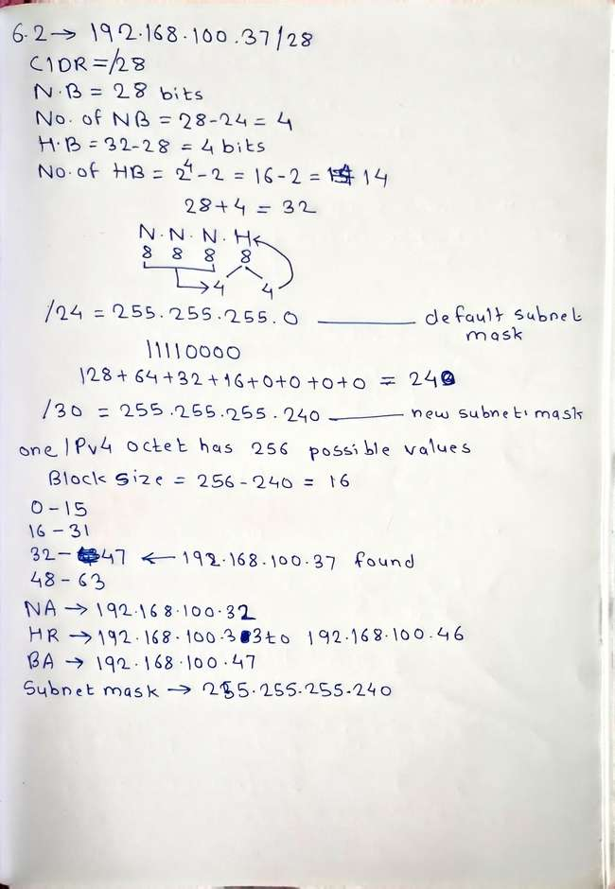
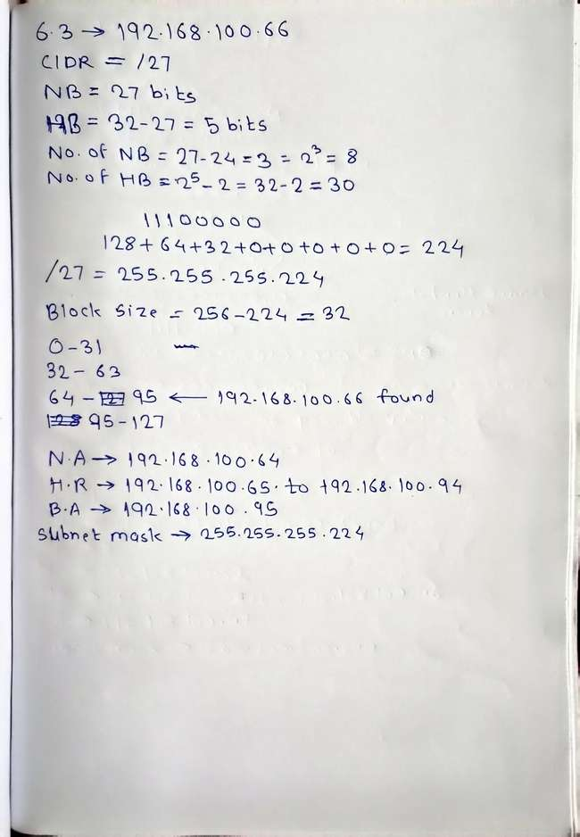
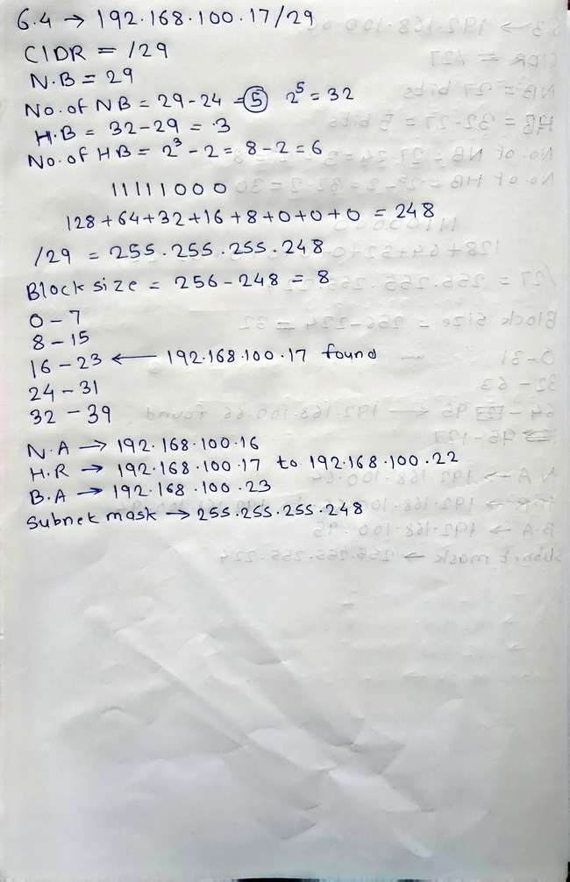
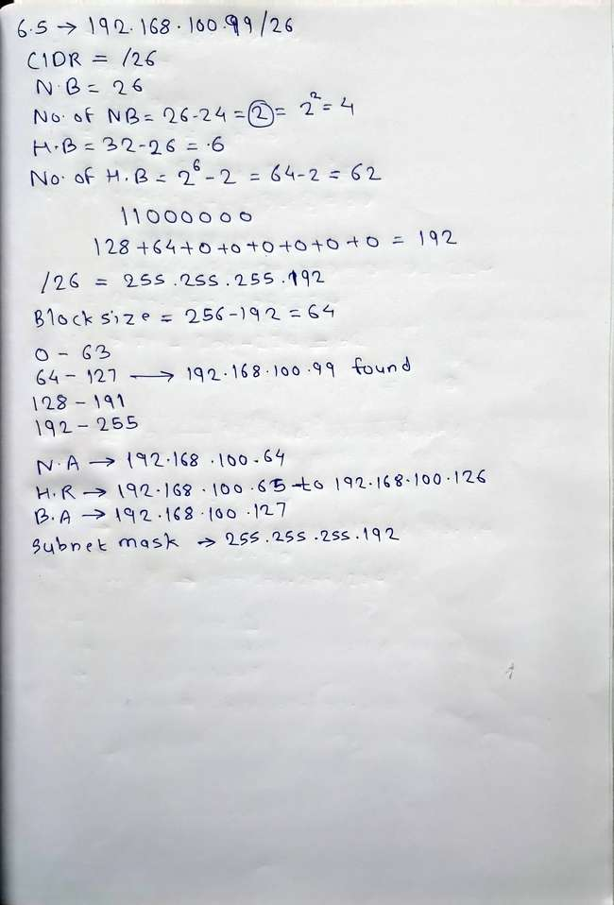
7. Class B Subnetting
7.1. You have a Class B network and need 29 subnets. What is your subnet mask?
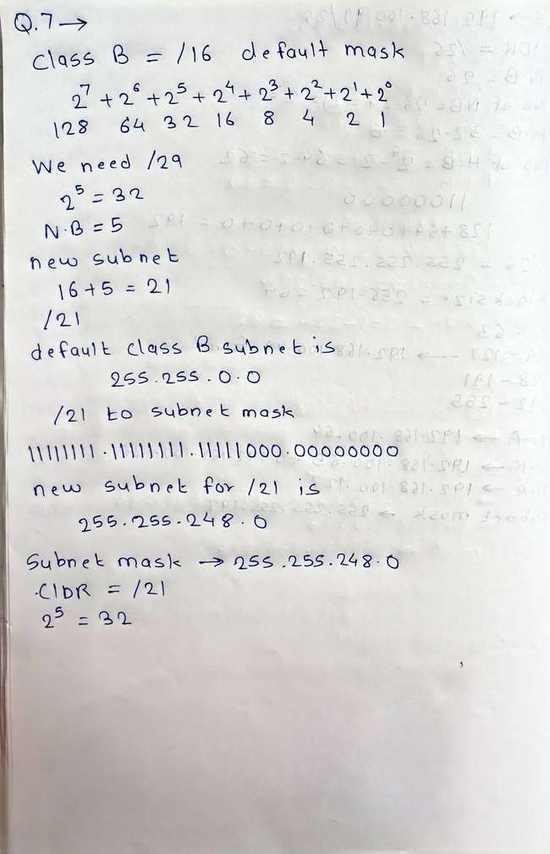
8. Broadcast Address
8.1. What is the broadcast address of 192.168.192.10/29?
9. Number of Hosts
9.1. How many hosts are available with a Class C /29 mask?
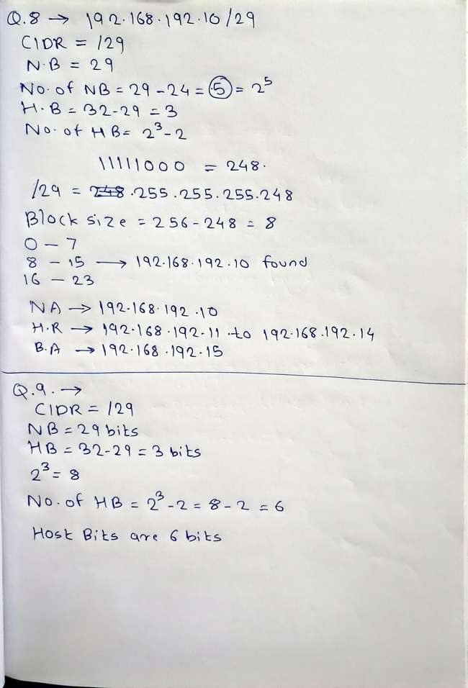
10. Find the Subnet
10.1. What is the subnet for host ID 10.16.3.65/23?
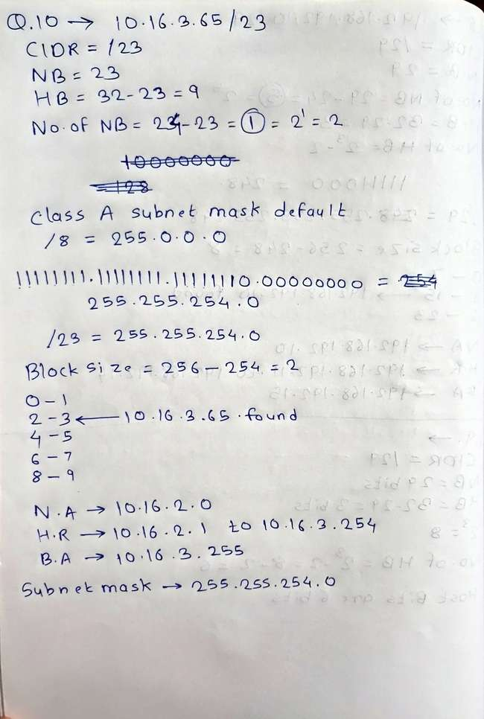
Assignment 4
PNR: 260740150022
Name:Shital Digambar Bhadre
Q.1. Your company's IP address is 192.168.10.0/24. You need to create subnets for four departments with host requirements of 120, 30, 60, 14 and 6. Calculate the network address, subnet mask, usable host range, and broadcast address for each department.
Department/Site | Hosts | Network Address | Subnet Mask | Usable Host Range | Broadcast
Department 1 | 120 | 192.168.10.0/25 | 255.255.255.128 | 192.168.10.1 – 192.168.10.126 | 192.168.10.127
Department 3 | 60 | 192.168.10.128/26 | 255.255.255.192 | 192.168.10.129 – 192.168.10.190 | 192.168.10.191
Department 2 | 30 | 192.168.10.192/27 | 255.255.255.224 | 192.168.10.193 – 192.168.10.222 | 192.168.10.223
Department 4 | 14 | 192.168.10.224/28 | 255.255.255.240 | 192.168.10.225 – 192.168.10.238 | 192.168.10.239
Department 5 | 6 | 192.168.10.240/29 | 255.255.255.248 | 192.168.10.241 – 192.168.10.246 | 192.168.10.247
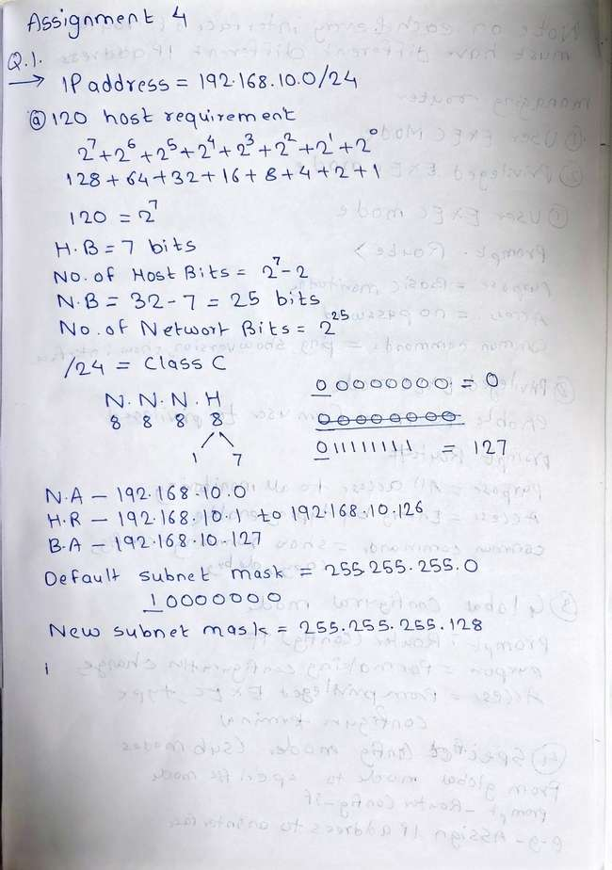
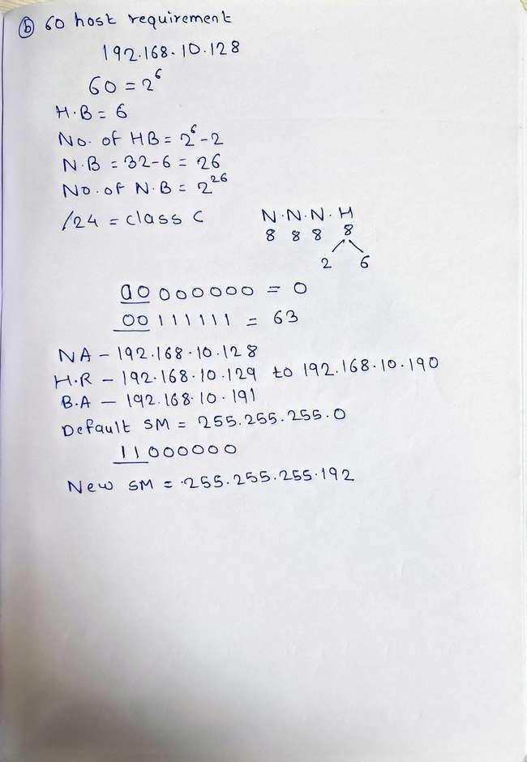
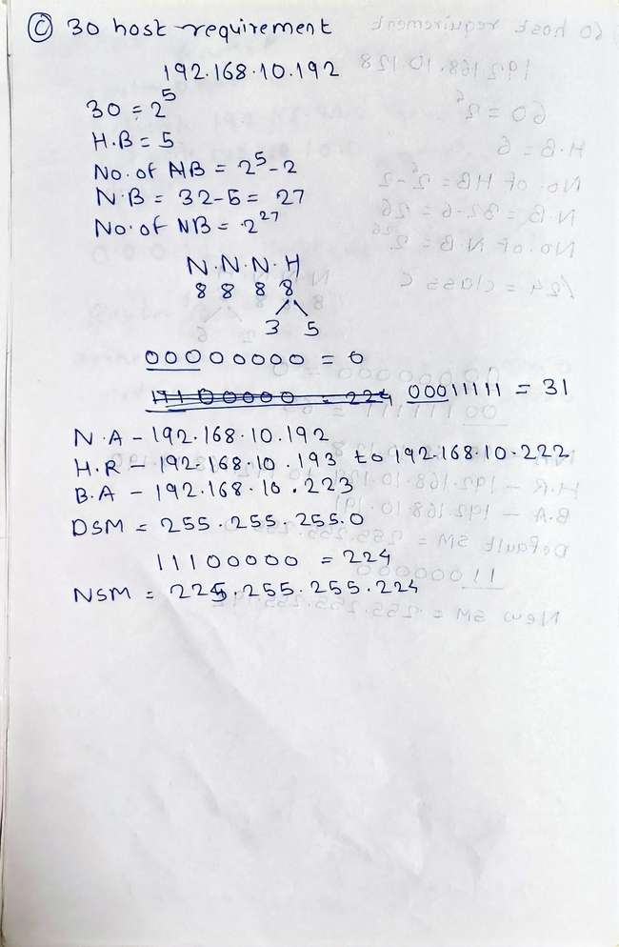
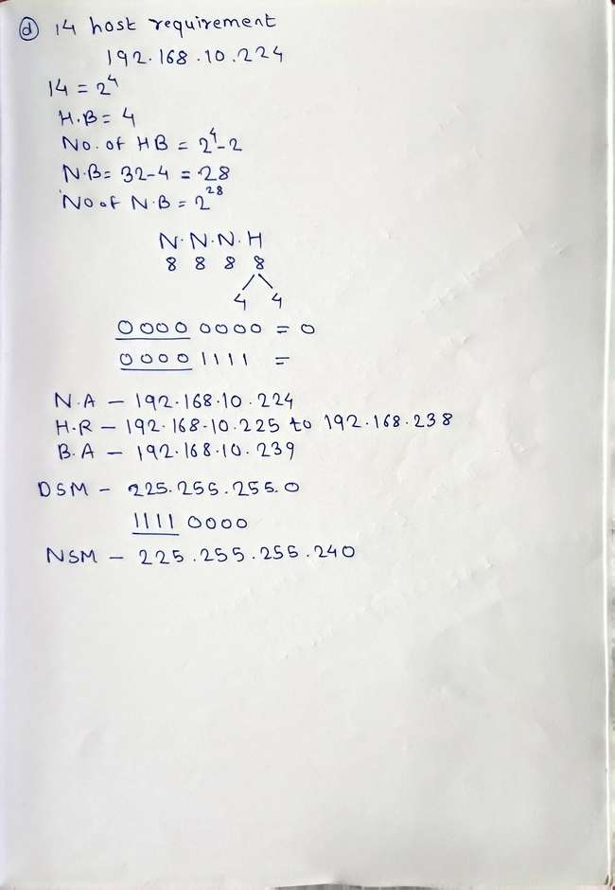
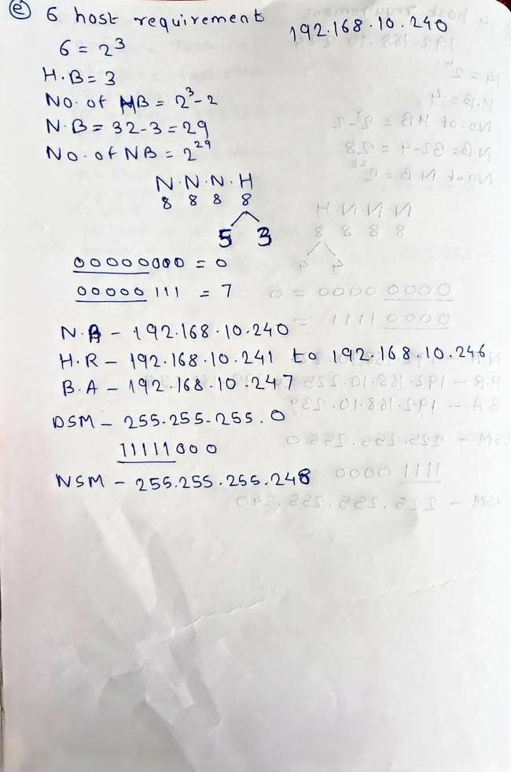
2. A company's IP address is 172.18.0.0/16. They need to create subnets for four sites with host requirements of 8,000, 60, 900, and 2,000. Using VLSM, calculate the network address, subnet mask, usable host range, and broadcast address for each site.
Department/Site | Hosts | Network Address | Subnet Mask | Usable Host Range | Broadcast
Site 1 | 8000 | 172.18.0.0/19 | 255.255.224.0 | 172.18.0.1 – 172.18.31.254 | 172.18.31.255
Site 4 | 2000 | 172.18.32.0/21 | 255.255.248.0 | 172.18.32.1 – 172.18.39.254 | 172.18.39.255
Site 3 | 900 | 172.18.40.0/22 | 255.255.252.0 | 172.18.40.1 – 172.18.43.254 | 172.18.43.255
Site 2 | 60 | 172.18.44.0/26 | 255.255.255.192 | 172.18.44.1 – 172.18.44.62 | 172.18.44.63
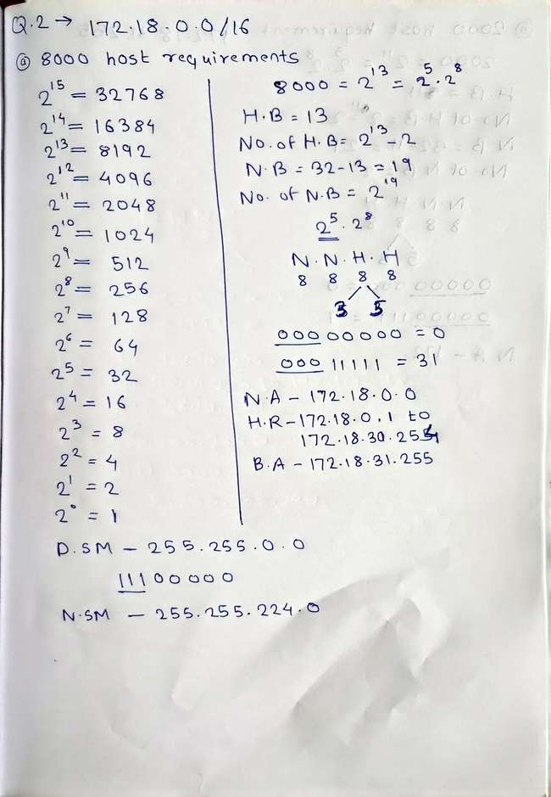
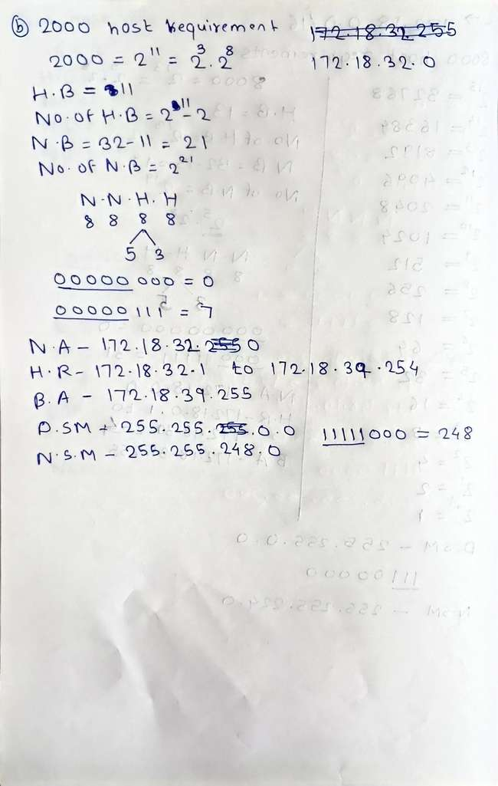
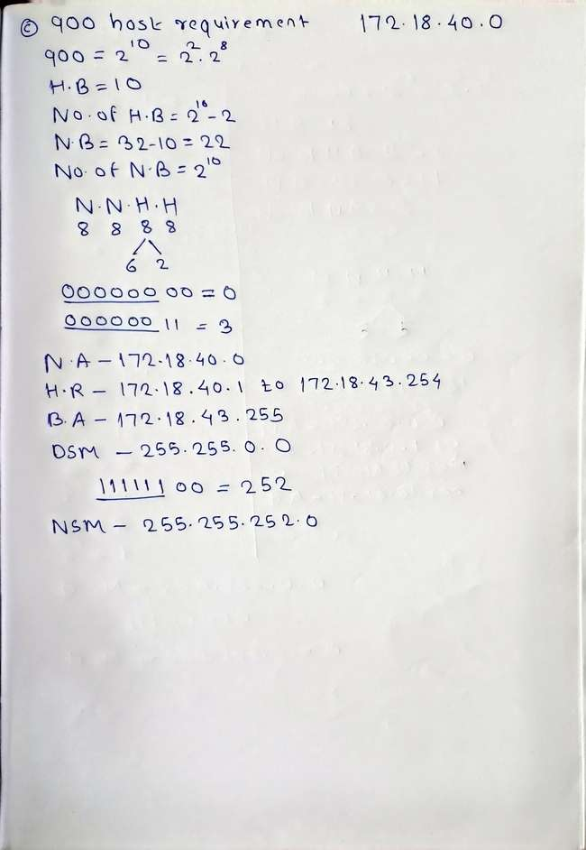
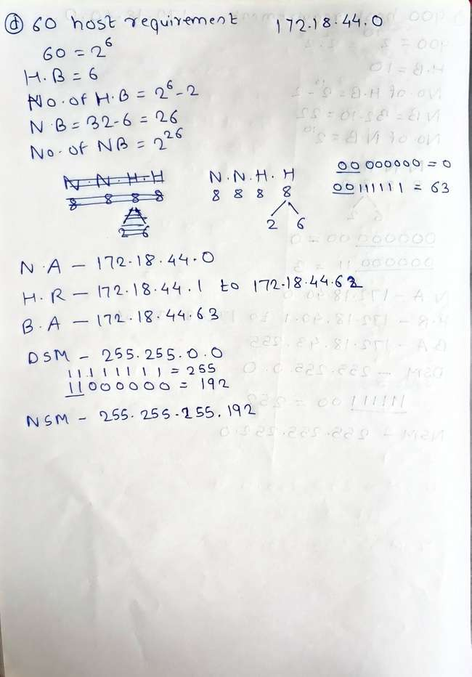
3. Your organization uses the IP address 10.0.0.0/8. You need to create subnets for three branch offices with 50,000, 20,000, and 5,000 hosts. Solve this VLSM problem and provide the subnet details for each office.
Department/Site | Hosts | Network Address | Subnet Mask | Usable Host Range | Broadcast
Branch Office 1 | 50000 | 10.0.0.0/16 | 255.255.0.0 | 10.0.0.1 – 10.0.255.254 | 10.0.255.255
Branch Office 2 | 20000 | 10.1.0.0/17 | 255.255.128.0 | 10.1.0.1 – 10.1.127.254 | 10.1.127.255
Branch Office 3 | 5000 | 10.1.128.0/19 | 255.255.224.0 | 10.1.128.1 – 10.1.159.254 | 10.1.159.255
