Shital Digambar Bhadre
PRN:260740150022
Utkarsha Subhash Pawar
PRN :260740150028

Assignment 4&5

1. Employee and Address
Problem Statement:
Create an Employee class that contains an object of an Address class representing the employee's residential address. The Address class should contain area,city, and PIN code. Accept and display the complete employee and address details.implement constructors.
#include<iostream>
using namespace std;

class Address
{
string area, city;
int pincode;
public:
Address()
{
cout << "Enter area: ";
cin >> area;
cout << "Enter city: ";
cin >> city;
cout << "Enter pincode: ";
cin >> pincode;
}
void display()
{
cout << "Area: " << area << endl;
cout << "City: " << city << endl;
cout << "Pincode: " << pincode << endl;
}
};

class employee{
int eid;
string ename;
Address addr;
public:
employee(){
cout << "Enter id: ";
cin >> eid;
cout << "Enter name: ";
cin >> ename;
}
void display(){
cout << "Employee id: " << eid << endl;
cout << "Employee name: " << ename << endl;
addr.display();
}
};

int main(){
employee e;
e.display();
return 0;
}

Output:
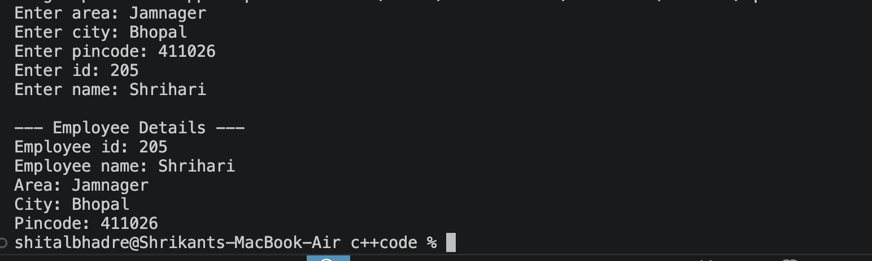

Concept: Object of one class as a data member of another class.
2. Book and Publisher
Problem Statement:
Create a Book class that contains an object of a Publisher class representing the publisher details. The Publisher class should contain publisher name, city, and contact number. Accept and display the book details along with its publisher information.
#include<iostream>
using namespace std;

class Publisher
{
string pname, city;
long contactNo;
public:
Publisher()
{
cout << "Enter publisher name: "<<endl;
cin >> pname;
cout << "Enter city: "<<endl;
cin >> city;
cout << "Enter contact number: "<<endl;
cin >> contactNo;
}
void display()
{
cout << "Publisher Name : " << pname << endl;
cout << "City : " << city << endl;
cout << "Contact Number : " << contactNo << endl;
}
};

class Book{
string title;
string author;
float price;
Publisher pub;

public:
Book(){
cout << "Enter book title: ";
cin >> title;
cout << "Enter author name: ";
cin >> author;
cout << "Enter price: ";
cin >> price;

}
void display(){
cout << "\n--- Book Details ---" << endl;
cout << "Title : " << title << endl;
cout << "Author : " << author << endl;
cout << "Price : " << price << endl;
cout << "\n--- Publisher Details ---" << endl;
pub.display();
}
};

int main(){
Book b;
b.display();
return 0;
}

Output:


Concept: Composition between Book and Publisher.
3.Employee and Joining Date
Problem Statement:
Create an Employee class that contains an object of a Date class representing the employee's joining date. The Date class should contain day, month, and year. Accept employee ID, employee name, salary, and joining date, and display all the details.
Concept: Employee has-a Date.
#include<iostream>
using namespace std;

class Date
{
int day, month, year;
public:
Date()
{
cout << "Enter day: ";
cin >> day;
cout << "Enter month: ";
cin >> month;
cout << "Enter year: ";
cin >> year;
}
void display()
{
cout << day << "/" << month << "/" << year << endl;
}
};

class Employee{
int eid;
string ename;
float salary;
Date joiningDate;
public:
Employee(){
cout << "Enter employee id: ";
cin >> eid;
cout << "Enter employee name: ";
cin >> ename;
cout << "Enter salary: ";
cin >> salary;
}
void display(){
cout << "\n--- Employee Details ---" << endl;
cout << "Employee ID : " << eid << endl;
cout << "Employee Name : " << ename << endl;
cout << "Salary : " << salary << endl;
cout << "Joining Date : ";
joiningDate.display();
}
};

int main(){
Employee e;
e.display();
return 0;
}

Output:
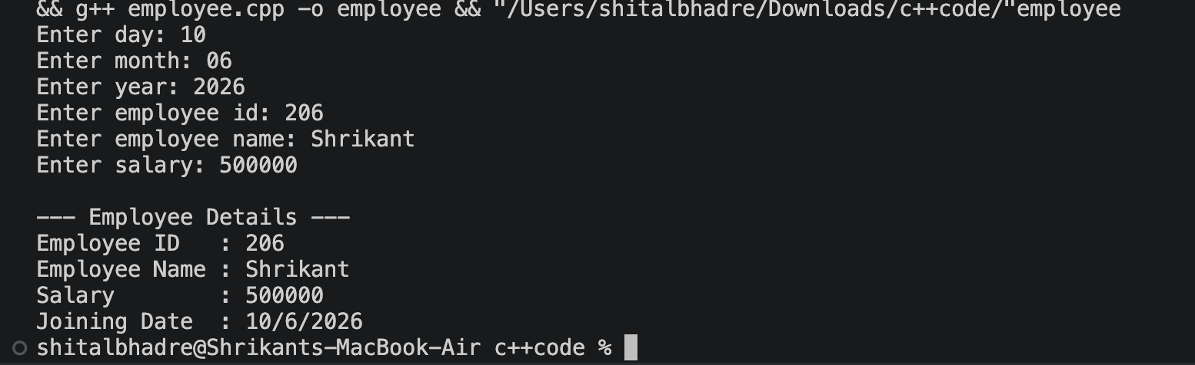

4. Customer and Contact Details
Problem Statement:
Create a Customer class that contains an object of a Contact class representing the customer's contact information. The Contact class should contain mobile number, email address, and city. Accept and display the customer details along with contact information.
Concept: Composition using a Contact object.
#include<iostream>
using namespace std;

class Contact
{
long mobileNo;
string email, city;
public:
Contact()
{
cout << "Enter mobile number: ";
cin >> mobileNo;
cout << "Enter email address: ";
cin >> email;
cout << "Enter city: ";
cin >> city;
}
void display()
{
cout << "Mobile Number : " << mobileNo << endl;
cout << "Email Address : " << email << endl;
cout << "City : " << city << endl;
}
};

class Customer{
int custId;
string custName;
Contact contact; // Contact class ka OBJECT — "Composition using a Contact object"

public:
Customer(){
cout << "Enter customer id: ";
cin >> custId;
cout << "Enter customer name: ";
cin >> custName;
// contact ka constructor is se pehle hi chal chuka hoga (member object)
}
void display(){
cout << "\n--- Customer Details ---" << endl;
cout << "Customer ID : " << custId << endl;
cout << "Customer Name : " << custName << endl;
cout << "\n--- Contact Details ---" << endl;
contact.display();
}
};

int main(){
Customer c;
c.display();
return 0;
}

Output:
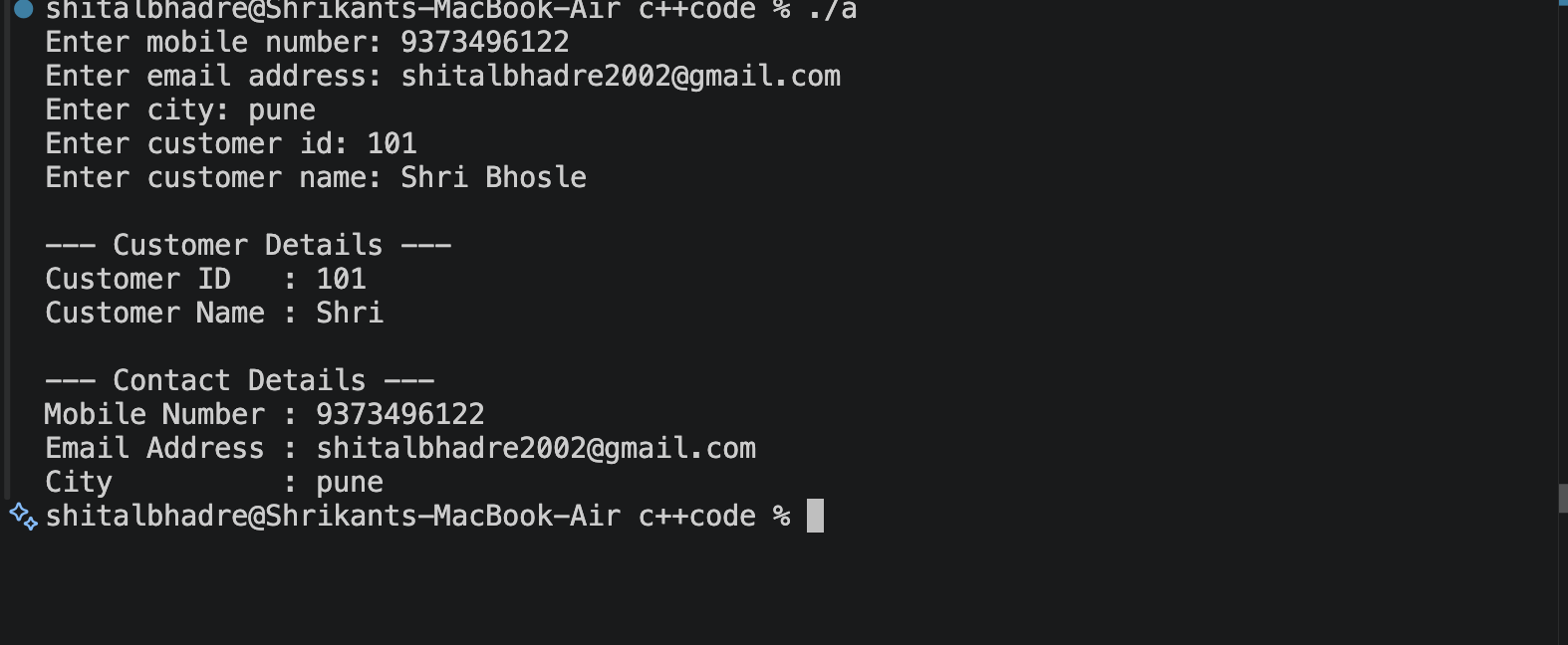

5. Vehicle and Engine
Problem Statement:
Create a Vehicle class that contains an object of an Engine class representing the vehicle's engine details. The Engine class should contain engine number, engine type, and engine capacity. Accept and display the complete vehicle and engine details.
Concept: Vehicle has-a Engine.
#include<iostream>
using namespace std;

class Engine
{
string engineNo, engineType;
float capacity;
public:
Engine()
{
cout << "Enter engine number: ";
cin >> engineNo;
cout << "Enter engine type: ";
cin >> engineType;
cout << "Enter engine capacity (in cc/litres): ";
cin >> capacity;
}
void display()
{
cout << "Engine Number : " << engineNo << endl;
cout << "Engine Type : " << engineType << endl;
cout << "Engine Capacity : " << capacity << endl;
}
};

class Vehicle{
string vehicleName;
string model;
Engine engine; // Engine class ka OBJECT — "Vehicle has-a Engine"

public:
Vehicle(){
cout << "Enter vehicle name: ";
cin >> vehicleName;
cout << "Enter model: ";
cin >> model;
// engine ka constructor is se pehle hi chal chuka hoga (member object)
}
void display(){
cout << "\n--- Vehicle Details ---" << endl;
cout << "Vehicle Name : " << vehicleName << endl;
cout << "Model : " << model << endl;
cout << "\n--- Engine Details ---" << endl;
engine.display();
}
};

int main(){
Vehicle v;
v.display();
return 0;
}

Output:
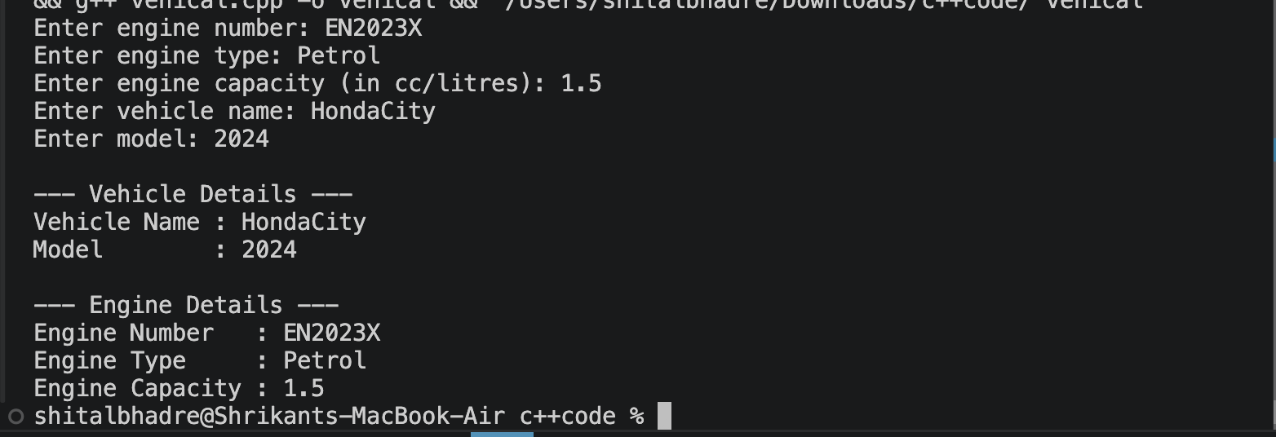

Assignment 5:
1. Program 1: Complex Number – Operator Overloading
Problem Statement:
Create a Complex class to represent complex numbers using real and imaginary parts. Overload the following operators to perform the corresponding operations on two complex number objects:

+ – Addition of two complex numbers
- – Subtraction of two complex numbers
++ – Pre Increment the real and imaginary parts of a complex number
++ – PostIncrement the real and imaginary parts of a complex number
<< and >> operator
Create appropriate objects and demonstrate the working of all the overloaded operators.

#include<iostream>
using namespace std;
class Complex {
private:
int real, img;
public:
Complex() {
this->real = this->img = 1;
}
Complex(int real, int img) {
this->real = real;
this->img = img;
}

Complex operator+(Complex &c) {
Complex temp;
temp.real = real + c.real;
temp.img = img + c.img;
return temp;

}
Complex operator-(Complex &c) {
Complex temp;
temp.real = real - c.real;
temp.img = img - c.img;
return temp;
}
Complex operator++(int a) {
Complex temp;
temp.real = this->real++;
temp.img = this->img++;
return temp;
}
Complex operator--(int b) {
Complex temp;
temp.real = this->real--;
temp.img = this->img--;
return temp;
}
friend ostream& operator<<(ostream &out, Complex &c)
{
out << c.real << " + " << c.img << "i";
return out;
}

friend istream& operator>>(istream &in, Complex &c)
{
cout << "Enter real part: ";
in >> c.real;

cout << "Enter imaginary part: ";
in >> c.img;
return in;
}
void Display() {
cout << "\n\n\t Complex : " << this->real << "+" << img << "i";
}
};
int main() {
{
Complex c1(10, 20);
Complex c2(2, 5);
Complex c3;

c3 = c1 + c2;

cout << "\n\t --------Complex operator+(Complex &c)------";
c1.Display();
c2.Display();
c3.Display();
}
{
Complex c1(10, 20);
Complex c2(2, 5);
Complex c3;

c3 = c1 - c2;

cout << "\n\t --------Complex operator-(Complex &d)------";
c3.Display();
}
{
Complex c1(10, 20);
Complex c3;

c3 = c1++;

cout << "\n\t *********Complex operator++()*****";
c1.Display();
c3.Display();
}
{
Complex c1(10, 20);
Complex c3;

c3 = c1--;

cout << "\n\t --------Complex operator--()------";
c1.Display();
c3.Display();
}
{
Complex c1(2,3);
cout << "\n\t --------Complex operator>>()-----";
cin>>c1;
cout<<c1;
}
{
Complex c1(10,20);
cout << "\n\t --------Complex operator<<()-----";
cout<<c1;
}
return 0;

}

Output:
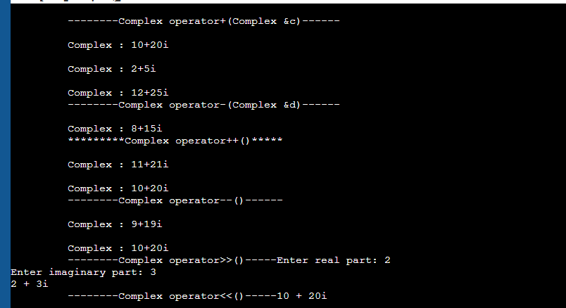

2. Program 2: Box – Relational Operator Overloading
Problem Statement:
Create a Box class with data members length, width, and height. Define a member function to calculate the volume of a box. Overload the > operator to compare two Box objects based on their volumes. Display
which box has the greater volume.

#include <iostream>
using namespace std;

class Box {
float length, width, height;

public:

Box(float l, float w, float h) {
length = l;
width = w;
height = h;
}

float volume() {
return length * width * height;
}

bool operator>(Box b) {
return volume() > b.volume();
}
};

int main() {
Box box1(10, 5, 4);
Box box2(8, 6, 3);

if (box1 > box2)
cout << "Box 1 has greater volume." << endl;

else if (box2 > box1)
cout << "Box 2 has greater volume." << endl;

else
cout << "Both boxes have equal volume." << endl;

cout << "Volume of Box 1 = " << box1.volume() << endl;
cout << "Volume of Box 2 = " << box2.volume() << endl;

return 0;
}

Output
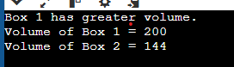

3. Create Array class Implement following.
Accept and Display function
Operator + for adding two arrays.
implement copy constructor.
implement destructor.
overload > operator.

#include<iostream>
using namespace std;

class Array {
int size;
int* arr;
public:
Array() {
size = 3;
arr = new int[size];
}
Array(int s)
{
size = s;
arr = new int[size];
}
void Accept()
{
cout << "\n\t Enter " << size << " Elements ";
for (int i = 0; i < size; i++)
cin >> arr[i];
}
void Display() {
cout << "\n\n\t Array Is \n";
for (int i = 0; i < size; i++)
cout << arr[i] << " ";
}

Array operator+(Array& obj) {
Array temp;
temp.size = this->size + obj.size;
temp.arr = new int[temp.size];
int j = 0;
for (int i = 0; i < this->size; i++)
temp.arr[j++] = this->arr[i];
for (int i = 0; i < obj.size; i++)
temp.arr[j++] = obj.arr[i];
return temp;

}
Array(const Array& obj) {
size = obj.size;
arr = new int[size];
for (int i = 0; i < obj.size; i++)
arr[i] = obj.arr[i];
}
~Array()
{
delete[]arr;

}
};
int main()
{
Array a1(4);
a1.Accept();

Array a2(3);
a2.Accept();

a1.Display();
a2.Display();

Array a3 = a1;
a3.Display();

Array a4(a1);
a4.Display();

}

Output
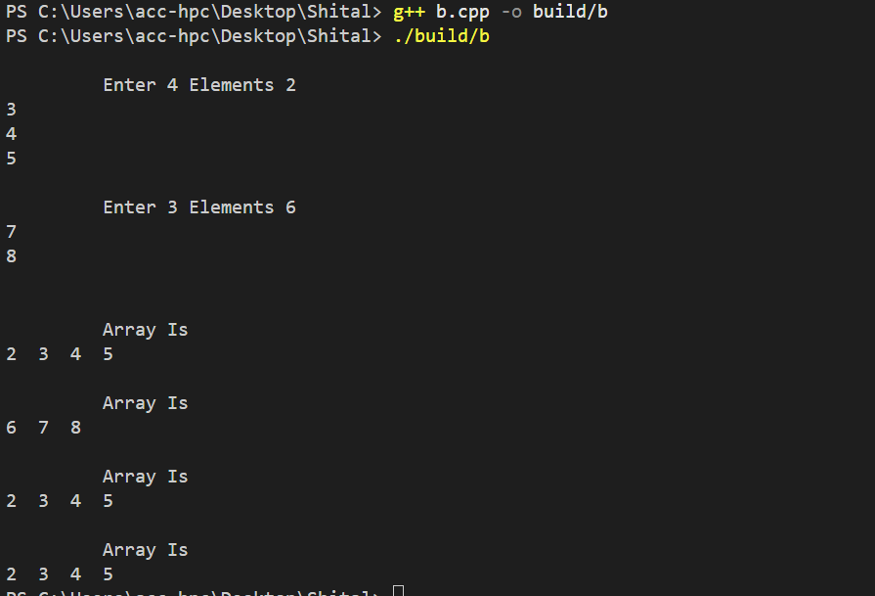

4. Create circle class with data member pi and redius.
1.Declare pi as const data member
2.implement display and getRedius function as const function
3. create const object and invoke all functions.

#include<iostream>
using namespace std;
class circle{
int red;
const float pi=3.14;
public:
circle(int r=2){
red=r;

}
void display()const{
cout<<"redius:"<<red<<endl;
cout<<"Area:"<<(pi * red * red )<<endl;
}
void getRadius()const {
cout<<red;

}
};
int main(){

const circle C1(5);
C1.display();
C1.getRadius();
return 0;
}

Output
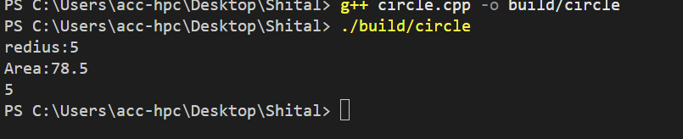

5. create class Person (age, name)
inherite person class and create student class with data member rno,and percentage.
create appropriate objects and invoke functions.

#include<iostream>
using namespace std;
class Person {
int age;
string name;
public:
Person() {
age = 22;
name = "priya";

}
Person( string name, int age) {
this->age = age;
this->name = name;
}
void Display() {

cout << "\n\tName : " << name;
cout << "\n\t Age: " << age<<endl;
}
};
class student :public Person
{
int rollno;
float per;
public:
student() {
rollno = 0;
per = 0;
}
student(int rollno, string name, int age, float per):Person(name,age) {
this->rollno = rollno;
this->per = per;
}
void Display() {

cout << "\n\t rollno " << rollno;
Person::Display();
cout << "\n\t percentage : " << per;
}

};

int main()
{
Person p1;
p1.Display();

student s1;

cout<<"Student Details"<<endl;
s1.Display();
student s2(106, "seeta", 25, 80);
s2.Display();

cout << "\n\n\n";
}

Output
