ID NO:7
Shital Digambar Bhadre
PRN NO:260740150022
Utkarsha Shubhash Pawar
PRN NO:260740150028

Assignment 6:
1.Create a base class Shape and derive three classes Circle, Rectangle, and Triangle from it. Implement the area() function using run-time polymorphism.
Base Class: Shape
Data Members:
string shapeName
Member Functions:
void acceptShapeName()
void displayShapeName()
virtual void area()
Derived Class: Circle
Data Members:
float radius
Member Functions:
void accept()
void area() — calculate and display the area of the circle.
Formula:
Area = π × radius × radius
Derived Class: Rectangle
Data Members:
float length
float width
Member Functions:
void accept()
void area() — calculate and display the area of the rectangle.
Formula:
Area = length × width
Derived Class: Triangle
Data Members:
float base
float height
Member Functions:
void accept()
void area() — calculate and display the area of the triangle.
Formula:
Area = 0.5 × base × height
Requirements
Use inheritance to derive the three classes from Shape.
Declare area() as a virtual function in the base class.
Override area() in every derived class.
Create a Shape* pointer.
Assign the address of each derived-class object to the base-class pointer.
Call area() through the base-class pointer to demonstrate run-time polymorphism.

Output:

Using Array:
#include <iostream>
#include <cmath>
using namespace std;

class Shape {
public:
virtual void accept() = 0;
virtual void display() = 0;
virtual double calculateArea() = 0;
virtual ~Shape() {}
};

class Circle : public Shape {
double radius;
public:
void accept() override {
cout << "Enter radius of Circle: ";
cin >> radius;
}
void display() override {
cout << "Circle with radius = " << radius << endl;
}
double calculateArea() override {
return M_PI * radius * radius;
}
};

class Rectangle : public Shape {
double length, breadth;
public:
void accept() override {
cout << "Enter length and breadth of Rectangle: ";
cin >> length >> breadth;
}
void display() override {
cout << "Rectangle with length = " << length
<< " and breadth = " << breadth << endl;
}
double calculateArea() override {
return length * breadth;
}
};

class Triangle : public Shape {
double base, height;
public:
void accept() override {
cout << "Enter base and height of Triangle: ";
cin >> base >> height;
}
void display() override {
cout << "Triangle with base = " << base
<< " and height = " << height << endl;
}
double calculateArea() override {
return 0.5 * base * height;
}
};

int main() {
Shape* shapes[10];
int choice, count = 0;

do {
cout << "\nMenu:\n";
cout << "1. Circle\n";
cout << "2. Rectangle\n";
cout << "3. Triangle\n";
cout << "4. Display all shapes and areas\n";
cout << "5. Exit\n";
cout << "Enter your choice: ";
cin >> choice;

switch(choice) {
case 1:
shapes[count] = new Circle();
shapes[count]->accept();
count++;
break;
case 2:
shapes[count] = new Rectangle();
shapes[count]->accept();
count++;
break;
case 3:
shapes[count] = new Triangle();
shapes[count]->accept();
count++;
break;
case 4:
for (int i = 0; i < count; i++) {
shapes[i]->display();
cout << "Area = " << shapes[i]->calculateArea() << endl;
}
break;
case 5:
cout << "Exiting program..." << endl;
break;
default:
cout << "Invalid choice!" << endl;
}
} while(choice != 5);

for (int i = 0; i < count; i++) {
delete shapes[i];
}

return 0;
}

Output:
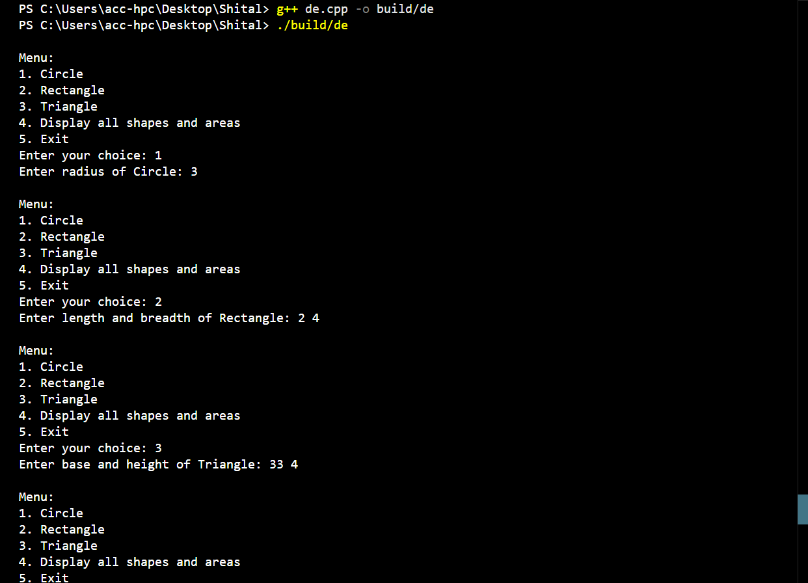
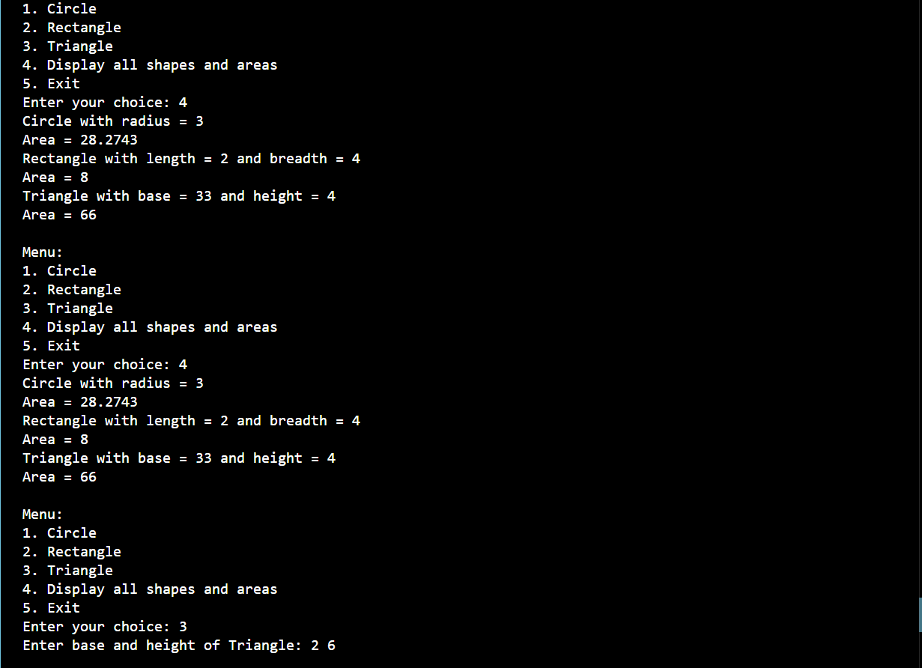

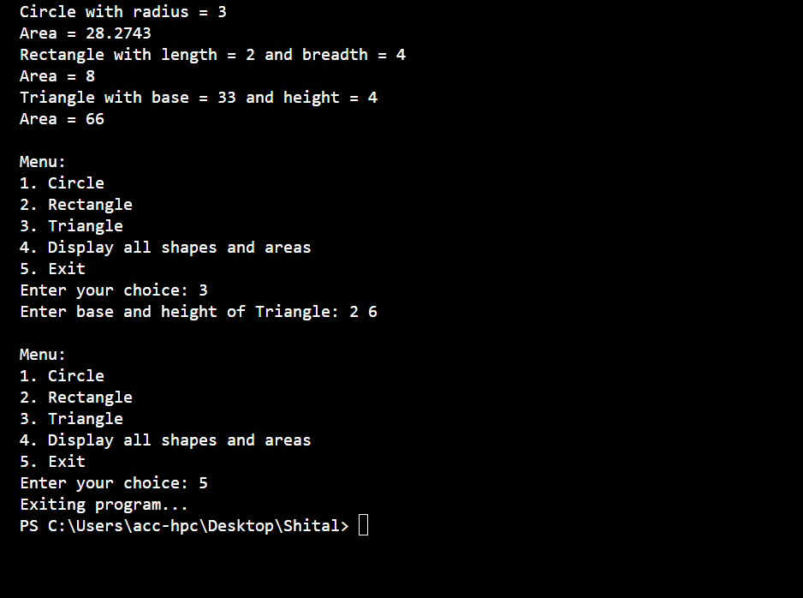
Q1.without Array:
#include <iostream>
#include <string>
using namespace std;
class shape {
private:
string shapename;
public:
void acceptShapeName() {
cout << "Shape Name: ";
cin >> shapename;
}

void displayShapeName() {
cout << "Shape Name: " << shapename << endl;
}

virtual void area() = 0;
virtual ~shape() {}
};

class Circle : public shape {
private:
float radius;
float calculatedArea;

public:
void Accept() {
cout << "Enter radius: ";
cin >> radius;
}

void area() override {
calculatedArea = 3.14* radius * radius;
}

void display() {
cout << "Area is: " << calculatedArea << endl;
}
};

class rectangle : public shape {
private:
float len, width;

public:
void Accept() {
cout << "Enter length and width: ";
cin >> len >> width;
}

void area() override {
float rectArea = len * width;
cout << "Area of rectangle: " << rectArea << endl;
}
};

class triangle : public shape {
private:
float base, height;

public:
void Accept() {
cout << "Enter Base and Height: ";
cin >> base >> height;
}

void area() override {
float triArea = 0.5f * base * height;
cout << "Area of Triangle: " << triArea << endl;
}
};

int main() {
int choice;

cout << "\n\t Choose a shape:\n";
cout << "\t 1. Circle\n";
cout << "\t 2. Rectangle\n";
cout << "\t 3. Triangle\n";
cout << "\t Enter choice (1-3): ";
cin >> choice;

switch (choice) {
case 1: {
Circle C1;
C1.Accept();
C1.area();
C1.display();
break;
}
case 2: {
rectangle R1;
R1.Accept();
R1.area();
break;
}
case 3: {
triangle T1;
T1.Accept();
T1.area();
break;
}
default:
cout << "\n\t Invalid choice." << endl;
break;
}

return 0;
}

Output:
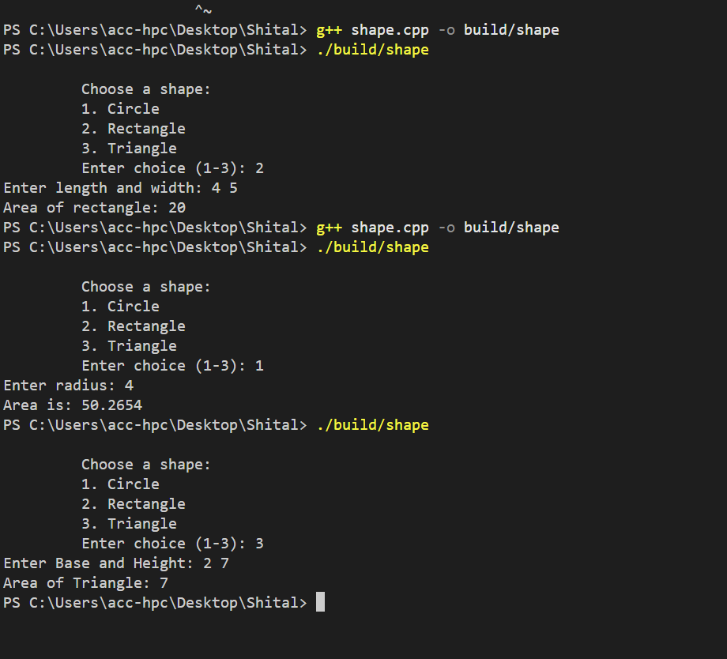
Q2:
Question 2: Employee Salary Using Run-Time Polymorphism
Create a base class Employee and derive Manager, Developer, and SalesEmployee classes from it. Calculate the salary of each employee using function overriding and run-time polymorphism.
Base Class: Employee
Data Members:
int employeeId
string employeeName
double basicSalary
Member Functions:
void accept()
void display()
virtual double calculateSalary()
Derived Class: Manager
Data Members:
double allowance
Member Functions:
void accept()
double calculateSalary()
Formula:
Salary = Basic Salary + Allowance
Derived Class: Developer
Data Members:
double bonus
Member Functions:
void accept()
double calculateSalary()
Formula:
Salary = Basic Salary + Bonus
Derived Class: SalesEmployee
Data Members:
double salesAmount
double commissionRate
Member Functions:
void accept()
double calculateSalary()
Formula:
Salary = Basic Salary + (salesAmount*commissionRate)
Requirements
Create an Employee* base-class pointer.
Create objects of Manager, Developer, and SalesEmployee.
Store the address of each derived object in the base-class pointer.
Invoke calculateSalary() using the base-class pointer.
Demonstrate run-time polymorphism.

#include <iostream>
#include <string>
using namespace std;
class employee {
private:
int eid;
string ename;
protected:
double salary;
public:
virtual void Accept() {
cout << "Enter emp id, name, salary: ";
cin >> eid >> ename >> salary;
}
virtual void display() {
cout << "\nEmployee ID: " << eid;
cout << "\nEmployee Name: " << ename;
cout << "\nBase Salary: " << salary << endl;
}
virtual double calculatesal() = 0;
virtual ~employee() {}
};
class manager : public employee {
private:
double allowance;
public:
void Accept() override {
employee::Accept();
cout << "Enter Allowance: ";
cin >> allowance;
}
double calculatesal() override {
return salary + allowance;
}
void display() override {
employee::display();
cout << "Total Salary : " << calculatesal() << endl;
}
};
class developer : public employee {
private:
double bonus;
public:
void Accept() override {
employee::Accept();
cout << "Enter Bonus: ";
cin >> bonus;
}

double calculatesal() override {
return salary + bonus;
}

void display() override {
employee::display();
cout << "Total Salary : " << calculatesal() << endl;
}
};
class salesemp : public employee {
private:
double salesAmount;
double commRate;
public:
void Accept() override {
employee::Accept();
cout << "Enter Sales Amount: ";
cin >> salesAmount;
cout << "Enter Commission Rate : ";
cin >> commRate;
}
double calculatesal() override {
return salary + (salesAmount * commRate);
}
void display() override {
employee::display();
cout << "Total Salary : " << calculatesal() << endl;
}
};
int main() {
employee* emp[10];
int choice, count = 0;
do {
cout << "\nMenu:\n";
cout << "1. Manager\n";
cout << "2. Developer\n";
cout << "3. Sales Employee\n";
cout << "4. Display all employees and salaries\n";
cout << "5. Exit\n";
cout << "Enter your choice: ";
cin >> choice;

switch (choice) {
case 1:
emp[count] = new manager();
emp[count]->Accept();
count++;
break;
case 2:
emp[count] = new developer();
emp[count]->Accept();
count++;
break;
case 3:
emp[count] = new salesemp();
emp[count]->Accept();
count++;
break;
case 4:
for (int i = 0; i < count; i++) {
emp[i]->display();
}
break;
case 5:
cout << "Exiting program..." << endl;
break;
default:
cout << "Invalid choice!" << endl;
}
} while (choice != 5);

for (int i = 0; i < count; i++) {
delete emp[i];
}

return 0;
}

Output:

