Assignment 3&4
Name-Shital Digambar Bhadre
PRN-260740150022

1.Write a Python function to find the maximum of three numbers.

#Question1
list1=[23,43,56]
print(list1)
print(max(list1))

Output:
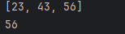

2.Create a function that takes a list of numbers and returns their sum.

#Question2
list2=[2,4,6]
print(list2)
print(sum(list2))

Output:
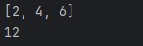

3.Write a function with a default argument that prints a greeting.

#Question3
def greet(name):
print("greeting " + name)
greet("Joy")

Output:

4.Write a function is_palindrome() that takes a string as an argument and returns True if the string is a palindrome (reads the same forward and backward) and False otherwise.

#Question4
def palindrome(word):
return word == word[::-1]
print(palindrome("madam"))
print(palindrome("121"))
print(palindrome("sir"))

Output:
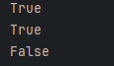

5.Write a function count_case() that accepts a string and returns a dictionary containing the count of uppercase and lowercase letters.

#Question5
def count_case(text):
counts = {"uppercase": 0, "lowercase": 0}

for char in text:
if char.isupper():
counts["uppercase"] += 1
elif char.islower():
counts["lowercase"] += 1

return counts
result = count_case("Welcome TO Jungle!")
print(result)

Output:

6.Write a function unique_list() that takes a list and returns a new list with distinct elements from the first list.

#Question6
def unique_list(numbers):
unique_set = set(numbers)
return list(unique_set)

list1 = [1, 2, 2, 3, 4, 4, 4, 5]
print(unique_list(list1))

Output:
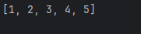

Assignment 4
Shital Digambar Bhadre
260740150022

1.Given the string s = "Python Programming", write code to:
o Print the first character.
o Print the character at index 7.
o Print a slice from index 2 up to (but not including) index 8.
o Print a slice from the beginning up to index 5.
o Print a slice from index 6 to the end.
o Print the last character using negative indexing.

s = "Python Programming"
print(s)
print(s[0])
print(s[7])
print(s[2:8])
print(s[0:6])
print(s[6:18])
print(s[-1])

Output:
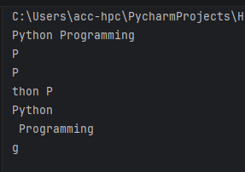

2.Given original_string = "Hello", demonstrate how to "update" this string to Goodbye by creating a new string and assigning it to the same variable.

original_string = "Hello"
print(original_string)
original_string = "Goodbye"
print(original_string)

Output:
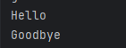

3.Write a string that includes a double quote within single quotes, and a single quote within double quotes, using escape characters where necessary.

#q4
string_one = 'Welcome to "C-DAC!"'
string_two = "hi i am 'C-DAC pune'"

escaped_single = 'Welcome to \"C-DAC!\"'
escaped_double = "hi i am \'C-DAC pune\'"

print(string_one)
print(string_two)
print(escaped_single)
print(escaped_double)

Output:
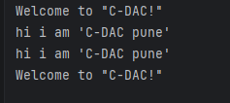

4.Demonstrate the use of the + operator for string concatenation.
string="Hello "
string1="World"
string2=string+string1
print(string2)
print(string+string1)

Output:
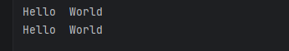

5.Demonstrate the use of the * operator for string repetition.

string = "Pune "
print((string)*2)

Output:


6.Use the in operator to check if a substring exists within a larger string.
name="python is script language!!!!!!"
print(name)
if 'python' in name:
print('yes')
else:
print('no')

Output:
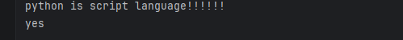.

7.Use the not in operator to check if a substring does not exist within a larger string.
name = "python is scripting ,web scripting and User friendly language!!!!!!"
print(name)
if 'hello' not in name:
print('yes')
else:
print('no')

Output:

8.Given name = "Alice" and age = 30, use the f-string formatting method to create a string that reads: "Alice is 30 years old."

name = "Alice"
age = 30
result = f"{name} is {age} years old"
print(result)

Output
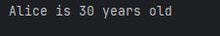

9.Given text = " Python is FUN! ", use built-in string methods to:
o Convert the string to all lowercase.
o Convert the string to all uppercase.
o Remove leading and trailing whitespace.
o Replace "FUN" with "amazing".
o Check if the string starts with "Py".
o Check if the string ends with "!".
o Count the occurrences of the letter 'o'.

text = "Python is FUN!!!"
print("original string:",text)

print("uppercase string:",text.upper())
print("lowercase string:",text.lower())

text1 = " Python is FUN!!! "
s_text = text1.strip()
print(s_text)

print(text.replace("FUN","amazing"))

if text.startswith("Py"):
print("yes")
else:
print("no")

if text.endswith("!"):
print("yes")
else:
print("no")

print(text.count("o"))

Output:
