Shital Digambar Bhadre
260740150022
Assignment 10

Question1
.An e-commerce platform passes item details to a checkout pipeline using dictionaries.
Write a function validate_checkout_item(item_dict) that processes items like {"name": "Laptop", "price": 1200.00, "quantity": 2}:
• Use standard structural logic to verify if the essential keys (name, price, quantity) exist. If any are missing, manually raise a KeyError specifying which key was dropped.
• Use an assert statement to confirm that quantity is an integer greater than 0.
• Use a second assert statement to confirm that price is a float or integer greater than 0.
• Wrap the logic in a try...except (KeyError, AssertionError) as error: block to print a custom failure message, then re-raise the error for the main application to log.

def validate_checkout_item(item_dict):
required_keys = ["name", "price", "quantity"]
try:
for key in required_keys:
if key not in item_dict:
raise KeyError(f"Missing required key: '{key}'")
quantity = item_dict["quantity"]
price = item_dict["price"]
assert isinstance(quantity, int) and not isinstance(quantity, bool) and quantity > 0, \
f"Invalid quantity: {quantity!r} (must be an integer greater than 0)"
assert isinstance(price, (int, float)) and not isinstance(price, bool) and price > 0, \
f"Invalid price: {price!r} (must be a number greater than 0)"
return True
except (KeyError, AssertionError) as error:
print(f"Checkout validation failed for item {item_dict}: {error}")
raise
if __name__ == "__main__":
test_items = [
{"name": "Laptop", "price": 1200.00, "quantity": 2},
{"name": "Mouse", "price": 25.50},
{"name": "Keyboard", "price": 50.00, "quantity": 0},
{"name": "Monitor", "price": -100, "quantity": 1},
{"name": "Webcam", "price": 45.99, "quantity": 3},
]
for idx, item in enumerate(test_items, start=1):
print(f"\n--- Test Case {idx}: {item} ---")
try:
validate_checkout_item(item)
print(f" Item is valid: {item}")
except (KeyError, AssertionError) as e:
print(f"Item rejected. Error type: {type(e).__name__}")
print("\n--- Enter your own item details ---")
try:
name = input("Item name: ")
price_input = input("Item price: ")
quantity_input = input("Item quantity: ")
try:
price_input = float(price_input)
except ValueError:
pass
try:
quantity_input = int(quantity_input)
except ValueError:
pass
user_item = {
"name": name,
"price": price_input,
"quantity": quantity_input
}
validate_checkout_item(user_item)
print(f"Your item is valid: {user_item}")
except (KeyError, AssertionError) as e:
print(f" Your item failed validation: {type(e).__name__} - {e}")

output:

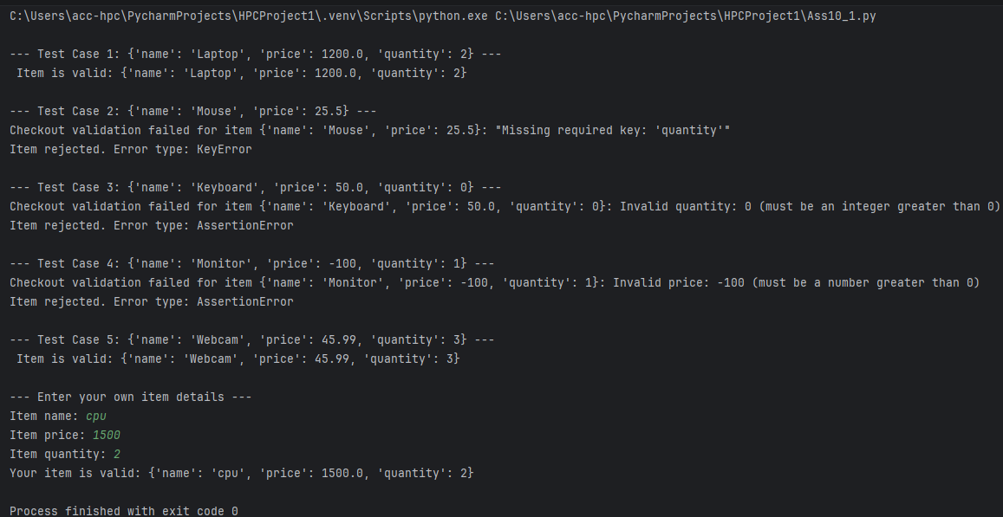

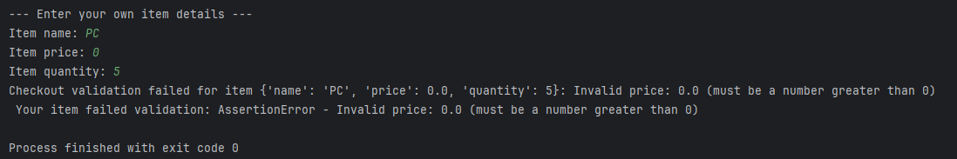

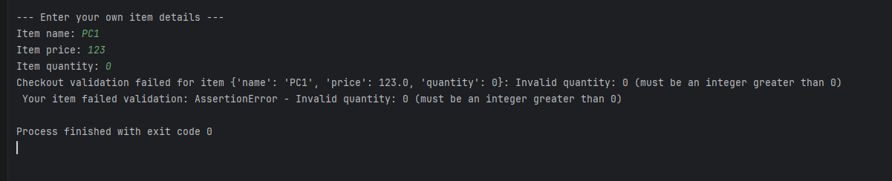

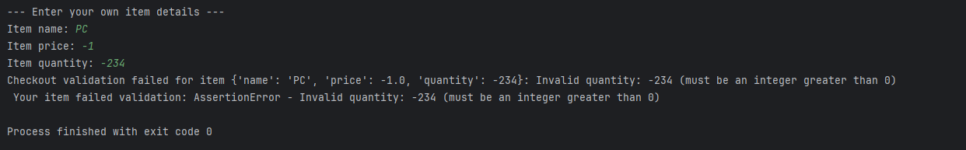
Question2.
You are writing a metrics engine that processes a monthly sales file (sales_data.csv). If the file is missing, the system should look for a default backup file (backup_data.csv).
Write a function process_monthly_report(filename) that:
• Tries to open and read the file specified by filename.
• Uses a try...except FileNotFoundError: block to catch a missing file. When caught, it should print a warning and attempt to open backup_data.csv instead.
• If the backup file is also missing, raise a custom runtime error named DataMissingError with the message "No source data or backup files available."
• Uses a finally block to ensure that if any file stream was successfully opened.

code:
class DataMissingError(RuntimeError):
pass
def process_monthly_report(filename):
file_stream = None
try:
file_stream = open(filename, "r")
data = file_stream.read()
print(f"Successfully loaded primary file: {filename}")
return data
except FileNotFoundError:
print(f"Warning: '{filename}' not found. Attempting to load backup_data.csv...")
try:
file_stream = open("backup_data.csv", "r")
data = file_stream.read()
print("Successfully loaded backup file: backup_data.csv")
return data
except FileNotFoundError:
raise DataMissingError("No source data or backup files available.")
finally:
if file_stream is not None:
file_stream.close()
print("File stream closed.")
if __name__ == "__main__":
try:
report_data = process_monthly_report("sales_data.csv")
print(report_data)
except DataMissingError as e:
print(f"Fatal error: {e}")

Sales_data.csv
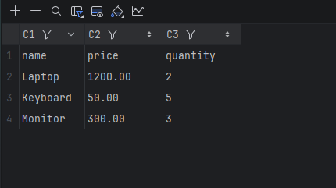

backup_data.csv
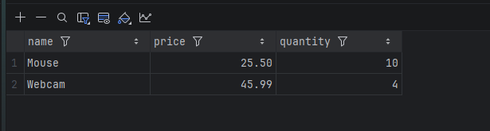

Output:

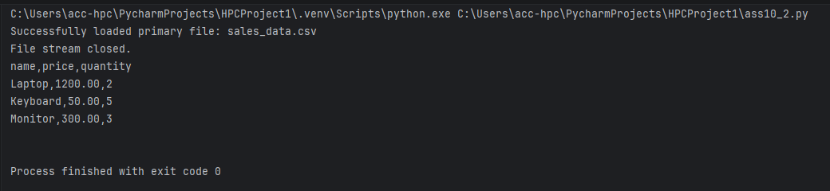

Shital Digambar Bhadre
260740150022
Assignment 11

1. Create a NumPy array containing 10 integers and display the array.
import numpy as np
arr = np.array([1, 2, 3, 4, 5, 6, 7, 8, 9, 10])
print(arr)
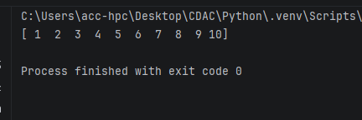

2.Create a NumPy array of numbers from 1 to 20 and find its sum, mean, maximum, and minimum.
import numpy as np

arr = np.arange(1, 21)
arr_sum = np.sum(arr)
arr_mean = np.mean(arr)
arr_max = np.max(arr)
arr_min = np.min(arr)

print("Array:", arr)
print("Sum:", arr_sum)
print("Mean:", arr_mean)
print("Max:", arr_max)
print("Min:", arr_min)

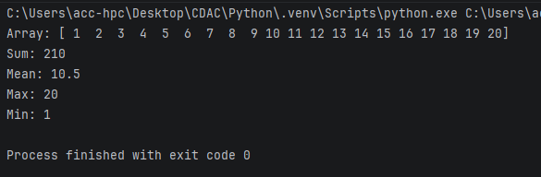
3.Create a 1-D NumPy array and perform addition, subtraction, multiplication, and division on its elements. import numpy as np

arr = np.array([10, 20, 30, 40, 50])
add_result = arr + 5
sub_result = arr - 3
mul_result = arr * 2
div_result = arr / 2

print("Original Array:", arr)
print("Addition (+ 5):", add_result)
print("Subtraction (- 3):", sub_result)
print("Multiplication (* 2):", mul_result)
print("Division (/ 2):", div_result)

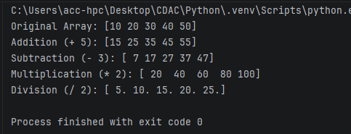
4. Create a 3×3 NumPy matrix and display its rows and columns.
import numpy as np
matrix = np.array([[1, 2, 3], [4, 5, 6], [7, 8, 9]])

print(" 3x3 Matrix")
print(matrix)

print("Rows")
for i, row in enumerate(matrix):
print(f"Row {i+1}: {row}")

print("Columns ")
for j in range(matrix.shape[1]):
print(f"Column {j+1}: {matrix[:, j]}")
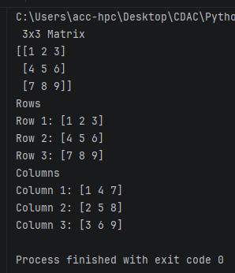
5. Create a NumPy array and find its shape, size, and data type.
import numpy as np
arr = np.array([[10, 20, 30], [40, 50, 60]])

print("Array:", arr)
print("Shape:", arr.shape)
print("Size:", arr.size)
print("Data Type:", arr.dtype)
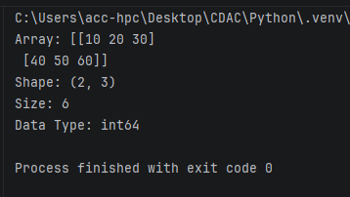
6. Create an array of 10 zeros and another array of 10 ones using NumPy.
import numpy as np
zeros_arr = np.zeros(10)
ones_arr = np.ones(10)

print("Zeros:", zeros_arr)
print("Ones: ", ones_arr)
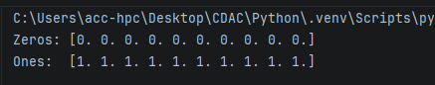
7. Create a NumPy array containing even numbers from 2 to 20.
import numpy as np
evens = np.arange(2, 21, 2)
print("Even numbers from 2 to 20:", evens)

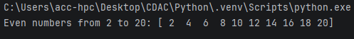
8.Create a 3×3 NumPy array and calculate the sum of each row and each column.
import numpy as np
arr_3x3 = np.array([[10, 20, 30], [40, 50, 60], [70, 80, 90]])

row_sum = arr_3x3.sum(axis=1)
col_sum = arr_3x3.sum(axis=0)

print("Array:", arr_3x3)
print("Sum of each row:", row_sum)
print("Sum of each column:", col_sum)
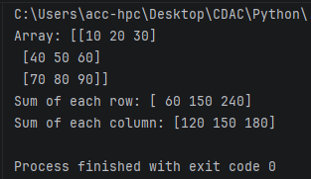
9.Create two NumPy arrays and perform element-wise addition and multiplication.
import numpy as np
a = np.array([1, 2, 3, 4])
b = np.array([10, 20, 30, 40])

addition = a + b
multiplication = a * b

print("Array A:", a)
print("Array B:", b)
print("Element-wise Addition:", addition)
print("Element-wise Multiplication:", multiplication)
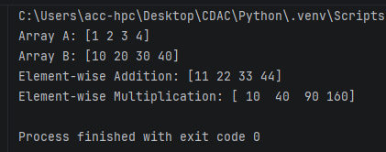
10. Create a NumPy array and sort its elements in ascending and descending order.
import numpy as np
arr_unsorted = np.array([42, 12, 88, 5, 23, 67])
arr_asc = np.sort(arr_unsorted)
arr_desc = np.sort(arr_unsorted)[::-1]

print("Original Array:", arr_unsorted)
print("Ascending Order:", arr_asc)
print("Descending Order:", arr_desc)
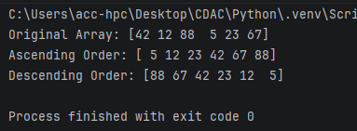
11. Create a NumPy array and replace all elements greater than 50 with 0.
import numpy as np
arr_data = np.array([15, 62, 45, 89, 30, 51, 90])
arr_modified = arr_data.copy()
arr_modified[arr_modified > 50] = 0

print("Original Array:", arr_data)
print("Modified Array:", arr_modified)
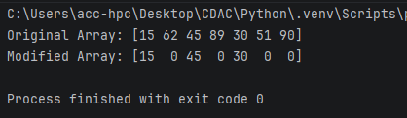
12. Create a NumPy array of student marks and find the highest, lowest, and average marks.
import numpy as np
student_marks =np.array([70,88,50,90,99,77,98])

highest=student_marks.max()
lowest=student_marks.min()
average=student_marks.mean()

print("student_Marks:",student_marks)
print(f"Highest Mark: {highest}")
print(f"Lowest Mark: {lowest}")
print(f"Average Mark: {average:.2f}")
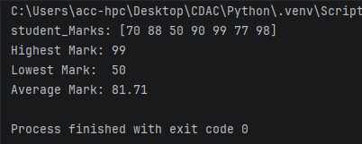
• Create a DataFrame from a dictionary containing employee name, department, and salary, and display the first 5 records.
import pandas as pd

# Dictionary with employee details
data = {
'Employee Name': ['sai', 'rani', 'sonali', 'kaveri', 'sneha', 'sumit', 'soham'],
'Department': ['HR', 'Engineering', 'Marketing', 'Engineering', 'Finance', 'HR', 'IT'],
'Salary': [65000, 85000, 72000, 90000, 78000, 62000, 71000]
}
df = pd.DataFrame(data)
print(df.head())

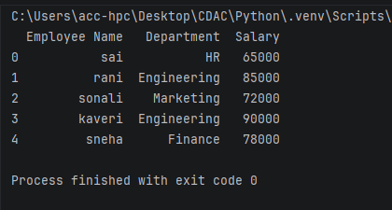
• Create a DataFrame and display its shape, columns, data types, and size.
import pandas as pd

data = {
'Employee ID': [101, 102, 103, 104, 105],
'Name': ['akash', 'pooja', 'rani', 'Divya', 'kaveri'],
'Department': ['HR', 'Engineering', 'Marketing', 'IT', 'Finance'],
'Salary': [65000.0, 85000.0, 72000.0, 90000.0, 78000.0],
}
df = pd.DataFrame(data)
print("Shape:", df.shape)
print("Columns:", df.columns.tolist())
print("\nData Types:\n", df.dtypes)
print("\nTotal Size:", df.size)

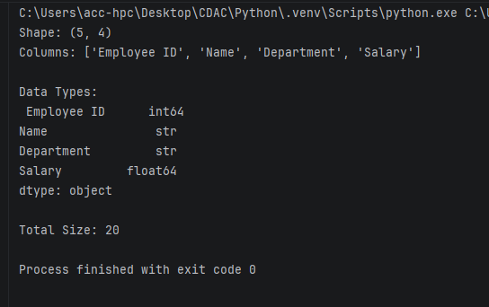
• Create a student DataFrame and display students who have marks greater than 60.
import pandas as pd
data = {
'Student Name': ['kaveri', 'pooja', 'shubhu', 'rani', 'neha', 'sneha'],
'Subject': ['c', 'c++', 'java', 'python', 'html', 'css'],
'Marks': [85, 35, 62, 58, 91, 74]
}
df = pd.DataFrame(data)

students = df[df['Marks'] > 60]
print(students)

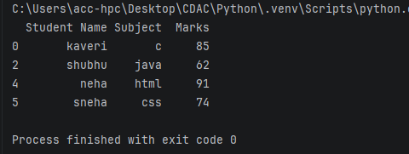
• Create a DataFrame of employee salaries and find the maximum, minimum, and average salary.
import pandas as pd

Emp_data = {
'Employee': ['Rani', 'kaveri', 'sonali', 'pooja', 'sai'],
'Salary': [75000, 85000, 70000, 90000, 88000]
}

df = pd.DataFrame(Emp_data)
max_salary = df['Salary'].max()
min_salary = df['Salary'].min()
avg_salary = df['Salary'].mean()

print("Maximum Salary:", max_salary)
print("Minimum Salary:", min_salary)
print("Average Salary:", avg_salary)

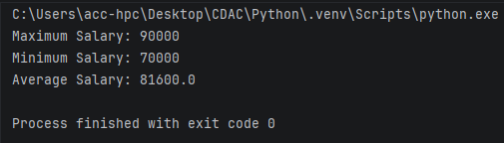
• Create a DataFrame and use head() and tail() to display the first and last 5 records.
import pandas as pd
dataFrame = {
'ID': range(101, 113),
'Name': ['Rani','sai','kaveri','pooja','sumit','kaveri','sonali','pooja','shubhu','sneha','soham','dipak'],
'Score': [85, 92, 78, 64, 90, 88, 76, 95, 82, 70, 89, 91]
}
df = pd.DataFrame(dataFrame)
print(" First 5 Records")
print(df.head())
print("\n Last 5 Records")
print(df.tail())
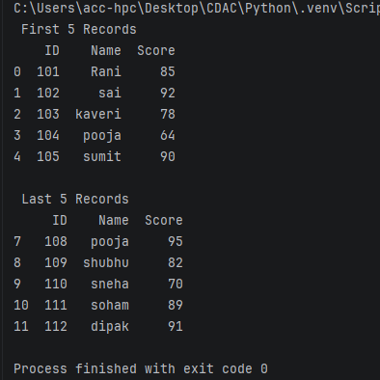
• Create a DataFrame containing missing values and replace the missing values with an appropriate value.
import pandas as pd
import numpy as np

df = pd.DataFrame({
'Employee': ["Rani", "kaveri", "sonali", "pooja", 'Jay'],
'Department': ['HR', 'IT', np.nan, 'IT', 'HR'],
'Salary': [60000, 75000, np.nan, 80000, 65000],
'Experience_Years': [3, np.nan, 8, np.nan, 5]
})

print("Original DataFrame with Missing Values ")
print(df)
print("\nMissing Values Count:")
print(df.isna().sum())

df['Salary'] = df['Salary'].fillna(df['Salary'].mean())

df['Experience_Years'] = df['Experience_Years'].fillna(df['Experience_Years'].median())

df['Department'] = df['Department'].fillna(df['Department'].mode()[0])

print("\n Cleaned DataFrame ")
print(df)

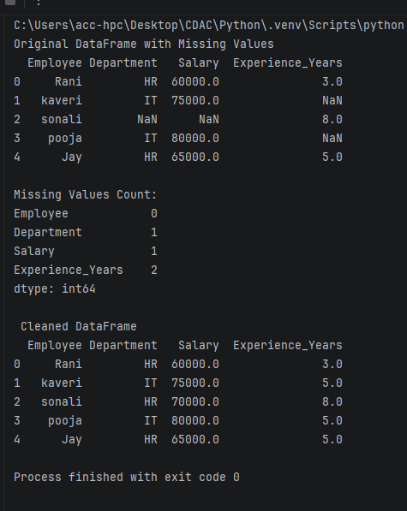

• Create a student DataFrame and sort the students by marks in descending order.
import pandas as pd
student_data = {
"Student_ID": [101, 102, 103, 104, 105],
"Name": ["Amit", "kaveri", "pooja", "Divya", "rani"],
"Marks": [85, 92, 78, 95, 88],
}
df = pd.DataFrame(student_data)
df_sorted = df.sort_values(by="Marks", ascending=False)

print(" Sorted Student DataFrame")
print(df_sorted)
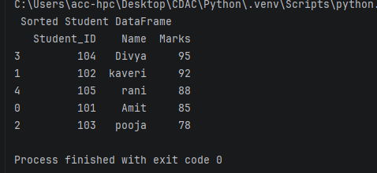
• Create an employee DataFrame and group employees by department and calculate the average salary.
import pandas as pd

emp_data = {
"Employee_ID": [1, 2, 3, 4],
"Name": ["kaveri", "rani", "pooja", "shubhu"],
"Department": ["HR", "CS", "IT", "HR"],
"Salary": [60000, 85000, 90000, 65000],
}

df = pd.DataFrame(emp_data)

avg_salary = (
df.groupby("Department")["Salary"]
.mean()
.reset_index(name="Average_Salary")
)
print(" Average Salary by Department ")
print(avg_salary)
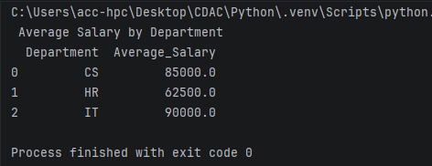
• Create a DataFrame and use describe() to generate statistical information about the data.
import pandas as pd

data = {
"Age": [25, 30, 35, 40, 22, 28, 55, 48],
"Salary": [50000, 62000, 75000, 90000, 48000, 58000, 110000, 95000],
"Years_Experience": [2, 5, 8, 12, 1, 4, 25, 18],
"Department": ["HR","IT","IT","finance","HR","IT","HR","IT",],
}
df = pd.DataFrame(data)
print(" DataFrame ")
print(df)

print(" Summary Statistics")
print(df.describe())
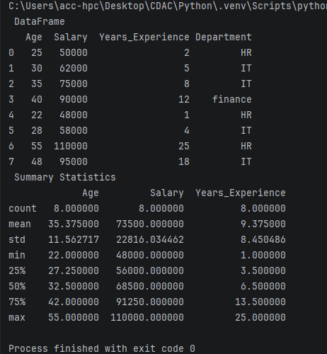

• Create a DataFrame and rename two of its columns using Pandas.
import pandas as pd

data = {
"first_name": ["Rani", "kaveri", "sonali", "pooja"],
"curr_age": [25, 30, 35, 40],
"annual_pay": [50000, 62000, 75000, 90000],
"dept": ["HR", "IT", "IT", "Finance"],
}

df = pd.DataFrame(data)

print("Original DataFrame ")
print(df)

df_renamed = df.rename(
columns={"curr_age": "Age", "annual_pay": "Salary"}
)
print(" DataFrame After Renaming Columns")
print(df_renamed)
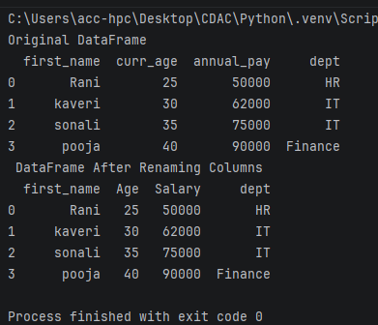

• Create a DataFrame containing student marks and find the student with the highest and lowest marks.
import pandas as pd

data = {
"student_name": ["Rani", "kaveri", "sonali", "pooja"],
"student_marks": [55, 50, 35, 99]
}

df = pd.DataFrame(data)

print("Original DataFrame ")
print(df)

max_marks=max(df["student_marks"])
print("maximum marks : ", max_marks)

min_marks=min(df["student_marks"])
print("minimum marks : ", min_marks)

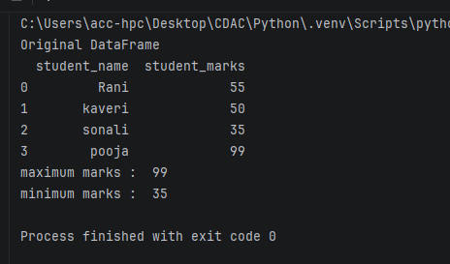
• Create two DataFrames containing student information and merge them using a common column.
import pandas as pd

df1 = pd.DataFrame({
'Student_ID': [101, 102, 103, 104],
'Name': ["Rani", "kaveri", "sonali", "pooja"],
'Age': [20, 21, 19, 22]
})

df2 = pd.DataFrame({
'Student_ID': [101, 102, 103, 104],
'Major': ['Computer Science', 'Data Science', 'Mathematics', 'Physics'],
'GPA': [3.8, 3.5, 3.9, 3.2]
})
merged_df = pd.merge(df1, df2, on='Student_ID')

print("DataFrame 1:")
print(df1)
print("\nDataFrame 2:")
print(df2)
print("\nMerged DataFrame:")
print(merged_df)
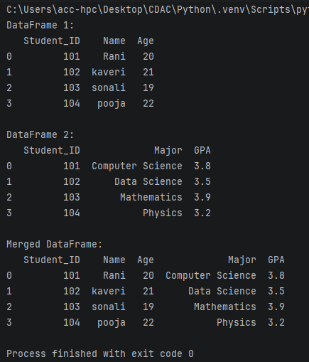
• Create a DataFrame and remove a specified row and column.
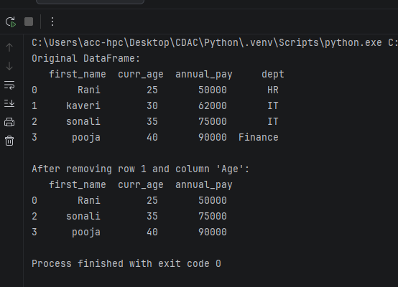
• Create a DataFrame containing product details and calculate the total value using price × quantity.
import pandas as pd

df = pd.DataFrame({
'Product_ID': ['P001', 'P002', 'P003', 'P004'],
'Product_Name': ['Laptop', 'Mouse', 'Keyboard', 'Monitor'],
'Price': [1200.00, 25.50, 45.00, 300.00],
'Quantity': [5, 50, 30, 10]
})

df['Total_Value'] = df['Price'] * df['Quantity']

print(df)

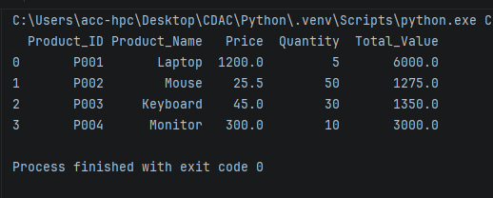
• Create a DataFrame containing employee records and display employees belonging to a particular department.
import pandas as pd
data = {
"first_name": ["Rani", "kaveri", "sonali", "pooja"],
"curr_age": [25, 30, 35, 40],
"annual_pay": [50000, 62000, 75000, 90000],
"dept": ["HR", "IT", "IT", "Finance"],
}
df = pd.DataFrame(data)

IT_dept = df[df['dept'] == 'IT']

print("IT Department Employees:")
print(IT_dept)

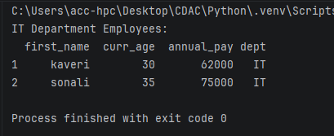
• Create a DataFrame and use value_counts() to count the number of students in each course.
import pandas as pd

data = {
'Student_ID': [101, 102, 103, 104, 105, 106, 107, 108],
'Name': ["Rani", "kaveri", "sonali", "pooja", 'Jay', 'Tanvi', 'AAchal', 'Adi'],
'Course': ['Computer Science', 'Data Science', 'Computer Science', 'Mathematics',
'Data Science', 'Computer Science', 'Physics', 'Data Science']
}

df = pd.DataFrame(data)

course_counts = df['Course'].value_counts()

print(" DataFrame ")
print(df)

print("\n Student Count per Course ")
print(course_counts)

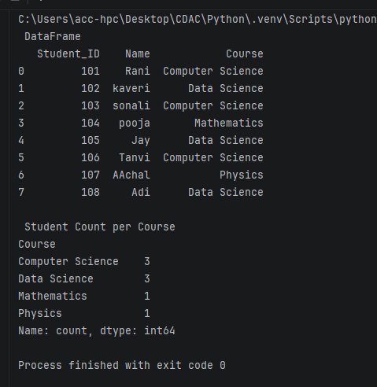
• Create a DataFrame containing sales data and find the total sales for each product.
import pandas as pd
data = {
'Product': ['Laptop', 'Mouse', 'Laptop', 'Keyboard', 'Mouse', 'Keyboard'],
'Quantity': [2, 5, 1, 3, 2, 4],
'Price': [1000, 25, 1000, 75, 25, 75]
}

df = pd.DataFrame(data)
df['Total_Sales'] = df['Quantity'] * df['Price']

product_sales = df.groupby('Product')['Total_Sales'].sum().reset_index()

print(product_sales)

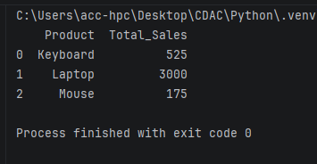
• Create a DataFrame and save it to a CSV file, then read the CSV file using Pandas.

import pandas as pd

data = {
'Employee_ID': [101, 102, 103, 104],
'Name': ["Rani", "kaveri", "sonali", "pooja"],
'Department': ['HR', 'Tech', 'Tech', 'Marketing'],
'Salary': [70000, 85000, 92000, 65000]
}
df = pd.DataFrame(data)

df.to_csv('employees.csv', index=False)

df_read = pd.read_csv('employees.csv')

print(df_read)

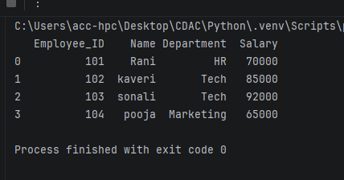

• Create a DataFrame containing student records and perform filtering, sorting, grouping, and basic statistical analysis using Pandas.

import pandas as pd

data = {
'Student_ID': [1, 2, 3, 4, 5, 6, 7, 8],
'Name': ["Rani", "kaveri", "sonali", "pooja", 'Jay', 'Tanvi', 'AAchal', 'Adi'],
'Grade': ['10th', '10th', '11th', '11th', '10th', '12th', '12th', '11th'],
'Subject': ['Math', 'Math', 'Science', 'Math', 'Science', 'Math', 'Science', 'Math'],
'Score': [88, 72, 95, 64, 91, 85, 78, 90],
'Attendance_%': [95, 80, 98, 75, 92, 88, 85, 94]
}
df = pd.DataFrame(data)
filtered_df = df[(df['Subject'] == 'Math') & (df['Score'] > 80)]
print("1. FILTERED DATA (Math & Score > 80) ")
print(filtered_df.to_string(index=False))

sorted_df = df.sort_values(by='Score', ascending=False)
print("\n 2. SORTED DATA (Score Descending) ")
print(sorted_df.to_string(index=False))

grouped_df = df.groupby('Grade')[['Score', 'Attendance_%']].mean().round(2).reset_index()
print("\n3. GROUPED DATA (Mean by Grade) ")
print(grouped_df.to_string(index=False))

stats_df = df[['Score', 'Attendance_%']].describe().round(2)
print("\n 4. STATISTICAL ANALYSIS =")
print(stats_df)

