Shital Digambar Bhadre
260740150022

Assignment 7
Q1:
Create a Student class with the following attributes: name, age, and student_id. The constructor should initialize these attributes.

Add a method display_info() that prints the student's details in a user-friendly format. Add a method is_eligible_to_vote() that returns True if the student's age is 18 or older,
and False otherwise.
Create a student object and test all the methods

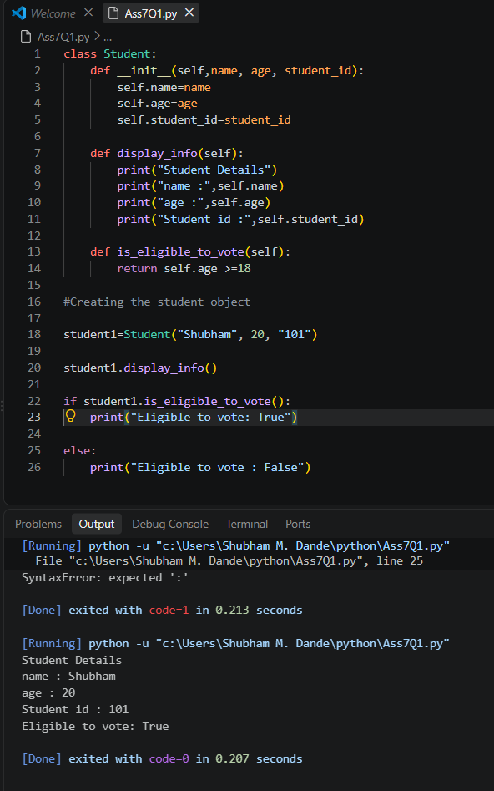

Q-2
- Create a base class Vehicle with attributes: make, model, and year. The constructor should initialize these.
- Add a method display_info() that prints the basic vehicle information.
- Create a child class Car that inherits from Vehicle.
- The Car class should have an additional attribute num_doors. The constructor should take make, model, year, and num_doors.
- Override the display_info() method in the Car class to also include the number of doors.
- Create instances of both Vehicle and Car to demonstrate inheritance and method overriding.

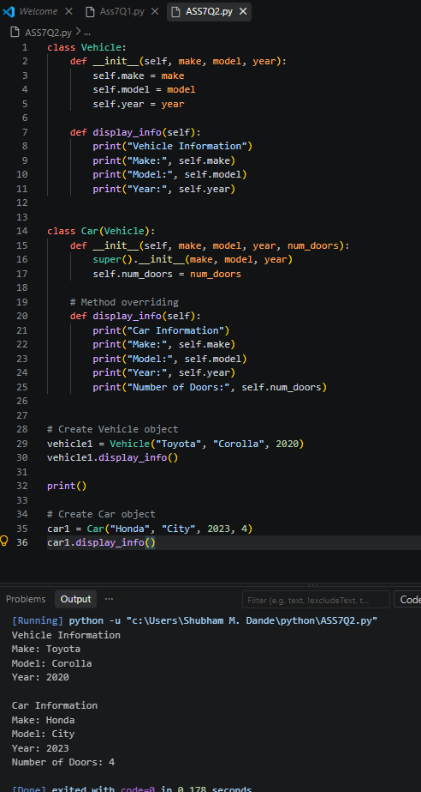

Q.3
- Employee Management System:
- Create a base class Employee with attributes name, employee_id, and salary.
- Create a derived class Manager that inherits from Employee and has an additional attribute for a list of employees they manage.
- Add methods to both classes, such as a method in Manager to add an employee to their managed list.

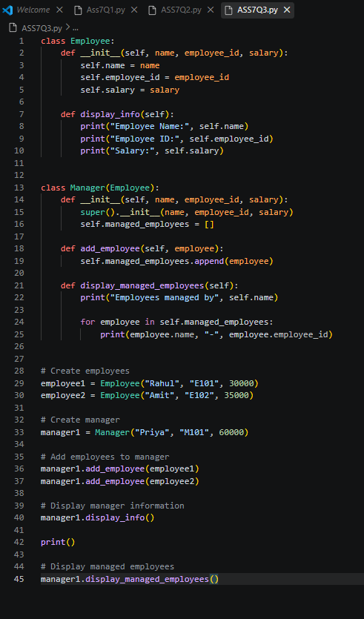

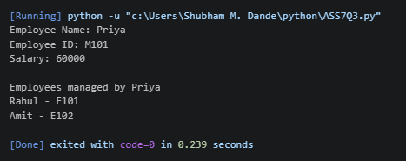
Q.4
Library Management System:
- Create a Book class with attributes like title, author, and is_available.
- Create a Library class that has a list of Book objects.
- Add methods to the Library class to:
- add_book(book): Adds a new book to the library's collection.
- borrow_book(title): Finds a book by title and changes its availability status.
- return_book(title): Changes a book's availability status back to available.
- display_available_books(): Prints the titles and authors of all available books.

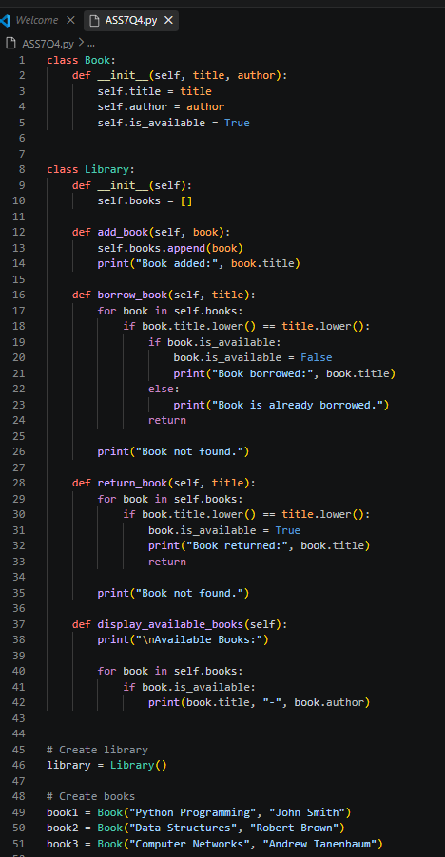

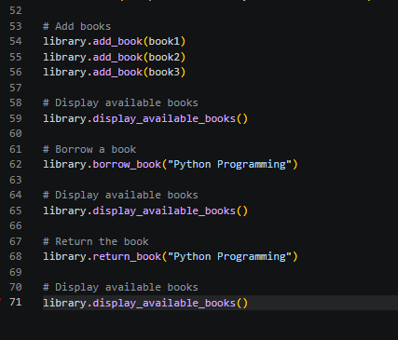
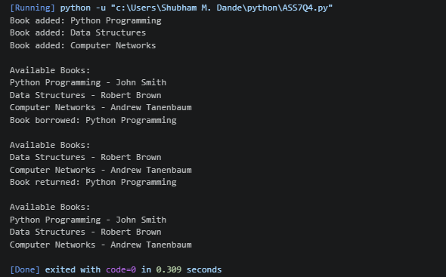

Q5:Write a Python function is_valid_phone(text) that takes a string and returns True if it is a valid 10-digit phone number, and False otherwise. A valid phone number should consist of exactly 10 digits.

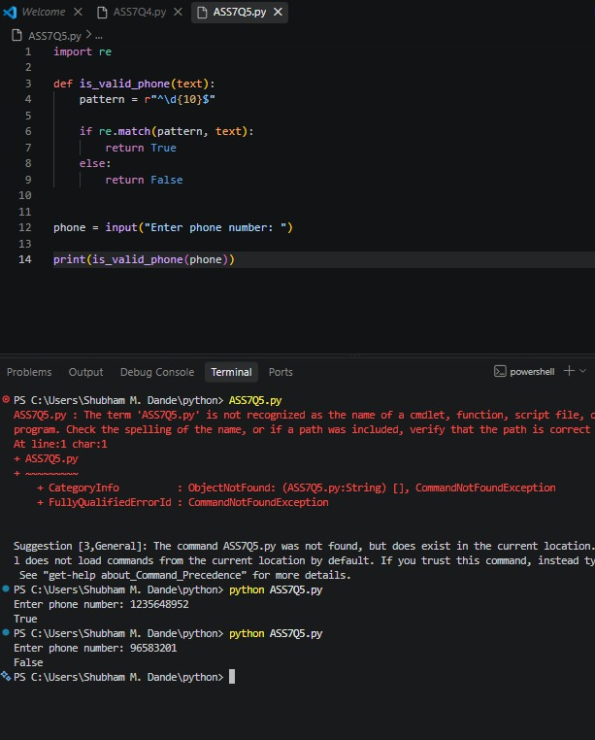

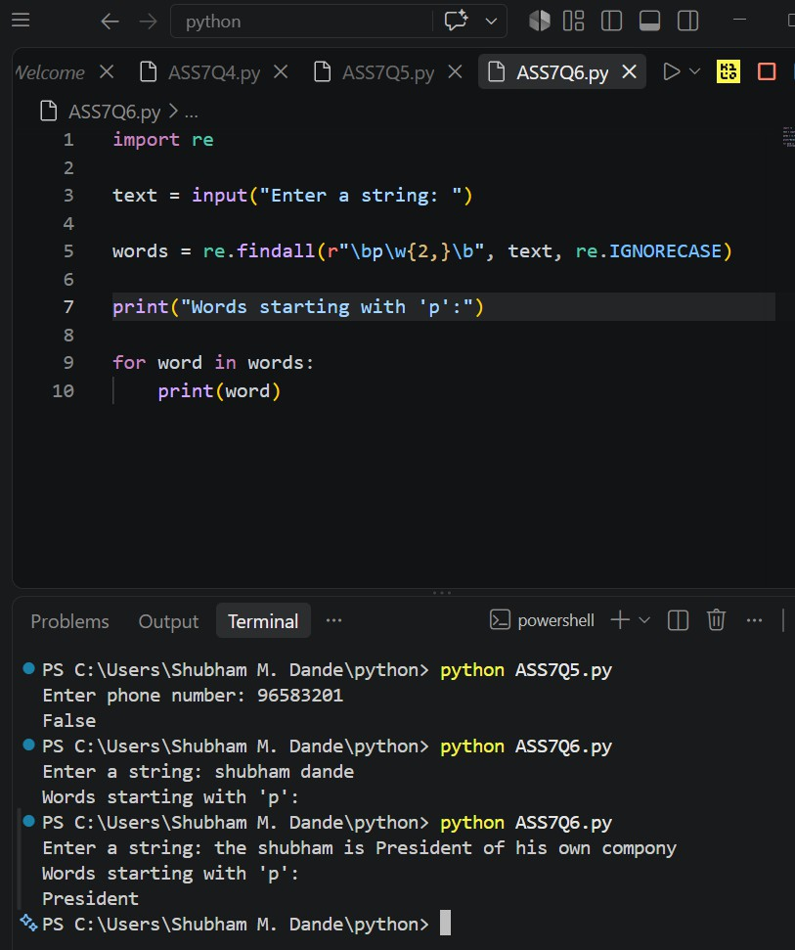
Q6:Write a Python program to find all words in a string that start with the letter 'p' (case-insensitive) and are at least 3 characters long.

Q7:Write a Python function find_dates(text) to find the first occurrence of a date in the format MM-DD-YYYY and prints the full match.

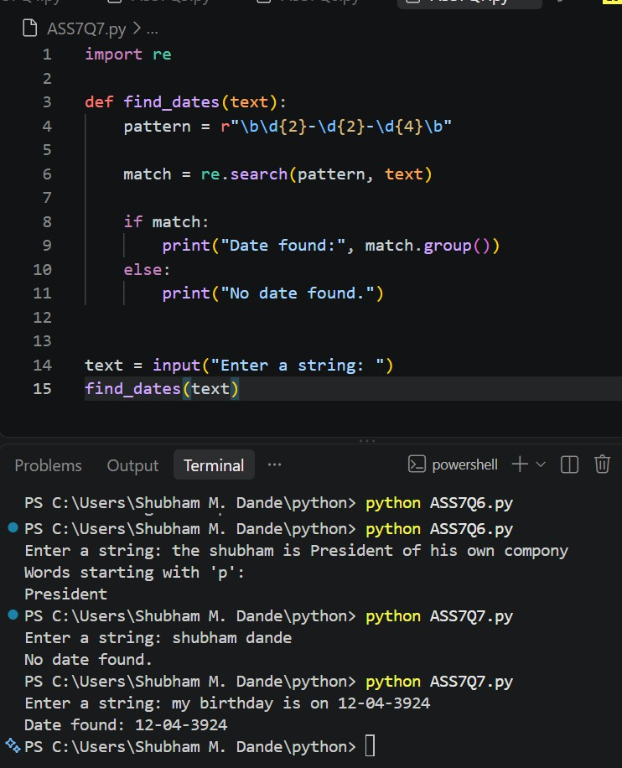

Q8:Write a Python function is_strong_password(password) that uses regex to check if a password meets the following criteria:
- At least 8 characters long.
- Contains at least one uppercase letter.
- Contains at least one lowercase letter.
- Contains at least one digit.
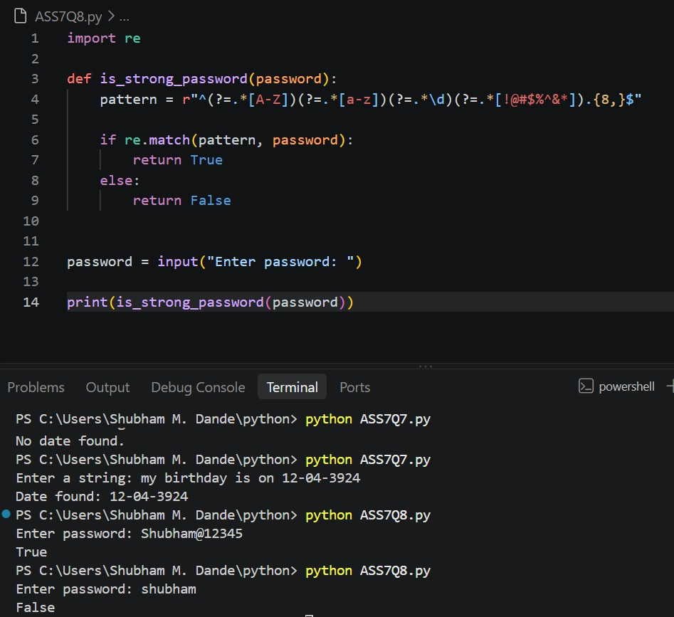
- Contains at least one special character (e.g., !, @, #, $, %, ^, &, *).

Q9:Write a Python function clean_string(text) that takes a string and performs the following cleaning tasks using regex:
- Replace multiple spaces with a single space.
- Remove leading and trailing whitespace.
- Capitalize the first letter of each sentence.

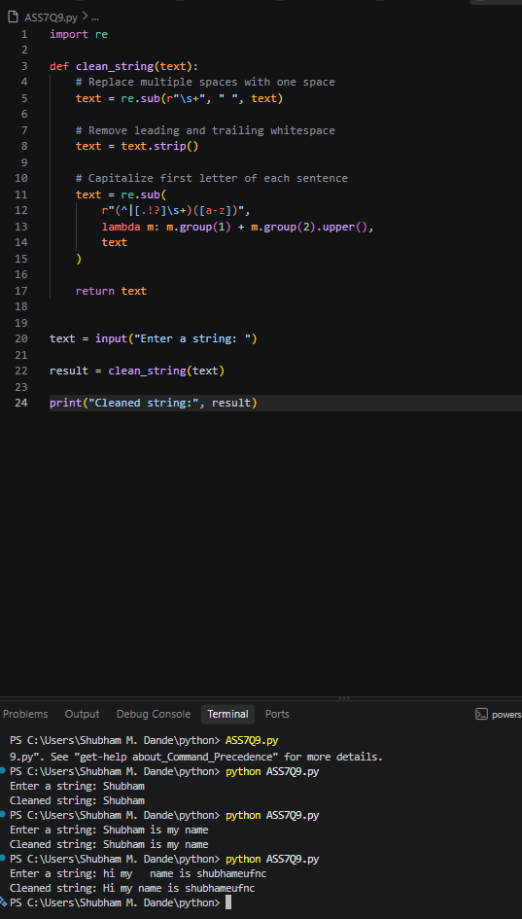

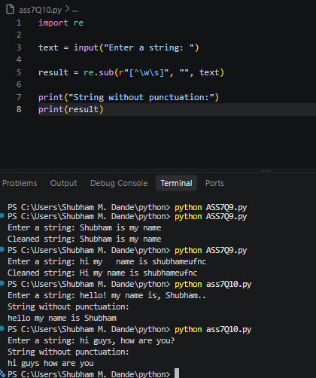
Q10:Write a Python program that takes a string and replace all punctuation marks (e.g., ,, ., !, ?) with an empty string.
Q11:Read and Print a File:
- Create a text file named data.txt with a few lines of text.
- Write a Python script that opens data.txt in read mode, reads the entire content, and prints it to the console.
- Make sure to use a with statement to handle the file automatically.
- Count Lines in a File:
- Use the data.txt file from the previous question.
- Write a Python program that counts the number of lines in the file and prints the total count.

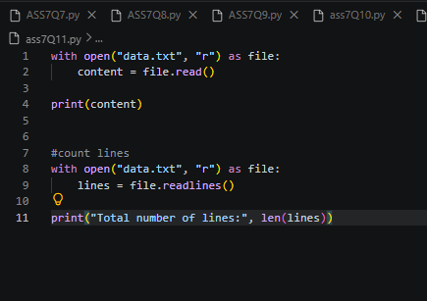
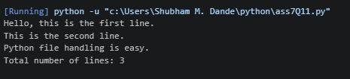
Q12:Append to a File:
- Create a file named log.txt.
- Write a Python program that prompts the user to enter a log message.
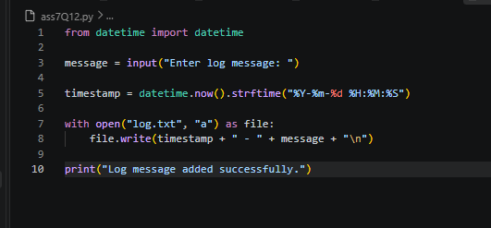
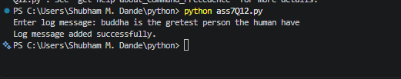
- The program should then append this message, along with a timestamp, to the end of log.txt on a new line.

Q13:Write a Simple CSV File:

- Write a Python script that takes a list of lists, where each inner list represents a row of data (e.g., [['Name', 'Age'], ['Alice', 30], ['John', 25]]).
- The script should write this data to a new CSV file named people.csv.
- Use the csv module for this task.
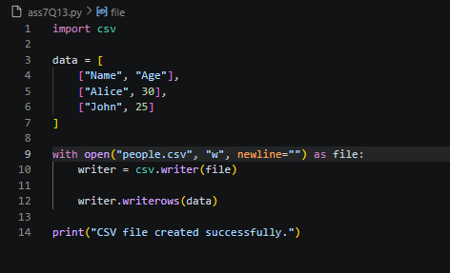
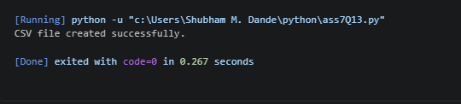
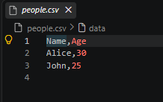

Assignment 8

Q1.
Write a Python program that accepts a sentence from the user and performs the following:
- Count the number of vowels and consonants.
- Count the number of digits and special characters.
- Find the longest word in the sentence.
- Display all words having more than 5 characters.
- Check whether the sentence is a palindrome after removing spaces and converting it to lowercase.

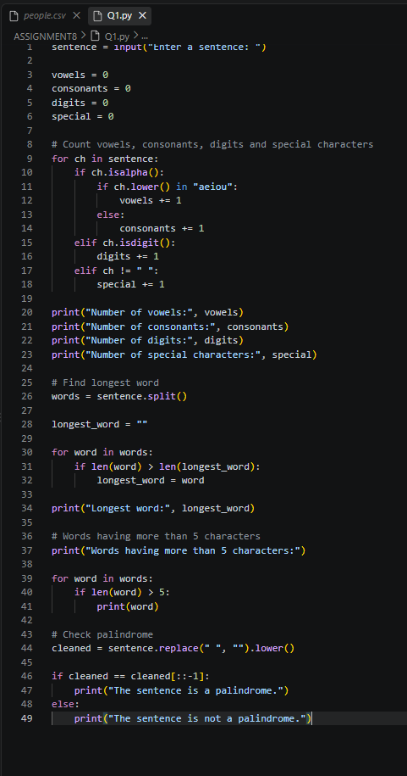

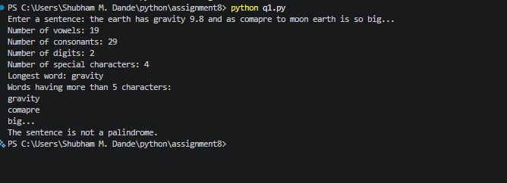
Q2.
Write a Python program to accept marks of n students into a list. Perform the following operations:
- Display all marks.
- Find the highest and lowest marks without using max() or min().
- Calculate the average marks.
- Display students who scored above the average.
- Count the number of students in each category:
  - 75 and above – Distinction
  - 60–74 – First Class
  - 50–59 – Second Class
  - Below 50 – Fail
- Display the list in reverse order using a loop.

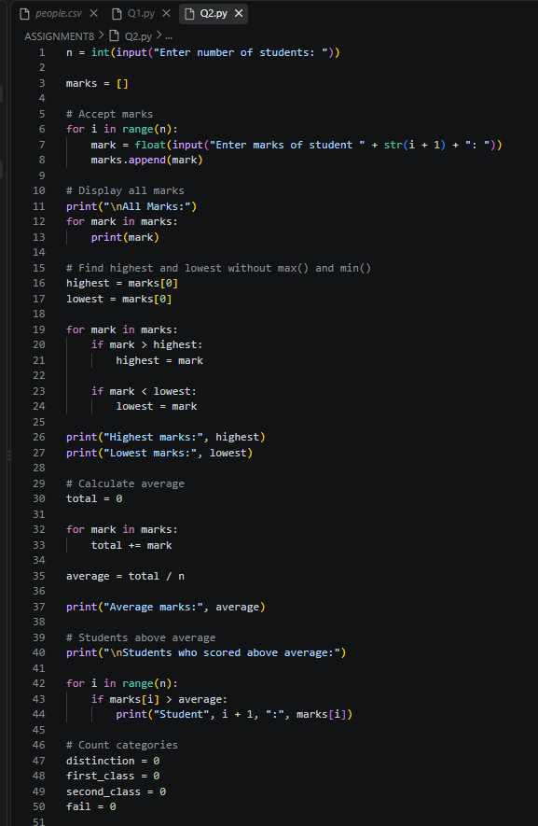

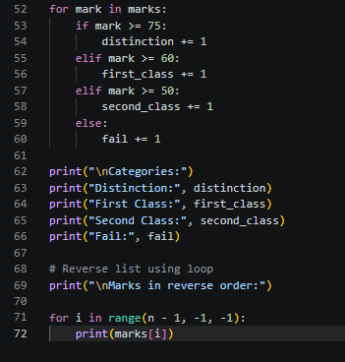

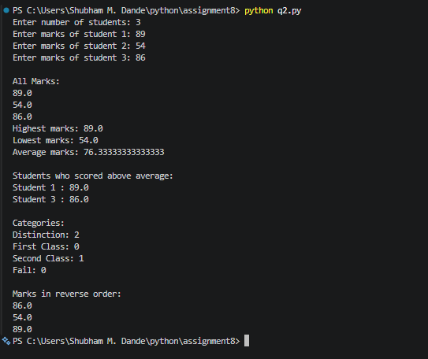

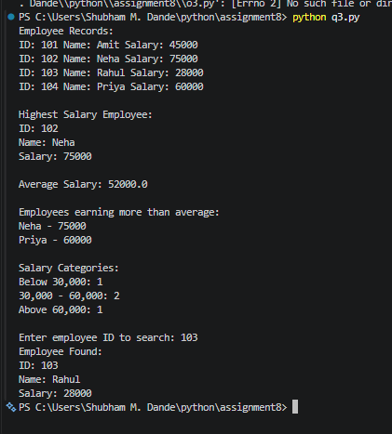

Q3.
Create a tuple containing employee records in the form: (employee_id, employee_name, salary)
Write a program to:
- Display all employees.
- Find the employee receiving the highest salary.
- Calculate the average salary.
- Display employees whose salary is greater than the average.
- Count employees based on salary categories:
  - Below 30,000
  - 30,000–60,000
  - Above 60,000
- Search for an employee by employee ID.

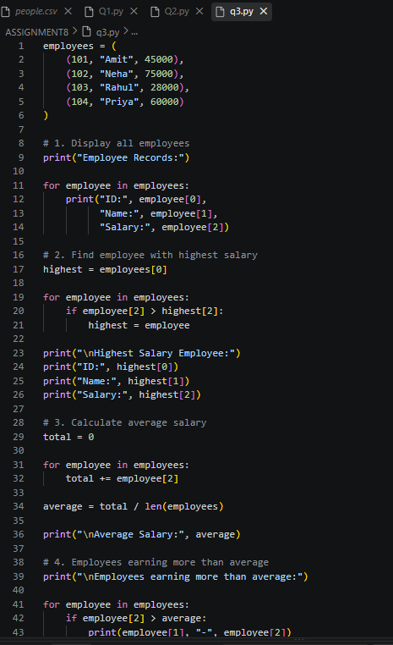

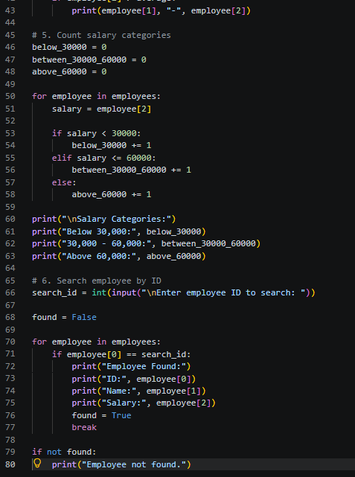

Q4.
Accept two lists of integers from the user and convert them into sets. Write a program to:
- Display unique elements from both lists.
- Find the union.
- Find the intersection.
- Find elements present only in the first list.
- Find elements present only in the second list.
- Display common even numbers.

- Display common odd numbers.
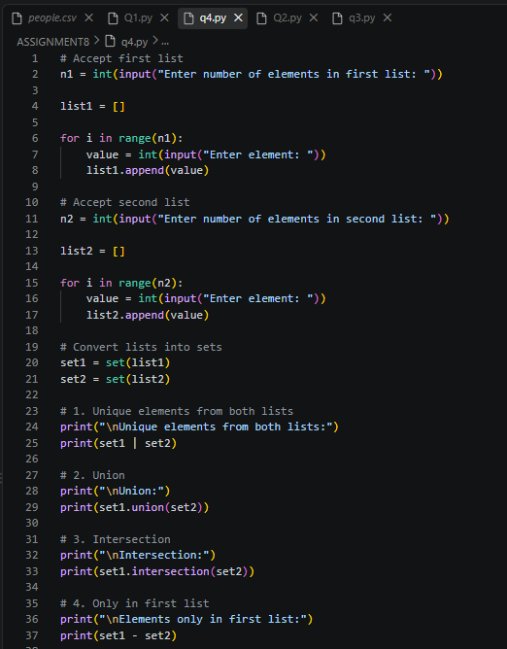

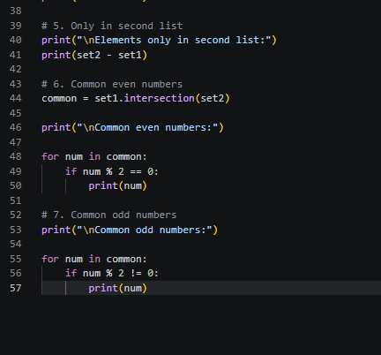
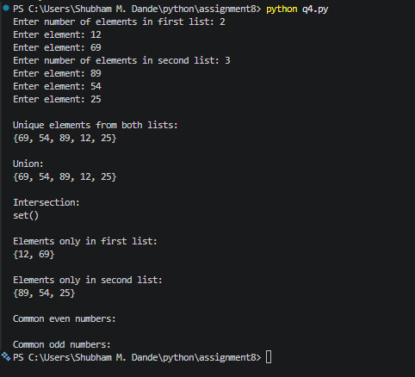

Q5.
Create a dictionary containing student names and their marks in three subjects. Example:
students = {
"Amit": [75, 82, 68],
"Neha": [91, 88, 95],
"Rahul": [45, 52, 48]
}
Write a program to:
- Calculate total and average marks for each student.
- Assign grades using conditional statements.
- Display students who have passed in all subjects.
- Display the student with the highest average.
- Count the number of students in each grade.
- Search for a student by name.

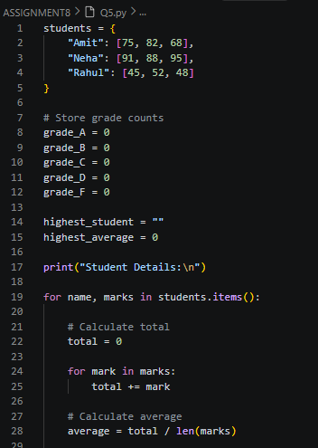

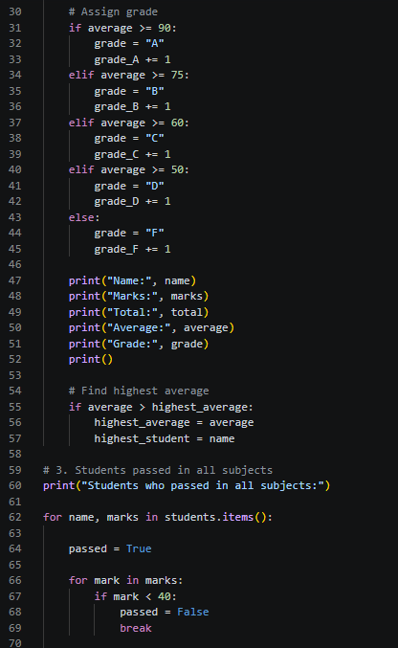

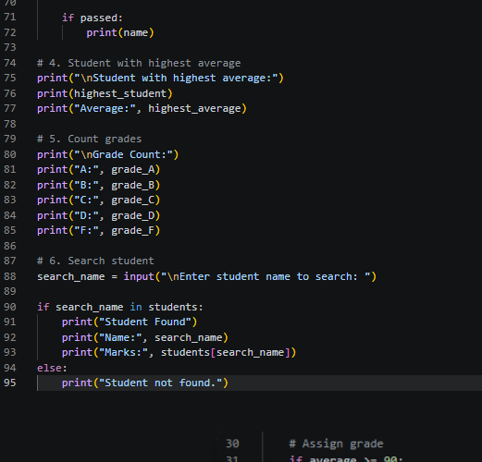

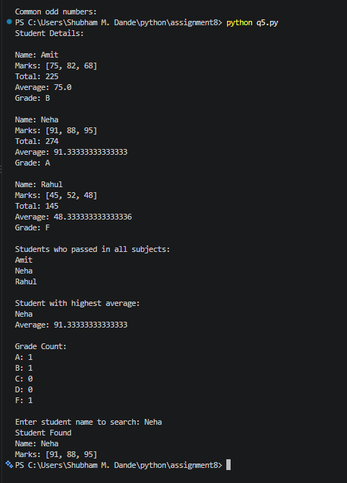

Q6.
Create a menu-driven Python program using user-defined functions. The menu should contain:
- Check Prime Number
- Check Palindrome
- Find Factorial
- Generate Fibonacci Series
- Exit
Create a separate function for each operation.

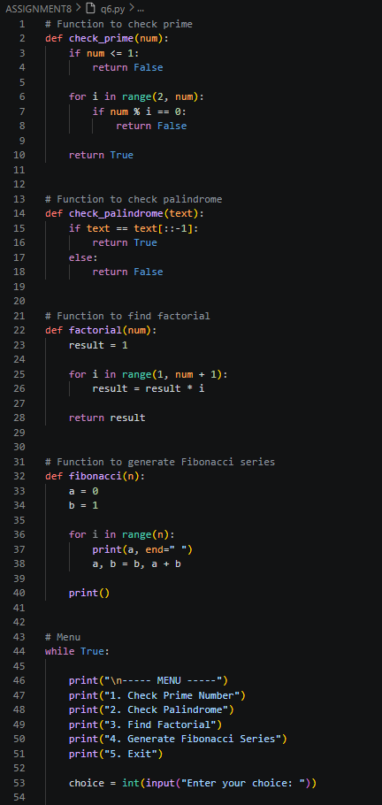

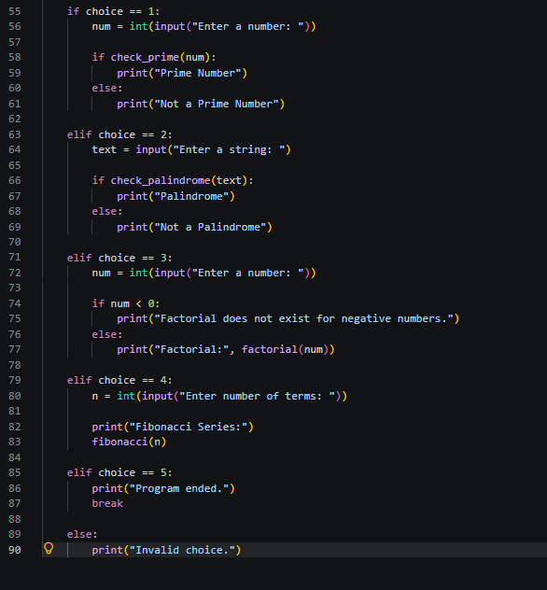
Output:

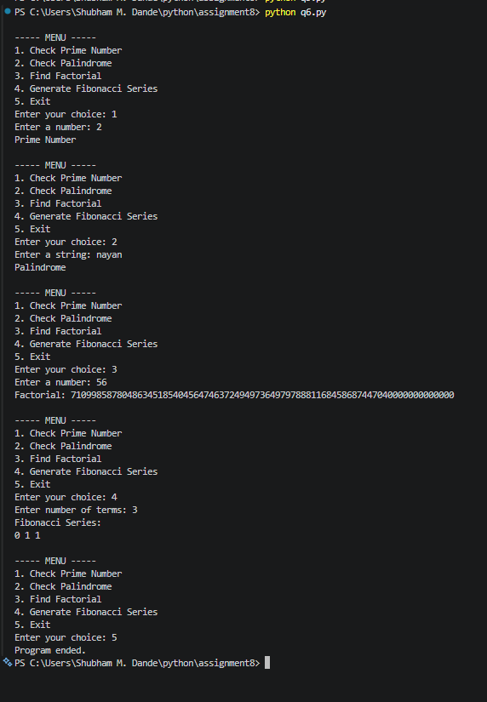

Q7.
Create a class BankAccount with the following attributes: account_number
customer_name balance
Create methods:
deposit() withdraw() check_balance() display_details()
Apply the following conditions:
- Deposit amount must be greater than zero.
- Withdrawal amount must not exceed the balance.
- Display an appropriate message for insufficient balance.
- Allow multiple transactions using a loop.
- Provide a menu:
- Deposit
- Withdraw
- Check Balance
- Account Details

- Exit 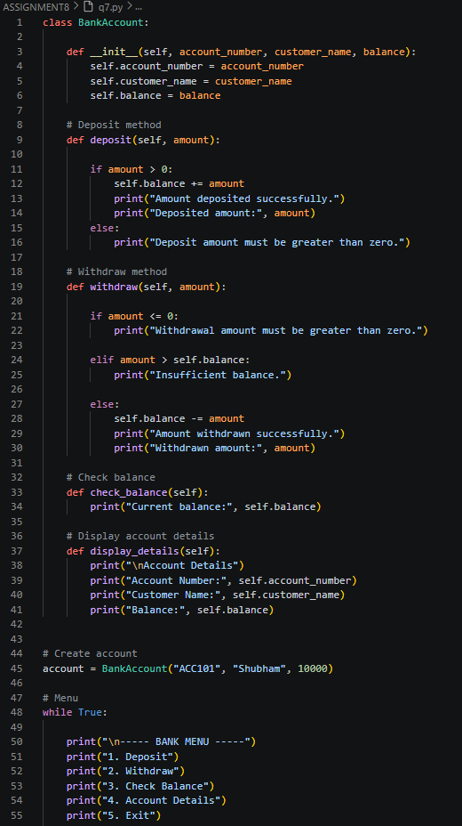

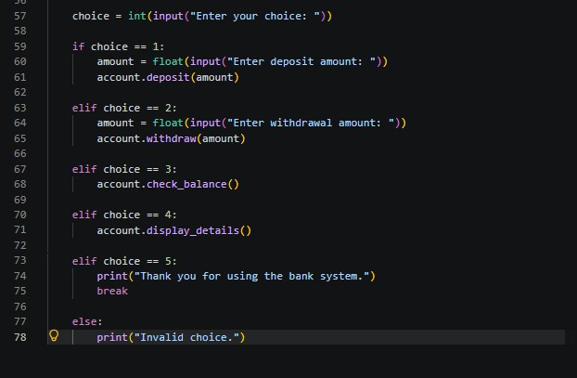
Output:

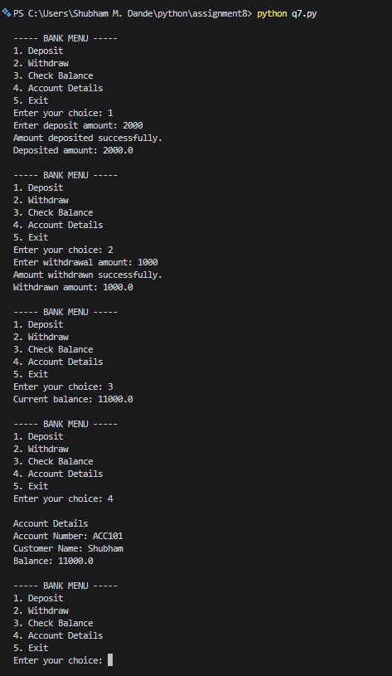

Q8.
Write a Python program using the re module to validate user input. Validate:
- Mobile number
- Email address
- Password
- PIN code
- Username
Use regular expressions and conditional statements to display whether each input is Valid or Invalid.
For the password, enforce:
  - At least 8 characters
  - At least one uppercase letter
  - At least one lowercase letter
  - At least one digit
  - At least one special character

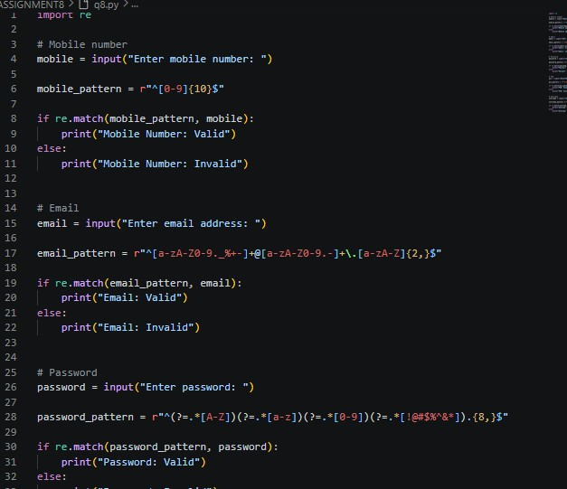

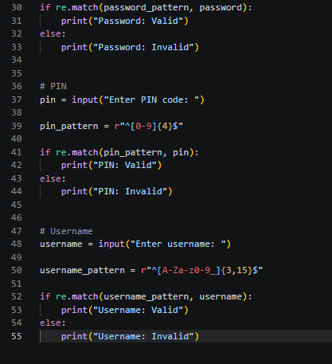
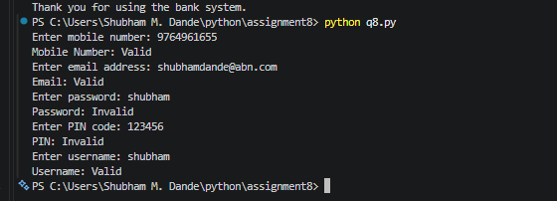

Assignment 9

Write a function apply_discount(price, discount_percentage) where:
  - An assert statement checks that discount_percentage is strictly between 0 and 100.
  - Another assert statement checks that the final price is never negative or higher than the original price.
  - Test your function with a valid discount (e.g., 20%) and an invalid discount (e.g., 120%) to show the traceback.

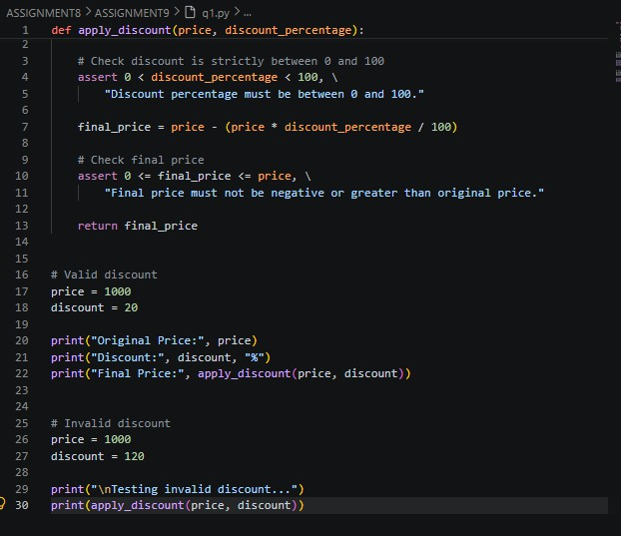

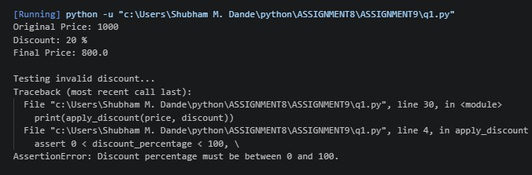
Create a program that prompts the user to enter two numbers (A and B) and outputs the result of A / B. Wrap the execution inside a try block and implement specific except clauses to handle.
  - ValueError: Handled when a user inputs a non-numeric string (e.g., "abc").

  - ZeroDivisionError: Handled when B is zero.
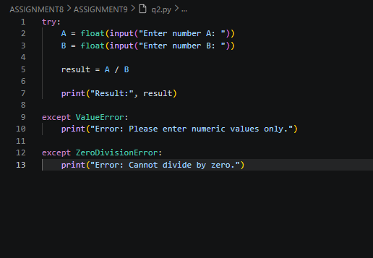
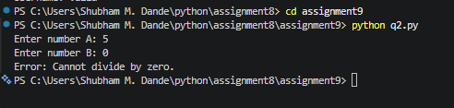

Write a program that requests a filename from the user and attempts to open it in read-only mode.
  - Intercept FileNotFoundError if the file doesn't exist.
  - Intercept PermissionError if the user lacks the credentials to open the file

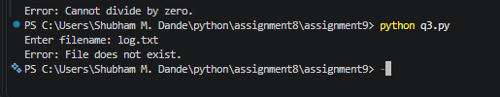

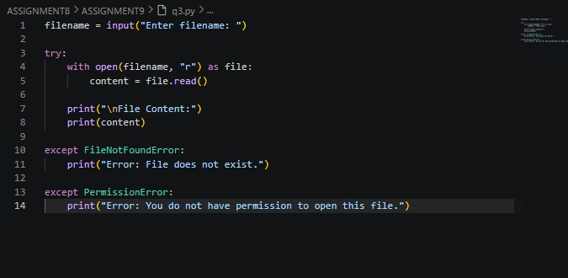
Create a class named Countdown.
  - The constructor _init_(self, start) should accept a starting integer.
  - Implement _iter_(self) to return the iterator object itself.
  - Implement _next_(self) to return numbers counting down to 0.
  - Once it hits 0, it should raise a StopIteration exception to halt the loop.

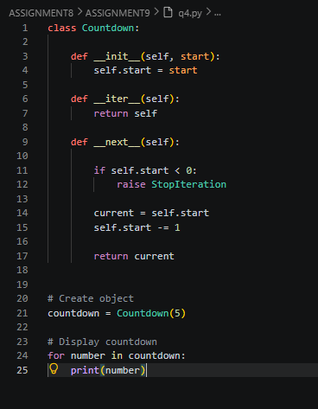

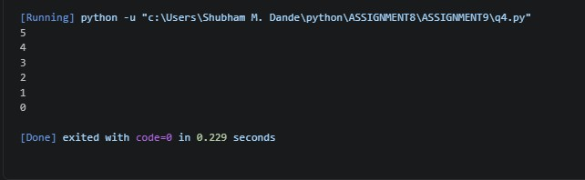
Write a generator function named fibonacci_gen(limit).
  - It should calculate and yield Fibonacci numbers one by one.
  - The generator must stop yielding once a number exceeds the specified limit.

