CYBER FORENSICS

ICA GROUP PROJECT — INVESTIGATION REPORT
Academic Year: 2026–27 | Project Component: 10 Marks | Group Size: 2–3
Project / Case Study Title: Cyber Threat Reconstruction Engine (CTRE): Offline Correlation of NTFS $MFT, $UsnJrnl and PCAP Metadata for Timestomping and Exfiltration Detection
Student name | Roll number | Program / Division
Vivek | [Enter details] | [Enter details]
Kshitij | [Enter details] | [Enter details]
Moksh | [Enter details] | [Enter details]
Aranck | [Enter details] | [Enter details]

Faculty: _____________________ Submission Date: _____________________

1. Abstract / Executive Summary
This report documents the investigation of a simulated data-theft incident on a Windows workstation using CTRE (Cyber Threat Reconstruction Engine), an offline, read-only tool built by the group. Three synthetic evidence items were examined: an NTFS $MFT extract, an NTFS change journal ($UsnJrnl:$J) and a network capture (PCAP). The objective was to establish whether file timestamps had been manipulated, when the suspicious file was really created, and whether data left the workstation around the same time. Evidence integrity was checked with SHA-256 before and after analysis, and the values did not change. CTRE flagged svchost.exe with two high-severity indicators and one medium-severity indicator: its $STANDARD_INFORMATION creation time (2019-01-01) predates both its $FILE_NAME creation time and its journal creation record (2026-10-20 11:00:00 UTC). The capture shows a DNS lookup and a 162,972-byte outbound TLS connection to exfil.example.net 31 seconds after the file was created. A control file was not flagged. The investigation is limited to synthetic evidence, and traffic was not decrypted, so the content of the transfer cannot be identified.

2. Case Study and Problem Definition
2.1 Case background and scenario: The case is a simulated incident prepared for this project. A Windows workstation with IP address 10.0.0.5 is suspected of data theft. Two files on its NTFS volume are of interest: report.docx, an ordinary document used as a control, and svchost.exe, a file whose name imitates a legitimate Windows process. The group acted as the investigators. All three evidence items were produced with the project's synthetic artifact generator, which writes real NTFS and libpcap structures containing a known, planted incident, so the investigation could be carried out and checked without handling real personal data.
2.2 Scope and assumptions: Included are the three evidence items E1 to E3 listed in Section 3, covering file-system activity and network traffic for the workstation 10.0.0.5. The recorded activity falls on 2026-10-20 between 09:00 and 11:01 UTC, apart from one claimed timestamp of 2019-01-01. Excluded are memory analysis, decryption of TLS traffic (excluded by design), live acquisition, full disk imaging, Windows event logs, the registry, and capture formats other than classic libpcap with Ethernet and IPv4. All timestamps are interpreted as UTC, and the clocks behind the journal and the capture are assumed to be consistent with each other.
2.3 Investigation objectives / questions: The evidence is used to answer four questions.
Q1. Were any file timestamps manipulated (timestomping)?
Q2. When was the suspicious file actually created, according to records that are hard to alter?
Q3. Did data leave the workstation, and if so, to where and how much?
Q4. Is the outbound transfer related in time to the suspicious file activity?
2.4 Authorization and ethical considerations: No third-party authorization was required because no real system, user or network was examined. The evidence is synthetic and contains no personal data. The external address 203.0.113.9 lies in a range reserved for documentation (RFC 5737) and the domain uses the reserved example.net name. CTRE opens evidence read-only and does not decrypt traffic; extracting encryption keys and decrypting communications was deliberately left out of the project because it would amount to an interception tool.

3. Evidence Identification and Preservation
Evidence ID | Source / filename | Type / size | Collected by / date | SHA-256 / status
E1 | sample_artifacts/mft.bin ($MFT extract) | NTFS $MFT, 2,048 bytes, 2 FILE records | Group (CTRE generator), 2026-11-02 18:06 UTC | 064e9040...8f7b67; verified unchanged
E2 | sample_artifacts/usnjrnl.bin ($UsnJrnl:$J) | NTFS change journal, 352 bytes, 4 USN_RECORD_V2 | Group (CTRE generator), 2026-11-02 18:06 UTC | 5ef2a7ec...e14fb; verified unchanged
E3 | sample_artifacts/capture.pcap | libpcap capture, 165,025 bytes, 122 packets | Group (CTRE generator), 2026-11-02 18:06 UTC | d695ca15...4e4824; verified unchanged
Collection method: the evidence was generated on the analyst workstation (Windows 11 Pro) by running python -m ctre gen sample_artifacts, which writes the three files into the sample_artifacts folder of the project.
Integrity checks: a SHA-256 hash of each file was computed with sha256sum immediately after generation (2026-11-02 18:06:42 UTC) and again after the analysis. The values were identical, which shows the analysis did not modify the evidence. CTRE opens every input read-only. Full hash values are listed in Appendix C.
Storage location: the files remain in the project folder on the analyst workstation. They are not committed to the source repository, but the generator is deterministic: regenerating the set produced byte-identical files with the same SHA-256 values.
Evidence limitations: the items are synthetic and small. They were not acquired from a physical disk with an imaging tool, so write blocking and disk imaging are not demonstrated.

3.1 Chain of custody
Evidence ID | Date/time | From → To | Action / purpose | Signature
E1, E2, E3 | 2026-11-02 18:06:42 UTC | CTRE generator → sample_artifacts/ (analyst workstation) | Evidence created; SHA-256 and sizes recorded
E1, E2, E3 | 2026-11-02 18:06 UTC | sample_artifacts/ → CTRE analyze (read-only) | Examination; HTML report generated
E1, E2, E3 | 2026-11-02 18:06 UTC | CTRE → sample_artifacts/ | SHA-256 recomputed; identical to initial values

4. Tools and Investigation Environment
Tool / version | Purpose | OS / setup | Output artifact
CTRE 0.1.0 (group-built) | Parse $MFT, $UsnJrnl and PCAP; detect timestomping; correlate; report | Windows 11 Pro, Python 3.13.1, standard library only | Console output, ctre-report.html, JSON results
scapy 2.7.0 | Independent cross-check of the PCAP metadata | Windows 11 Pro, Python 3.13.1 | Cross-check output (Listing 4)
sha256sum (Git for Windows) | Evidence hashing before and after analysis | Git Bash on Windows 11 Pro | Hash values (Listing 1, Appendix C)
pytest 9.0.3 | Run the tool's 20 automated tests | Windows 11 Pro, Python 3.13.1 | Test log (Listing 5)
Microsoft Edge (headless) | Capture screenshots of the CTRE interface and report | Windows 11 Pro | Figures 4 to 8
Autopsy, FTK Imager, Wireshark and a hex editor were not used. The evidence was generated directly as files rather than imaged from a disk, and its formats are read by CTRE's own parsers; scapy was used as an independent reference to check the network parser's output.

5. Forensic Investigation Methodology
The investigation followed the standard forensic workflow. Each stage is listed with what was done in this case.
• Identification: the relevant artifacts were the $MFT (file metadata and timestamps), the change journal (an append-only record of file changes kept by the kernel) and a packet capture (network activity). These became E1 to E3.
• Acquisition / preservation: synthetic copies were generated instead of imaging a disk (deviation, explained below). SHA-256 hashes were recorded and every file was handled read-only.
• Verification: hashes were recomputed after analysis. The tool itself was verified by 20 automated tests and by comparing its network output with scapy.
• Examination: CTRE parsed the $MFT FILE records (applying the NTFS fixup array), the USN_RECORD_V2 journal entries, and the PCAP flows, DNS queries and TLS server names.
• Analysis: four timestomping rules compared the $STANDARD_INFORMATION times with the $FILE_NAME times and the journal (Figure 2). Outbound flows of at least 100,000 bytes were matched to journal changes within 5 minutes (Figure 3), and all events were merged into one UTC timeline.
• Reporting: CTRE produced an HTML report and JSON results; this document interprets them.
Deviation: no physical acquisition took place. The evidence was generated so that the planted incident is known in advance, which lets the findings be checked against ground truth. Figure 1 shows the overall processing pipeline.
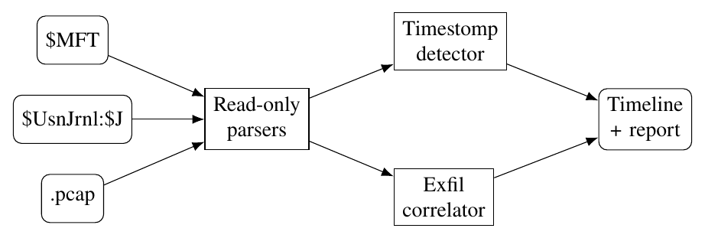
Figure 1: CTRE processing pipeline. The three artifacts are parsed read-only, analysed for timestamp tampering and disk/network correlation, and merged into one timeline and report.
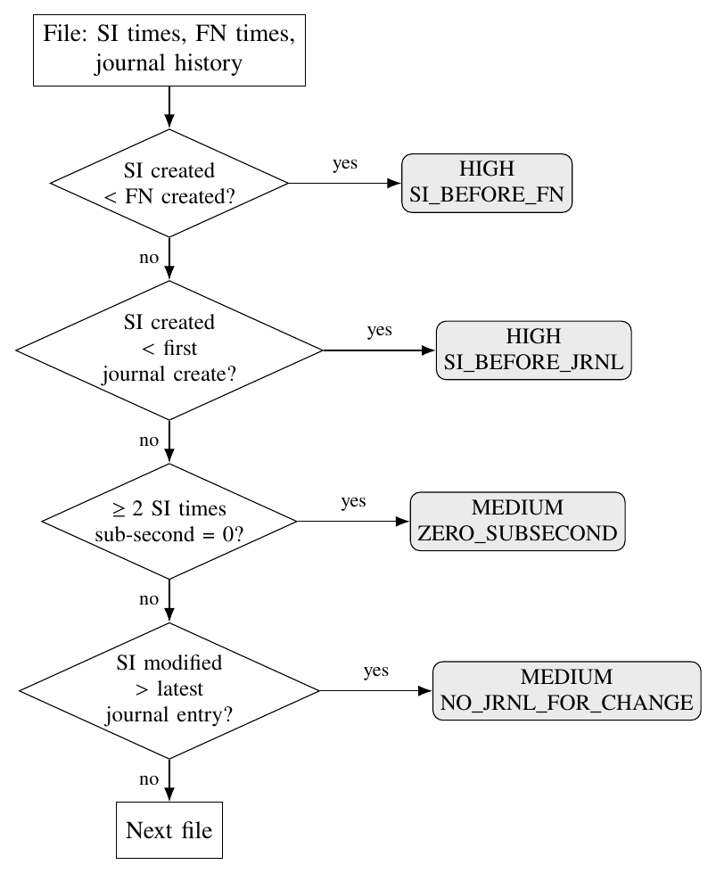
Figure 2: Timestomping checks applied to each file. SI = $STANDARD_INFORMATION (easy to alter), FN = $FILE_NAME (maintained by the kernel).
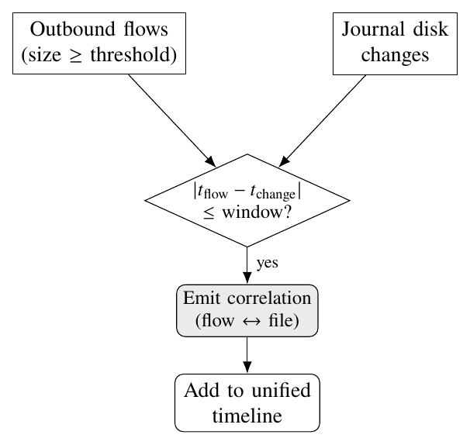
Figure 3: Exfiltration correlation. Each large outbound flow is paired with any journal change inside the time window.

6. Implementation and Evidence Examination
Each step below follows the same format: objective, input, tool, procedure, output and interpretation.
Step 1: Objective: Create the evidence set and record its integrity.
Input evidence / Evidence ID: none (generated) → E1, E2, E3.
Tool and feature: CTRE artifact generator (ctre gen); sha256sum.
Procedure performed: ran python -m ctre gen sample_artifacts from the project folder, then recorded the size and SHA-256 hash of each output file at 2026-11-02 18:06:42 UTC.
Output / observation: three files were written (Listing 1).
Listing 1: Evidence generation and initial hashes (console output).
> python -m ctre gen sample_artifacts
Wrote synthetic artifacts:
mft sample_artifacts\mft.bin
usnjrnl sample_artifacts\usnjrnl.bin
pcap sample_artifacts\capture.pcap
2026-11-02 18:06:42 UTC
mft.bin 2048 bytes 064e904059ff849ab4f75115427a3a7d4a781d4540ee14fec337c9bade8f7b67
usnjrnl.bin 352 bytes 5ef2a7ec5c78f546eb6bacf2bde45f3019eca79d1df58f204e083e0fbeea14fb
capture.pcap 165025 bytes d695ca15d7bc87d52c186fe817cff96b9439fe2f47a68cb2d00c070c821e4824

Interpretation: these hashes are the baseline for the integrity check in Step 7. The step does not represent acquisition from real media.
Step 2: Objective: Load the evidence into the CTRE interface and set the analysis parameters.
Input evidence / Evidence ID: E1, E2, E3.
Tool and feature: CTRE web interface (python -m ctre web), "Load sample case".
Procedure performed: started the local server (bound to 127.0.0.1 only) and loaded the sample case, which regenerates the same three files inside the server's temporary workspace. Options were left at their defaults: exfiltration threshold 100,000 bytes, correlation window 5 minutes, MFT record size 1024 bytes.
Output / observation: the interface listed the three evidence items with sizes of 2.0 KB, 352 B and 161.2 KB (Figures 4 and 5).
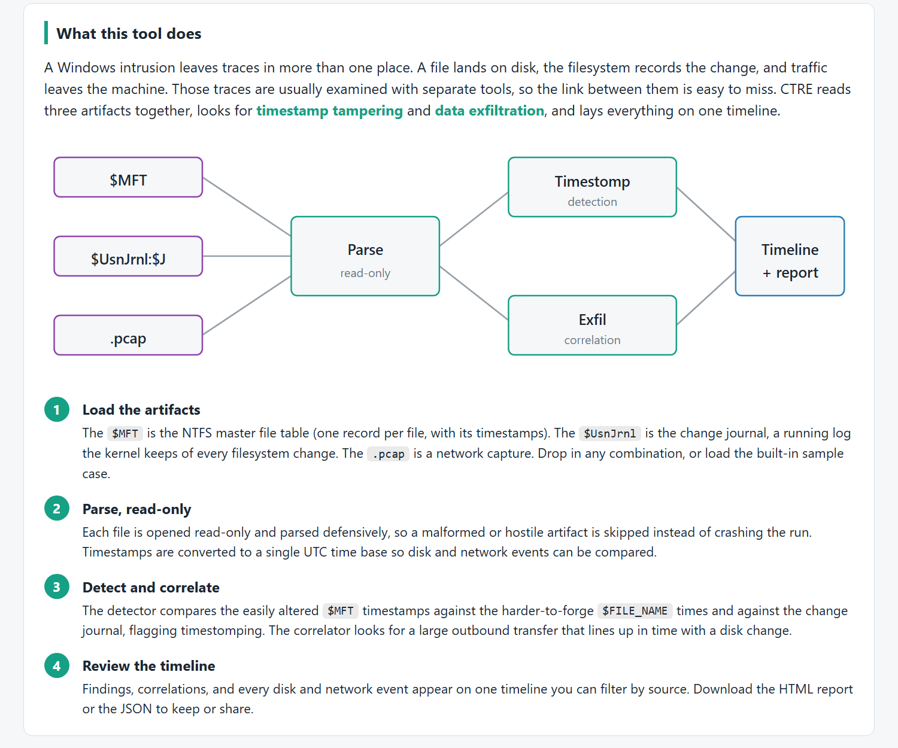
Figure 4: CTRE interface overview, showing the processing pipeline and the four investigation steps.
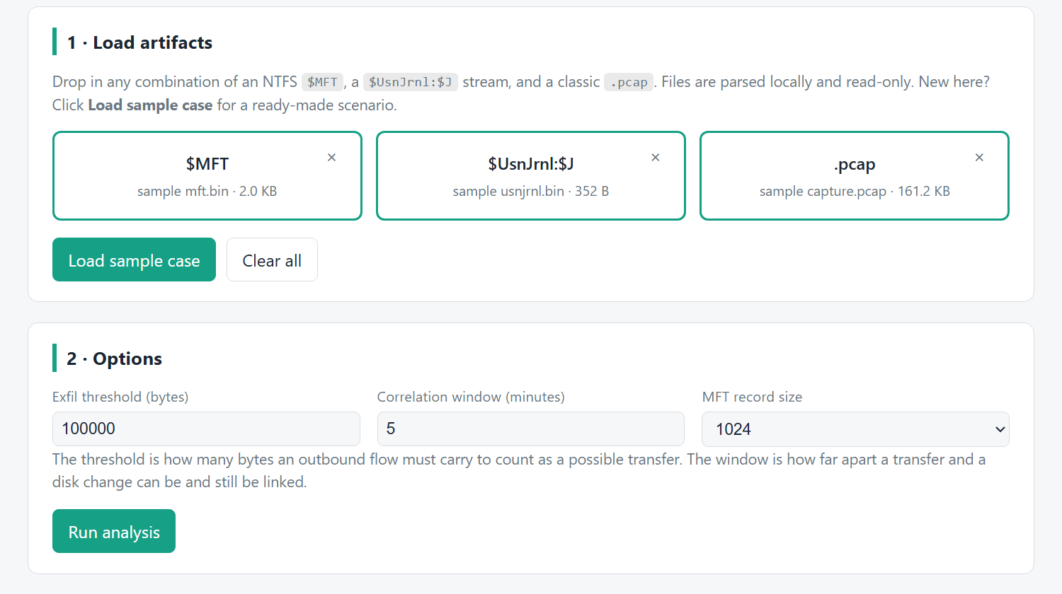
Figure 5: Evidence E1 to E3 loaded in CTRE, with the analysis options used in this investigation.
Interpretation: the displayed sizes match the evidence manifest in Section 3, and the options shown are the parameters behind every result below.
Step 3: Objective: Parse the file-system metadata (E1 and E2).
Input evidence / Evidence ID: E1, E2 (E3 parsed in the same run).
Tool and feature: CTRE analyze command: $MFT parser with fixup handling; USN_RECORD_V2 journal parser.
Procedure performed: ran the command in Listing 2, then printed the parsed $MFT timestamps (Listing 3).
Listing 2: CTRE analysis run (console output).
> python -m ctre analyze --mft sample_artifacts/mft.bin \
--usnjrnl sample_artifacts/usnjrnl.bin \
--pcap sample_artifacts/capture.pcap --report sample_artifacts/report.html
[+] Parsed 2 MFT entries from sample_artifacts/mft.bin
[+] Parsed 4 USN records from sample_artifacts/usnjrnl.bin
[+] Parsed 122 packets / 2 flows from sample_artifacts/capture.pcap
[+] Timestomping findings: 3
[HIGH ] svchost.exe: SI_BEFORE_FN
[HIGH ] svchost.exe: SI_BEFORE_JRNL
[MEDIUM] svchost.exe: ZERO_SUBSECOND
[+] Exfil correlations: 2
[+] Wrote HTML report to sample_artifacts/report.html

Listing 3: Parsed $MFT creation times ($STANDARD_INFORMATION vs $FILE_NAME).
MFT 64 report.docx SI 2026-10-20 09:00:00.500000+00:00 FN 2026-10-20 09:00:00.500000+00:00
MFT 65 svchost.exe SI 2019-01-01 00:00:00+00:00 FN 2026-10-20 11:00:00.500000+00:00

Output / observation: 2 $MFT entries and 4 journal records were parsed. The journal holds FILE_CREATE (09:00:00.5) and DATA_EXTEND (09:05:00.5) for report.docx, and FILE_CREATE (11:00:00.5) and DATA_OVERWRITE (11:01:00.5) for svchost.exe, all on 2026-10-20 UTC.
Interpretation: the two timestamp sets agree for report.docx but disagree by almost eight years for svchost.exe. Parsing shows the discrepancy; Step 4 evaluates it.
Step 4: Objective: Test the files for timestamp manipulation.
Input evidence / Evidence ID: E1, E2.
Tool and feature: CTRE timestomping detector (four rules, Figure 2).
Procedure performed: the detector ran as part of the analysis in Step 3; results were reviewed in the generated report.
Output / observation: three findings, all on svchost.exe (Figure 6): SI_BEFORE_FN and SI_BEFORE_JRNL (high) and ZERO_SUBSECOND (medium, on the created, modified and accessed times). report.docx raised no finding.
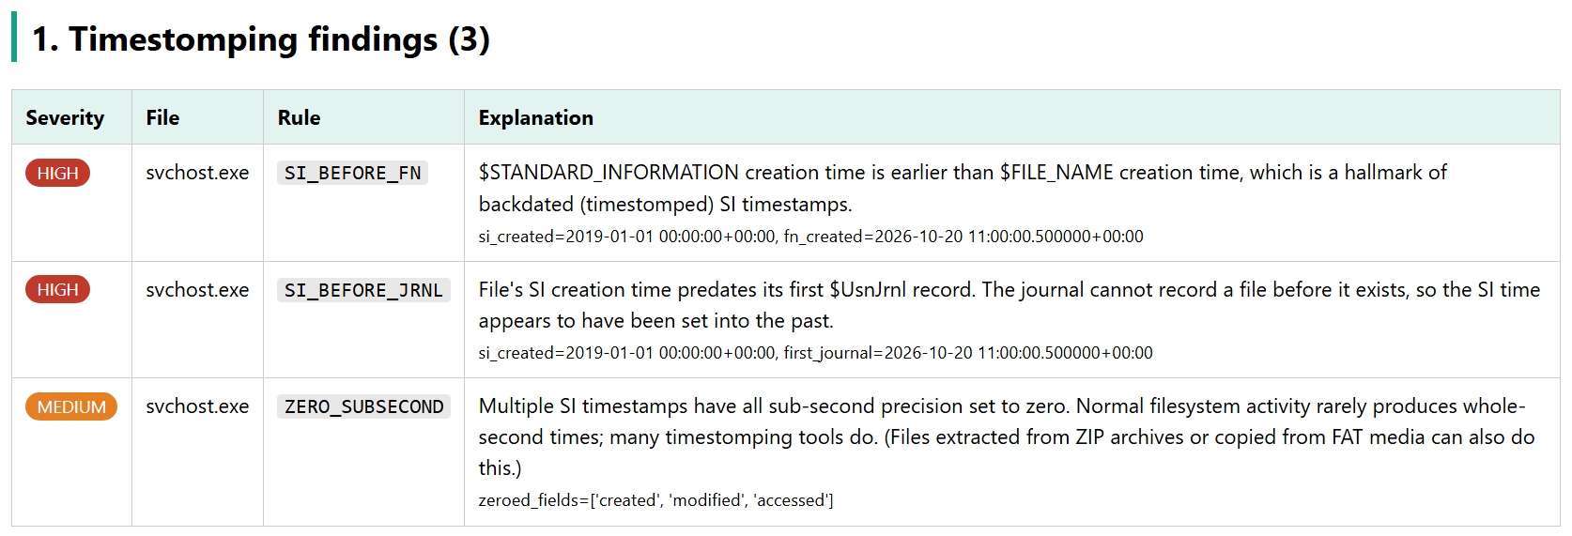
Figure 6: Timestomping findings from the CTRE report (generated 2026-11-02 18:06:42 UTC).
Interpretation: the $STANDARD_INFORMATION creation time of svchost.exe is earlier than two independent records of its creation, so it was very likely set into the past. The zeroed sub-seconds support this but on their own could have benign causes, such as extraction from an archive.
Step 5: Objective: Extract network metadata from the capture without decryption.
Input evidence / Evidence ID: E3.
Tool and feature: CTRE PCAP parser (flows, DNS names, TLS server name); scapy 2.7.0 for cross-checking.
Procedure performed: CTRE parsed E3 in the Step 3 run. The same file was then read with scapy and the key values were compared (Listing 4).
Output / observation: 122 packets in 2 flows: a UDP DNS query from 10.0.0.5:50000 to 10.0.0.1:53 for exfil.example.net (77 bytes), and a TCP connection from 10.0.0.5:50001 to 203.0.113.9:443 whose TLS ClientHello names exfil.example.net, with 162,972 bytes sent from the workstation.
Listing 4: Cross-check of CTRE network metadata against scapy.
packets scapy=122 ctre=122
DNS query scapy=['exfil.example.net'] ctre=['exfil.example.net']
TLS SNI scapy=exfil.example.net ctre=['exfil.example.net']
bytes out scapy=162972 ctre=[162972]

Interpretation: the workstation resolved an external host and sent it about 160 KB over an encrypted connection. The two tools agree on every value. Because the traffic was not decrypted, the content of the transfer is unknown.
Step 6: Objective: Correlate network and disk activity and build the timeline.
Input evidence / Evidence ID: E1, E2, E3.
Tool and feature: CTRE correlator (threshold 100,000 bytes, window 5 minutes) and unified timeline.
Procedure performed: the correlator ran as part of the analysis in Step 3; the correlations and timeline were reviewed in the generated report.
Output / observation: two correlations link the 162,972-byte transfer (11:00:31.5) to the FILE_CREATE and DATA_OVERWRITE records of svchost.exe (Figure 7). The timeline holds 9 events (Figure 8).
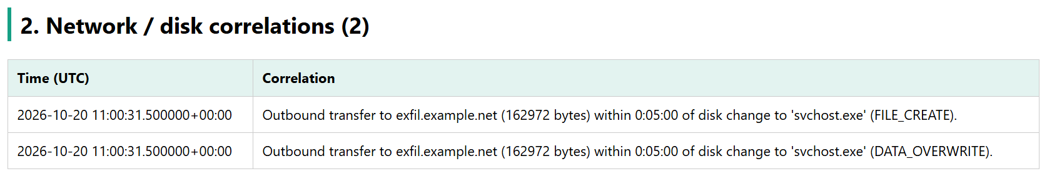
Figure 7: Network / disk correlations from the CTRE report.
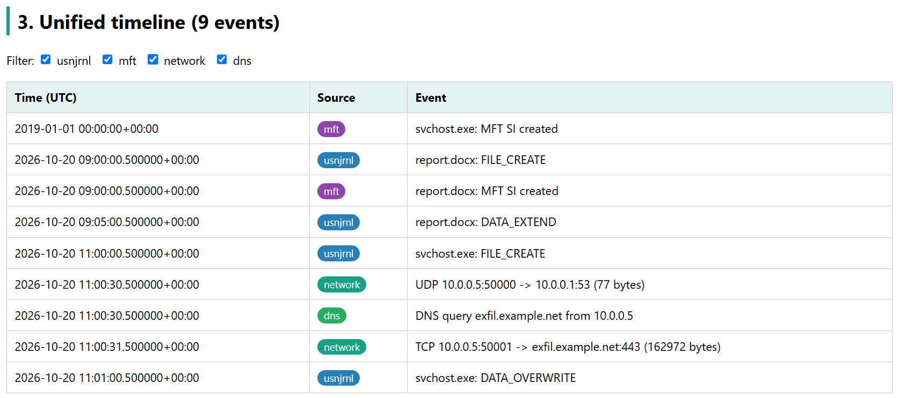
Figure 8: Unified timeline of disk and network events from the CTRE report.
Interpretation: the transfer began 31 seconds after svchost.exe was created and 29 seconds before it was overwritten. That timing fits a stage-and-send pattern, but it is a temporal link only; no artifact shows that the transferred bytes came from svchost.exe.
Step 7: Objective: Verify evidence integrity and the tool's behaviour.
Input evidence / Evidence ID: E1, E2, E3; the CTRE test suite.
Tool and feature: sha256sum; pytest 9.0.3.
Procedure performed: recomputed the SHA-256 of each evidence file after the analysis, and ran the 20 automated tests with python -m pytest -q.
Listing 5: Post-analysis hashes and test run (console output).
> sha256sum sample_artifacts/mft.bin sample_artifacts/usnjrnl.bin sample_artifacts/capture.pcap
064e904059ff849ab4f75115427a3a7d4a781d4540ee14fec337c9bade8f7b67 *sample_artifacts/mft.bin
5ef2a7ec5c78f546eb6bacf2bde45f3019eca79d1df58f204e083e0fbeea14fb *sample_artifacts/usnjrnl.bin
d695ca15d7bc87d52c186fe817cff96b9439fe2f47a68cb2d00c070c821e4824 *sample_artifacts/capture.pcap
> python -m pytest -q
.................... [100%]
20 passed in 3.83s

Output / observation: all three hashes match Listing 1, and all 20 tests passed.
Interpretation: the evidence was not altered by the analysis. The tests show the parsers, detection rules, correlation and report behave as designed on known inputs; they are not a formal validation of the tool for court use.

7. Results and Findings
Finding ID | Supporting evidence / figure | Observed result | Interpretation / confidence
R1 | E1; Figure 6, Listing 3 | svchost.exe: SI created 2019-01-01 00:00:00 UTC; FN created 2026-10-20 11:00:00.5 UTC (SI_BEFORE_FN, high) | Inference: SI creation time was backdated. Confidence: high.
R2 | E2; Figure 6 | Journal FILE_CREATE for svchost.exe at 2026-10-20 11:00:00.5 UTC, later than its SI creation time (SI_BEFORE_JRNL, high) | An independent artifact corroborates R1. Confidence: high.
R3 | E1; Figure 6 | SI created, modified and accessed times of svchost.exe have zero sub-seconds (ZERO_SUBSECOND, medium) | Consistent with a timestamp-editing tool; benign causes possible. Confidence: medium.
R4 | E3; Listing 4 | DNS query for exfil.example.net at 11:00:30.5; TLS connection to 203.0.113.9:443 (SNI exfil.example.net) at 11:00:31.5 sending 162,972 bytes | Observation: data left the workstation. Content unknown (not decrypted). Confidence in metadata: high (cross-checked).
R5 | E2, E3; Figures 7 and 8 | Transfer start falls within 5 minutes of svchost.exe FILE_CREATE (11:00:00.5) and DATA_OVERWRITE (11:01:00.5) | Inference: transfer is related in time to the file's activity. Confidence: medium (temporal only).
R6 | E1, E2; Listing 3, Figure 8 | report.docx: SI and FN creation times agree with its journal FILE_CREATE (09:00:00.5); no finding raised | Control file behaves normally; no false positive. Confidence: high.
Observation, inference and allegation: the timestamps, journal records and flow metadata in R1 to R6 are observations read directly from the evidence. That svchost.exe was backdated (R1 to R3) and that the transfer is linked to its activity (R5) are inferences. The evidence does not support, and this report does not claim, that the transferred bytes were svchost.exe or any particular data, that svchost.exe is malicious (its contents were not examined), or that any specific person carried out the activity.

8. Event Timeline and Evidence Correlation
Date/time + timezone | Event | Evidence IDs | Interpretation
2019-01-01 00:00:00 UTC | svchost.exe: claimed SI creation time | E1 | Contradicted by E1 ($FILE_NAME) and E2; backdated value
2026-10-20 09:00:00.5 UTC | report.docx created (journal FILE_CREATE; SI and FN agree) | E1, E2 | Normal baseline activity
2026-10-20 09:05:00.5 UTC | report.docx extended (DATA_EXTEND) | E2 | Normal edit of the control file
2026-10-20 11:00:00.5 UTC | svchost.exe created (journal FILE_CREATE; $FILE_NAME creation time) | E1, E2 | Actual creation time of the suspicious file
2026-10-20 11:00:30.5 UTC | DNS query for exfil.example.net from 10.0.0.5 to 10.0.0.1:53 | E3 | Workstation resolves the external destination
2026-10-20 11:00:31.5 UTC | TLS connection 10.0.0.5:50001 → 203.0.113.9:443 (SNI exfil.example.net), 162,972 bytes out | E3 | Large outbound transfer 31 s after file creation
2026-10-20 11:01:00.5 UTC | svchost.exe overwritten (DATA_OVERWRITE) | E2 | File modified 29 s after the transfer began
The artifacts corroborate each other. E1 ($FILE_NAME) and E2 (the journal) are independent records, and both place the creation of svchost.exe at 2026-10-20 11:00:00.5 UTC, contradicting the 2019 date in its $STANDARD_INFORMATION attribute. E3 is a third independent source and places a DNS lookup and a large outbound transfer inside the one-minute window in which the file was created and then overwritten. No artifact contradicts this sequence. The control file report.docx shows consistent times across E1 and E2, which supports the reliability of the method. The link between the transfer and the file rests on timing alone.

9. Final Forensic Investigation Report
9.1 Case overview and evidence examined: three synthetic evidence items from a simulated Windows workstation (10.0.0.5) were examined offline with CTRE: an $MFT extract (E1, 2 file records), a change journal (E2, 4 records) and a packet capture (E3, 122 packets in 2 flows). Integrity was preserved and verified with SHA-256.
9.2 Key findings:
1. svchost.exe carries a backdated $STANDARD_INFORMATION creation time of 2019-01-01 00:00:00 UTC, while its $FILE_NAME creation time and its journal FILE_CREATE record both show 2026-10-20 11:00:00.5 UTC (E1, E2; Figure 6; R1, R2).
2. All three $STANDARD_INFORMATION timestamps of svchost.exe have zeroed sub-second values, consistent with a timestamp-editing tool (E1; R3).
3. At 11:00:30.5 UTC the workstation resolved exfil.example.net, and at 11:00:31.5 UTC it opened a TLS connection to 203.0.113.9:443 with that server name, sending 162,972 bytes (E3; Listing 4; R4).
4. The transfer began 31 seconds after svchost.exe was created and 29 seconds before it was overwritten (E2, E3; Figures 7 and 8; R5).
5. The control file report.docx shows consistent timestamps and raised no finding (E1, E2; R6).
9.3 Investigation limitations: the evidence is synthetic and small, and was generated rather than acquired. Traffic was not decrypted, so the content of the transfer is unknown, and the link between the transfer and svchost.exe is temporal only. The contents of svchost.exe were not available, so its purpose cannot be established. Activity is not attributed to any user account. Times assume the journal and capture clocks agree. CTRE is a group-built tool, checked by 20 tests and an independent scapy comparison, but not formally validated.
9.4 Conclusion: Q1: yes, the timestamps of svchost.exe were manipulated; two independent records contradict its $STANDARD_INFORMATION creation time. Q2: the file was created on 2026-10-20 at 11:00:00.5 UTC, not 2019-01-01. Q3: yes, 162,972 bytes left the workstation for 203.0.113.9 (exfil.example.net) over TLS. Q4: the transfer falls inside the file's creation-to-overwrite window, a timing that is consistent with staging and exfiltration, though the evidence does not show what was sent.
9.5 Recommendations: isolate the workstation and acquire a full disk image and memory capture to examine the contents of svchost.exe; hash the file and check it against threat-intelligence sources; block and investigate exfil.example.net and 203.0.113.9; keep the NTFS change journal at a size that retains enough history for investigations; and monitor endpoints for $STANDARD_INFORMATION / $FILE_NAME mismatches and for large outbound transfers to newly resolved domains.

10. References and Appendices
References:
[1] B. Carrier, File System Forensic Analysis. Addison-Wesley, 2005.
[2] K. Kent, S. Chevalier, T. Grance and H. Dang, "Guide to Integrating Forensic Techniques into Incident Response," NIST SP 800-86, Aug. 2006.
[3] H. Carvey, Windows Forensic Analysis Toolkit, 4th ed. Syngress, 2014.
[4] Microsoft, "USN_RECORD_V2 structure (winioctl.h)," Microsoft Learn.
[5] Microsoft, "FILETIME structure (minwinbase.h)," Microsoft Learn.
[6] The Tcpdump Group, "pcap-savefile: libpcap savefile format," tcpdump.org.
[7] D. Eastlake 3rd, "Transport Layer Security (TLS) Extensions: Extension Definitions," RFC 6066, IETF, 2011.
[8] J. Arkko, M. Cotton and L. Vegoda, "IPv4 Address Blocks Reserved for Documentation," RFC 5737, IETF, 2010.
[9] Scapy project documentation, version 2.7.0, scapy.readthedocs.io.
[10] Python Software Foundation, Python 3.13 Standard Library documentation, docs.python.org.
[11] CTRE source code and documentation: github.com/B-u-f-f/cyber-threat-reconstruction-engine.
Appendix A: Screenshots and artifact extracts (numbered)
Figures 1 to 8 and Listings 1 to 5 appear in the body of the report at the step they document: Figure 1 pipeline; Figure 2 timestomping checks; Figure 3 correlation logic; Figures 4 and 5 CTRE interface with evidence loaded; Figure 6 timestomping findings; Figure 7 correlations; Figure 8 unified timeline.
Appendix B: Tool-generated forensic report (Autopsy HTML/PDF, if used)
Autopsy was not used. The CTRE-generated HTML report (generated 2026-11-02 18:06:42 UTC) is reproduced in Figures 6 to 8 and is included in the project repository as report/ctre-report.html.
Appendix C: Hash values, evidence manifest, supplemental logs (if applicable)
Evidence manifest and SHA-256 values (before and after analysis identical).
ID File Size (bytes) SHA-256
E1 sample_artifacts/mft.bin 2,048 064e904059ff849ab4f75115427a3a7d4a781d4540ee14fec337c9bade8f7b67
E2 sample_artifacts/usnjrnl.bin 352 5ef2a7ec5c78f546eb6bacf2bde45f3019eca79d1df58f204e083e0fbeea14fb
E3 sample_artifacts/capture.pcap 165,025 d695ca15d7bc87d52c186fe817cff96b9439fe2f47a68cb2d00c070c821e4824

Hashed: 2026-11-02 18:06:42 UTC (after generation) and after analysis.
Regenerated with `python -m ctre gen`: identical hashes (generator is deterministic).

Student Declaration
We declare that this case study, implementation, observations, and written analysis are our original group work, with sources acknowledged and no fabricated forensic findings.
Student signatures: __________________________ Date: ______________

Faculty Evaluation Rubric — ICA Group Project (10 Marks)
Assessment component | Criteria | Maximum | Awarded
Appropriate analysis | Evidence handling, sound methodology, implementation and interpretation | 5
Appropriate report | Complete structure, traceable findings, screenshots, clarity and conclusion | 5
TOTAL |  | 10
Faculty comments: __________________________________________________________
Course Outcome alignment: CO2 (forensic operations) and CO3 (professional, ethical and legal issues); CO1 where file-system analysis is applicable.

