LAB REPORT
RIP and EIGRP Redistribution with VLANs, DHCP, DNS and Web Server
OBJECTIVES
- Configure two routers, R1_RIP and R2_EIGRP, using RIP Version 2 and EIGRP AS 100 in different routing domains.
- Implement two-way route redistribution between RIP and EIGRP for full communication between both networks.
- Configure VLANs 10, 20 and 30 on Layer 2 switches for traffic separation.
- Configure router-on-a-stick using 802.1Q trunking so that multiple VLANs can communicate through one router interface.
- Deploy DHCP servers and use ip helper-address for dynamic IP assignment across VLANs.
- Configure DNS and HTTP services and verify end-to-end connectivity using domain name and web access.
- Observe routing behaviour and verify successful redistribution of routes between the two protocols.

COMPONENTS REQUIRED

Device | Qty | Hostname | Role
Router-PT (Gigabit) | 2 | R1_RIP, R2_EIGRP | RIP and EIGRP routers
Cisco 2960-24TT | 2 | SW1_RIP, SW2_EIGRP | Layer 2 VLAN switches
Server-PT | 4 | DHCP1, DHCP2, DNS, Web | DHCP, DNS and HTTP services
PC-PT | 4 | PC1_VLAN10, PC2_VLAN20, PC3_VLAN10, PC4_VLAN20 | End-user hosts

Protocols Used
- RIP Version 2
- EIGRP AS 100
- Route Redistribution
- IEEE 802.1Q VLAN Trunking
- DHCP with IP Helper-Address
- DNS and HTTP

THEORY
RIP Version 2 is a classless distance-vector routing protocol that uses hop count as its metric. It supports VLSM and CIDR and is suitable for small networks. EIGRP is an advanced Cisco routing protocol that uses the DUAL algorithm and provides fast convergence. It uses bandwidth and delay in its composite metric and supports efficient route updates.

In this lab, RIP is used on the left network (R1_RIP side) and EIGRP is used on the right network (R2_EIGRP side). Since both routing protocols are different, route redistribution is required so that networks learned by RIP can be shared with EIGRP and networks learned by EIGRP can be shared with RIP.

VLANs are used to divide a switch into multiple logical networks. Because several VLANs exist on each side but each router has only one LAN physical interface, router-on-a-stick is used. In this method, one physical router interface is divided into multiple subinterfaces, and each subinterface acts as the default gateway for one VLAN using 802.1Q encapsulation.

DHCP is used to assign IP addresses dynamically to hosts. Since the DHCP server is located in a different VLAN from some clients, ip helper-address is used on router subinterfaces to forward DHCP broadcast requests to the correct DHCP server. DNS resolves domain names to IP addresses, and the web server tests application-level connectivity.

NETWORK DESIGN

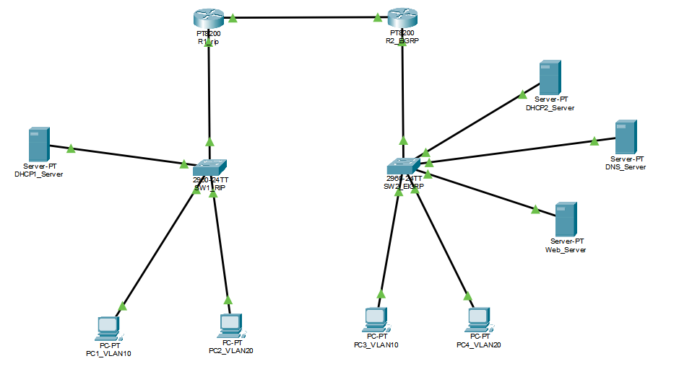
VLAN Plan
Side | VLAN | Network | Purpose
RIP Side | VLAN 10 | 192.168.10.0/24 | Users
RIP Side | VLAN 20 | 192.168.20.0/24 | Users
RIP Side | VLAN 30 | 192.168.30.0/24 | Servers
EIGRP Side | VLAN 10 | 172.16.10.0/24 | Users
EIGRP Side | VLAN 20 | 172.16.20.0/24 | Users
EIGRP Side | VLAN 30 | 172.16.30.0/24 | Servers
WAN Link | --- | 10.10.10.0/30 | Router to Router

IP ADDRESSING SCHEME
Device | Interface | IP Address | Subnet Mask | Gateway
R1_RIP | Gig0/0/0.10 | 192.168.10.1 | 255.255.255.0 | ---
R1_RIP | Gig0/0/0.20 | 192.168.20.1 | 255.255.255.0 | ---
R1_RIP | Gig0/0/0.30 | 192.168.30.1 | 255.255.255.0 | ---
R1_RIP | Gig0/0/1 | 10.10.10.1 | 255.255.255.252 | ---
R2_EIGRP | Gig0/0/0.10 | 172.16.10.1 | 255.255.255.0 | ---
R2_EIGRP | Gig0/0/0.20 | 172.16.20.1 | 255.255.255.0 | ---
R2_EIGRP | Gig0/0/0.30 | 172.16.30.1 | 255.255.255.0 | ---
R2_EIGRP | Gig0/0/1 | 10.10.10.2 | 255.255.255.252 | ---
DHCP1_Server | Fa0 | 192.168.30.10 | 255.255.255.0 | 192.168.30.1
DHCP2_Server | Fa0 | 172.16.30.10 | 255.255.255.0 | 172.16.30.1
DNS_Server | Fa0 | 172.16.30.20 | 255.255.255.0 | 172.16.30.1
Web_Server | Fa0 | 172.16.30.30 | 255.255.255.0 | 172.16.30.1
PC1_VLAN10 | Fa0 | DHCP | --- | 192.168.10.1
PC2_VLAN20 | Fa0 | DHCP | --- | 192.168.20.1
PC3_VLAN10 | Fa0 | DHCP | --- | 172.16.10.1
PC4_VLAN20 | Fa0 | DHCP | --- | 172.16.20.1

PROCEDURE
Step 1: Configure SW1_RIP
enable
configure terminal
hostname SW1_RIP

vlan 10
name VLAN10_USERS
exit

vlan 20
name VLAN20_USERS
exit

vlan 30
name VLAN30_SERVERS
exit

interface fastEthernet 0/1
description Trunk_to_R1
switchport mode trunk
exit

interface fastEthernet 0/2
description DHCP1_Server
switchport mode access
switchport access vlan 30
exit

interface fastEthernet 0/3
description PC1_VLAN10
switchport mode access
switchport access vlan 10
exit

interface fastEthernet 0/4
description PC2_VLAN20
switchport mode access
switchport access vlan 20
exit

interface vlan 10
ip address 192.168.10.2 255.255.255.0
no shutdown
exit

ip default-gateway 192.168.10.1
end
write memory

Step 2: Configure SW2_EIGRP
enable
configure terminal
hostname SW2_EIGRP

vlan 10
name VLAN10_USERS
exit

vlan 20
name VLAN20_USERS
exit

vlan 30
name VLAN30_SERVERS
exit

interface fastEthernet 0/1
description Trunk_to_R2
switchport mode trunk
exit

interface fastEthernet 0/2
description DHCP2_Server
switchport mode access
switchport access vlan 30
exit

interface fastEthernet 0/3
description DNS_Server
switchport mode access
switchport access vlan 30
exit

interface fastEthernet 0/4
description Web_Server
switchport mode access
switchport access vlan 30
exit

interface fastEthernet 0/5
description PC3_VLAN10
switchport mode access
switchport access vlan 10
exit

interface fastEthernet 0/6
description PC4_VLAN20
switchport mode access
switchport access vlan 20
exit

interface vlan 10
ip address 172.16.10.2 255.255.255.0
no shutdown
exit

ip default-gateway 172.16.10.1
end
write memory

Step 3: Configure R1_RIP
enable
configure terminal
hostname R1_RIP

interface GigabitEthernet0/0/0
no ip address
no shutdown
exit

interface GigabitEthernet0/0/0.10
encapsulation dot1Q 10
ip address 192.168.10.1 255.255.255.0
ip helper-address 192.168.30.10
exit

interface GigabitEthernet0/0/0.20
encapsulation dot1Q 20
ip address 192.168.20.1 255.255.255.0
ip helper-address 192.168.30.10
exit

interface GigabitEthernet0/0/0.30
encapsulation dot1Q 30
ip address 192.168.30.1 255.255.255.0
exit

interface GigabitEthernet0/0/1
ip address 10.10.10.1 255.255.255.252
no shutdown
exit

router rip
version 2
network 192.168.10.0
network 192.168.20.0
network 192.168.30.0
network 10.10.10.0
no auto-summary
redistribute eigrp 100 metric 5
exit

router eigrp 100
network 10.10.10.0 0.0.0.3
no auto-summary
redistribute rip metric 10000 100 255 1 1500
exit

end
write memory

Step 4: Configure R2_EIGRP
Note: Router uses GigabitEthernet0/0/0 (LAN) and GigabitEthernet0/0/1 (WAN).
enable
configure terminal
hostname R2_EIGRP

interface GigabitEthernet0/0/0
no ip address
no shutdown
exit

interface GigabitEthernet0/0/0.10
encapsulation dot1Q 10
ip address 172.16.10.1 255.255.255.0
ip helper-address 172.16.30.10
exit

interface GigabitEthernet0/0/0.20
encapsulation dot1Q 20
ip address 172.16.20.1 255.255.255.0
ip helper-address 172.16.30.10
exit

interface GigabitEthernet0/0/0.30
encapsulation dot1Q 30
ip address 172.16.30.1 255.255.255.0
exit

interface GigabitEthernet0/0/1
ip address 10.10.10.2 255.255.255.252
no shutdown
exit

router eigrp 100
network 172.16.10.0 0.0.0.255
network 172.16.20.0 0.0.0.255
network 172.16.30.0 0.0.0.255
network 10.10.10.0 0.0.0.3
no auto-summary
redistribute rip metric 10000 100 255 1 1500
exit

router rip
version 2
network 10.10.10.0
no auto-summary
redistribute eigrp 100 metric 5
exit

end
write memory

Step 5: Configure DHCP1_Server
Desktop > IP Configuration
Field | Value
IP Address | 192.168.30.10
Subnet Mask | 255.255.255.0
Default Gateway | 192.168.30.1
DNS Server | 172.16.30.20

Services > DHCP > ON — Delete default pool, then create:
Pool Name | Default Gateway | Start IP
VLAN10 | 192.168.10.1 | 192.168.10.50
VLAN20 | 192.168.20.1 | 192.168.20.50

Step 6: Configure DHCP2_Server
Desktop > IP Configuration
Field | Value
IP Address | 172.16.30.10
Subnet Mask | 255.255.255.0
Default Gateway | 172.16.30.1
DNS Server | 172.16.30.20

Services > DHCP > ON — Delete default pool, then create:
Pool Name | Default Gateway | Start IP
VLAN10 | 172.16.10.1 | 172.16.10.50
VLAN20 | 172.16.20.1 | 172.16.20.50

Step 7: Configure DNS_Server
Desktop > IP Configuration
Field | Value
IP Address | 172.16.30.20
Subnet Mask | 255.255.255.0
Default Gateway | 172.16.30.1
DNS Server | 172.16.30.20

Services > DNS > ON — Add records:
Name | Address
www.networklab.local | 172.16.30.30
networklab.local | 172.16.30.30

Step 8: Configure Web_Server
Desktop > IP Configuration
Field | Value
IP Address | 172.16.30.30
Subnet Mask | 255.255.255.0
Default Gateway | 172.16.30.1
DNS Server | 172.16.30.20

Services > HTTP > ON — Edit index.html:
<html>
<head><title>Network Lab</title></head>
<body>
<h1>Welcome to RIP and EIGRP Redistribution Lab done by utsav bhatta.</h1>
<p>DNS name: www.networklab.local</p>
</body>
</html>

Step 9: Configure PCs
Click each PC > Desktop > IP Configuration > select DHCP

PC | Expected IP After DHCP
PC1_VLAN10 | 192.168.10.50
PC2_VLAN20 | 192.168.20.50
PC3_VLAN10 | 172.16.10.50
PC4_VLAN20 | 172.16.20.50

VERIFICATION
On R1_RIP — type end first, then:
show ip route
show ip protocols
show ip eigrp neighbors

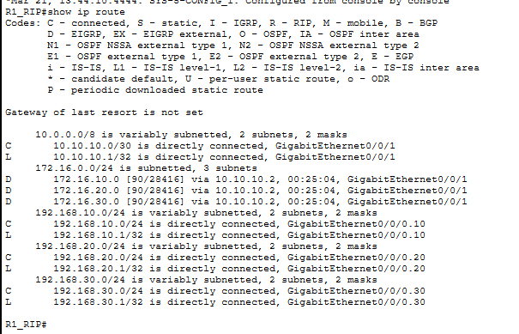

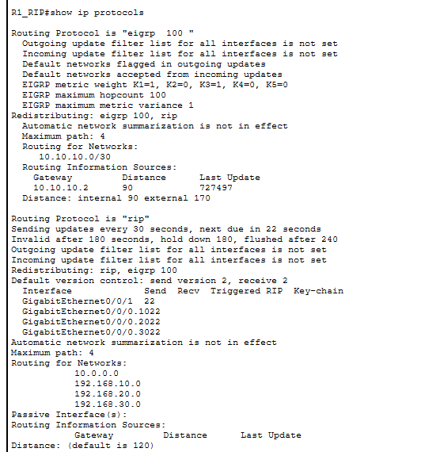

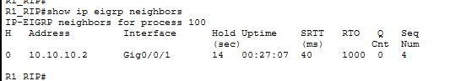

On R2_EIGRP — type end first, then:
show ip route
show ip protocols
show ip eigrp neighbors
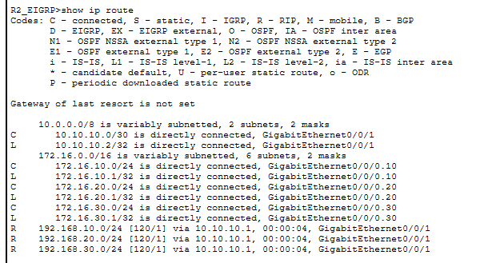

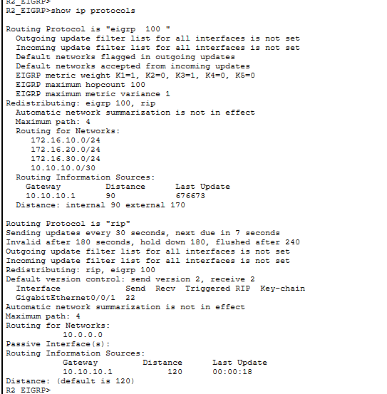
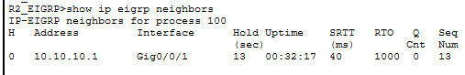

VERIFICATION ON SWITCHES:
On Switches
show vlan brief
show interfaces trunk

SW_RIP:
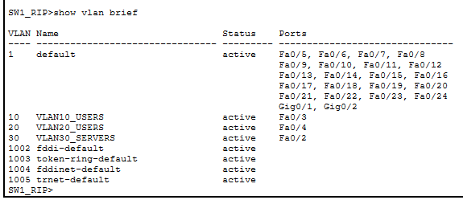
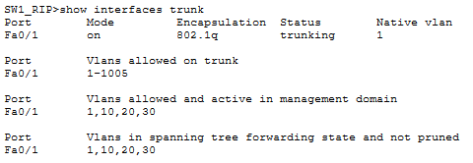
SW_EIGRP:
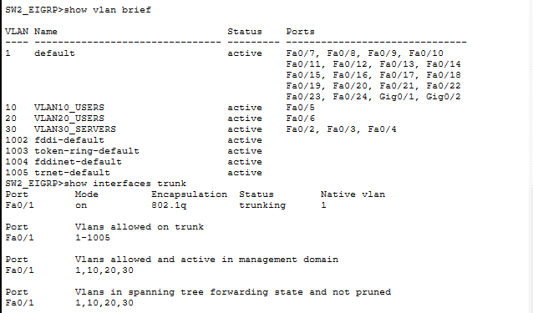

On PCs — Desktop > Command Prompt
ipconfig
ping 192.168.10.1
ping 172.16.30.30

PING TEST IN PC1_VLAN10:
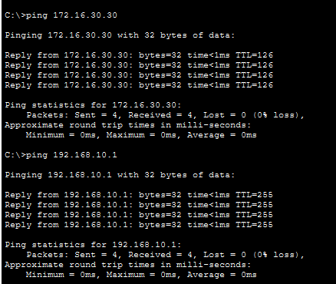

Browser test in PC3_VLAN10: Desktop > Web Browser

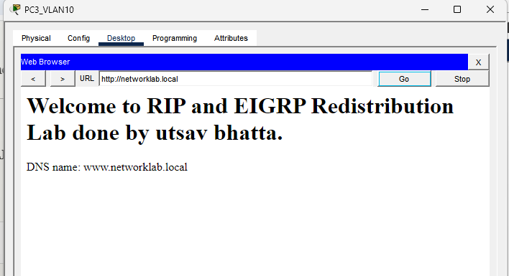
OBSERVATION
Routing Table on R1_RIP
Route Code | Network | Learned From
C | 192.168.10.0/24 | Directly connected
C | 192.168.20.0/24 | Directly connected
C | 192.168.30.0/24 | Directly connected
C | 10.10.10.0/30 | Directly connected
D EX | 172.16.10.0/24 | Redistributed from EIGRP
D EX | 172.16.20.0/24 | Redistributed from EIGRP
D EX | 172.16.30.0/24 | Redistributed from EIGRP

Routing Table on R2_EIGRP
Route Code | Network | Learned From
C | 172.16.10.0/24 | Directly connected
C | 172.16.20.0/24 | Directly connected
C | 172.16.30.0/24 | Directly connected
C | 10.10.10.0/30 | Directly connected
R | 192.168.10.0/24 | Redistributed from RIP
R | 192.168.20.0/24 | Redistributed from RIP
R | 192.168.30.0/24 | Redistributed from RIP

VLAN Assignment on Switches
Switch | Port | VLAN | Device
SW1_RIP | Fa0/1 | Trunk | R1_RIP
SW1_RIP | Fa0/2 | 30 | DHCP1_Server
SW1_RIP | Fa0/3 | 10 | PC1_VLAN10
SW1_RIP | Fa0/4 | 20 | PC2_VLAN20
SW2_EIGRP | Fa0/1 | Trunk | R2_EIGRP
SW2_EIGRP | Fa0/2 | 30 | DHCP2_Server
SW2_EIGRP | Fa0/3 | 30 | DNS_Server
SW2_EIGRP | Fa0/4 | 30 | Web_Server
SW2_EIGRP | Fa0/5 | 10 | PC3_VLAN10
SW2_EIGRP | Fa0/6 | 20 | PC4_VLAN20

RESULT
The project was completed successfully. RIP and EIGRP networks were connected through two-way redistribution. VLAN communication, DHCP, DNS, and web services worked properly, and devices from both sides communicated successfully.

DISCUSSION
This project showed how different routing protocols can work together using route redistribution. It also demonstrated the use of router-on-a-stick for VLANs and DHCP relay for automatic IP assignment across networks. Proper metrics and correct configuration were necessary for successful communication.

CONCLUSION
The project proved that RIP and EIGRP can be integrated into one working network. With proper VLAN setup, redistribution, and network services, full end-to-end connectivity was achieved.

