LAB 7: Switch Configuration, VLAN Setup and Inter-VLAN Routing

OBJECTIVES
- To create and configure multiple VLANs on a network switch.
- To configure trunk links and assign switch ports to the correct VLANs.
- To implement and test Inter-VLAN Routing using a router.

THEORY

1) Switch Configuration
A network switch operates at Layer 2 of the OSI model and connects multiple devices within a Local Area Network (LAN).
It forwards frames based on MAC addresses, enabling efficient communication.
Switch configuration includes setting up interfaces, enabling or disabling ports, and assigning ports to VLANs.
Proper configuration improves network performance, reduces collisions, and organizes traffic effectively.

2) Virtual Local Area Network (VLAN)
A VLAN is a logical method of dividing a physical network into smaller segments within a switch.
Devices can be grouped together even if they are connected to different switch ports.
This separation reduces broadcast traffic, improves security, and simplifies network management.
Each VLAN operates as an independent broadcast domain.

3) VLAN Configuration
VLAN configuration involves creating VLANs with unique VLAN IDs and names.
After creation, switch ports are configured in access mode and assigned to specific VLANs.
Devices connected to these ports communicate only within the same VLAN unless routing is enabled.
This configuration improves scalability and network traffic management.

4) Inter-VLAN Routing
Inter-VLAN routing allows communication between devices located in different VLANs.
Since VLANs are separate broadcast domains, a Layer 3 device such as a router is required.
In this approach, one router interface is divided into multiple sub-interfaces, each mapped to a VLAN.
This method is commonly called Router-on-a-Stick.

Network Topology :
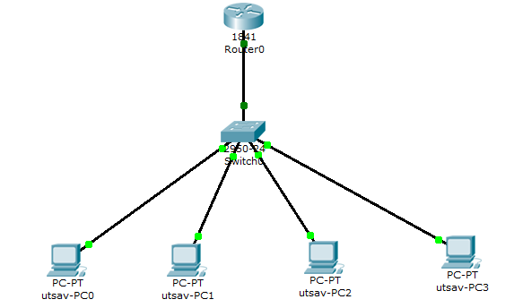

VLAN and IP Addressing Scheme

VLAN | Name | Network | Gateway
10 | Computer | 192.168.10.0/24 | 192.168.10.1
20 | Electronics | 192.168.20.0/24 | 192.168.20.1

Device | IPv4 address | Subnet Mask | Default Gateway
utsav_PC0 | 192.168.10.2 | 255.255.255.0 | 192.168.10.1
utsav_PC1 | 192.168.10.3 | 255.255.255.0 | 192.168.10.1
utsav_PC2 | 192.168.20.2 | 255.255.255.0 | 192.168.20.1
utsav_PC3 | 192.168.20.3 | 255.255.255.0 | 192.168.20.1

Verification:
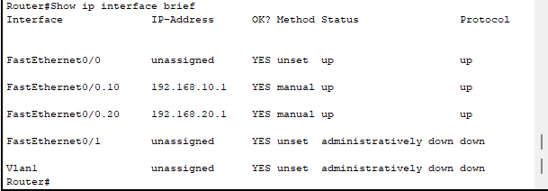
Commands :
Switch Configuration :
- Create VLANS
Switch(config)# vlan 10
Switch(config-vlan)# name Computer
# exit
Switch(config)# vlan 20
Switch(config-vlan)# name Electronics
# exit
- Assign port to VLANS Switch(config)# interface range fa0/1-2
# switchport mode access
# switchport access vlan 10
# exit
# interface range fa0/3-4
# switchport mode access
# switchport access vlan 20
# exit

- Configure Trunk Port (Switch-Router) Switch(config)# interface fa0/5
# switchport mode trunk
# exit
Verification Switch :
Switch# show vlan brief
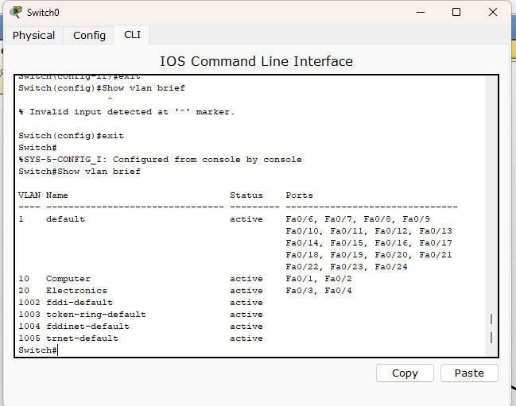

Router Configuration (Inter-VLAN Routing)

Router(config)# interface GigabitEthernet 0/0.10
#encapsulation dot1Q 10
#ip address 192.168.10.1 255.255.255.0
#exit

Router(config)# interface GigabitEthernet 0/0.20
#encapsulation dot1Q 20
#ip address 192.168.20.1 255.255.255.0
#exit

RESULT
The switch was successfully configured with multiple VLANs and the ports were assigned to the appropriate VLANs.A trunk link was established between the switch and router. Inter-VLAN routing was implemented using router sub-interfaces. Devices within the same VLAN communicated successfully, and communication between VLANs was achieved through the router.

DISCUSSION
VLAN implementation logically separated the network into multiple broadcast domains. This separation reduced unnecessary broadcast traffic and improved overall efficiency. Assigning switch ports to VLANs grouped devices according to their roles. The trunk link allowed multiple VLAN frames to pass between the switch and router using VLAN tagging. Inter-VLAN routing enabled controlled communication between VLANs while preserving segmentation.

CONCLUSION
The experiment successfully demonstrated VLAN creation, switch port assignment, trunk configuration, and inter-VLAN routing using a router.

