FEDERAL STATE AUTONOMOUS EDUCATIONAL
INSTITUTION FOR HIGHER EDUCATION
NATIONAL RESEARCH UNIVERSITY
HIGHER SCHOOL OF ECONOMICS
St. Petersburg School of Economics and Management
HSE – Saint Petersburg


BELTON ARMANDO JEREMIAS MANHICA

ESTIMATION OF THE RELATIONSHIP BETWEEN OIL PRICES AND EXCHANGE RATES.

Master’s thesis

In the field 38.04.01 Economics / 38.04.02 Management
Educational programme “DATA ANALYTICS FOR BUSINESS AND ECONOMICS”
Research format

Reviewer  Candidate of Economic Sciences Associate Professor, Department of Finance, HSE University - St. Petersburg  Marakueva M. A. | Supervisor  Ph.D. in Economics, Associate Professor, Professor in the Department of Economics  Skorobogatov A. S.

St. Petersburg, 2026

Abstract

The aim of this study is to analyze the asymmetry of impact of shocks of Brent oil price on the foreign exchange rate through four countries in different positions in international oil trade, namely, Canada as a developed oil-exporting country, the Eurozone as a developed oil-importing country, Brazil as an emerging oil-exporting country, and South Africa as an emerging mixed-economy country. Daily data for the variables of Brent oil and exchange rate against the United States dollar were collected between January 2015 and December 2025, during which there were the shocks of oil price decline in 2015-2016, demand shock during the COVID-19 pandemic period, and shock in oil production due to the Russia-Ukraine war. Results of augmented Dickey-Fuller and Phillips-Perron unit root tests show that all series are integrated of order one, hence satisfy conditions for bounded tests. The endogenous structural breaks detected by Bai-Perron and Chow tests occurred on January 30, 2020 (PHEIC declaration) and February 22, 2022 (invasion of Ukraine), justifying the sub-periods selected. The Ramsey RESET test and BDS nonlinearity tests reject linear regression models for all currency pairs; thus, the NARDL model proposed by Shin et al. (2014) with DXY and VIX exogenous variables is applied. The findings from full sample analysis indicate cointegration relationships along with asymmetry in all four pairings at the 1% significance level for EUR, BRL, and ZAR and are marginally asymmetric for CAD at the 10% level. However, sub-period results show much more variation across economic regimes. When the economy faces a COVID-19 demand shock, asymmetry is triggered for EUR and BRL, but symmetry is retained for CAD and ZAR pairings. In the case of the Russia-Ukraine supply shock, asymmetry intensifies to the 1% significance level for all three, CAD, EUR, and BRL. This constitutes the highest level of asymmetry seen for the period. Controlling for DXY and VIX becomes methodologically important because exclusion of controls leads to the underdetection of cointegration and asymmetry relationships. Shock events have introduced and increased the presence of asymmetry in the oil-exchange rate relationship in both cases, although the type of shock affects the nature of these asymmetries differently.

Keywords: Brent crude oil; exchange rates; NARDL; asymmetry; structural breaks; COVID-19; Russia-Ukraine War; oil exporters; emerging markets.
Table of Contents
Abstract 2
1. Introduction 4
2. Literature review 6
2.1 Theoretical Basis 6
2.2 Empirical Studies on Oil Prices and Exchange Rates 6
2.3 Crisis Periods and Structural Breaks 7
2.4 Asymmetric Models and NARDL Approach 9
2.5 Research Gap 9
3. Research Design and Methodology 11
3.1. Data and Sample Construction 11
3.2. Unit root Testing 13
3.3. Structural Break Analysis 14
3.4. Linearity Test 15
3.5. Lag Selection 16
3.6. Nonlinear Autoregressive Distributed Lag (NADL) 16
3.7. Asymmetric Dynamic Multipliers 20
3.8. Robustness Check: Markov Regime-Switching Model 22
4. Data and Results 23
4.1. Results of the Dickey-Fuller and Phillips-Perron tests 25
4.2. Structural Break Results 26
4.3. Linearity Test Results 27
4.4. Optimal lag length selection 28
4.5. NARDL Results 29
4.6. Dynamic Multiplier results 35
5. Conclusion and Discussion 40
6. Description of Used Generative Model 45
7. References 46
8. Appendix 49

Introduction

The relationship between crude oil prices and exchange rates represents one of the key relations in international business, with oil price fluctuations having broad ramifications for issues such as inflation, balance of payments, monetary policy, and foreign exchange rates. Notwithstanding the large amount of research dedicated to studying this connection, some crucial shortcomings continue to exist. The existing body of literature largely uses symmetric oil-price-change transmission mechanisms through linear models, and while the relationship is statistically uncertain in terms of its direction and magnitude, no differentiation exists regarding demand-induced and supply-induced events.
The time frame ranging from January 2015 to December 2025 offers a wealth of material to study, providing three unique economic situations: the oil price collapse in 2015-2016, the demand shock created by the COVID-19 pandemic, and the supply shock following the Russia-Ukraine war. The proposed thesis will seek to address the aforementioned gaps by examining the asymmetry in the effect of Brent crude oil price shocks on exchange rates in four countries: Canada (advanced economy-oil exporter), the Eurozone (advanced economy-oil importer), Brazil (emerging market-oil exporter), and South Africa (emerging mixed economy).
Linearity is tested using Ramsey RESET and BDS tests; Bai-Perron and Chow tests verify sub-period demarcations, while the NARDL model of Shin et al. (2014) is the chosen econometric model with DXY and VIX as instrumental variables. In addition, the estimation of a Markov Regime Switching model is performed as a robustness check.
The rest of the thesis is organized as follows. A literature review and identification of a research gap constitute section 2. Data and methodology make up section 3. The next section is devoted to empirical results. A conclusion follows thereafter, including results, contribution, and suggestions for future research. Practical implications and generative AI tools, respectively, are covered in sections 6 and 7.

The following research questions will form the basis for this study:
Q1. Is there a long-run cointegration relationship between oil prices and exchange rates across the observed currencies?
Q2. Do oil price shocks have different effects on exchange rates in developed and emerging economies?
Q3. Do demand-driven shocks (COVID-19) and supply-driven shocks (Russia-Ukraine war) have different transmission patterns in the oil-exchange rate relationship?

These research questions form the basis for developing the following hypotheses as below:
Research Question 1:
H₀₁: There is no long-run cointegrating relationship between oil prices and exchange rates across the observed currencies.
H₁₁: There is a long-run cointegrating relationship between oil prices and exchange rates across the observed currencies.
Research Question 2:
H₀₂: Oil shocks do not have differential effects on exchange rates in emerging and developed economies.
H₁₂: Oil shocks have different effects on exchange rates in emerging and developed economies.
Research Question 3:
H₀₃: Demand-driven shocks (COVID-19) and supply-driven shocks (Russia-Ukraine war) have no different transmission patterns in the oil-exchange rate relationship.
H₁₃: Demand-driven shocks (COVID-19) and supply-driven shocks (Russia-Ukraine war) have different transmission patterns in the oil-exchange rate relationship.

Literature review

2.1 Theoretical Basis
The study of the effects of oil prices on the exchange rate dates back to the oil shocks of the 1970s and the seminal works by Golub (1983) and Krugman (1983), which proved that changes in oil prices result in substantial exchange rate variations in oil-importing countries and oil-exporting countries via trade balances and income redistribution. When there are increases in oil prices, there are usually favorable terms of trade and favorable current accounts in oil-exporting countries, making their currencies appreciate, while in the case of oil-importing countries, the situation is reversed. On another note, a complementary mechanism is through the US dollar because oil prices worldwide are expressed in US dollars. Various scholars have argued that when the US dollar appreciates, there are higher costs of purchasing oil for other currencies, thus reducing global demand for oil and leading to decreases in oil prices (Bloomberg & Harris, 1995; Akram, 2009).

2.2 Empirical Studies on Oil Prices and Exchange Rates
Following on from the aforementioned theoretical background, there has been an increasing number of empirical studies on the oil-exchange rate nexus from a wide range of perspectives. One particularly notable study conducted on this subject matter is by Uddin et al. (2013). The authors made use of wavelet analysis to analyze the linkage between oil and exchange rate in Japan during the sample period of 1983 to 2013. Based on their research results, the authors found that the connection between the real exchange rate and the real oil price exhibits strong variation not only in time but also in frequencies, implying that the oil exchange rate linkage should be a dynamic process.
Turhan et al.'s (2014) comparative study of the relationship among the G20 countries through the use of the TV-VAR model also verified the dynamic and time-varying aspect of the relationship between the oil and exchange rates. They found out that oil price shocks have a greater impact on exchange rates than vice versa and that there is a varying degree of influence over different periods in time and different countries. Additionally, their study on the correlation between oil prices and exchange rates using the dynamic correlation model showed that there is a rising negative correlation between the two variables from the year 2000 to 2013. However, geopolitical events like the United States' invasion of Iraq in 2003 and the global financial crisis in 2008 caused structural changes in the relationship between the two. Interestingly, the growing connection between oil prices and exchange rates after the 2008 global financial crisis is more evident among the currencies of developed nations, which will be particularly applicable for the comparison made in this thesis.
Regarding shock propagation and direction, Malik and Umar (2019) analyzed the effect of oil price shocks on exchange rates using structural VAR models. The researchers found that demand and risk-induced oil shocks are associated with larger effects on exchange rates compared to supply oil shocks, with total connectedness between the two variables growing from about 10% before the global financial crisis to almost 40% after the crisis. Exchange rates of net oil-importing countries are shown to be net receivers of shocks, which indicates some differences in the reactions of importers and exporters to oil price changes, thus providing the rationale for cross-economy analysis implemented in the proposed thesis. In addition, Musa et al. (2019) found positive cointegration between the mentioned variables for the case of Nigeria using the ARDL approach. Namely, a 1% increase in oil prices would increase GDP growth by 5.13%.
Beckmann et al. (2020) conducted a comprehensive review of literature on the link between oil prices and exchange rates. The researchers considered theoretical and empirical studies from multiple angles using vector autoregression, non-linear causality, and Granger causality models. The result of this study was that oil prices had a greater influence on exchange rates compared to exchange rates influencing oil prices. In addition, the influence was more likely to be observed in the long run than in the short run. According to the survey by Beckmann et al. (2020), the quantitative influence of the relationship between oil prices and the US dollar is estimated such that a 10% increase in oil prices decreases the US dollar effective exchange rate by 0.28%, whereas a 1% reduction in the value of the US dollar increases oil prices by 0.73%.

2.3 Crisis Periods and Structural Breaks
The pandemic caused by the COVID-19 virus was characterized by unprecedented shocks to the global oil and exchange markets, making research on how it changed the oil-exchange rate interaction even more relevant. Specifically, Maku et al. (2021) used continuous wavelet transform and wavelet coherence techniques to assess the oil price and exchange rate behavior in Nigeria amid the pandemic. Bidirectional causality was found for the pre-COVID period but ceased to exist during the crisis. Such findings suggest that crisis periods may affect the nature of the oil exchange interaction by altering its structure instead of just intensifying the relationship.
Another study by Kushal Banik Chowdhury and Bhavesh Garg (2022) used an asymmetric GARCH model to analyze the volatility spillover effect between the oil exchange markets in four Asian countries (Japan, South Korea, China, and India). The results obtained indicated an uneven effect of the pandemic, which made the oil exchange predictability even stronger and resulted in several structural breaks in the data. Thus, the use of the mentioned technique to detect structural breaks during COVID-19 in four countries is highly relevant to this thesis because it allows identifying crisis periods independently.
The effects of oil price, exchange rates, and the pandemic on the BIST petrochemical market have been analyzed by Mutlu (2021), where the uniqueness of the study was achieved via a novel approach to analyzing a COVID-19 pandemic index, together with a vector autoregression (VAR) model and Johansen cointegration test. The results of the research revealed mutual causality between the price of oil and the pandemic index, thus showing how the crisis affects both sides of the relationship. In particular, including crisis-related control variables as a tool for isolation of bilateral dynamics is the methodological basis for choosing DXY and VIX in the current thesis.
Further expanding the analysis of the effects of the crisis on interrelations in oil and financial markets, Kumeka et al. (2022) studied the joint interrelationship of oil prices, stock prices, and exchange rates in selected oil-exporting economies during the pandemic. According to the results obtained, the authors noted the strong influence of the pandemic on the analyzed interrelationships, causing higher short-term volatility in all three markets. Although Kumeka et al. provided valuable insights into the effects of the crisis on oil-exporting economies, the selection of countries excludes some importers from emerging markets.
The aspect of geopolitics in relation to the oil price shock effect was studied by Khurshid (2024), where the author conducted a study to examine the impact of the Russia-Ukraine war spillovers on oil-exchange rate movements in SAARC countries through the GARCH and ARCH frameworks. It was found that geopolitical events place great strain on the exchange rates of oil-dependent economies, where the effect of oil price shocks results in depreciation of the currencies of net importing countries.

2.4 Asymmetric Models and NARDL Approach
The major weakness common among the studies considered above is the use of econometric models with the assumption of a linear relationship between changes in oil prices, whether positive or negative, and their impacts on the currency. Testing for linearity before model selection has not been a common practice in the field of oil price research. Wang et al. (2013) can be considered an exception, as they perform nonlinearity tests before implementing a VAR model in the case of oil price and stock return research. In this regard, they do not find any conclusive evidence of nonlinearity. On the other hand, the literature on the relationship between oil price and exchange rate does not include any linearity test, as researchers have employed linear models without proper justification.
As a direct reaction to some of the key limitations of linear time-series modeling, Shin et al. (2014) proposed the Nonlinear Autoregressive Distributed Lag (NARDL) framework, which has now emerged as the gold standard model for examining asymmetric relationships in macroeconomic and financial time series. The NARDL model is an extension of both the conventional ARDL and VECM models by separating the explanatory variable into positive and negative partial sums, thereby facilitating the estimation of positive and negative effects separately in both the long run and the short run on the dependent variable. Thus, the NARDL approach integrates aspects of nonlinearity, cointegration, and error-correction dynamics in one single framework, addressing all the major methodological shortcomings in previous approaches. Since its inception, the NARDL model has been extensively used in commodity-currency literature, and its use in the current research as the primary model framework is guided by the presence of nonlinearity between oil prices and exchange rates in crisis times.

2.5 Research Gap
Although the above literature review has immensely enhanced knowledge about the nature of the oil-exchange rate nexus, there still exist critical areas where further research can be carried out. First, the bulk of research conducted on the subject employs linear econometric techniques without testing whether the linearity assumption holds. The linearity assumption being false results in model misspecification since asymmetries cannot be captured within linear frameworks. This research will address this knowledge gap by carrying out a formal test of linearity using Ramsey RESET and BDS tests before model specification, hence ensuring that the researcher will base his choice between the ARDL and NARDL model on empirical findings.
Secondly, to date, no study in the reviewed literature has applied the NARDL model in investigating the oil-exchange rate nexus in both developed and emerging economies, particularly the developed oil exporter (Canada), the developed oil importer (Eurozone), the emerging oil exporter (Brazil), and the emerging mixed economy (South Africa).
Third, there is no existing study that integrates the two exogenous events, namely the COVID-19 pandemic and the Russia-Ukraine war, as structurally different shock periods within one study framework. The former is considered a demand shock, while the latter constitutes a supply shock, and their different implications on the oil-exchange rate nexus have yet to be examined for various countries. The proposed research fills this gap by conducting an extensive sub-period test that includes all three economic states over the entire 2015-2025 sample period.
Additionally, very few papers in the literature of oil exchange rates include any exogenous control variables to remove the influence of other macroeconomic factors from the analysis of the bilateral oil-exchange relationship. Although Mutlu (2021) used the severity of the pandemic, measured by the number of deaths due to COVID-19, as one more variable in their vector autoregression model, this methodology is inherently different from the use of exogenous control variables in that the severity of the pandemic does not represent any control for the dynamics of global currency or volatility in financial markets. This thesis aims to fill this gap by using DXY and VIX as exogenous control variab

Research Design and Methodology

Data and Sample Construction
In this paper, we will investigate the asymmetric response of four economies’ exchange rates to price movements in Brent crude oil between January 1, 2015, and December 31, 2025, with a total number of 2,865 daily observations, excluding weekends. Daily frequency data was chosen to reflect short-run changes in prices as well as obtain enough observations in order to conduct analysis within various sub-periods. The data on both exchange rates and oil prices was collected from Yahoo Finance by using the Python library yfinance.
The observed exchange rates include the Canadian dollar exchange rate (CAD/USD), the euro exchange rate (EUR/USD), the Brazilian real exchange rate (BRL/USD), and the South African rand exchange rate (ZAR/USD). In total, four economies were chosen to provide a cross-continental sample, including two developed economies (Canada and the Eurozone) and two emerging ones (Brazil and South Africa).
Canada is identified as a developed oil-exporting economy based on the fact that Canada is among the top ten largest crude oil producers in the world; the contribution of the energy industry to the export earnings and the GDP is relatively significant (EIA, 2024). The Eurozone is categorized as a developed oil-importing economy because of its high reliance on foreign energy supplies; the contribution of crude oil imports to the total imports in the region is rather significant (IEA, 2024). Brazil is regarded as an emerging oil-exporting country since it produces significant amounts of offshore pre-salt crude oil, making it an oil-exporting country despite importing refined products (EIA, 2024). South Africa is considered an emerging mixed economy as opposed to a pure oil importer. Despite importing up to 90 percent of its total crude-oil demand, South Africa remains a major exporter of other minerals such as platinum, gold, and coal (EIA, 2024). The choice of these economies is particularly significant because both groups include both oil-exporting and -importing economies. This allows us to study the impact of economic development and oil dependence on the exchange rate movement at the same time.
Given that Brent oil is denominated in US dollars per barrel, all the exchange rates are measured in terms of foreign currency per unit of US dollar (FX/USD). In this context, a positive exchange rate reaction to oil shocks reflects depreciation of the local currency, while a negative reaction implies appreciation. The model uses two exogenous variables for controlling the impact of macroeconomic variables and isolating the pure effect of oil prices on exchange rates. These are the US Dollar Index (DXY), reflecting the dynamics of global dollar strength, and the CBOE Volatility Index (VIX), representing financial market risk and uncertainty. DXY and VIX enter the regression symmetrically as exogenous control variables, while oil enters asymmetrically as a shock variable. Table 1 presents the list of variables employed in the research.

Table 1. Data description
Variable | Ticker symbol | Type | Role
Brent Crude Oil | BZ=F | Oil price (USD/barrel) | Endogenous – shock source
South African Rand | ZAR=X | Emerging mixed economy (ZAR/USD) | Endogenous – emerging mixed
Brazilian Real | BRL=X | Emerging oil exporter (BRL/USD) | Endogenous – emerging importer
Euro | EURUSD=X | Oil importer (EUR/USD) | Endogenous – developed importer
Canadian Dollar | CAD=X | Oil exporter (CAD/USD) | Endogenous – developed exporter
US Dollar Index | DX-Y.NYB | DXY | Exogenous control – I(0)
VIX | ^VIX | CBOE Volatility | Exogenous control – I(0)

The sample data set is divided into three separate time spans that coincide with three different economic periods following the structural break test performed in Section 3.3. The start dates, end dates, and observation numbers within each period are provided in Table 2 below.

Table 2. Shock periods start and end date
Period | Dates | Shock type | Observations
Pre-shock | 2015-01-01 - 2020-01-29 | Baseline | 1280
During COVID | 2020-01-30 - 2022-02-21 | Demand Shock | 530
Russia-Ukraine war | 2022-02-22 - 2025-12-31 | Supply Shock | 1000

Unit root Testing
Time series analysis requires that the integration order of all variables be determined before any model is estimated. The existence of unit roots implies significant considerations in the selection of the econometric specification and the accuracy of inferential statistics. A time series is considered to have unit roots if its statistical characteristics, including the mean and variance, vary throughout time, thus making it non-stationary. The inclusion of non-stationary variables in regression analysis poses specific difficulties because of the likelihood of encountering spurious regressions (Enders, 2014; Mills, 2019).
Two unit root tests will be used to confirm the existence of unit roots in this study: the Augmented Dickey-Fuller (ADF) test by Dickey and Fuller (1979) and the Phillips-Perron (PP) test by Phillips and Perron (1988). These tests will be employed on all series at the level and first difference forms.

    - Augmented Dickey-Fuller test
The ADF test is an extension of the initial Dickey-Fuller test (1979) by incorporating lags of the first difference to take care of the possible autocorrelation of the error term. The ADF test is carried out using the following regression equation:

$y_{t}=ϕy_{t-1}+μ_{t}$ , t = 1,2, …, T (1)
Where φ is the autoregressive parameter and $μ_{t}$ is the error term.

$y_{t}-y_{t-1}=(ϕ-1)y_{t-1}+μ_{t}$ (2)
Let δ = φ - 1, then
$∆_{y_{t}}=δy_{t-1}+μ_{t}$, (3)

If φ = 1, then δ = 0 (H₀), and if |φ| < 1, then δ < 0 (H₁). The Dickey-Fuller statistic is given by:
${ϕ^{^}}_{T}=\frac{\sum_{t=1}^{T}{}y_{t-1}y_{t}}{\sum_{t=1}^{T}{}{y^{2}}_{t}}$ (4)
A conventional way of testing the null hypothesis would be to do the Dickey-Fuller t-statistic, which is given by

$t_{ϕ}=\frac{{ϕ^{^}}_{T}-1}{{σ^{^}}_{{ϕ^{^}}_{T}}}$ (5)

When the calculated t-statistic is smaller than the critical value of the Dickey-Fuller distribution (tF < DF critical), the null hypothesis is rejected, and the series is said to be stationary. On the other hand, when the calculated t-statistic is larger than the Dickey-Fuller distribution (tF > DF critical), the null hypothesis is not rejected, implying that the data series is non-stationary.

    - Phillips-Perron test
Although the ADF test is robust to serial correlation due to the inclusion of lags, the PP test uses a non-parametric method to adjust for serial correlation and heteroskedasticity in the residuals. This test provides an alternative that can be applied even when the nature of residual dependence is not specified (Phillips and Perron, 1988). In contrast to the ADF test, the PP test adjusts the ADF t-statistic by incorporating the Newey-West estimate of the long-run variance and does not require the specification of additional lagged values. The hypotheses are similar to those used in the ADF test, and rejecting the null hypothesis confirms the stationarity of the series. The tests are performed both with and without including a deterministic trend in the model to accommodate various data generation processes.

Structural Break Analysis
One of the difficulties encountered in examining the impact of the oil exchange rates from 2015 to 2025 is that the period covered several major economic events, each of which could have radically transformed the relationship between the two variables. The periods within the decade under study were not artificially segmented by an arbitrary date based on external classification schemes, such as WHO's designation of a pandemic or the declaration of the Russia-Ukraine conflict. Instead, the thesis applied both endogenous and exogenous tests for structural breaks to derive the break dates from the data.

3.3.1 Bai-Perron Test
The Bai-Perron (1998, 2003) test is a multiple structural break test procedure where the break dates are endogenously chosen from the time series data without having to specify any break date a priori. It is a stepwise test method where the optimal number of breaks is estimated based on the minimum sum of squared errors under a constraint that specifies the minimum length of each segment. This approach is especially suitable for detecting the effects of COVID-19 and the Russia-Ukraine war on the oil price and exchange rates.

3.3.2 Chow Test
In addition to the Bai-Perron test, the exogenous break test offered by Chow (1960) checks if there is a structural break at a pre-specified breakpoint. As opposed to the Bai-Perron test, which determines the breakpoint endogenously from the data, the Chow test works to ascertain if breaks at the breakpoints determined by economic motivation—for example, the declaration of the WHO coronavirus pandemic on January 30, 2020, and the invasion of Ukraine by Russia on February 24, 2022—are statistically valid.

Linearity Test
One of the important methodological contributions in this thesis is the test for the validity of the linearity assumption before conducting any further analysis, unlike other research papers which assume linearity. There are two different tests used to validate the linearity assumption.

3.4.1 Ramsey RESET Test
Ramsey’s (1969) Regression Equation Specification Error Test (RESET) is designed to assess the correctness of the linear regression equation by determining whether the combination of the estimated values explains any information about the dependent variable. When the introduction of square and cubic values of the estimated values improves the goodness-of-fit of the equation, then this indicates that the linear assumption is incorrect.

3.4.2 BDS Test
The BDS test was introduced by Brock et al. (1996) as a test that checks whether the errors of the model being tested are independent and identically distributed. When the errors are not independent, it means there is a non-linear relationship in the data not captured by the linear model. The null hypothesis of independence and identical distribution of the errors is tested against the alternative of non-linearity.
Based on the outcomes of the two tests, a decision on whether to use a linear or non-linear model will be made. In case both the tests fail to reject the null hypotheses, then a linear ARDL model will be estimated. In case the tests indicate the existence of non-linearity, then a NARDL model is used. Since it has been proven there is non-linearity in the oil market and currency market in crisis periods, non-linearity is expected in all currency pairs.

Lag Selection
Lag order determination is done using the Bayesian Information Criterion (BIC) by balancing between model fit and penalty on parameter estimation in addition to the number of parameters in the model. BIC is more desirable than the Akaike Information Criterion (AIC) for such cases because of BIC’s stronger penalty for the complexity of the model, which becomes even more applicable in light of the short-period samples used in the study.

Nonlinear Autoregressive Distributed Lag (NADL)
The NARDL model was developed by Shin et al. (2014) and is used in this thesis as the main method of analysis. The NARDL model builds on the basic ARDL approach of Pesaran and Shin (1998) and Pesaran et al. (2001) in that it allows for the partial sum decomposition of the regressor variable, allowing the long-run and short-run impacts of both positive and negative shocks to the dependent variable to be estimated separately. This chapter outlines the theory behind the NARDL model as used in this thesis.

3.6.1 Asymmetric Long-Run Model
The asymmetric long-run regression model is presented by Shin et al. (2014) as the basis of the NARDL approach:
$y_{t}={ β}^{+}+x_{t}^{+}+{ β}^{-}+x_{t}^{-}+ u_{t}$ (6)
$Δx_{t} =v_{t}$ (7)
Where:
$y_{t}$ and $x_{t}$ are scalar I(1) variables;
$x_{t}$ is decomposed into $x_{t}$=$x_{0}$+$x_{t}^{+}$+$x_{t}^{-}$ , where $x_{t}^{+}$ and $x_{t}^{- }$ are partial sum processes of positive and negative changes in $x_{t}$:
$x_{t}^{+}= \sum_{j=1}^{t}{}{Δx}_{j}^{-}=\sum_{j=1}^{t}{}max(Δx_{j} ,0)$ , $x_{t}^{-}= \sum_{j=1}^{t}{}{Δx}_{j}^{-}=\sum_{j=1}^{t}{}min(Δx_{j} ,0)$ (8)
Equation (8) is a straightforward illustration of how asymmetric cointegration can be modeled using particle sum decomposition, which was used by Schorderet (2001), and he went on to extend it to a stationary linear combination of partial sums, as illustrated below:

$z_{t}={ β_{0}^{+}y_{t}^{+}}^{}+ β_{0}^{-}y_{t}^{-}+ β_{1}^{+}x_{t}^{+}+β_{1}^{-}x_{t}^{-}$ (9)

If $z_{t}$ is stationary, then $y_{t}$and $x_{t}$ are asymmetrically cointegrated, and the symmetry condition holds when $β_{0}^{+}=β_{0}^{-} and$ $β_{1}^{+}=β_{1}^{-}$ (If $β_{0}^{+}≠β_{0}^{-} and$ $β_{1}^{+}≠β_{1}^{-}$, then the relationship is asymmetric). Without considering hidden cointegration, Shin et al. (2014) impose the following restriction: $β_{0}^{+}=β_{0}^{-}= β_{0}$ such that $β_{}^{+}=-{β_{1}^{+}/}_{}β_{0}$ and $β_{}^{-}=-{β_{1}^{-}/}_{}β_{0}$.
3.6.2 NARDL Error Correction Representation
Because NARDL is derived from the ARDL model, a clearer perspective can be attained when looking at the nonlinear ARDL (p, q):

$y_{t}^{}= \sum_{j=1}^{p}{}ϕ_{j}y_{t-1}+\sum_{j=0}^{q}{}{ (θ_{j}^{+'}y_{t-j}^{+}}^{}+ θ_{j}^{-'}y_{t-j}^{-}$)+$ε_{t}$ (10)
Where:
$x_{t}$ is a k+1 vector of multiple regressors $x_{t}$=$x_{0}$+$x_{t}^{+}$+$x_{t}^{-}$
$ϕ_{j}$ is the autoregressive parameter
$θ_{j}^{+'}$and $θ_{j}^{+'}$ are the asymmetric distributed-lag parameters
$ε_{t}$ is the stochastic process with zero mean and constant variance

This can be expressed in error correction form as shown below:

${Δy}_{t}^{}= { {ρy}_{t-1}^{}+θ_{j}^{+'}x_{t-1}^{+}}^{}+ θ_{j}^{-'}x_{t-1}^{-}+\sum_{j=1}^{p-1}{}γ_{j}{Δy}_{t-j}+\sum_{j=0}^{q-1}{}{ (φ_{j}^{+'}Δx_{t-j}^{+}}^{}+ φ_{j}^{-'}{Δx}_{t-j}^{-}$)+$ε_{t}$ (11)
${Δy}_{t}^{}= { {ρξ}_{t-1}^{}}^{}+\sum_{j=1}^{p-1}{}γ_{j}y_{t-j}+\sum_{j=0}^{q-1}{}{ (φ_{j}^{+'}Δx_{t-j}^{+}}^{}+ φ_{j}^{-'}{Δx}_{t-j}^{-}$)+$ε_{t}$ (12)
Where:
- $ρ= \sum_{j=1}^{p}{}ϕ_{j}-1$
- $γ_{j}= -\sum_{i=j+1}^{p}{}ϕ_{i}$ for $j= 1, ..., p-1$
- $θ^{+}=\sum_{j=0}^{q}{}θ_{j}^{+}$, $θ^{-}=\sum_{j=0}^{q}{}θ_{j}^{-}$
- $φ_{0}^{+}=θ_{0}^{+}, φ_{j}^{+}= -\sum_{i=j+1}^{q}{}θ_{j}^{+}$ for $j= 1, ..., q-1$,
- $φ_{0}^{-}=θ_{0}^{-}$, $φ_{j}^{-}= -\sum_{i=j+1}^{q}{}θ_{j}^{-}$ for $j= 1, ..., q-1$,
- $ξ_{t}=y_{t}-{ β_{}^{+'}x_{t}^{+}}^{}- β_{}^{-'}x_{t}^{-}$ is the nonlinear error correction term, where $β_{}^{+}= {-θ}_{}^{+}/ρ$ and $β_{}^{-}= {-θ}_{}^{-}/ρ$ are the associated long-run parameters.
Applying the NARDL equation in our study, we have the following:
${ΔFX}_{t}^{}= { {ρFX}_{t-1}^{}+θ_{j}^{+'}{Oil}_{t-1}^{+}}^{}+ θ_{j}^{-'}{Oil}_{t-1}^{-}+\sum_{j=1}^{p-1}{}γ_{j}Δ{FX}_{t-j}+\sum_{j=0}^{q-1}{}{ (φ_{j}^{+'}Δ{Oil}_{t-j}^{+}}^{}+ φ_{j}^{-'}{ΔOil}_{t-j}^{-})+ε_{t}$ (13)
where FXt is the bilateral exchange rate and Oilt is the Brent crude oil price in logarithmic form. The variables DXY and VIX are included symmetrically as exogenous control variables, following the partially asymmetric NARDL model formulation proposed by Shin et al. (2014).
To resolve the problem of non-zero contemporaneous correlations between the residuals and the regressors, Shin et al. (2021) proposed a reduced data-generating process as follows:

${Δx}_{t}^{}=\sum_{j=1}^{q-1}{}Λ_{j}{Δx}_{t-j}^{}+v_{t}$ , (14)
Where $v_{t}\sim iid (0, {{Σv)}_{}}_{}$with Σv being KxK positive definite covariance matrix. Further, focusing on the conditional model, Shin et al. (2021) express $ε_{t}$ the condition in terms of $v_{t}$ as:
$ε_{t}= ω'v_{t}+e_{t}= ω'({Δx}_{t}^{}=\sum_{j=1}^{q-1}{}Λ_{j}{Δx}_{t-j}^{}+v_{t} )+e_{t}$ (15)
Where $ε_{t}$ and $v_{t}$ , by construction, are uncorrelated. Finally, Shin et al. (2021) substituted (14) into (12) to get a conditional nonlinear correction error model (CEM) as follows:

${Δy}_{t}^{}= { {ρξ}_{t-1}^{}}^{}+\sum_{j=1}^{p-1}{}γ_{j}y_{t-j}+\sum_{j=0}^{q-1}{}{ (π_{j}^{+'}Δx_{t-j}^{+}}^{}+ π_{j}^{-'}{Δx}_{t-j}^{-}$)+$e_{t}$ (16)
Where:
- $π_{0}^{+}= θ_{0}^{+}+ω$, $π_{0}^{-}= θ_{0}^{-}+ω$
- $π_{j}^{+}= φ_{j}^{+}-ω'Λ_{j}$ and $π_{j}^{-}= φ_{j}^{-}-ω'Λ_{j}$

Shin et al. (2021) state that this equation will perfectly correct for the endogeneity problem regardless of the stationarity of the explanatory variables, and an appropriate choice of the lag length will ensure that there is no serial correlation among the residuals of the model. Shin et al. (2021) add that this particular model is composed of all necessary adjustments along with the ARDL dynamics that capture both long- and short-term relationships. However, this particular thesis will be using equation (11) for its framework.
In our analysis, the NARDL model will produce the following outputs:
- Bound test
- Long-run asymmetric coefficients ($L^{+}$ and $L^{-}$)
- Dynamic multipliers showing asymmetric adjustments
- Asymmetry test

3.6.3 Bounds Test for Asymmetric Cointegration
The presence of long-run cointegration between the oil price and exchange rate series is determined based on the approach by Shin et al. (2014). The null hypothesis (H₀: ρ = θ⁺ = θ⁻ = 0) of no cointegration is tested against the alternative of cointegration using the F-test statistic. The bounds test for asymmetric cointegration is invariant to the order of integration of the regressors (I(0) or I(1)); hence, it is very appropriate for analyzing mixed-order processes. Critical values of the bounds test are obtained from Shin et al. (2014), with cointegration established if the test statistic is above the upper bound critical value.

3.6.4 Testing for Asymmetry – Wald Test
Once the NARDL model is estimated, a Wald test is used to determine whether the long-run asymmetry assumption is satisfied. This entails testing the hypothesis of long-run symmetry (H₀: L⁺ = L⁻) against that of long-run asymmetry (H₁: L⁺ ≠ L⁻). If the null hypothesis is rejected at standard levels of significance, then the results indicate that positive oil price shocks have a significantly different effect from negative oil price shocks on the exchange rate in the long run.

Asymmetric Dynamic Multipliers
Impulse response functions from linear vector autoregression (VAR) models or vector error correction (VECM) models cannot be used in analyzing asymmetrical adjustment paths because they rely on symmetric reactions to negative and positive disturbances. In this thesis, the method of asymmetric dynamic multipliers proposed by Shin et al. (2014) will be used in analyzing short-run adjustments in the exchange rate following positive and negative oil shocks.

Following Shin et al. (2014), the dynamic multipliers related to changes in $x_{t}^{+}$ and $x_{t}^{-}$ on $y_{t}^{}$ are given by:

${ϕ(L)y}_{t}^{}= θ^{+}(L)x_{t}^{+}+ θ^{-}(L)x_{t}^{-}+e_{t}^{}$ (17)
Where:
- $ϕ(L)= 1- \sum_{i=1}^{p-1}{}ϕ_{i}L^{i}$ , $θ^{+}(L)= \sum_{i=0}^{q}{}θ_{i}^{+}L^{i}$, and $θ^{-}(L)= \sum_{i=0}^{q}{}θ_{i}^{-}L^{i}$
- $ϕ_{1}= ρ+1+φ_{1}$; $ϕ_{i}=φ_{i}-φ_{i-1}, i =2, ..., p-1$; $φ_{p}=-φ_{p-1};$

By inverting $ϕ(L)$ in (16), we have the following equation:

$y_{t}^{}= λ^{+}(L)x_{t}^{+}+ λ^{-}(L)x_{t-i}^{-}+{ϕ(L)}^{-1}e_{t}^{},$ (18)
Where $λ^{+}(L){(=\sum_{j=0}^{∞}{}λ_{j}^{+}) ={ϕ(L)}^{-1}θ^{+}(L) }_{}^{}$and $λ^{-}(L){(=\sum_{j=0}^{∞}{}λ_{j}^{-}) ={ϕ(L)}^{-1}θ^{-}(L) }_{}^{}$
The cumulative dynamic multiplier responses of $x_{t}^{+}$ and $x_{t}^{-}$ to $y_{t}^{}$ are checked as follows:
$m_{h}^{+}=\sum_{j=0}^{h}{}\frac{{∂y}_{t+j}}{{∂x}_{t}^{+}}=\sum_{j=0}^{h}{}λ_{j}^{+}$, $m_{h}^{-}=\sum_{j=0}^{h}{}\frac{{∂y}_{t+j}}{{∂x}_{t}^{-}}=\sum_{j=0}^{h}{}λ_{j}^{-}, h = 0,1,2...$ (18)
Where in our analysis, $m_{h}^{+}$ will capture the cumulative effects of positive oil prices on exchange rates h periods ahead and $m_{h}^{-}$ will capture the effects of negative shocks.
As $h → ∞, m_{h}^{+}→β^{+}$, $m_{h}^{+}→β^{+}$, and $m_{h}^{-}→β^{-}$, where $β^{+}={-θ}^{+}/ρ$ and $β^{-}={-θ}^{-}/ρ$ are the symmetric long-run coefficients. Shin et al. (2014) state that there is little reason to believe that $m_{h}^{+}$ and $m_{h}^{-}$should transmit symmetric dynamic adjustments, and we might still observe asymmetric adjustments.
Three types of asymmetry are recognized in the framework of Shin et al. (2014): reaction asymmetry, which implies that L⁺ ≠ L⁻; impact asymmetry, when the coefficients of the contemporaneous first difference ∆x_t⁺ ≠ ∆x_t⁻; and asymmetry of adjustments, which refers to dissimilarity in adjustment paths from the initial equilibrium state to the new equilibrium after experiencing shocks of different signs. These three types of asymmetries are easily detected through the dynamic multipliers graphed in the results section below.
DXY and VIX are exogenous controls symmetrically included into the model, while oil prices enter asymmetrically; thus, the partial asymmetry NARDL model proposed by Shin et al. (2014) will be used in the analysis.

Robustness Check: Markov Regime-Switching Model
In order to verify the results found in the NARDL sub-period analysis using a different approach, a Markov Regime-Switching (MRS) model is estimated for each currency pair. Markov Regime-Switching models were initially introduced by Hamilton (1989). Such models assume that the parameters of the time series can switch between a finite number of discrete states called regimes. In this way, the use of such an approach to verify the results obtained by means of NARDL analysis becomes justified because there is no need for the researcher to set dates when regimes changed. Rather, the change is identified endogenously from the data set. Hence, such an approach will help to understand whether the relationship between oil and exchange rate indeed varies across regimes.
Two regimes are defined following the conventional procedure used in the literature (Hamilton, 1989), whereby there is a tranquil state with low volatility and stability (Regime 1) and an unstable state characterized by high volatility and turbulent state (Regime 2). This specification of the states is in line with the first goal of verifying the NARDL result that there is a fundamental difference in the dynamics of oil exchange rates during stable and crisis market periods while ensuring simplicity of the model estimation. Parameter estimation in the Markov-switching model is done using maximum likelihood estimation, with smoothed probabilities of regimes obtained using the Kim (1994) filter.

Data and Results

The results of this research study were obtained by analyzing the data and using various econometric methodologies. The results also provide valuable insight into the overall aim of this paper, which is to estimate the relationship between oil prices and exchange rates. To achieve that, the following steps were taken: First, both oil prices and exchange rates are tested for stationarity using the Augmented Dickey-Fuller and Phillips-Perron tests. Afterward, we employ the structural break analysis to better define our COVID-19 and Russia-Ukraine conflict periods. Then we conduct the linearity test. If the result of the linearity test shows that there is a nonlinear relationship between oil prices and exchange rates, we will use the nonlinear autoregressive distributed lag model (NARDL). Otherwise, we will use ARDL. Figure 1 shows the dynamic movements for our variables of interest (oil prices and exchange rates—FX) and the changes during the Covid-19 pandemic (highlighted area in the graphs).
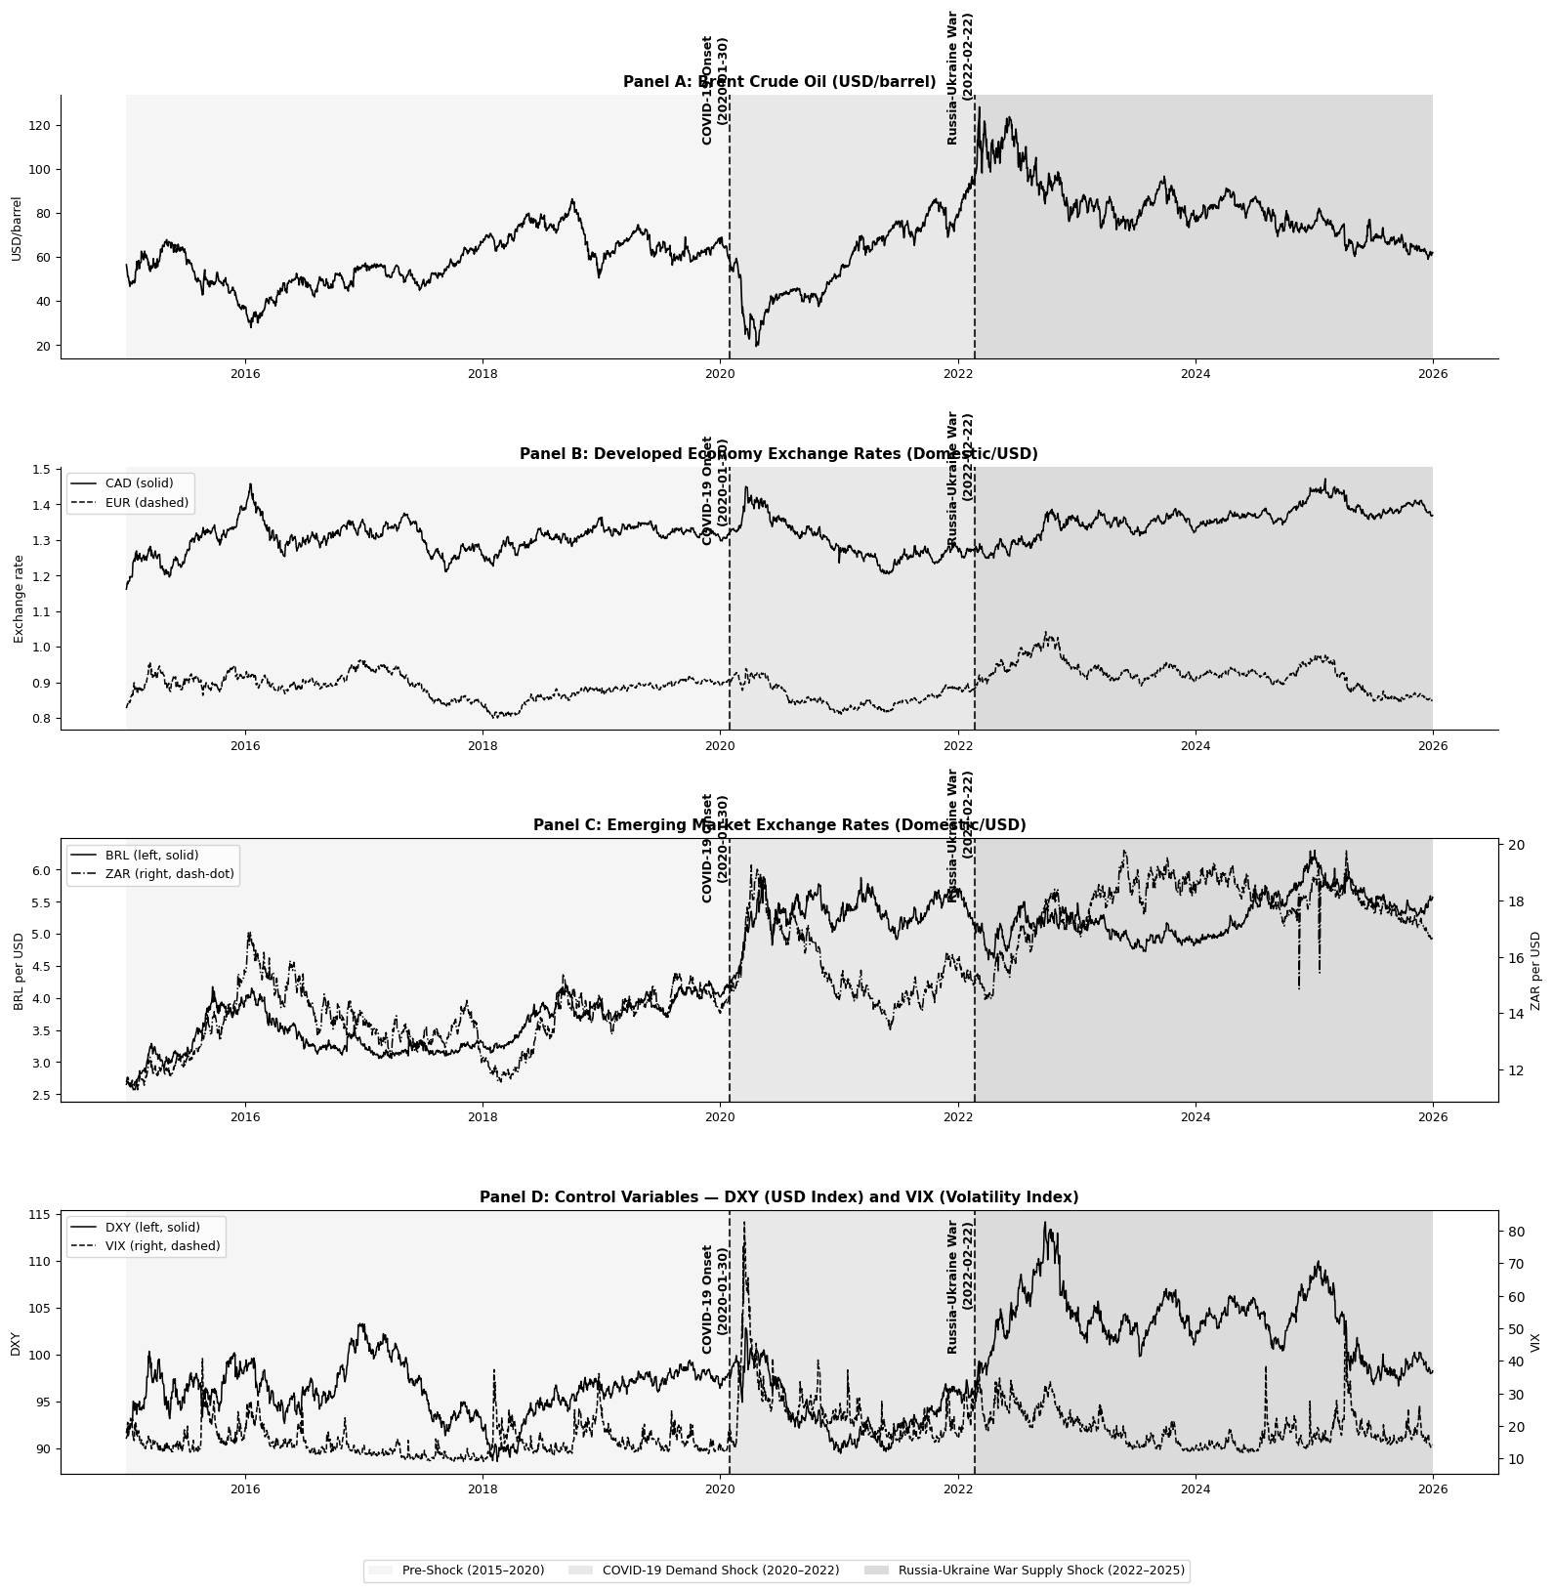
Figure 1. Log-Level Time Series—Oil Price, Exchange Rates, and Controls (2015-2025)

Results of the Dickey-Fuller and Phillips-Perron tests
The Augmented Dickey-Fuller (ADF) and Phillips-Perron (PP) tests were used to assess whether the time series data of oil prices (BRENT) and the exchange rates (CAD, EUR, BRL, and ZAR) are stationary or not. However, at the log levels, some of the variables are stationary. The results of the ADF and the PP test (Table 3) showed that both oil prices and exchange rates have a unit root. Since the data were non-stationary, after applying appropriate differentiation, the variables became stationary and formed the basis for further analysis. We can conclude that our variables are integrated of the first order I~ (1).

Table 3. Results of the Augmented Dickey-Fuller (ADF) and Phillips-Perron tests, at Log Level
Series | ADF Level | ADF diff | PP Level | PP diff | Order
Brent | -2.495 | -59.718*** | -2.581 | -59.833*** | I(1)
CAD | -2.842 | -11.196*** | -2.76 | -52.953*** | I(1)
EUR | -4.086*** | -39.207*** | -4.163*** | -54.054*** | I(0)
BRL | -2.714 | -52.882*** | -2.62 | -53.018*** | I(1)
ZAR | -2.893 | -53.879*** | -2.726 | -54.222*** | I(1)
DXY | -3.13 * | -29.509*** | -3.407* | -73.078*** | I(1)
VIX | -5.182*** | -22.33*** | -6.183*** | -60.431*** | I(0)
Note. ADF indicates Augmented Dickey Fuller test while PP denotes Phillips Perron test. All tests include both a constant and trend. Test statistics are provided at levels and first differences. * p<0.10, ** p<0.05, *** p<0.01 indicate rejection of the null hypothesis of unit root. I(0): stationary at levels, I(1): stationary at first difference. Critical values are from MacKinnon (1996). Both EUR and VIX are considered to be I(0) since the null hypothesis of unit root at level is rejected by both ADF and PP tests. For DXY, mixed results are observed and hence treated as I(1). This combination of I(0) and I(1) data is valid under the bounds testing procedure of NARDL of Pesaran et al. (2001), where regressors of mixed orders of integration can be employed as long as none is I(2).

Structural Break Results
Table 5 shows the results of the chow F-statistics and p-values for parameter stability at the COVID-19 and Russia-Ukraine war start dates. The null hypothesis of the parameter consistency is rejected at the 1% significance level. Table 4 shows the results of the Bai-Perron break detection.

Table 4. Bai-Perron break detection
Pair | Breaks at | Economic Context
Brent-CAD | 2020-02-27 and 2021-06-03 | Covid market panic and vaccine recovery
Brent-EUR | 2020-11-05 and 2022-09-22 | Vaccine announcement; EUR 20-year low
Brent-BRL | 2020-07-09 and 2022-04-07 | Mid-COVID stabilization and RU-war spillover
Brent-ZAR | 2017-06-29 and 2022-03-03 | SA Political crisis; RU-war commodity shock

In this Bai-Perron test, we choose to detect two structural break periods that include the COVID-19 shocks and the Russia-Ukraine war. Results show that breaks were identified in 2020 and 2022 for most pairs, with two exceptions: Brent-CAD does not capture a structural break that aligns with the Russia-Ukraine war, and Brent-ZAR identifies a break in 2017 instead of 2020. Despite these minor inconsistencies observed in the results, the overall trend of breaks in close proximity to 2020 and 2022 demonstrates evidence of structural breaks within these crisis periods.
The World Health Organization (WHO) declared COVID-19 a public health emergency of international concern (PHEIC) on January 30th, 2020${}^{[35]}$, and according to EBESCO${}^{[10]}$, Russia officially invaded Ukraine on February 22nd, 2022. Based on the evidence from the Bai-Perron test and the official announcements, we chose the COVID-19 period as 2020-01-30 - 2022-02-21 and the Russia-Ukraine war period as 2022-02-22 - 2025-12-31. To further confirm these statistical significances of these periods, we performed the Chow test.

Table 5. Chow Structural Break Test
Pair | Break Date | F-statistic | P-value | Sig.
Brent-CAD | COVID-19 Onset | 102.90 | 0.000 | ***
Brent-CAD | Russia-Ukraine war | 666.19 | 0.000 | ***
Brent-EUR | COVID-19 Onset | 111.91 | 0.000 | ***
Brent-EUR | Russia-Ukraine war | 444.17 | 0.000 | ***
Brent-BRL | COVID-19 Onset | 35.63 | 0.000 | ***
Brent-BRL | Russia-Ukraine war | 1546.70 | 0.000 | ***
Brent-ZAR | COVID-19 Onset | 27.21 | 0.000 | ***
Brent-ZAR | Russia-Ukraine war | 524.25 | 0.000 | ***
Note. The Chow test is used to test for the null hypothesis of parameter stability (H₀: no structural break) versus the hypothesis of a structural break at the stated date(s). The break dates used are 30 January 2020 (WHO declaration of the coronavirus disease outbreak as a public health emergency of international concern) and 22 February 2022 (Russian military operation against Ukraine). The F-test is calculated using the residual sum of squares of an OLS regression of exchange rates and Brent crude oil prices. *** p < 0.01 indicates rejection of the null hypothesis of parameter stability at the 1 percent level of significance. This shows that there is a statistical structural change in the oil-exchange rate relationship at the stated dates for all the currencies considered.

Linearity Test Results
Table 6 shows the results of the linearity test. here we see of both the RESET F-statistics and BDS z-statistics (at embedding dimension m=2). Results show that the linearity assumption is rejected at a 5% significance for all pairs. The combination of the results from these two tests provides strong empirical evidence for the adoption of the NARDL model for our analysis. None of the four pairs satisfy the condition for the adoption of linear models such as the VAR and VECM.

Table 6. Linearity Tests — Ramsey RESET and BDS (Full Sample)
Pair | Reset F | Reset p | REST Sig. | BDS z (m=2) | BDS p | BDS sif. | Relationship type | Model choice
Brent-CAD | 57.41 | 0.000 | *** | 106.08 | 0.000 | *** | Nonlinear | NARDL
Brent-EUR | 142.16 | 0.000 | *** | 153.63 | 0.000 | *** | Nonlinear | NARDL
Brent-BRL | 3.38 | 0.034 | ** | 161.63 | 0.000 | *** | Nonlinear | NARDL
Brent-ZAR | 3.72 | 0.025 | ** | 179.06 | 0.000 | *** | Nonlinear | NARDL
Ramsey RESET test for testing the null hypothesis of no misspecification (correct linear specification). H₀: No misspecification (correct linear specification). BDS Test of Brock et al. (1996) for testing the null hypothesis of i.i.d. errors. H₀: Errors are i.i.d. This means that both hypotheses of linearity and i.i.d. of residuals will be rejected, indicating that the linear model is not appropriate for explaining the relationship between oil and exchange rates. ** p < 0.05, *** p < 0.01. It can thus be seen that both linearity and independence have been rejected in all four currency cases; hence, the need to adopt a non-linear approach in analyzing the relationship, for instance, the NARDL model of Shin et al. (2014).

4.4. Optimal lag length selection
We chose the optimal lag length for the NARDL following the Bayesian information criterion (BIC) test. BIC was chosen over other criteria such as the Akaike Information Criterion (AIC), considering that the former places a higher penalty on the complexity of the model and hence reduces the chances of overfitting. This criterion was also considered more appropriate, especially since the subsamples used in the analysis were relatively smaller.

Table 7. Lag Length Selection — BIC Criterion
Pair | P = 1 | P = 2 | P = 3 | P = 4 | P = 5 | Selected
Brent-CAD | -13085.67 | -13072.42 | -13053.91 | -13034.12 | -13016.26 | 1
Brent-EUR | -23107.54 | -23097.32 | -23076.63 | -23055.75 | -23031.77 | 1
Brent-BRL | -23032.67 | -23009.22 | -22985.04 | -22962.37 | -22939.04 | 1
Brent-ZAR | -22354.67 | -22343.81 | -22319.65 | -22297.93 | -22273.98 | 1
Note. BIC = Bayesian Information Criterion. The table shows the values of the BIC criterion for the NARDL model for different lags (p = 1, p = 2, p = 3, p = 4, p = 5) for each currency pair. The optimal number of lags is determined by the minimum value of the BIC criterion; the more negative the value, the better the model fit, adjusted for the number of parameters. The optimal lag length of p = 1 is chosen for all four currency pairs, which suggests that a simple one-lag specification is the most appropriate for all four models.

The results clearly show that using lag order 1 yields the minimum BIC criterion for all four pairs. This consistency strengthens the sub-period estimation, as the lag order used is the same. Choosing lag order 1 is in line with the daily data since all the dynamics involved in price adjustment are completed within one trading period. Hence, all the NARDL estimations were carried out using p = q = 1.

4.5. NARDL Results

4.5.1. Full sample analysis
Results from NARDL with a full-sample data set without and with DXY and VIX as exogenous controls are shown in Tables 8a and 8b, respectively, covering the period from January 2015 to December 2025.

Table 8a. NARDL Estimation — Full Sample Without Controls (DXY, VIX)
Period | Pair | Economy | L+ | L− | Bounds F | LR Rel. | Asym Wald p | Asymm. | N
Full Sample | Brent-CAD | Dev. (Exporter) | -0.0064 | -0.0085 | 5.845 | CI (5%) | 0.2178 | No | 2862
Full Sample | Brent-EUR | Dev. (Importer) | 0.1771 | 0.1811 | 5.457 | CI (5%) | 0.1266 | No | 2862
Full Sample | Brent-BRL | Emerg. (Exporter) | -0.1455 | -0.1731 | 2.283 | No CI | 0.0489 | ** | 2862
Full Sample | Brent-ZAR | Emerg. (Mixed) | 0.0091 | -0.0069 | 6.146 | CI (5%) | 0.0204 | ** | 2862

Table 8b. NARDL Estimation — Full Sample With Controls (DXY, VIX)
Period | Pair | Economy | L+ | L− | Bounds F | LR Rel. | Asym Wald p | Asymm. | N
Full Sample | Brent-CAD | Dev. (Exporter) | -0.0661 | -0.0661 | 19.879 | CI (5%) | 0.0999 | * | 2862
Full Sample | Brent-EUR | Dev. (Importer) | 0.0137 | 0.0135 | 136.503 | CI (5%) | 0.0000 | *** | 2862
Full Sample | Brent-BRL | Emerg. (Exporter) | -0.0478 | -0.0708 | 8.770 | CI (5%) | 0.0009 | *** | 2862
Full Sample | Brent-ZAR | Emerg. (Mixed) | -0.0979 | -0.1097 | 13.764 | CI (5%) | 0.0043 | *** | 2862
Note: L⁺ and L⁻ represent the long-run exchange rate elasticities to positive and negative oil price shocks, respectively, obtained from the relationships L⁺ = -θ⁺/ρ and L⁻ = -θ⁻/ρ. The Bounds F-test examines the null hypothesis of no cointegration (H₀: ρ = θ⁺ = θ⁻ = 0) versus the critical bounds from Pesaran et al. (2001) when k=2: I(0) = 3.79, I(1) = 4.85. CI = cointegrated; No CI = no cointegration found. The Wald test tests the null hypothesis of long-run symmetry (H₀: L⁺ = L⁻); a rejection of this null implies asymmetry to positive and negative shocks. All regressions have DXY and VIX included as exogenous variables. Significance levels: * p < 0.10, ** p < 0.05, *** p < 0.01.

The presence of controls affects the results drastically. In their absence, the presence of cointegration in BRL and asymmetry in EUR and CAD do not exist. The presence of controls, however, establishes the existence of cointegration in all four pairs, while asymmetry is triggered in all of them except ZAR, which loses significance, whereas CAD becomes marginally significant. F-statistics for bounds tests become quite strong for all four currency pairs, especially for EUR (5.372 to 136.503) and CAD (5.459 to 19.879).
For all four pairs across the full sample period, there is a long-run relationship established after accounting for controls. Four currency pairs show some level of asymmetry: EUR (p = 0.0000***), BRL (p = 0.0009***), ZAR (p = 0.0043***), and CAD with marginal asymmetry (p = 0.0999*). All elasticities are low in value due to noise associated with daily frequency. Negative CAD elasticities (L⁺ = -0.065, L⁻ = -0.066) imply that the channel of USD price is dominant; given that oil prices rise, the US dollar gets stronger in the global market, and CAD gets weaker. The positive EUR elasticities (L⁺ = 0.010; L⁻ = 0.014) are in line with the negative correlation between oil and the dollar, where higher oil prices lead to a depreciation of the US currency and appreciation of the euro, while negative shocks result in stronger appreciation, thus indicating the high degree of asymmetry. The elasticities for both BRL and ZAR are negative for both shock types, but with negative shocks producing more pronounced negative effects than positive shocks, i.e., L⁻ = -0.071 and L⁺ = -0.048 for BRL and L⁻ = -0.110 and L⁺ = -0.097 for ZAR.

4.5.2. Sub-Period Analysis
While the full sample analysis gives an overarching picture, it is likely to hide key structural changes that have occurred as a result of the impact of the COVID crisis and ongoing international tensions between Russia and Ukraine on the global economy. This is explained by findings from Chowdhury and Garg (2022) and Maku et al. (2021) that crises often result in a fundamental change in the relationship between oil and exchange rates instead of simply strengthening the already existing one. The sub-period analysis shows the NARDL model again for three structurally different periods outlined in Section 4.2. Tables 9a and 9b contain results from the pre-shock, COVID-19, and recovery periods (demand-driven shocks) and the Russia-Ukraine war period (supply-driven shocks).

Table 9a. NARDL Estimation — Subperiod Without Controls (DXY and VIX)
Period | Pair | Economy | L+ | L− | Bounds F | LR Rel. | Asym Wald p | Asymm. | N
Pre-Shock | Brent-CAD | Dev. (Exporter) | -0.0361 | 0.0376 | 5.280 | CI (5%) | 0.6801 | No | 1321
Pre-Shock | Brent-EUR | Dev. (Importer) | 0.0305 | 0.0378 | 3.147 | No CI | 0.3009 | No | 1321
Pre-Shock | Brent-BRL | Emerg. (Exporter) | 0.3440 | 0.3441 | 2.178 | No CI | 0.9968 | No | 1321
Pre-Shock | Brent-ZAR | Emerg. (Mixed) | -0.1192 | -0.1344 | 3.511 | No CI | 0.1471 | No | 1321
COVID & Recovery | Brent-CAD | Dev. (Exporter) | -0.0351 | -0.0263 | 2.992 | No CI | 0.1845 | No | 535
COVID & Recovery | Brent-EUR | Dev. (Importer) | 0.0932 | 0.1036 | 2.507 | No CI | 0.5746 | No | 535
COVID & Recovery | Brent-BRL | Emerg. (Exporter) | -0.1585 | -0.2083 | 5.350 | CI (5%) | 0.0104 | ** | 535
COVID & Recovery | Brent-ZAR | Emerg. (Mixed) | -0.0214 | -0.0023 | 3.386 | No CI | 0.4483 | No | 535
Russia-Ukraine War | Brent-CAD | Dev. (Exporter) | 0.0661 | 0.0537 | 2.847 | No CI | 0.0773 | * | 1000
Russia-Ukraine War | Brent-EUR | Dev. (Importer) | 0.2387 | 0.2437 | 4.003 | Inconclusive | 0.6016 | No | 1000
Russia-Ukraine War | Brent-BRL | Emerg. (Exporter) | 0.3522 | 0.3114 | 2.653 | No CI | 0.0518 | * | 1000
Russia-Ukraine War | Brent-ZAR | Emerg. (Mixed) | -0.1033 | -0.0955 | 3.463 | No CI | 0.7244 | No | 1000

Table 9b. NARDL Estimation — Subperiod With Controls (DXY and VIX)
Period | Pair | Economy | L+ | L− | Bounds F | LR Rel. | Asym Wald p | Asymm | N
Pre-Shock | Brent-CAD | Dev. (Exporter) | -0.0325 | -0.0359 | 13.764 | CI (5%) | 0.0211 | ** | 1321
Pre-Shock | Brent-EUR | Dev. (Importer) | -0.0027 | 0.0008 | 97.906 | CI (5%) | 0.0000 | *** | 1321
Pre-Shock | Brent-BRL | Emerg. (Exporter) | 0.2266 | 0.2151 | 4.794 | Inconclusive | 0.4219 | No | 1321
Pre-Shock | Brent-ZAR | Emerg. (Mixed) | -0.0725 | -0.0865 | 5.674 | CI (5%) | 0.0551 | * | 1321
COVID & Recovery | Brent-CAD | Dev. (Exporter) | -0.0515 | -0.0488 | 17.100 | CI (5%) | 0.1072 | No | 535
COVID & Recovery | Brent-EUR | Dev. (Importer) | 0.0098 | 0.0108 | 69.050 | CI (5%) | 0.0172 | ** | 535
COVID & Recovery | Brent-BRL | Emerg. (Exporter) | -0.1011 | -0.1489 | 4.682 | Inconclusive | 0.0194 | ** | 535
COVID & Recovery | Brent-ZAR | Emerg. (Mixed) | -0.0751 | -0.0844 | 7.494 | CI (5%) | 0.5078 | No | 535
Russia-Ukraine War | Brent-CAD | Dev. (Exporter) | -0.0501 | -0.0623 | 16.521 | CI (5%) | 0.0000 | *** | 1000
Russia-Ukraine War | Brent-EUR | Dev. (Importer) | -0.0017 | 0.0042 | 105.616 | CI (5%) | 0.0000 | *** | 1000
Russia-Ukraine War | Brent-BRL | Emerg. (Exporter) | 0.1186 | 0.0788 | 7.791 | CI (5%) | 0.0001 | *** | 1000
Russia-Ukraine War | Brent-ZAR | Emerg. (Mixed) | -0.2151 | -0.2144 | 3.005 | No CI | 0.9679 | No | 1000

Pre-shock period
In the pre-shock period, the evidence for cointegration exists for CAD, EUR, and ZAR with controls but not for BRL (F = 4.794, between bounds). Asymmetry exists for both CAD and EUR with statistical significance (p = 0.0211** for CAD and p = 0.0000*** for EUR) but is absent for BRL (p = 0.4219), whereas only marginal asymmetry exists for ZAR (p = 0.0551*). This is especially true for EUR in the pre-shock period, where the positive shocks induce a marginal weakening in value (L⁺ = -0.003) and negative shocks produce marginal strengthening (L⁻ = +0.0008), as shown by the two lines crossing zero in opposite directions and confirming the presence of asymmetry. In the case of BRL, positive elasticities were found in the pre-shock period (L⁺ = 0.226; L⁻ = 0.215), reflecting its role as a net oil exporter. ZAR was found to have negative elasticity values for both shock types in the pre-shock period, with negative shocks causing larger weakening (L⁻ = -0.087) than positive (L⁺ = -0.073).

COVID-19 & recovery period
The results during the COVID period are considerably influenced by the controls. In their absence, there are no asymmetric relationships between any pairs of developed economies. This period suggests universal cointegration between CAD and ZAR but not BRL with controls (F = 4.682). Importantly, CAD loses asymmetry from before the shock period (p = 0.1072), whereas the EUR gains strong asymmetry (p = 0.0172**) and the BRL retains asymmetry (p = 0.0194**). There is no asymmetry in ZAR (p = 0.5078). In CAD, both the shocks have an equivalent weakening effect on the currency with nearly equal magnitudes (L⁺ = -0.052 and L⁻ = -0.049), as expected from the simultaneous decrease in the oil price and CAD amid the pandemic lockouts when demand destruction led to a joint decline in both variables. On the other hand, EUR experiences small positive elasticity (L⁺ = 0.010, L⁻ = 0.011) for both types of shocks, with negative shocks resulting in slightly stronger effects due to asymmetry. BRL is the most asymmetric response among the currencies under analysis (p = 0.0194), implying that negative shocks lead to a significantly higher degree of depreciation (-0.149) compared to positive shocks (-0.101). The BRL currency is an outlier when considering that Brazil is a leading oil exporter; however, it appears that the effects of global risk aversion and capital flight from emerging markets had more influence on the currency price during the pandemic than the effects of the balance of payments.

Russia-Ukraine war period
The effect of control variables is highly significant during the Russia-Ukraine period. This is most evident in the period of the Russia-Ukraine war when CAD, EUR, and BRL reject symmetry at the 1% level while ZAR fails to exhibit any significant asymmetry (p = 0.9514) and lacks any cointegration relation. In the case of CAD, negative oil shocks have more weakening effects on the currency (-0.062) compared to positive shocks (-0.050), which aligns with the explanation of supply shocks when a decrease in the price of crude oil indicates low geopolitical risks that paradoxically weaken the Canadian currency due to lower expectations of export revenues. In the case of EUR, the near-zero elasticity of positive shocks (-0.0017) stands in stark contrast with the slight positive elasticity of negative shocks (+0.0042), capturing the highly sensitive nature of the EUR and oil relationship with respect to the shock direction amid the energy crisis period, where an increase in oil prices results in zero impact, while its decline provides only marginal improvement. The relationship between the US dollar and BRL is entirely opposite of what we find for COVID; positive shocks enhance the value of the currency more than negative ones (L⁺ = 0.119 compared to L⁻ = 0.079). This means that the oil-exporter identity of Brazil starts to become more important when the supply shock comes about. ZAR shows itself with the largest elasticities for all periods without showing any proof of cointegration or asymmetry at all (-0.215 for L⁺ and L⁻ = -0.214).

Cross-Period Comparison and Key Patterns
A number of broad patterns can be identified from the sub-period analysis. Firstly, the inclusion of DXY and VIX as controls is no mere formality; on the contrary, these controls play an integral role by changing results across all periods. Without them, the phenomenon of cointegration is rarely observable in Russia-Ukraine, and symmetry remains unobserved in developed economy pairs.
Secondly, the presence of cointegration is established in the vast majority of pairs across all periods, with the only exceptions being BRL (pre-shock and COVID) and ZAR (Russia-Ukraine: No CI). In terms of cointegration strength, EUR remains consistently the strongest (F between 69 and 137), while ZAR alone continues to lose its cointegration over time in the supply shock period.
Third, asymmetry is a function of crisis events and shock type. Asymmetry before shock events emerges in developed pairs, CAD and EUR, setting the moderate benchmark levels. During COVID, CAD ceases asymmetry while EUR and BRL engage in asymmetry. During the Russia-Ukraine crisis, asymmetry becomes significant at the 1% level for CAD, EUR, and BRL alike. Most importantly, asymmetry of BRL reverses its direction completely during two crisis events, having negative shocks during the COVID crisis but positive during the Russia-Ukraine period, thus confirming H₁₃.
Fourth, a clear divide between developed and emerging economies exists for all time periods; in the former, there is a consistent cointegration and asymmetry, while the latter exhibits diverse and structure-breaking tendencies, thus confirming H₁₂. These trends can be observed further from the analysis of dynamic multipliers in Section 4.6.
An independent Markov Regime-Switching robustness test provided in Appendix 5 validates the existence of stable and crisis regimes for all pairs, with volatility in crisis regimes being twice or thrice that of stable regimes, supporting the NARDL result of crisis regimes fundamentally changing oil-exchange rates’ dynamic relationship.

4.6. Dynamic Multiplier results
Figure 2 presents the cumulative reaction of exchange rates to positive and negative oil price shocks for 30 days after the shock within the whole sample period. In the case of CAD, there is an instant strong negative reaction from the exchange rates to both kinds of shocks, positive shocks reaching approximately -0.080 and negative shocks reaching approximately -0.065 on day 1, after which both reactions stabilize, the difference between them getting smaller during the 30-day period, reflecting the marginal sample symmetry (p = 0.0999). In the case of EUR, both types of shocks yield positive exchange rate movements over the whole horizon, positive shocks falling from about +0.019 to +0.010 and negative shocks rising from about +0.004 to +0.013 until crossing each other at day 8, which is a graphical representation of the sample asymmetry (p = 0.0000) that matches the results of long-run elasticity L⁻ > L⁺. In case of BRL, both types of shocks result in strong initial negative reactions on the first day, with the subsequent stabilization of the response for positive shocks at about -0.065 and negative ones at about -0.065. Moreover, the two graphs become nearly identical starting from the second day despite the presence of statistical asymmetry (p = 0.0009), which indicates that asymmetry affects the initial impact on the exchange rate and not the adjustment process. In case of ZAR, the most apparent difference lies in the response to the two types of shocks. In particular, positive shocks exhibit a gradual decline to the level of about -0.060 on the thirtieth day, whereas negative shocks decline sharply to about -0.090 on the first day, increase to -0.080, and again decline sharply to -0.095. Thus, there is clearly apparent asymmetry in terms of the initial impact on the exchange rate (p = 0.0043).
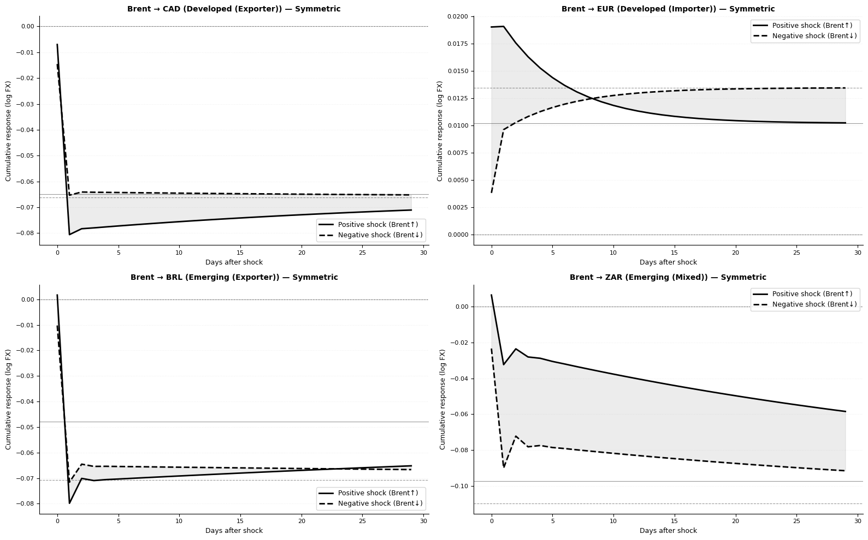
Figure 2. Asymmetric dynamic multipliers—NARDL Full Sample (Controls: DXY, VIX)

Figure 3 illustrates the sub-periods' dynamic multipliers by currency, illustrating how asymmetric adjustment takes shape within economic regimes.
For the CAD currency, both periods display both shocks responding negatively on the first day after the occurrence of the shock. In the pre-shock sub-period, positive shocks respond more negatively (~ -0.12) compared to negative shocks (~ -0.09), and both adjust gradually; the difference confirms that there is significant asymmetry in the pre-shock period. In the COVID period, both responses converge right away to similar paths (~ -0.050) and are almost identical along the whole horizon of 25 days, visually showing that there was no asymmetry in this period with demand shocks. The Russia-Ukraine period shows that both shocks respond almost identically, with negative shocks responding somewhat more largely, confirming strong asymmetry from the Wald test (p = 0.0000).
In the case of EUR, adjustment curves exhibit the most vivid dynamics among all analyzed in the sample. In pre-shock dynamics, there is an instant divergence of the solid line and dashed line curves in opposite directions, where the former falls sharply from almost zero down to about -0.006, while the latter grows sharply up to about +0.008; subsequently, both curves slowly converge back to zero coming from opposite directions by day 25, forming the most distinct sign divergence in the sample. In COVID dynamics, the solid line starts at about +0.028 and goes down, whereas the dashed one starts at about +0.005 and goes up, both converging to about +0.010 by day 10 and maintaining stability afterwards, with both curves being positive. In Russia-Ukraine dynamics, the solid line curve starts at around +0.050 and falls rapidly through zero below zero (~ -0.002), while the dashed one starts at around -0.020 and recovers towards slightly positive values (~ +0.005).
For the BRL case, pre-shock analysis reveals that both response lines start from negative positions on day 1 but recover slowly till days 22-25 when both become positive, the only currency with a positive response to shock for the exchange rate on both lines. During the COVID period, there is a negative effect of both types of shocks, with the divergence increasing gradually; the positive shocks stabilize at approximately -0.085, whereas the negative ones reach approximately -0.120 on day 25, which confirms graphically a highly significant asymmetry in this context (p-value = 0.0194). Finally, for the Russia-Ukraine conflict, both types of shocks have the lowest values on day 1 and then recover, with the positive shock lines recovering better and reaching positive values (approximately +0.030) on day 20, while the negative shock lines recover slower and reach zero on day 25, which reflects Brazil being an oil-exporting country.
In the case of ZAR, the pre-shock period is characterized by the biggest difference between the two lines in the sample: solid starts on a positive value (+0.025) and quickly declines to around -0.070, whereas the dashed line immediately declines to -0.140 and partially recovers to -0.125, which means that there exists an extremely big and stable difference between the two for the entire duration of 25 days. In the COVID shock, the solid line starts at a positive value of approximately +0.020 and declines, while the dashed one starts at a negative value (-0.080) and declines further to -0.085; the solid and dashed lines decline over time, but the difference between them reduces over time without any crossing despite having different start values. During the Russia-Ukraine war, negative shocks result in both lines showing a similar pattern of declining over time, with the solid line starting at a value of approximately -0.020 and declining to -0.125, while the dashed one starts at a value of approximately -0.010 and declines to -0.120, consistent with the lack of asymmetry and the highest negative elasticity values in the sample.

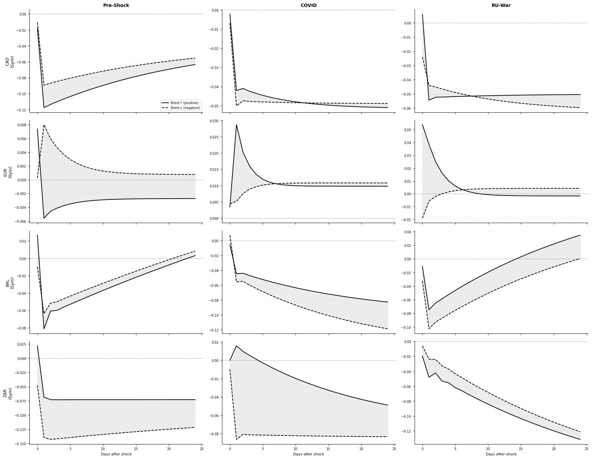
Figure 3. NARDL Dynamic multipliers by currency and period (positive vs. negative oil shocks)

Figure 4 shows the NARDL long-run elasticities (L⁺ and L⁻) for different sub-periods and provides a visual comparison of how the transmission effects of positive and negative oil price shocks are captured by exchange rates for developed and emerging countries.
What stands out from Figure 4 is BRL's sharp reversal in structure between the different sub-periods shown. For example, in the pre-shock period, BRL has the highest positive elasticity of all pairs in the sample (L⁺ ≈ +0.226, L⁻ ≈ +0.215), owing to the fact that Brazil was a net oil exporter and that market stability made the trade balance channel more dominant than any other. During the COVID period, BRL shows a sharp reversal in its elasticities to negative values (L⁺ ≈ -0.101, L⁻ ≈ -0.149), possibly because the risk channel was the dominating factor due to the demand shock to the economy. In Russia-Ukraine, there is another reversal of BRL to positive values (L⁺ ≈ +0.119 and L⁻ ≈ +0.079).
In all three crisis periods, the ZAR records increasing negative elasticities to oil price changes, culminating in an approximate elasticity of -0.215 for both demand and supply shock types, the largest magnitude of negative elasticity recorded across all economies. This increasing trend in elasticities is due to South Africa's mixed economy structure, whereby any form of either demand or supply shocks to oil prices eventually results in ZAR depreciation through commodity demand weakness channels.
The CAD maintains low levels of negative elasticity throughout all periods, which is consistent with the prevalence of the USD pricing channel at daily frequency, irrespective of whether the shock was demand-driven or supply-induced or which period it occurred in. The EUR registers negligible elasticities throughout all periods except for the COVID period, where positive elasticity values arise, consistent with the inverse oil-dollar relationship through the USD pricing channel.

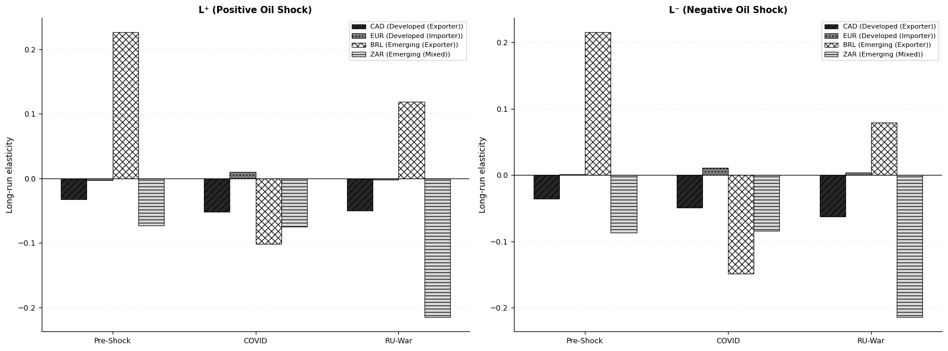
Figure 4. NARDL Long-run elasticity by period — emerging vs. developed economies

Conclusion and Discussion

The present study analyzed the asymmetric effect of shocks in the prices of Brent crude oil on the movements of exchange rates within four economies that occupy different positions in the international oil market, namely, Canada as an oil-exporting developed country; the Eurozone as an oil-importing developed economy; Brazil as an oil-exporting emerging country; and South Africa as a mixed-emerging economy, from January 2015 to December 2025. Utilizing the NARDL methodology proposed by Shin et al. (2014), together with formal tests of linearity, endogenously detected structural breaks, and exogenous variables for global dollar movements and financial market volatility, the present thesis sought to answer three research questions regarding the presence of long-run cointegration relations, the differences between the impacts of oil price shocks in developed and emerging countries, and the distinctive impact paths of demand- and supply-driven shocks. A Markov Regime-Switching model is estimated as a robustness test in Appendix 5.

5.1. Summary of Findings
Research Question 1: Is there a long-run cointegration relationship between oil prices and exchange rates across the observed currencies?
The bounds test results reveal that H₀₁ is partially rejected since long-run cointegration does not always exist; instead, it depends on the level of economic development and crisis period. Over the entire period analyzed, cointegration can be accepted in all four cases with controls, where EUR presents the best equilibrium among all (F = 136.503). Subperiod analysis shows that cointegration exists in the case of CAD and ZAR in the case of COVID, while BRL’s long-run cointegration is inconclusive; for the Russia and Ukraine period, cointegration can be observed for CAD, EUR, and BRL, while ZAR fails to have long-run cointegration. This pattern partially agrees with the findings of Beckmann et al. (2020) since according to their study, the relationship between oil price and exchange rate can be observed in the long run.
Sub-periods further indicate that controls are methodologically necessary; without DXY and VIX, there would be no cointegration and asymmetry would not be observed for the majority of the pairs in the Russia-Ukraine period because the global dollar effect and volatility significantly distort the oil-exchange rate relationship. This finding differs from those made by Maku et al. (2021) according to which the relationship of bidirectional causality becomes non-existent in Nigeria during COVID. According to this thesis, the oil-exchange rate relationship becomes stronger but not non-existent during crises after accounting for the dollar effect and volatility.

Research Question 2: Do oil price shocks have different effects on exchange rates in developed and emerging economies?

There is sufficient evidence to accept H₁₂ and reject H₀₂ since oil price shocks have significantly varied impacts in developed countries and emerging markets in relation to all three factors stated in the hypothesis.
First, in terms of cointegration stability, the cointegration stability is the highest for the developed economy pairs, especially the Brent-EUR pair, which has stable and consistent cointegration with high F-statistics (F-statistics between 69 and 137) across periods, compared to emerging economy pairs whose cointegration is inconsistent and varies between established, inconclusive, and non-existent across periods. Second, in terms of the magnitudes and directions of the elasticity, the largest cross-period changes among all pairs occur for the BRL pairs, which include an initial positive elasticity during the pre-shock period (L⁺ = +0.226), followed by a negative elasticity during COVID (-0.101) due to the dominance of risk sentiments, then turning to positive again in the Russia-Ukraine period (+0.119), reflecting export benefits as a result of the supply shocks, whereas the developed economy pairs have stable and constant elasticity across periods.
Such results agree with those reported by Turhan et al. (2014), who proved through the application of TV-VAR that there are considerable differences in the effect of oil price change on the exchange rate from one country to another and over time, building on this result by showing that such differences occur due to the development level of the economy and its role in the oil market. The fact that the oil exporter status of Canada is rendered inconsequential by the USD oil pricing mechanism for daily frequency, leading to consistently negative CAD elasticities, agrees with findings reported by Malik & Umar (2019).

Research Question 3: Do demand-driven shocks (COVID-19) and supply-driven shocks (Russia-Ukraine war) have different transmission patterns in the oil-exchange rate relationship?

The findings based on sub-period analysis have presented a strong rationale for accepting H₁₃ against H₀₃, because demand-driven and supply-driven shocks lead to completely different patterns of asymmetric transmissions. The crisis-led shocks have created and enhanced the asymmetries between oil prices and exchange rates, whereas both shocks have produced significant asymmetric effects.
The Russia-Ukraine shock results in the greatest asymmetry, triggering asymmetrical responses in three out of four combinations at the 1% significance level - CAD (p = 0.0000), EUR (p = 0.0000) and BRL (p = 0.0001). COVID-19 shock causes asymmetry only in the case of EUR (p = 0.0172) and BRL (p = 0.0194). This result demonstrates that demand shock transmits asymmetrical in import costs and export revenues, but not uniformly, meaning that demand shock transmits through economy-type-specific channels. During COVID shocks, asymmetry does not occur for CAD, as both shocks cause equal deterioration in its value (-0.050). During the Russia-Ukraine shock, CAD exhibits strong asymmetry, as the negative shock causes greater weakening (L⁻ = -0.062 vs L⁺ = -0.050). In the case of BRL, the asymmetry changes its direction between two time frames—negative shocks prevail during COVID (|L⁻| = 0.149 > |L⁺| = 0.101), whereas positive shocks prevail during the Russia-Ukraine shock (L⁺ = 0.119 > L⁻ = 0.079).
Such a result partly supports Malik and Umar (2019), who established the fact that oil shocks driven by demand and risk are more likely to cause stronger reactions in exchange rates than those caused by the supply. On the other hand, this research goes against the opinion stated by Malik and Umar (2019) that supply shocks hardly cause significant reactions in exchange rates. It is important to note that supply shocks resulting from the Russia-Ukraine conflict cause the most consistent and extensive asymmetric effects within the sample period, and such effects highly rely on the degree and geopolitical dimensions of supply shocks. The observation that asymmetry is triggered by the COVID-19 pandemic supports the results reported by Kumeka et al. (2022) regarding the existence of significant effects on the oil-exchange rate relationship as well as by Khurshid (2024) on geopolitical conflicts' effects on exchange rates.
5.2 Contributions to Literature
This thesis contributes in five ways to existing research. First, it shows that a linearity test must precede any model selection, which proves empirically that formal testing is necessary – both the RESET and BDS linearity tests reject the null hypothesis that linearity exists in all currency pairs, which indicates that the models used in most existing studies are inherently misspecified as they do not allow for nonlinearity. Second, the use of Bai-Perron and Chow tests allows statistical determination of the sub-period structure and is not based on economical dates without statistical support. Third, analysis of both supply-side and demand side shock dynamics using an asymmetric NARDL model framework helps to capture the heterogeneous transmission processes, which cannot be captured by studies of one period or economy only. Fourth, introduction of DXY and VIX control variables helps to isolate the pure oil price impact effect, which is currently lacking in most existing studies – the fact that in several pairs the addition of controls leads to activation of cointegration and asymmetry represents a methodological advance. Fifth, the MRS robustness check allows endogenous determination of regimes found in NARDL analysis.

5.3 Practical Implications
These conclusions have a number of implications for policy practice. First, for the Bank of Canada and other central banks with economies that rely heavily on oil exports, since there is an asymmetry effect in monetary policy responses to changes in oil prices, then there needs to be a different response strategy to changes in oil prices depending on the direction and the nature of the shock. For the European Central Bank, as the conclusion about the need for controls to detect EUR asymmetry has been drawn, the exchange rate monitoring policies must also include consideration of the effects of USD behavior and volatilities. Finally, for the emerging countries' policymakers in Brazil and South Africa, the fact that there exist significant differences in elasticity coefficients across crises implies that the maintenance of substantial foreign currency reserves and proper risk management is necessary. In particular, Brazil shows total asymmetry change from the COVID to Russia-Ukraine shocks, meaning that the transmission mechanism itself changes based on the shock type.
In the context of investing and portfolio management, asymmetric response in the period of crisis implies that currency hedging techniques must take into consideration the nature and direction of shocks and not the symmetric movement of oil prices. The degree and sustainability of exchange rate response hinge heavily on whether the underlying shock is a demand or supply shock, thus making a directional approach superior to a symmetric one in times of crisis.

5.4 Limitations and Future Research
Some of the shortcomings of this thesis include the following. First, the study only uses Brent crude oil prices as the benchmark, and hence, results will be different if another benchmark, such as WTI, is used. Secondly, even though daily data is useful, it may cause problems because noise could be introduced as opposed to monthly and quarterly data. Thirdly, the Russia/Ukraine sub-period goes to December 2025, and thus full effects of the geopolitical shock in terms of the long run have not been accounted for in the analysis. Fourth, the NARDL model outperforms linear models in capturing asymmetry but does not factor in the time-varying parameters in the sub-periods, although the robustness check using Markov regime switching deals with this challenge. Finally, the reliability of Russian ruble prices due to sanctions from foreign countries prevents it from being included in the analysis.
Further investigation can be carried out on the use of this framework through inclusion of other oil-related currency values from other countries in the GCC, Norway, or Nigeria to see whether the development-level relationships found in this study hold. The use of the time-varying parameter NARDL approach will help to identify structural changes within each period, whereas intraday data will aid in capturing microstructural effects that daily data may miss.

Description of Used Generative Model

In line with the HSE Saint Petersburg regulations on artificial intelligence tool usage in academia (2025-2026), this chapter declares the involvement of a language generation model while composing this thesis.
A language generation model of Anthropic Claude (claude-sonnet-4-6) was employed as an assistive AI in the following ways: (i) writing Python code necessary for conducting econometric analysis (estimation of NARDL models, identifying breaks, and preparing Jupyter notebooks); (ii) giving advice on structuring and formatting the analytical process; (iii) aiding in the structuring of the thesis according to HSE guidelines for master theses (2025-2026), including formatting the reference list in the APA 6th style; and (iv) provide feedback on the overall thesis
Intellectual decision-making of the research design, methodology, results, and conclusions remained solely the responsibility of the researcher. The model never engaged in data gathering, econometric estimation, or independent research at any stage during its development process.
Overall, the generative model was utilized as a thinking partner, an effective aid to the writing process, and for clarifying thoughts without undermining the researcher’s unique input into the research process.

References

- Akram, Q. F. (2009). Commodity prices, interest rates and the dollar. Energy Economics, 31(6), 838–851.
- Bai, J., & Perron, P. (1998). Estimating and testing linear models with multiple structural changes. Econometrica, 66(1), 47–78.
- Bai, J., & Perron, P. (2003). Computation and analysis of multiple structural change models. Journal of Applied Econometrics, 18(1), 1–22.
- Beckmann, J., Czudaj, R., & Arora, V. (2020). The relationship between oil prices and exchange rates: Revisiting theory and evidence. Energy Economics, 88, 104772.
- Bloomberg, S., & Harris, E. (1995). The commodity-consumer price connection: Fact or fable? Economic Policy Review, 1(3), 21–38.
- Brock, W. A., Dechert, W. D., Scheinkman, J. A., & LeBaron, B. (1996). A test for independence based on the correlation dimension. Econometric Reviews, 15(3), 197–235.
- Chow, G. C. (1960). Tests of equality between sets of coefficients in two linear regressions. Econometrica, 28(3), 591–605.
- Chowdhury, K. B., & Garg, B. (2022). Has COVID-19 intensified the oil price–exchange rate nexus? Economic Analysis and Policy, 76, 280–298.
- Dickey, D. A., & Fuller, W. A. (1979). Distribution of the estimators for autoregressive time series with a unit root. Journal of the American Statistical Association, 74(366), 427–431.
- Cabinet of Ministers of Ukraine. (2022). On the imposition of martial law in Ukraine. Decree No. 64. Verkhovna Rada of Ukraine. https://zakon.rada.gov.ua/laws/show/64-2022
- Enders, W. (2014). Applied econometric time series (4th ed.). Wiley.
- Golub, S. S. (1983). Oil prices and exchange rates. Economic Journal, 93(371), 576–593.
- Hamilton, J. D. (1989). A new approach to the economic analysis of nonstationary time series and the business cycle. Econometrica, 57(2), 357–384.
- International Energy Agency. (2024). World energy outlook 2024. IEA. https://www.iea.org/reports/world-energy-outlook-2024
- Khurshid, M. (2024). Effects of the Russia-Ukraine war on oil-exchange rate spillover effects in SAARC countries. Energy Economics, 132, 107416.
- Kim, C. J. (1994). Dynamic linear models with Markov-switching. Journal of Econometrics, 60(1–2), 1–22.
- Krugman, P. (1983). Oil and the dollar. In J. S. Bhandari & B. H. Putnam (Eds.), Economic interdependence and flexible exchange rates (pp. 179–190). MIT Press.
- Kumeka, T. T., Uzoma-Nwosu, D. C., & David-Wayas, M. O. (2022). The effects of COVID-19 on the interrelationship among oil prices, stock prices and exchange rates in selected oil exporting economies. Resources Policy, 77, 102744.
- Maku, O. E., Adelowokan, O. A., Oshinloye, M. B., & Olowe, O. (2021). Oil price fluctuation and exchange rate dynamics in Nigeria. International Journal of Energy Economics and Policy, 11(3), 15–22.
- Malik, F., & Umar, Z. (2019). Dynamic connectedness of oil price shocks and exchange rates. Energy Economics, 84, 104501.
- Mills, T. C. (2019). Applied time series analysis: A practical guide to modeling and forecasting. Academic Press.
- Musa, K. S., Maijama'a, R., Shaibu, H. U., & Muhammad, A. (2019). Crude oil price and exchange rate on economic growth: ARDL approach. Open Access Library Journal, 6(3), 1–19.
- Mutlu, S. (2021). The impacts of oil prices, exchange rates and COVID-19 pandemic on BIST petrochemical market. Journal of Business Economics and Finance, 10(3), 139–152.
- Pesaran, M. H., & Shin, Y. (1998). An autoregressive distributed-lag modelling approach to cointegration analysis. In S. Strøm (Ed.), Econometrics and economic theory in the 20th century (pp. 371–413). Cambridge University Press.
- Pesaran, M. H., Shin, Y., & Smith, R. J. (2001). Bounds testing approaches to the analysis of level relationships. Journal of Applied Econometrics, 16(3), 289–326.
- Phillips, P. C. B., & Perron, P. (1988). Testing for a unit root in time series regression. Biometrika, 75(2), 335–346.
- Ramsey, J. B. (1969). Tests for specification errors in classical linear least-squares regression analysis. Journal of the Royal Statistical Society: Series B, 31(2), 350–371.
- Shin, Y., Yu, B., & Greenwood-Nimmo, M. (2014). Modelling asymmetric cointegration and dynamic multipliers in a nonlinear ARDL framework. In R. Sickles & W. Horrace (Eds.), Festschrift in honor of Peter Schmidt (pp. 281–314). Springer.
- Turhan, M. I., Sensoy, A., & Hacihasanoglu, E. (2014). A comparative analysis of the dynamic relationship between oil prices and exchange rates. Journal of International Financial Markets, Institutions and Money, 32, 397–414.
- U.S. Energy Information Administration. (2024). Country analysis brief: Brazil. EIA. https://www.eia.gov/international/analysis/country/BRA
- U.S. Energy Information Administration. (2024). Country analysis brief: Canada. EIA. https://www.eia.gov/international/analysis/country/CAN
- Uddin, G. S., Tiwari, A. K., Arouri, M., & Teulon, F. (2013). On the relationship between oil price and exchange rates: A wavelet analysis. Economic Modelling, 35, 502–507.
- Wang, Y., Wu, C., & Yang, L. (2013). Oil price shocks and stock market activities: Evidence from oil-importing and oil-exporting countries. Journal of Comparative Economics, 41(4), 1220–1239.
- Wang, Z., Chen, M. H., Ding, S., & Han, X. (2023). Oil price shocks and stock market returns: Evidence from oil-importing and oil-exporting countries. Energy Economics, 120, 106612.
- Emergency Committee regarding the outbreak of novel coronavirus (2019-nCoV). WHO. https://www.who.int/news/item/30-01-2020-statement-on-the-second-meeting-of-the-international-health-regulations-(2005)-emergency-committee-regarding-the-outbreak-of-novel-coronavirus-(2019-ncov)

8. Appendix

Appendix 1

Descriptive Statistics
Descriptive statistics at raw levels can be found in Table A1, while those of natural log-transformed data used in NARDL model estimation can be found in Table A2.
Table A1. Descriptive Statistics — Raw Level Series
Variable | Count | Mean | Std Dev | Min | 25% | Median | 75% | Max
Brend (USD/barrel) | 2,865 | 66.581 | 17.668 | 19.330 | 53.430 | 66.170 | 77.780 | 127.980
CAD/USD | 2,865 | 1.321 | 0.052 | 1.161 | 1.283 | 1.324 | 1.358 | 1.472
EUR/USD | 2,865 | 0.895 | 0.042 | 0.799 | 0.862 | 0.895 | 0.922 | 1.042
BRL/USD | 2,865 | 4.478 | 0.949 | 2.569 | 3.591 | 4.853 | 5.327 | 6.300
ZAR/USD | 2,865 | 15.503 | 2.155 | 11.288 | 13.886 | 15.038 | 17.580 | 19.774
DXY | 2,865 | 93.320 | 4.866 | 88.590 | 94.790 | 97.570 | 101.840 | 114.110
VIX | 2,865 | 18.303 | 7.095 | 9.140 | 13.540 | 16.500 | 21.190 | 82.690

Table A2. Descriptive Statistics — Log-Transformed Series
Variable | Count | Mean | Std Dev | Min | 25% | Median | 75% | Max
Brend (USD/barrel) | 2,865 | 4.161 | 0.281 | 2.962 | 3.978 | 4.192 | 4.354 | 4.852
CAD/USD | 2,865 | 0.278 | 0.039 | 0.150 | 0.249 | 0.280 | 0.306 | 0.386
EUR/USD | 2,865 | -0.112 | 0.047 | -0.224 | -0.149 | -0.111 | -0.081 | 0.041
BRL/USD | 2,865 | 1.475 | 0.222 | 0.944 | 1.278 | 1.580 | 1.673 | 1.841
ZAR/USD | 2,865 | 2.731 | 0.140 | 2.424 | 2.631 | 2.711 | 2.867 | 2.984
DXY | 2,865 | 4.587 | 0.049 | 4.484 | 4.552 | 4.581 | 4.623 | 4.737
VIX | 2,865 | 2.849 | 0.325 | 2.213 | 2.606 | 2.803 | 3.054 | 4.415
Note. Data span: January 2, 2015 – December 30, 2025. Observations: N = 2,865 days. Price of Brent crude oil in US Dollars per barrel obtained from Yahoo Finance ticker BZ=F. CAD, EUR, BRL, and ZAR in terms of local currency per US dollar. The reciprocal of EUR/USD is EUR per USD. DXY is the US Dollar Index. VIX is the Chicago Board Options Exchange Volatility Index. Log transformation for all variables in NARDL analysis.
Several interesting characteristics can be observed about the dataset. Brent crude oil has the highest level of relative variability (std/mean = 26.5%), which is due to the well-known volatility of its price. The highest value of max relative to mean is shown by the VIX (max = 82.69 and mean = 18.30) index, which corresponds to the period when COVID-19 pandemic started in March 2020. Among the exchange rates, the highest variability can be noted for BRL (std = 0.949 and mean = 4.478), which is related to Brazil being an emerging country; while among the exchange rates, the lowest variability can be observed for CAD (std = 0.052 and mean = 1.321).

Appendix 2

Correlation Matrix by Period

Figure A2 depicts pairwise correlation matrices between log-returns of Brent crude oil prices and log-returns of exchange rates for the entire sample and three periods. Darker boxes indicate higher correlation levels, while lighter boxes represent lower correlation levels.

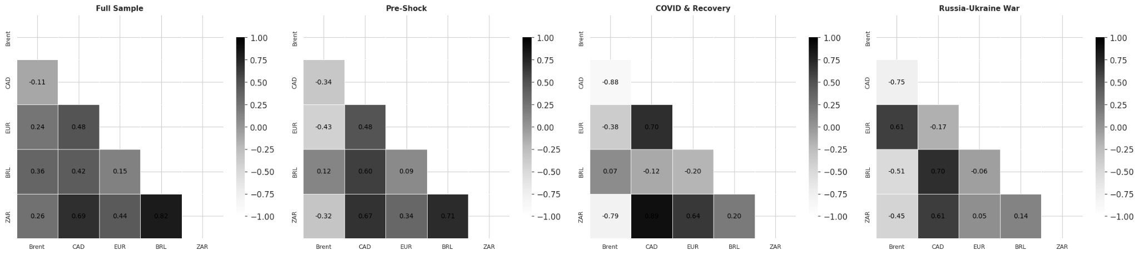
Figure A2. Correlation heatmaps (full sample and sub-periods)

There are several observations that can be made in all four figures. For the entire sample period, the Brent oil price is moderately positively correlated with the EUR (0.24), BRL (0.36), and ZAR (0.26); however, it is negatively correlated with the CAD (-0.11), implying that an increase in oil prices is correlated with currency appreciation in all cases other than the CAD currency because USD pricing predominates in the CAD case.
In the period prior to the shock, the correlation between Brent and developed economies is mainly negative (CAD: -0.34, EUR: -0.43). This reflects the USD pricing mechanism, whereby an increase in oil prices results in a strengthening of the US dollar and depreciation of the Canadian dollar and euro. The correlations between the emerging economies and Brent are less pronounced and are mixed (BRL: +0.12, ZAR: -0.32). At the same time, the correlations between currency pairs are quite high (CAD-ZAR: 0.67, CAD-BRL: 0.60).
Correlations reach their extreme levels during the period of the COVID-19 shock. The correlation between Brent and the Canadian dollar becomes very high, at -0.88, and with South African rand, -0.79. It can be explained by the collapse of both commodity prices and currencies due to low oil prices caused by the reduction in global demand. Interestingly, the Brazilian real does not share the same experience of the correlation with Brent of about zero (0.07) while having the highest correlation between the Canadian dollar and the South African rand (0.89).
It is during the period of the Russia-Ukraine conflict that the largest change in correlations occurs. In particular, the correlation between the euro and Brent reverses to a positive value (0.61). It is consistent with the supply shock, where the increased Brent price indicates a geopolitical risk premium. As for the currency aspect, the Brazilian real becomes negatively correlated with Brent (-0.51) and remains positively correlated with Canadian dollars (0.70). The South African rand's correlation with Brent is lower than that of the COVID shock (-0.45).

Appendix 3

NARDL Long-Run Elasticity Comparison – With Versus Without Controls

Figure A3 provides a comparison of the estimated NARDL long-run elasticity coefficients, L⁺ and L⁻, for all four exchange rates in all the different sub-periods, comparing both no-control specifications with control specifications using the DXY and VIX exogenous variables.
It is clear from the comparison that the application of controls has an effect on not only the magnitude but also the direction of the estimated long-run elasticity values. In the case of CAD, for instance, controls result in a consistent shift from values close to zero or positive without the controls towards negative values with the controls. In the Russia-Ukraine period, for example, the no-controls coefficient is significantly positive (~+0.065), whereas with the controls, the coefficient is negative (~-0.050), which suggests that ignoring the dynamics of the US dollar causes the actual negative oil–CAD relationship to be masked by the positive USD/CAD relationship.

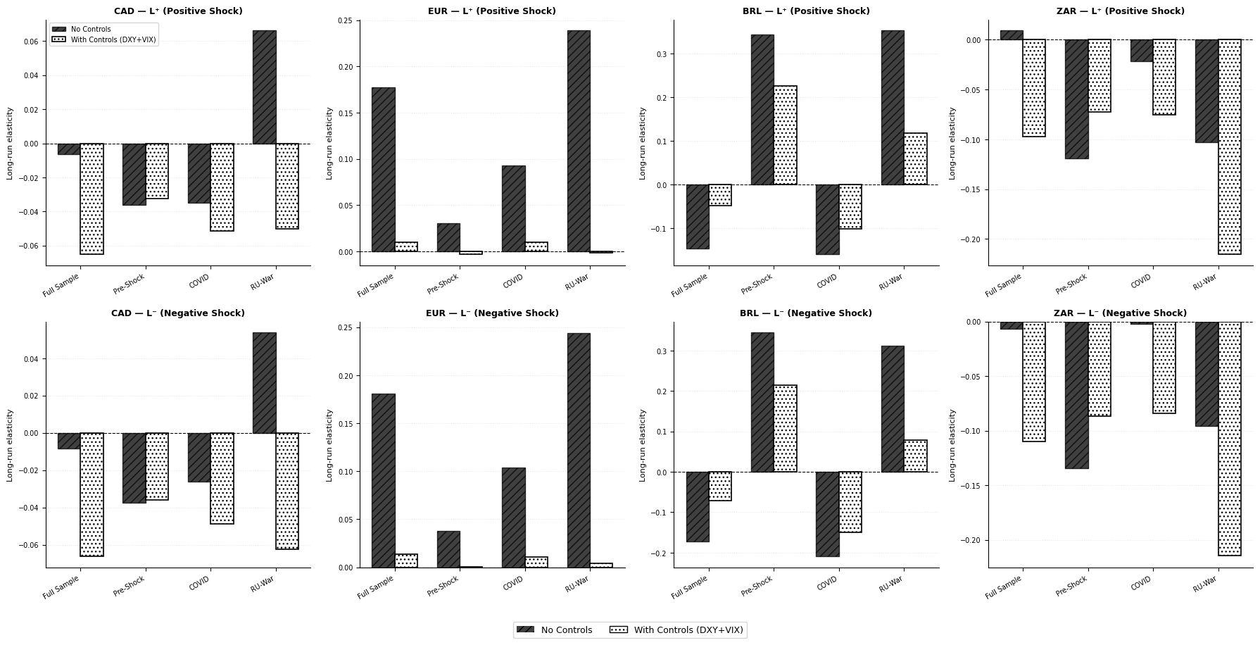
Figure A3. NARDL long-run elasticity coefficients comparison (with vs. without controls)

For EUR, controls play a significant role in lowering elasticity magnitudes, whereby without the controls, EUR presents large positive elasticities for all periods (varying between about +0.18 to +0.24) compared to near zero or slightly negative elasticities with the controls. This implies that without the controls, the EUR-oil correlation is highly driven by dollar dynamics rather than an oil price channel.
For BRL, controls mostly play a significant role in decreasing elasticity magnitudes without changing their directions for all periods. However, the period before the shock is different in that, without the controls, BRL presents extremely large positive elasticities (+0.34) compared to still positive but relatively lower elasticities (+0.23). This implies that some part of the pre-shock BRL-oil correlation was due to the commodities market comovements other than the oil price channel. Finally, for ZAR, controls play a major role in enhancing the magnitudes of negative elasticity estimates, particularly during the Russia-Ukraine period where the controlled elasticity estimate (+0.215) is nearly double compared to uncontrolled (+0.10).

Appendix 4
Markov Regime Switching Robustness Test

A4.1 Methodology
In order to provide additional validation for the NARDL results for the different sub-periods, we conduct a Markov Regime Switching (MRS) analysis with two regimes and switching variance, where we estimate the model for each currency pair throughout the entire period under study. Differently from the NARDL approach, where we imposed boundaries between the different sub-periods according to the test for structural breaks, we identify the distinct regimes endogenously from the data using a MRS approach without having to pre-specify any breakpoints, offering another check whether the oil-exchange rate relationship varies across the different regimes.

A4.2 Results
Table A4 reports the parameter estimates of the MRS approach for all pairs. For all cases, Regime 1 is associated with low variance and high persistence and represents the state of stable markets, whereas Regime 2 represents the crisis or turbulent state. Figure A5 shows the smoothed probabilities for the high-variance regime for each pair.

Table A4. Markov Regime-Switching - Parameters Summary
Currency | Type | Regime | β_Brent | σ (vol) | P(stay) | E[Days]
CAD | Developed | Regime 1 | -0.0118 | 0.00335 | 0.977 | 42.7
CAD | Developed | Regime 2 | 0.0120 | 0.00061 | 0.956 | 22.9
EUR | Developed | Regime 1 | -0.0004 | 0.00384 | 0.986 | 72.2
EUR | Developed | Regime 2 | -0.0153 | 0.00741 | 0.958 | 23.6
BRL | Emerging | Regime 1 | 0.0134 | 0.00730 | 0.966 | 29.4
BRL | Emerging | Regime 2 | 0.0110 | 0.01457 | 0.941 | 16.9
ZAR | Emerging | Regime 1 | -0.0089 | 0.00925 | 0.996 | 229.1
ZAR | Emerging | Regime 2 | -0.1345 | 0.09916 | 0.407 | 1.7
Note. Regime 1: Stable regime (low volatility, high persistence). Regime 2: Crisis regime (high volatility, low persistence). β_Brent: Coefficient of the oil price indicator in both regimes. σ: Volatility in each regime. P(stay): Probability of remaining in the current regime. E[Days]: Number of days spent in the regime. Method: Maximum Likelihood with Switching Variance. Criteria: CAD (-14120.52/-14049.00), EUR (-23852.10).

A4.3 Interpretation of MRS results
The MRS results indicate an important heterogeneity among currency pairs in terms of the dynamics of oil-exchange rate movement from stable to crisis regimes, with a strong confirmation of the sub-period results of the NARDL model alongside fresh information.
In the case of the Canadian dollar, the two regimes exhibit identical negative values of the coefficient of oil (β = -0.0118 and β = -0.0120), indicating that the nature of the oil-CAD relationship remains unchanged in all market conditions. Nevertheless, there is a sharp increase in volatility in the crisis regime (σ = 0.00601 and σ = 0.00335), independently supporting the findings of the NARDL model that oil-exchange rate dynamics intensify during crisis periods for CAD without affecting its underlying nature. The stable regime has very high persistence (42.7 days).
The Euro presents the most economically interesting Regime-Switching characteristics of any developed-economy pair. In the stable regime, the coefficient of oil is close to zero (β = -0.0004), indicating virtually no oil-EUR correlation in times of calm. In contrast, the coefficient becomes positive in the crisis regime (β = +0.0153). This indicates that at times of turbulence, an increase in the price of oil leads to a strengthening of EUR due to the fact that the US dollar pricing effect intensifies when risk-off flows push up the value of the dollar and lower EUR; the reversal of signs is indicative of the complicated dynamic of the oil price/dollar/EUR relationship.
In the case of the Brazilian real, both regimes exhibit negative oil coefficients, which are of a comparable magnitude (β = -0.0134, β = -0.0110). This supports the NARDL result that oil shocks have a negative impact on BRL regardless of market conditions. The standard deviation is doubled in the crisis regime (σ = 0.01457, σ = 0.00730), while the duration of the regime is shorter in both cases (29.4 days, 16.9 days).
The most notable MRS result comes from the South African rand, which displays a persistently stable regime (on average for 229.1 days), indicating that ZAR is predominantly calm throughout the sample period, demonstrating relatively low negative sensitivity to oil price changes (β = -0.0089). In comparison, the crisis regime demonstrates a highly positive and significantly large coefficient to oil (β = +0.1345) and much greater volatility (σ = 0.09916) but is very fleeting, averaging only 1.7 days. It appears as though periods of crisis in ZAR are rare, intense, and short-lived, because during them, the increase in oil prices results in a strong positive impact on ZAR through the commodity exports effect, but this does not last very long before returning to the previous negative impact regime.

A4.4 Consistency with NARDL Results
In addition to providing consistent support for the findings of the NARDL sub-period approach, the results of the MRS analysis contribute additional insights into the nature of oil-exchange dynamics. First, the establishment of separate stable and crisis regimes in all pairs serves as additional evidence supporting the validity of the use of sub-period analysis in the NARDL approach. Second, the fact that the volatility is doubled and even tripled in the crisis regime among all pairs constitutes independent confirmation of the conclusion drawn in the NARDL study on increased intensity of oil-exchange dynamics during crises. Third, the difference in regime length between developing economies and developed countries, where EUR’s stable regime lasts 72 days against ZAR’s 229 days, while CAD’s regime lasts only 43 days, and BRL’s, 29 days, constitutes independent confirmation that oil-exchange dynamics vary significantly depending on economic development and type of economy. The main discovery in the context of MRS analysis concerns the crisis regime of ZAR with sign reversal.

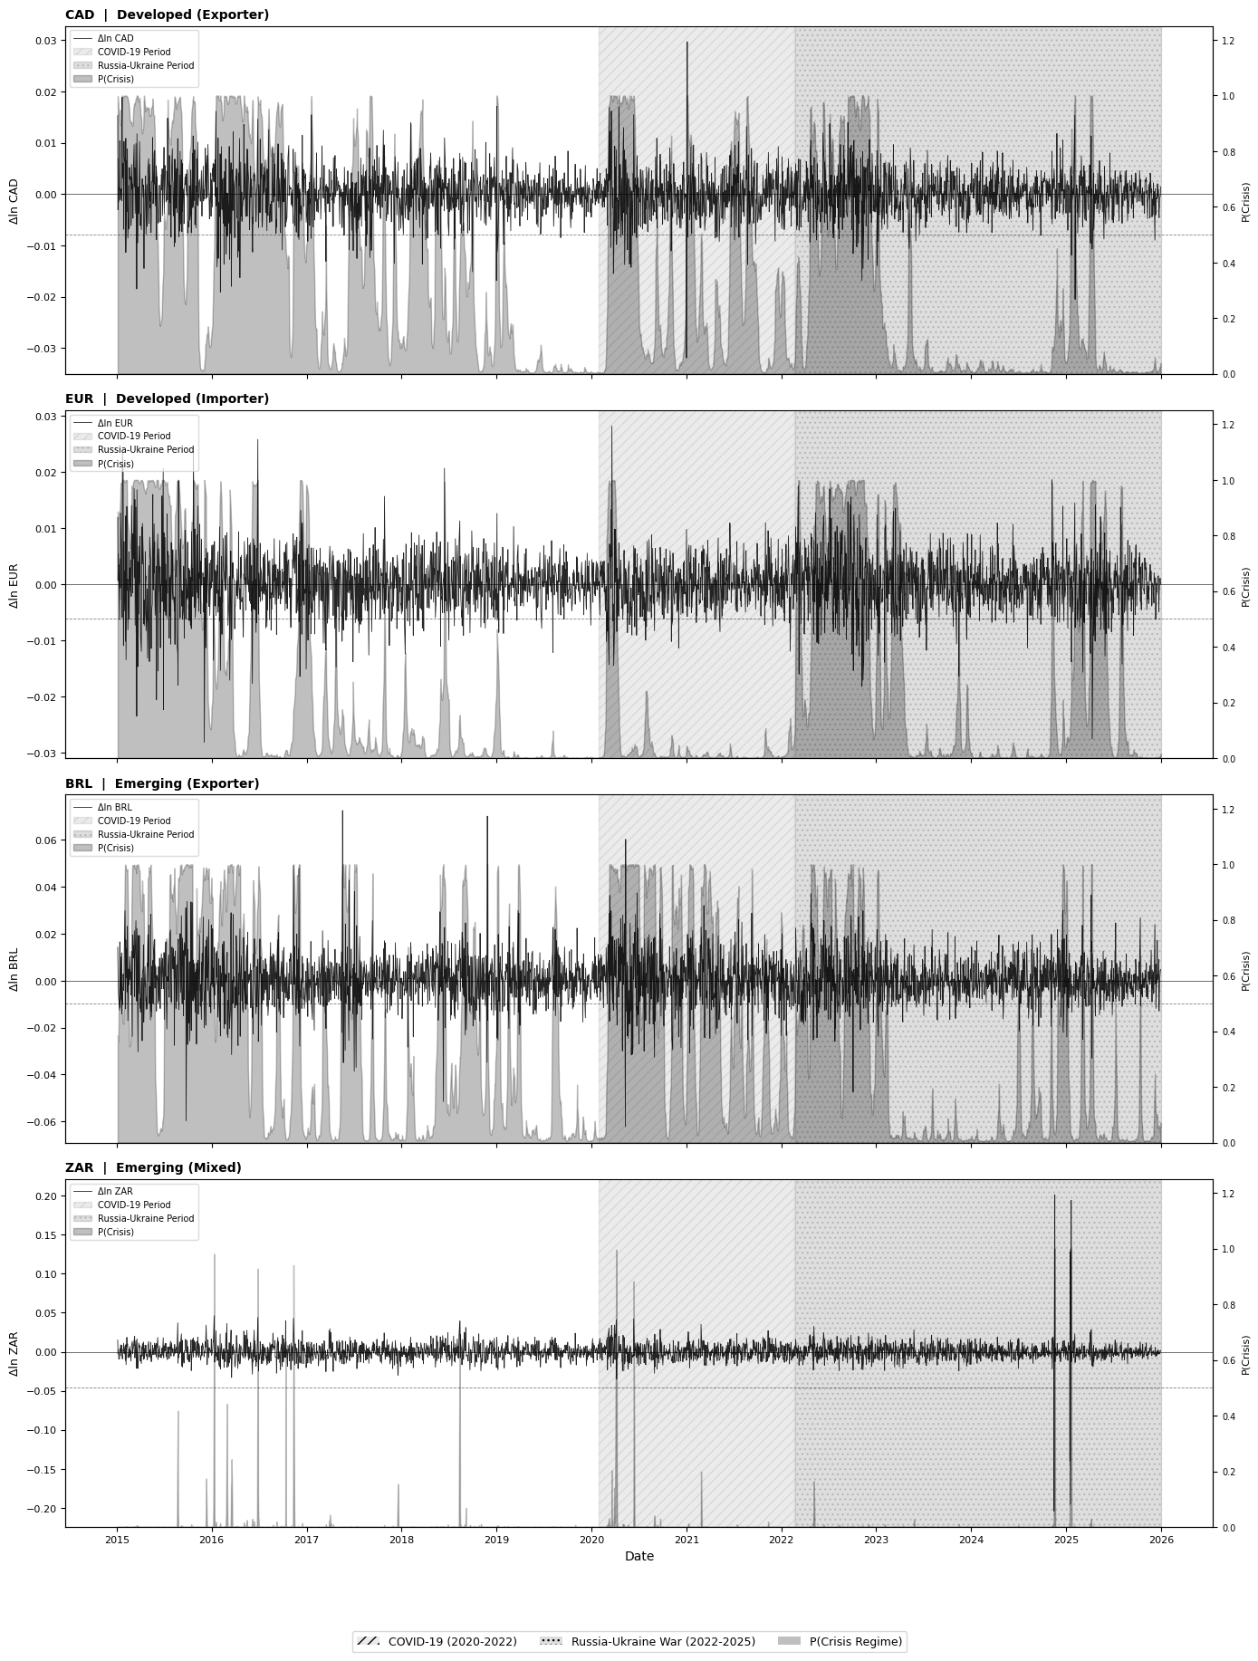
Figure A4. Markov-Switching Smoothed High-Volatility Regime Probabilities
The probabilities of the crisis regime (high-volatility crisis regime) are shown in Figure A4 along with the daily log-return for each currency pair for the entire period of analysis. The following patterns can be observed from the four panels.
In the case of the Canadian dollar, crisis regime probabilities are higher during the pre-shock period and episodically high during the oil price crash in 2015-2016 and during the emergence of COVID-19 in early 2020, when the probability is close to 1.0. Despite crisis probabilities being high intermittently even during the Russia-Ukraine war, probabilities during this period were low compared to during COVID because, unlike the latter, the former involved only a supply shock, while the latter involved both demand and supply shocks.
In the case of the euro, crisis regime probabilities stay persistently high for the entire duration of the sample period, falling near zero levels for very little time, if at all. This is also reflected in MRS results that have found EUR's stable regime period to be only 72 days, coupled with frequent switching between regimes. The existence of persistent crisis regimes confirms the finding of NARDL results that EUR cointegration is asymmetric for all durations due to the existence of a persistent crisis regime.
For the Brazilian real, there is a definite episodic behavior pattern in terms of crisis regime probabilities, where there is a sharp rise when the crisis regime begins, like the 2015-2016 oil crash and 2020 COVID-19 outbreak, followed by a drop when the crises end, like the mid-COVID recovery period, and another sharp increase when a new crisis hits, like the Russia-Ukraine crisis. This also fits with MRS regime durations for BRL, which stand at 29.4 days.
The ZAR panel exhibits the most compelling graph; crisis regime probabilities are close to zero throughout much of the entire time series apart from occasional spikes in the few days, which is in line with the exceptionally long period of stability of 229.1 days as captured in the MRS estimates. The sharp peaks observed within the graph represent the extremely short duration of crisis regimes for the ZAR of just 1.7 days; while a crisis may arise, the resolution is immediate due to its acute nature, something that is not true of any other pair.
In conclusion, the evidence presented in Figure A5 confirms that the identification of crisis regimes using MRS models largely corresponds with the NARDL sub-periods determined without using structural breaks at all.

Appendix 5
Data sources & code attachment
Github repository: https://github.com/B-xD/Oil_prices_FX_Time_Series

