

SWDQ Assignment

-

Software Design Document

**Conor O’Mathuna - B00074979**

**Aiden Barrett – B00075033**

**Piotr Barycki – B00069188**

***Department of Engineering***

***School of Informatics & Engineering***

***Institute of Technology, Blanchardstown***

***Dublin 15.***

**Software Design and Quality 21st December 2015**

Table of Contents

Table of Figures 1

1 Introduction 2

2 Problem Statement 2

3 Fully-dressed Use Case Analysis 3

3.1 Use Case Model 3

3.2 Fully-dressed Use Case 1 Description 3

3.3 Fully-dressed Use Case 2 Description 4

3.4 Fully-dressed Use Case 3 Description 4

3.5 Fully-dressed Use Case 4 Description 5

3.6 Fully-dressed Use Case 5 Description 5

4 Detailed Sequence Diagrams 7

4.1 Admin generating class report Sequence Diagram 7

4.2 Admin login failure Sequence Diagram 7

4.3 Admin login success Sequence Diagram 8

4.4 Student taking quiz Sequence Diagram 8

5 Final Refined Class Diagram 9

# Table of Figures

Figure 1 - Use Case Model 3

Figure 2 - Admin generating class report Sequence Diagram 7

Figure 3 - Admin login failure Sequence Diagram 7

Figure 4 - Admin login success Sequence Diagram 8

Figure 5 - Student taking quiz Sequence Diagram 8

Figure 6 - Final Refined Class Diagram 9

# Introduction

This document is part of the design phase of a software quiz program, as described by the problem statement below.

# Problem Statement

*You are required to develop a C++ Multiple Choice Quiz application to aid students taking the module “Software Design & Quality” study for their exams. Users will be presented with a randomly chosen set of 10 questions from a question bank and be presented with a choice of solutions. The user must then chose a correct answer and move to the next question. The application will generate a report of how well the student did after the quiz has completed. The student’s result is saved to their profile. The application can manage many student profiles and can generate an overall class report. The quiz may be administrated by an admin user. An admin user has full access to all student’s attempts, but a student user can only see their own attempts as such Student’s must login to their profile before starting the quiz. Students are allowed have multiple attempts which are all persistently saved against their individual profile. Questions and solutions are saved in a simple text file which is read by the quiz application.*

# Fully-dressed Use Case Analysis

## Use Case Model

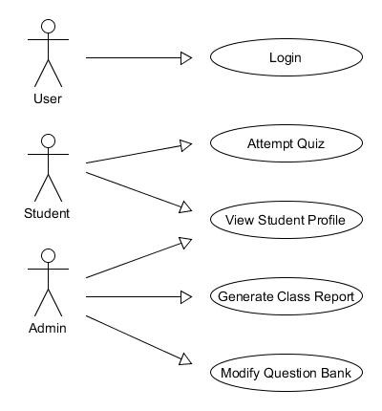

Figure 1 - Use Case Model

## Fully-dressed Use Case 1 Description

**Primary actor:** User

**Goal in context:** Logging into the system

**Level:** User level

**Stakeholders and Interests:**

Student: wants to access their profile and take quiz

**Preconditions:** The system must be able to verify the credentials

**Minimum guarantee:** The user will be prompted to try again, if login attempt is unsuccessful

**Success guarantees:** User has successfully logged into their system account

**Trigger:** User selects the sign in option

**Main success scenario:**

1. User credentials verified
2. User logged in to correct account

**Extension:**

1a. User does not enter any details, results in prompt to enter details

**Frequency of use:** Several times per day

**Priority:** 1

## Fully-dressed Use Case 2 Description

**Primary actor:** Student

**Goal in context:** Taking a quiz

**Level:** User level

**Stakeholders and Interests:**

Student: wants to take quiz and view results

**Preconditions:** The student must already be logged in

**Minimum guarantee:** Student is able to take the quiz

**Success guarantees:** Student can complete the quiz and view the result

**Trigger:** Student selects the option to begin quiz

**Main success scenario:**

1. Student is permitted to take the quiz
2. Student answers all 10 questions
3. Upon quiz completion, student is presented with quiz result
4. Student may exit back to main menu after quiz result is displayed

**Extension:**

1a. Quiz report is saved to student’s profile

**Frequency of use:** Several times per day

**Priority:** 1

## Fully-dressed Use Case 3 Description

**Primary actor:** Admin

**Goal in context:** Viewing student profile

**Level:** Admin level

**Stakeholders and Interests:**

Admin: wants to view a specific student’s results

**Preconditions:** The admin must already be logged in

**Minimum guarantee:** Admin is able to enter a student ID to view

**Success guarantees:** Admin can search for and view a specific student profile

**Trigger:** Admin selects the option to view a profile

**Main success scenario:**

1. Admin enters student ID
2. Admin is presented with the student’s profile

**Extension:**

1a. ID entered not found in system

2a. Desired profile does not exist

**Frequency of use:** Several times per day

**Priority:** 1

## Fully-dressed Use Case 4 Description

**Primary actor:** Admin

**Goal in context:** Generating class report

**Level:** Admin level

**Stakeholders and Interests:**

Admin: wants to create a class report

**Preconditions:** Student profile must be available to combine into class report

**Minimum guarantee:** Admin has option to generate class report

**Success guarantees:** Class report is generated and displayed for the Admin to view

**Trigger:** Admin selects ‘create class report’ option

**Main success scenario:**

1. Admin selects option to generate class report.
2. All student profiles are combined into a class report.
3. Class report is displayed.

**Extension:**

1a. No students enrolled in class so report impossible to create

**Frequency of use:** Once per week

**Priority:** 1

## Fully-dressed Use Case 5 Description

**Primary actor:** Admin

**Goal in context:** Modify question bank

**Level:** Admin level

**Stakeholders and Interests:**

Admin: Wants to edit questions in question bank

**Preconditions:** Admin must be able to access question bank

**Minimum guarantee:** Admin able to access questions in the question bank

**Success guarantees:** Admin able to add, delete and modify questions in the question bank. All changes made to the question bank can be saved.

**Trigger**: Admin selects the ‘modify questions’ option

**Main success scenario:**

1. Admin selects the ‘modify questions’ option.
2. Admin is brought to the questions editing page.
3. Admin is then able to add, delete and modify questions in the question bank.
4. Admin is able to save changes made to the question bank.
5. Admin can then select the option to return to the menu screen.

**Frequency of use:** Once per week

**Priority:** 1

# Detailed Sequence Diagrams

## Admin generating class report Sequence Diagram

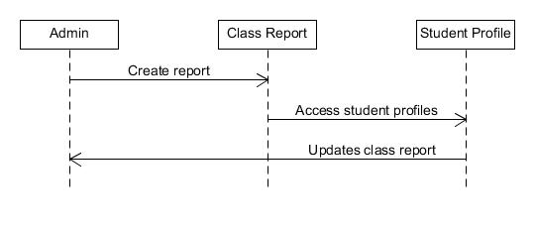

Figure 2 - Admin generating class report Sequence Diagram

## Admin login failure Sequence Diagram

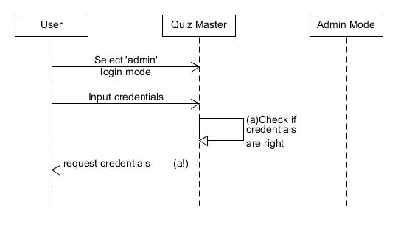

Figure 3 - Admin login failure Sequence Diagram

## Admin login success Sequence Diagram

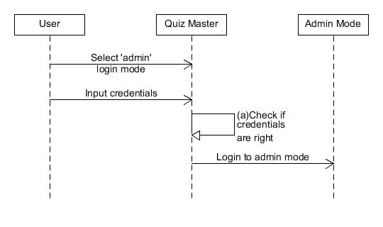

Figure 4 - Admin login success Sequence Diagram

## Student taking quiz Sequence Diagram

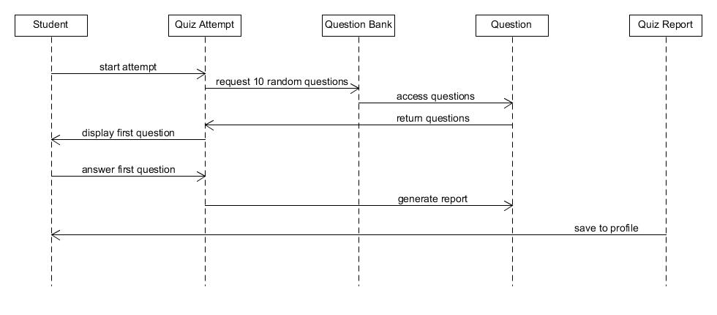

Figure 5 - Student taking quiz Sequence Diagram

# Final Refined Class Diagram

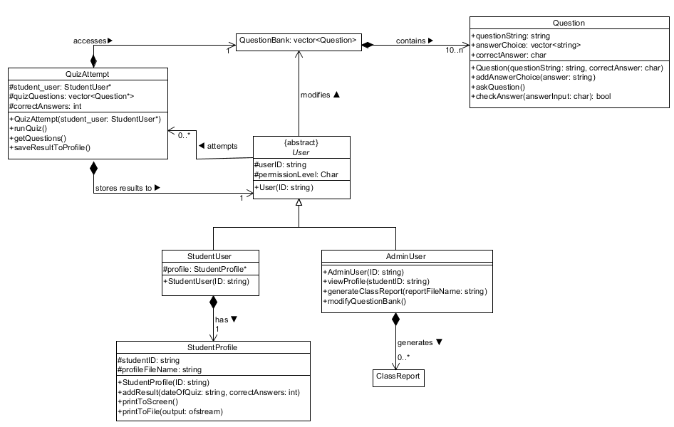

Figure 6 - Final Refined Class Diagram