

SWDQ Assignment

-

Software Analysis Document

**Conor O’Mathuna - B00074979**

**Aiden Barrett – B00075033**

**Piotr Barycki – B00069188**

***Department of Engineering***

***School of Informatics & Engineering***

***Institute of Technology, Blanchardstown***

***Dublin 15.***

**Software Design and Quality 21st December 2015**

Table of Contents

Table of Figures 1

1 Introduction 2

2 Problem Statement 2

3 High-level Use Case Model 3

3.1 Use Case 1 3

3.2 Use Case 2 3

3.3 Use Case 3 3

3.4 Use Case 4 4

3.5 Use Case 5 4

4 Conceptual Model 5

4.1 UML Class Conceptual Model 5

5 Behaviour Analysis 6

5.1 High-level Sequence Diagrams 6

5.1.1 Student taking quiz Sequence Diagram 6

5.1.2 Admin creating class report Sequence Diagram 6

5.2 High-level Activity Diagrams 7

5.2.1 User logging in Activity Diagram 7

5.2.2 Student taking quiz Activity Diagram 8

5.3 High-level State Diagram 9

# Table of Figures

Figure 1 - Use Case Model 3

Figure 2 - UML Class Conceptual Model 5

Figure 3 - Student taking quiz Sequence diagram 6

Figure 4 - Admin creating class report Sequence diagram 6

Figure 5 - User logging in Activity diagram 7

Figure 6 - Student taking quiz Activity diagram 8

Figure 7 –High-level State Diagram 9

# Introduction

This document is the first phase in the analysis and design of the problem stated below, and includes analysis of use cases, several sequence diagrams, an activity diagram, and a state diagram.

# Problem Statement

*You are required to develop a C++ Multiple Choice Quiz application to aid students taking the module “Software Design & Quality” study for their exams. Users will be presented with a randomly chosen set of 10 questions from a question bank and be presented with a choice of solutions. The user must then chose a correct answer and move to the next question. The application will generate a report of how well the student did after the quiz has completed. The student’s result is saved to their profile. The application can manage many student profiles and can generate an overall class report. The quiz may be administrated by an admin user. An admin user has full access to all student’s attempts, but a student user can only see their own attempts as such Student’s must login to their profile before starting the quiz. Students are allowed have multiple attempts which are all persistently saved against their individual profile. Questions and solutions are saved in a simple text file which is read by the quiz application.*

# High-level Use Case Model

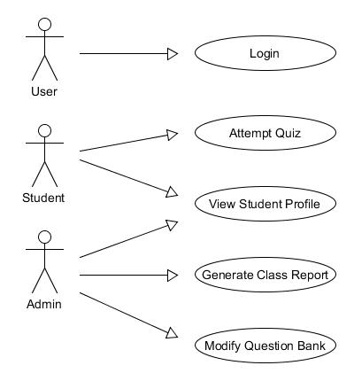

Figure 1 - Use Case Model

## Use Case 1

The user is presented with an interface where they are asked to input their login credentials – username and password. The system verifies that that username and password are correct and determines whether the user has access as either a student or as an administrator.

## Use Case 2

The student has successfully logged into the system and is presented with the option to take a quiz. When the student starts the quiz, they are then given a series of 10 randomly chosen multiple-choice questions that must be answered. Once the student has completed the quiz, the quiz report is displayed and the results are saved to the student’s profile. The student can then exit back to the student menu screen.

## Use Case 3

When an admin selects the option to view a student profile, they are prompted to enter the username of the student profile they wish to view. In the student profile, they can view the results of the students’ previous quiz attempts.

When the student selects the option to view the student profile, they are brought directly to their own profile only. In their own profile, they can view the results of their previous quiz attempts.

## Use Case 4

The admin has the option to generate a class report. When selected, the report will display the results of each student and the average of their combined grades.

## Use Case 5

The admin has the option to modify existing questions and add additional questions to the question bank.

# Conceptual Model

The conceptual model aims to identify the relationships between the different concepts involved within the problem domain and then detail how the concepts are related to each other.

## UML Class Conceptual Model

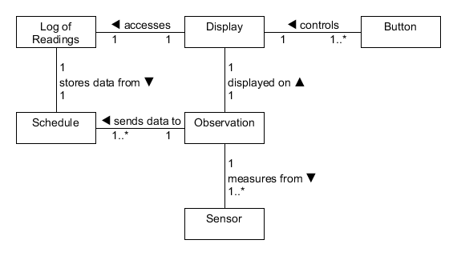

Figure - UML Class Conceptual Model

# Behaviour Analysis

## High-level Sequence Diagrams

### Student taking quiz Sequence Diagram

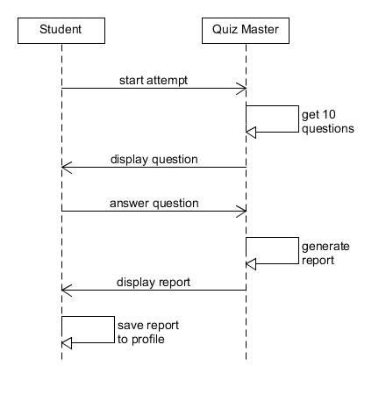

Figure - Student taking quiz Sequence diagram

### Admin creating class report Sequence Diagram

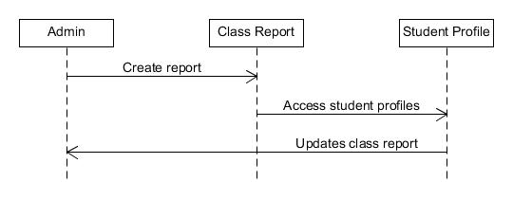

Figure - Admin creating class report Sequence diagram

## High-level Activity Diagrams

### User logging in Activity Diagram

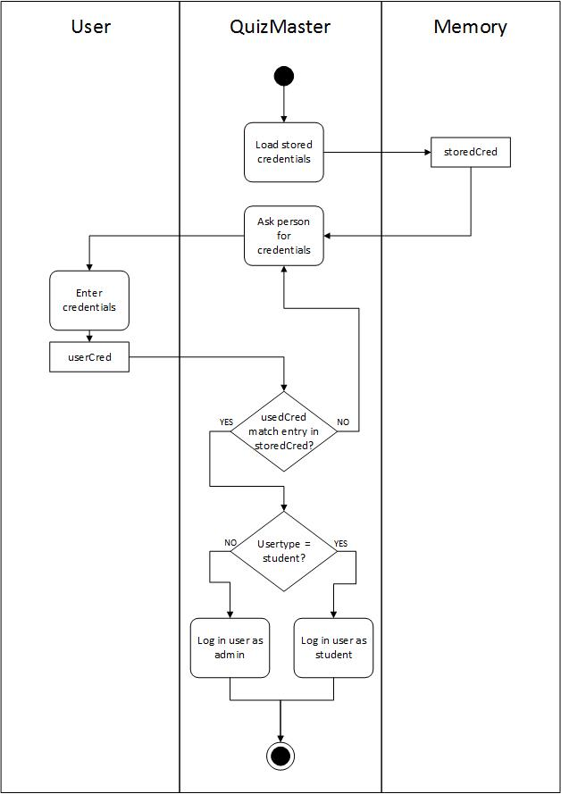

Figure - User logging in Activity diagram

### Student taking quiz Activity Diagram

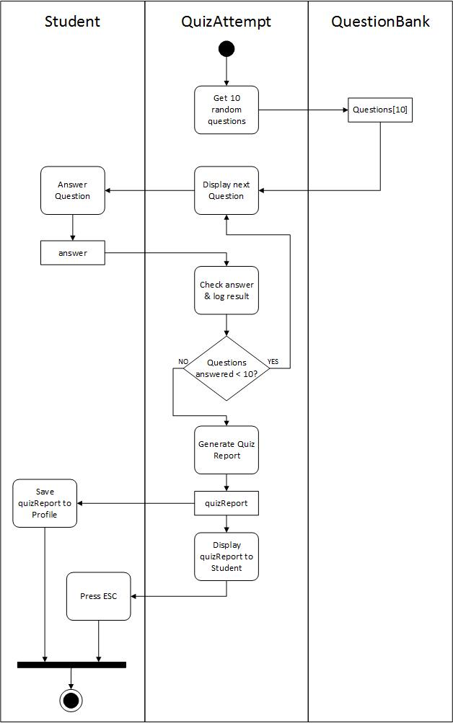

Figure - Student taking quiz Activity diagram

## High-level State Diagram

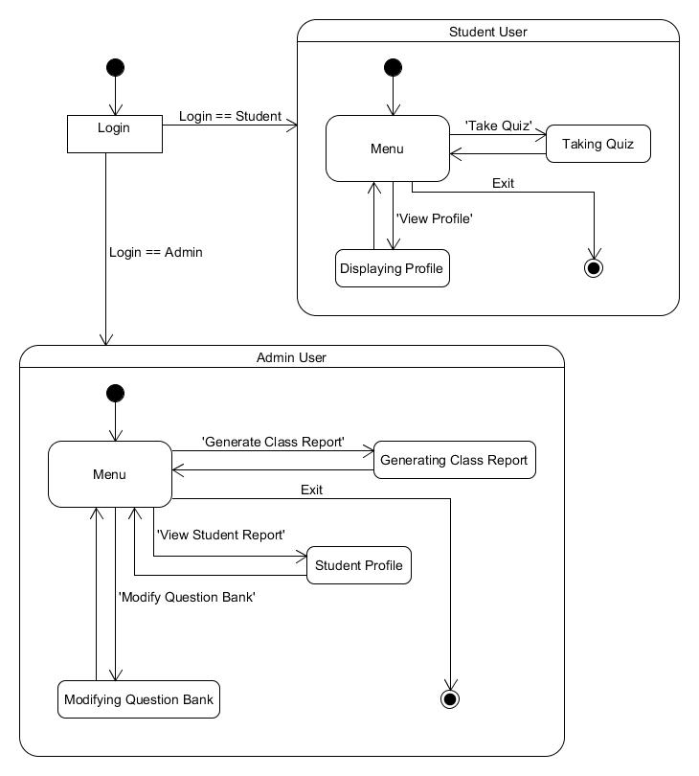

Figure –High-level State Diagram