# Part 1

## Password Hashing Implementation

### Before and after code screenshots

#### Register

##### Before

##### After

#### Login

##### Before

##### After

## Input Field Character Limitations

### Register

Limiting length code

### Login

Limiting length

## Handling Null or Blank Inputs

### Registration

### Login

## Escaping User Input: Form Validation

### Registration

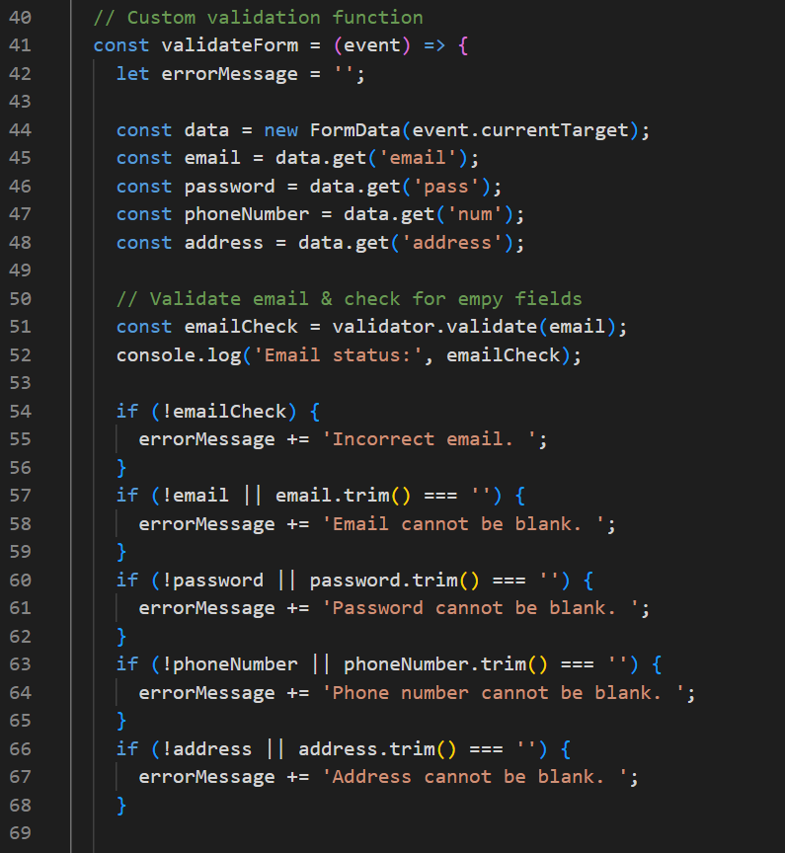

### Login

