Title


Russel, Makani
B00164413

Department of Engineering
School of Informatics & Engineering
Institute of Technology, Blanchardstown
Dublin 15.

Module Title: Software Development and Quality
Submission date:

Introduction:
In this lab you will practice creating visual models of a problem domain to better understand
the problem before moving onto the Design Phase and defining the software architecture
next week.
In the last lecture we started to discover problem domain concepts that will form the basis
of our software classes later. As you have found, analysis is NOT a trivial task, especially
when done on your own. Requirements analysis and conceptual modelling is a collaborative
exercise

Problem Statement:
We have been tasked with designing the software system for a simple weather-station. A weather station records local weather information and periodically transfers this to a weather information system using a satellite link. Currently the system keeps track of temperature, wind speed (Anemometer) and pressure (barometer) but must be flexible enough to be expanded at a later stage.
The system is composed of a basic Micro-controller, a single temperature sensor, a display, memory bank and user buttons.
The system displays temperature readings in real time on the display. It also keeps track of historical information on an hourly and daily basis. This historical data can be pulled up on the display at the request of the user by pressing the appropriate button.

Use case Analysis

Use case model
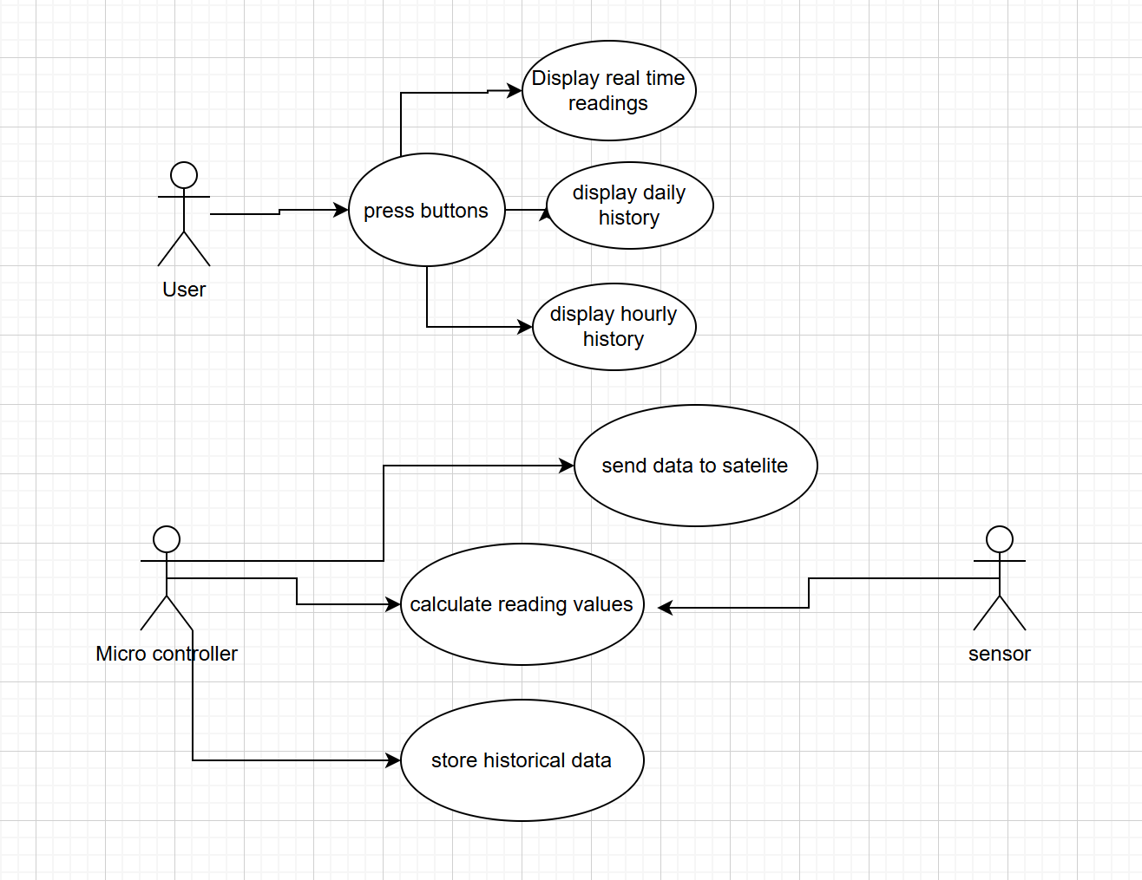

Description:
The weather station system provides two main categories of functionality: user interaction and automated data management.

User Interactions:
The user initiates actions by pressing one of the buttons available on the system. This triggers the microcontroller to retrieve and display different categories of information on the display screen - real-time temperature readings, hourly historical summaries, or daily historical summaries. The display updates to show the requested information based on the button pressed.

Automated System Operations:
Independent of user actions, the system continuously monitors weather conditions. Sensors (temperature sensor, anemometer, and barometer) gather raw environmental data. The microcontroller periodically reads this sensor data, processes it into standardized weather readings, and stores these readings in memory for future historical reference. The system organizes this stored data into hourly and daily summaries to enable efficient historical data retrieval.
At scheduled intervals, the microcontroller packages the collected weather data and transmits it via satellite link to the external Weather Information System for remote monitoring and further analysis.

Actors:
A list of actors in this system include:
- The user
- The microcontroller
- Sensors

Conceptual model:

Physical/Tangible Objects:
- Temperature Sensor
- Anemometer (wind speed sensor)
- Barometer (pressure sensor)
- Display
- User Button
- Micro-controller

Transactions:
- Data Transfer
- Reading Capture

Abstract Nouns:
- Temperature Reading
- Wind Speed Reading
- Pressure Reading
- Historical Data
- Hourly Summary
- Daily Summary

Events:
- Button Press Event
- Periodic Recording Event
- Data Transfer Event

Modelling Assumptions
- Sensor Abstraction: Sensor is a generalised concept with Temperature Sensor, Anemometer, and Barometer as specific types. This allows for future expansion.
- Button Functionality: We assume multiple buttons exist with different functions (view real-time, view hourly history, view daily history), though the exact number is not specified in the requirements.
- Periodic Operations: We assume the system has an internal timer/scheduler capability within the microcontroller that triggers periodic recording and data transmission, even though this is not explicitly detailed as a hardware component.
- Display Limitations: We assume the display shows one type of information at a time (either real-time data or historical data), not multiple simultaneously.

