**Assignment One – Human Computer Interaction**

**Usability Report**

**A mobile application > “MyFitnessPal”**

Contents

The Chosen System 3

The Usability Test Plan 5

Usability Test Results 8

Statistical Analysis 13

Findings and Recommendations 26

Gestalt Psychology 28

Visual Structure 33

Visual Hierarchy 36

Message Visibility 37

Conclusion 38

## The Chosen System

“MyFitnessPal” is a mobile and web-based application that specialises in helping its users manage and record their health and nutrition goals. The app provides state of the art tools for tracking daily food intake, activities, various health metrics such as weight, making it convenient and accessible for individuals to monitor their overall wellness based on their health targets.

Users can log their meals by using an add food feature that allows the user to either search for a food item manually or scan the barcode of the food items packaging. The app calculates and displays the nutritional content breakdown within the logged food, including calories, carbohydrates, proteins and fats, plus all the finer micronutrients. This is displayed within a food diary menu within the app, detailing the logged meals and consumed/remaining calories. Users can also log their daily activity and workouts which displays a unique calorie expenditure amount based on the user’s chosen activity. Users can set personalised goals such as weight loss, gain or maintenance, in which the app provides a specific calorie recommendation based on the user’s recorded metrics (weight, age, activity levels). Users can add external wearables and apps such as fitness trackers, smartwatches, and other health apps, syncing more health data to seamlessly get a better overall view of their daily health metrics and activities. Users can add a feature for an additional payment which adds more detailed nutritional analysis, customised meal plans and ad-free usage which can enable better functionality.

The application was created by brothers Mike lee and Albert Lee who had pedigree in technology and software development. They co-founded MyFitnessPal in 2005, and it quickly became one of the most popular and widely used nutrition tracking apps attracting a global user base. It added millions of users per month and expanded to over 100 countries. In 2005, it was first released as a web-based application, which allowed users to access the app via an internet browser on any computer with access to the internet.

In 2009, the mobile app launched on IOS and android, and is currently on version 24.6.0, having had multiple previous versions which have been updated over the last 15 years. Each update removed a variety of updates including bug fixes, enhanced features and general improvements.

In 2015, global sports brand Under Armour, acquired the company as part of its expansion into the health and fitness marketplace. As of 2021, the app has over 200 million registered users worldwide.

I chose MyFitnessPal as my system for assignment one because it is an app that I have been regularly using for over 10 years, and it has greatly helped me on my own health journey. It’s helped me lose over 5 stone in weight and gain control over my health, wellness and relationship with food. It also features heavily in my part-time role as a fitness coach in which I help clients improve their well-being and achieve their health goals via using the app. MyFitnessPal is easy to use and suits my individual needs as a health enthusiast. I was interested to see if there’s anything that can be improved and if it can be made more suitable. MyFitnessPal claims to help users achieve their wellness goals through effective tracking of food, activity and lifestyle so I was eager to find out if users were achieving this claim. I wanted to test how challenging the app is to use for a variety of age groups which different levels of tech related skills, across its platform, and different functions as the app has the potential to change a person’s health.

## The Usability Test Plan

The primary purpose of my usability test plan was to collect initial data about the effectiveness of the MyFitnessPal application and determine if any improvements could be made based on the potential issues that may arise after testing. Other purposes were to evaluate the effectiveness of MyFitnessPal for different types of users performing basic, common tasks (Rubin. 2008) whilst testing the functionality of the app’s features.

Equipment used to test the mobile application was a mobile device with the latest capabilities. A Samsung S23 was used for each test participant for testing. Time was recorded using a digital timer to record each task, pen/paper for the test moderator to record the timings, observations and apparent issues within a test notebook. Appropriate questionnaire surveys were also designed to be completed by each participant before and after the test. Session schedules were created prior to testing alongside a session script outlining the testing protocols used.

I assigned myself as the moderator of the test, and recruited five other participants via WhatsApp and scheduled an appropriate date/time for each session. Each participants sessions lasted no longer than 35 minutes.

The following table (below) showcases all data collected from the characteristics questionnaire which each participant completed prior to testing. It provides a profile of each participant, generating an insight into the types of different participant.

|  |  |  |  |  |
| --- | --- | --- | --- | --- |
| **Characteristics of Participants** | | | | |
| **User ID** | **Gender** | **Age** | **Occupation** | **Competence\*** |
| 001 | Male | 56 | Aerospace Engineer | Average |
| 002 | Female | 24 | Data Analylst | Excellent |
| 003 | Male | 20 | Student | Good |
| 004 | Female | 76 | Receptionist (retired) | Poor |
| 005 | Male | 31 | Police Officer | Average |

*(Mobile device technical competence from Poor to Excellent)

|  |  |
| --- | --- |
| **Test Participant Summary** | |
| **Characteristics** | **Number of Participants** |
| **Age**  Under 18  18 > 28  29 > 39  40 > 50  51 > 61  62 > 72  73 > 83  80+ | 0  1  2  0  1  0  1  0 |
| **Gender**  Female  Male | 2  3 |
| **Technical Competence**  Poor  Average  Good  Excellent | 1  2  1  1 |
| **Purpose of food tracking**  Nutrition Awareness  Weight Management  Fitness and Performance  Food Control  Mean Planning  Accountability  All of the above | 1  1  0  0  1  1  1 |

Recording quantitative data allowed me to analyse performance measures.

Metrics recorded included a record of the amount of time spent on completing each task, overall rate of completion, accuracy of tests and error occurrences. Qualitative data was recorded through note observations (verbal/written) and questionnaires. Each metric was recorded by the moderator (me) and the ratings of each task were recorded by each participant by completing the questionnaires and a post-test survey.

**Test Plan Procedure:**

**Introduction (10 minutes)**

* Welcome and consent form > 5 mins
* Ask the participant to fill in their pre-questionnaire > 5 mins

**Carry out the test tasks (30 minutes)**

**Post-test Debrief (10 minutes)**

* Ask the participant to fill in the post-questionnaire (5 mins)
* Post test interview (5 minutes)

Test conditions were kept the same for each participant throughout the test which was carried out in a secure, controlled environment to ensure reliability.

Every result was recorded using the appropriate equipment.

Participants were asked to score MyFitnessPal by the chosen task using a 5-point Likert Tier ranging from Strong Disagree to Strong Agree (see appendix 1) and post-test questionnaires were created prior to each test in a digital text format.

Post Test Subjective Measures included:

* How difficult was it to track food on the app
* Whether the participants found the app easy to use
* Was it easy to navigate through the app

(See Statistical Analysis)

## Usability Test Results

|  |  |  |  |  |  |  |
| --- | --- | --- | --- | --- | --- | --- |
| **User ID** | **Task Number** | **Task Description** | **Time Elapsed** | **Observations** | **Success Criteria** | **Maximum Time** |
| 001 | 1 | Manually add a food item using the ‘add food icon’ | 46s | Initially looked confused at where to navigate but after a few seconds tapped the plus icon on the dashboard. Was able to search for a food and add it successfully to diary. | A new food item is added to your diary. Calories will be subtracted from your precalculated daily limit and displayed on the dashboard/food diary | 2 minutes |
| 001 | 2 | Scan the barcode of a food item’s packaging adding it to your diary | 43s | Tapped the camera icon on the food diary menu. Took a few seconds to open camera app and scan the foods barcode. | Successfully scan and add a food item based on its barcode. The item will be added to user’s food diary | 1 minute |
| 001 | 3 | Add and log your weight on your profile | 102s | Couldn’t find how to find where to log weight. Tapped in and out of different app features. Eventually seen log weight on app’s side menu. | Weight added and logged onto profile successfully and nutrition targets appropriately adjusted | 2 minutes |
| 001 | 4 | Create a new exercise activity within your profile | 32s | Used previous plus icon to add an exercise to diary. Searched for an exercise with ease. | Successfully add a new exercise activity from choices which will appear on user’s dashboard | 2 minutes |
| 001 | 5 | Modify the serving size of a food item to grams | Did not finish | Did not understand how to adjust a food item’s serving size. Tried many options and got frustrated. Claimed “it doesn’t make it easy to find”. | A tracked food item’s serving size is successfully adjusted to grams | 2 minutes |
| 001 | 6 | Navigate to where you can find your macronutrient targets | Did not finish | Initially navigated to food diary. Spent time scrolling through menus before time ran out. | A macronutrient breakdown is successfully displayed once correct icon is selected | 2 minutes |
| 002 | 1 | Manually add a food item using the ‘add food icon’ | 16s | Immediately found and tapped the plus icon to add food to food diary. | A new food item is added to your diary. Calories will be subtracted from your precalculated daily limit and displayed on the dashboard/food diary | 2 minutes |
| 002 | 2 | Scan the barcode of a food item’s packaging adding it to your diary | 12s | Navigated to food diary, selected the camera icon and scanned the food items barcode adding it to diary. | Successfully scan and add a food item based on its barcode. The item will be added to user’s food diary | 1 minute |
| 002 | 3 | Add and log your weight on your profile | 34s | Scrolled to the settings menu, and found weight settings. Entered their weight and logged it to diary. | Weight added and logged onto profile successfully and nutrition targets appropriately adjusted | 2 minutes |
| 002 | 4 | Create a new exercise activity within your profile | 23s | Immediately used the plus icon on app home screen to select and add a custom exercise to diary. | Successfully add a new exercise activity from choices which will appear on user’s dashboard | 2 minutes |
| 002 | 5 | Modify the serving size of a food item to grams | 45s | Navigated to the food diary by tapping the diary icon. Tapped on a logged food item and selected 3 dots next to food item. Adjusted the serving size from oz to grams correctly. | A tracked food item’s serving size is successfully adjusted to grams | 2 minutes |
| 002 | 6 | Navigate to where you can find your macronutrient targets | 26s | Scanned the home screen and noticed the pie chart icon on the top right-hand corner. Tapped the icon and displayed macronutrients. | A macronutrient breakdown is successfully displayed once correct icon is selected | 2 minutes |
| 003 | 1 | Manually add a food item using the ‘add food icon’ | 44s | Took their time to read through icons on the home screen. Claimed he was “Trying to find the work add food”. Eventually tapped the plus icon. | A new food item is added to your diary. Calories will be subtracted from your precalculated daily limit and displayed on the dashboard/food diary | 2 minutes |
| 003 | 2 | Scan the barcode of a food item’s packaging adding it to your diary | 76s | Looked confused as to where to find the barcode scanner feature on the app. Went in and out of menus. Managed to luckily find and tap camera icon. | Successfully scan and add a food item based on its barcode. The item will be added to user’s food diary | 1 minute |
| 003 | 3 | Add and log your weight on your profile | 23s | Used previous knowledge of adding food to add weight. Tapped the plus icon on app home dashboard. | Weight added and logged onto profile successfully and nutrition targets appropriately adjusted | 2 minutes |
| 003 | 4 | Create a new exercise activity within your profile | 27s | Navigated to home screen using plus icon to add a new exercise activity. Asked “could I add any exercise?” Eventually searched for running and added it to diary. | Successfully add a new exercise activity from choices which will appear on user’s dashboard | 2 minutes |
| 003 | 5 | Modify the serving size of a food item to grams | 85s | Got confused about what this meant and kept trying to search for a food item. Took more time than needed to modify serving size. | A tracked food item’s serving size is successfully adjusted to grams | 2 minutes |
| 003 | 6 | Navigate to where you can find your macronutrient targets | 54s | Scrolled through app side menu and landed on nutrition. Initially navigated to correct page but didn’t select macros until some trial and error. | A macronutrient breakdown is successfully displayed once correct icon is selected | 2 minutes |
| 004 | 1 | Manually add a food item using the ‘add food icon’ | 114s | Scanned the screen for a long time looking very confused as to where to start. Eventually associated the plus icon with adding an item. | A new food item is added to your diary. Calories will be subtracted from your precalculated daily limit and displayed on the dashboard/food diary | 2 minutes |
| 004 | 2 | Scan the barcode of a food item’s packaging adding it to your diary | Did not finish | Tried swiping and scrolling through menu. Did not navigate to scan barcode icon. Vocally said that a lot of icons are small and hard to see. | Successfully scan and add a food item based on its barcode. The item will be added to user’s food diary | 1 minute |
| 004 | 3 | Add and log your weight on your profile | 113s | Got confused about how to navigate back to home menu. Used plus icon. | Weight added and logged onto profile successfully and nutrition targets appropriately adjusted | 2 minutes |
| 004 | 4 | Create a new exercise activity within your profile | 43s | Became more competent. Successfully found the correct icon to add exercise. Used the search feature. | Successfully add a new exercise activity from choices which will appear on user’s dashboard | 2 minutes |
| 004 | 5 | Modify the serving size of a food item to grams | Did not finish | Tried to find the food item they had already logged. Did not tap the food diary icon and ran out of time. | A tracked food item’s serving size is successfully adjusted to grams | 2 minutes |
| 004 | 6 | Navigate to where you can find your macronutrient targets | Did not finish | Did not understand the differences in icons. Couldn’t differentiate the correct icon to choose from. | A macronutrient breakdown is successfully displayed once correct icon is selected | 2 minutes |
| 005 | 1 | Manually add a food item using the ‘add food icon’ | 12s | Easily found in main dashboard. | A new food item is added to your diary. Calories will be subtracted from your precalculated daily limit and displayed on the dashboard/food diary | 2 minutes |
| 005 | 2 | Scan the barcode of a food item’s packaging adding it to your diary | 26s | Swiftly found the barcode icon and scanned the barcode correctly. | Successfully scan and add a food item based on its barcode. The item will be added to user’s food diary | 1 minute |
| 005 | 3 | Add and log your weight on your profile | 23s | Used previous plus icon to manually log a new weight entry. “Easiest icon to find and know what it does”. | Weight added and logged onto profile successfully and nutrition targets appropriately adjusted | 2 minutes |
| 005 | 4 | Create a new exercise activity within your profile | 18s | Executed easily. | Successfully add a new exercise activity from choices which will appear on user’s dashboard | 2 minutes |
| 005 | 5 | Modify the serving size of a food item to grams | 36s | Navigated to food diary and used to three dots next to the food to modify the serving size. | A tracked food item’s serving size is successfully adjusted to grams | 2 minutes |
| 005 | 6 | Navigate to where you can find your macronutrient targets | 31s | Used the side bar menu to try and find the nutrition tab. | A macronutrient breakdown is successfully displayed once correct icon is selected | 2 minutes |

## Statistical Analysis

**Successful task completion rates by user**

(Figure 1)

|  |  |  |  |  |  |  |  |  |
| --- | --- | --- | --- | --- | --- | --- | --- | --- |
| **User ID** | **Task 1** | **Task 2** | **Task 3** | **Task 4** | **Task 5** | **Task 6** | **Total Success by Participant** | **Completion Rates by Participant** |
| 001 | **x** | **x** | **x** | **x** |  |  | **4** | **66%** |
| 002 | **x** | **x** | **x** | **x** | **x** | **x** | **6** | **100%** |
| 003 | **x** | **x** | **x** | **x** | **x** | **x** | **6** | **100%** |
| 004 | **x** |  | **x** | **x** |  |  | **3** | **50%** |
| 005 | **x** | **x** | **x** | **x** | **x** | **x** | **6** | **100%** |
| **Total Success by Task** | **5** | **4** | **5** | **5** | **3** | **3** | **Total Success** | **25** |
| **Completion Rates by Task** | **100%** | **80%** | **100%** | **100%** | **60%** | **60%** | **Total Average Success** | **83%** |

**Shown in the figure above (figure 1), users 002, 003 and 005 had the best performances with a 100% completion rate in all tasks. User 001 had a completion rate of 66% and user 004 with 50%. All users successfully completed tasks 1, 3 and 4.**

**Tasks 5 and 6 had the lowest rate of completion of 60%. 83% was the total average success rate amongst all tasks, with a total of 25 out of 30 tasks being completed by the user.**

|  |  |  |  |  |  |  |  |  |
| --- | --- | --- | --- | --- | --- | --- | --- | --- |
| **Time on task (seconds)** | **Task 1** | **Task 2** | **Task 3** | **Task 4** | **Task 5** | **Task 6** | **Total Time for each participant (for completed tasks)** | **Average Time for participant (if all tasks completed)** |
| **001** | **46** | **43** | **102** | **32** | **-** | **-** | **223** | **-** |
| **002** | **16** | **12** | **34** | **23** | **45** | **26** | **156** | **26** |
| **003** | **44** | **76** | **23** | **27** | **85** | **54** | **309** | **51.5** |
| **004** | **114** |  | **113** | **43** | **-** | **-** | **270** | **-** |
| **005** | **12** | **26** | **23** | **18** | **36** | **31** | **146** | **24.3** |
| **Total time for each task (if completed)** | **232** | **157** | **295** | **143** | **166** | **111** |  |  |
| **Average time for each task (if completed)** | **46.4** | **39.25** | **59** | **28.6** | **55.3** | **37** |  |  |

**Average time taken to complete each task (if completed)**

(Figure 2)

The totals and averages in the figure above (figure 2) reflect the times from the completed tasks.

The task that took the longest to complete was task 3, “Add and log your weight on your profile”. The shortest time to complete this task was 23 and longest was 113 by user 004. Task 1 had a similar task completion time at 232s.

Tasks 2, scan the barcode of a food item’s packaging, task 4, create a new exercise activity on your profile and task 6, navigate to where you can find your macronutrient targets, had very similar averages ranging from 28.6 to 39.25.

Users 002 and 005 had averages of 26 and 24.3 seconds, most likely due to high competency using mobile applications.

**Tasks and Questions**

(Figure 3)

|  |  |  |  |
| --- | --- | --- | --- |
| **Task** | | **Question** | |
| **1** | Manually add a food item using the ‘add food icon’ | **1** | “I think that Task One will be…” |
| **2** | Scan the barcode of a food item’s packaging adding it to your diary | **2** | “I think that Task Two will be…” |
| **3** | Add and log your weight on your profile | **3** | “I think that Task Three will be…” |
| **4** | Create a new exercise activity within your profile | **4** | “I think that Task Four will be…” |
| **5** | Modify the serving size of a food item to grams | **5** | “I think that Task Five will be…” |
| **6** | Navigate to where you can find your macronutrient targets | **6** | “I think that Task Six will be…” |

**Pre-Task Questionnaire**

(Figure 4)

|  |  |  |  |  |  |  |  |
| --- | --- | --- | --- | --- | --- | --- | --- |
| **User** | **Task** | **Question** | **Very Difficult** | **Somewhat Difficult** | **Neutral** | **Somewhat Easy** | **Very Easy** |
| **1** | **1** | **1** |  |  |  | **X** |  |
|  | **2** | **2** |  |  | **X** |  |  |
|  | **3** | **3** |  | **X** |  |  |  |
|  | **4** | **4** |  |  |  | **X** |  |
|  | **5** | **5** |  |  |  |  |  |
|  | **6** | **6** |  |  | **X** |  |  |
| **User** | **Task** | **Question** | **Very Difficult** | **Somewhat Difficult** | **Neutral** | **Somewhat Easy** | **Very Easy** |
| **2** | **1** | **1** |  |  |  |  | **X** |
|  | **2** | **2** |  |  |  | **X** |  |
|  | **3** | **3** |  |  | **X** |  |  |
|  | **4** | **4** |  |  | **X** |  |  |
|  | **5** | **5** |  |  |  | **X** |  |
|  | **6** | **6** |  |  | **X** |  |  |
| **User** | **Task** | **Question** | **Very Difficult** | **Somewhat Difficult** | **Neutral** | **Somewhat Easy** | **Very Easy** |
| **3** | **1** | **1** |  |  | **X** |  |  |
|  | **2** | **2** |  | **X** |  |  |  |
|  | **3** | **3** |  |  | **X** |  |  |
|  | **4** | **4** |  |  | **X** |  |  |
|  | **5** | **5** |  | **X** |  |  |  |
|  | **6** | **6** |  | **X** |  |  |  |
| **User** | **Task** | **Question** | **Very Difficult** | **Somewhat Difficult** | **Neutral** | **Somewhat Easy** | **Very Easy** |
| **4** | **1** | **1** |  | **X** |  |  |  |
|  | **2** | **2** |  | **X** |  |  |  |
|  | **3** | **3** | **X** |  |  |  |  |
|  | **4** | **4** |  | **X** |  |  |  |
|  | **5** | **5** | **X** |  |  |  |  |
|  | **6** | **6** | **X** |  |  |  |  |
| **User** | **Task** | **Question** | **Very Difficult** | **Somewhat Difficult** | **Neutral** | **Somewhat Easy** | **Very Easy** |
| **5** | **1** | **1** |  |  |  | **X** |  |
|  | **2** | **2** |  |  |  | **X** |  |
|  | **3** | **3** |  |  |  | **X** |  |
|  | **4** | **4** |  |  | **X** |  |  |
|  | **5** | **5** |  |  |  | **X** |  |
|  | **6** | **6** |  |  |  | **X** |  |

Above (figure 4) shows the results from the user’s pre-task questionnaires.

The results show that just two users (user 002 and user 005) thought that the tasks would be easy to very easy. These were the users that had previously used the app and high levels of competency and confidence navigating mobile applications.

The majority of the test group believed that the majority of tasks would be somewhat difficult (60%) or very difficult. The oldest user (user 004) thought that 80% of tasks would be very difficult, most likely due to their age and inexperience using a mobile device or any mobile app.

**Tasks and Questions**

(Figure 5)

|  |  |  |  |
| --- | --- | --- | --- |
| **Task** | | **Question** | |
| **1** | Manually add a food item using the ‘add food icon’ | **1** | “How did you find task one?” |
| **2** | Scan the barcode of a food item’s packaging adding it to your diary | **2** | “How did you find task two?” |
| **3** | Add and log your weight on your profile | **3** | “How did you find task three?” |
| **4** | Create a new exercise activity within your profile | **4** | “How did you find task four?” |
| **5** | Modify the serving size of a food item to grams | **5** | “How did you find task five?” |
| **6** | Navigate to where you can find your macronutrient targets | **6** | “How did you find task six?” |

**Post-task questionnaire**

(figure 6)

|  |  |  |  |  |  |  |  |
| --- | --- | --- | --- | --- | --- | --- | --- |
| **User** | **Task** | **Question** | **Very Difficult** | **Somewhat Difficult** | **Neutral** | **Somewhat Easy** | **Very Easy** |
| **1** | **1** | **1** |  |  | **X** |  |  |
|  | **2** | **2** |  |  | **X** |  |  |
|  | **3** | **3** |  | **X** |  |  |  |
|  | **4** | **4** |  |  |  | **X** |  |
|  | **5** | **5** |  |  |  |  |  |
|  | **6** | **6** | **X** |  |  |  |  |
| **User** | **Task** | **Question** | **Very Difficult** | **Somewhat Difficult** | **Neutral** | **Somewhat Easy** | **Very Easy** |
| **2** | **1** | **1** |  |  |  |  | **X** |
|  | **2** | **2** |  |  |  |  | **X** |
|  | **3** | **3** |  |  |  | **X** |  |
|  | **4** | **4** |  | **X** |  |  |  |
|  | **5** | **5** |  |  |  | **X** |  |
|  | **6** | **6** |  |  | **X** |  |  |
| **User** | **Task** | **Question** | **Very Difficult** | **Somewhat Difficult** | **Neutral** | **Somewhat Easy** | **Very Easy** |
| **3** | **1** | **1** |  | **X** |  |  |  |
|  | **2** | **2** | **X** |  |  |  |  |
|  | **3** | **3** |  |  | **X** |  |  |
|  | **4** | **4** |  |  | **X** |  |  |
|  | **5** | **5** | **X** |  |  |  |  |
|  | **6** | **6** |  | **X** |  |  |  |
| **User** | **Task** | **Question** | **Very Difficult** | **Somewhat Difficult** | **Neutral** | **Somewhat Easy** | **Very Easy** |
| **4** | **1** | **1** | **X** |  |  |  |  |
|  | **2** | **2** | **X** |  |  |  |  |
|  | **3** | **3** | **X** |  |  |  |  |
|  | **4** | **4** |  | **X** |  |  |  |
|  | **5** | **5** | **X** |  |  |  |  |
|  | **6** | **6** | **X** |  |  |  |  |
| **User** | **Task** | **Question** | **Very Difficult** | **Somewhat Difficult** | **Neutral** | **Somewhat Easy** | **Very Easy** |
| **5** | **1** | **1** |  |  |  |  | **X** |
|  | **2** | **2** |  |  |  | **X** |  |
|  | **3** | **3** |  |  |  | **X** |  |
|  | **4** | **4** |  |  |  |  | **X** |
|  | **5** | **5** |  |  |  | **X** |  |
|  | **6** | **6** |  |  |  | **X** |  |

Above (figure 6) are the final results from the users’ post-task questionnaires, highlighting how each user found each individual task ranging from very easy to very challenging.

The test results show that overall, users found the tasks equivalent to what they thought before they took the test. Their answers were very similar from those expected prior to the test. Users that predicted that they would find tasks most easy (users 002 and 005) actually found them even easier. Users that predicted tasks would be difficult (users 001, 003, and 004) on average found tasks more challenging.

This means that users are not as likely to use the app if they pre-conceive the app to be difficult to use. The app may require too high a technical competency and could use with simplification or further explanation.

**Post-test task ratings per user**

(Figure 7)

|  |  |  |  |  |  |  |  |
| --- | --- | --- | --- | --- | --- | --- | --- |
| **User ID** | **Task** | **Task Ratings** | **Strongly Disagree** | **Disagree** | **Neutral** | **Agree** | **Strongly Agree** |
|  |  |  | **1** | **2** | **3** | **4** | **5** |
| **001** | **1** | **Information was easy to find** |  |  |  | **X** |  |
| **The app was well organised** |  |  |  | **X** |  |
| **The app was easy to navigate** |  | **X** |  |  |  |
| **2** | **Information was easy to find** |  |  |  | **X** |  |
| **The app was well organised** |  |  |  | **X** |  |
| **The app was easy to navigate** |  |  | **X** |  |  |
| **3** | **Information was easy to find** |  | **X** |  |  |  |
| **The app was well organised** |  | **X** |  |  |  |
| **The app was easy to navigate** |  |  | **X** |  |  |
| **4** | **Information was easy to find** |  |  |  | **X** |  |
| **The app was well organised** |  |  |  | **X** |  |
| **The app was easy to navigate** |  |  |  | **X** |  |
| **5** | **Information was easy to find** |  | **X** |  |  |  |
| **The app was well organised** |  |  | **X** |  |  |
| **The app was easy to navigate** |  | **X** |  |  |  |
| **6** | **Information was easy to find** |  |  | **X** |  |  |
| **The app was well organised** |  | **X** |  |  |  |
| **The app was easy to navigate** |  |  | **X** |  |  |
| **User ID** | **Task** | **Task Ratings** | **Strongly Disagree** | **Disagree** | **Neutral** | **Agree** | **Strongly Agree** |
| **002**  **002** | **1** | **Information was easy to find** |  |  |  |  | **X** |
| **The app was well organised** |  |  |  | **X** |  |
| **The app was easy to navigate** |  |  |  |  | **X** |
| **2** | **Information was easy to find** |  |  |  | **X** |  |
| **The app was well organised** |  |  |  | **X** |  |
| **The app was easy to navigate** |  |  |  |  | **X** |
| **3** | **Information was easy to find** |  |  |  |  | **X** |
| **The app was well organised** |  |  |  | **X** |  |
| **The app was easy to navigate** |  |  |  | **X** |  |
| **4** | **Information was easy to find** |  |  | **X** |  |  |
| **The app was well organised** |  |  |  | **X** |  |
| **The app was easy to navigate** |  |  |  | **X** |  |
| **5** | **Information was easy to find** |  |  | **X** |  |  |
| **The app was well organised** |  | **X** |  |  |  |
| **The app was easy to navigate** |  |  |  | **X** |  |
| **6** | **Information was easy to find** |  |  |  | **X** |  |
| **The app was well organised** |  |  |  | **X** |  |
| **The app was easy to navigate** |  |  |  | **X** |  |
| **User ID** | **Task** | **Task Ratings** | **Strongly Disagree** | **Disagree** | **Neutral** | **Agree** | **Strongly Agree** |
| **003** | **1** | **Information was easy to find** |  |  | **X** |  |  |
| **The app was well organised** |  | **X** |  |  |  |
| **The app was easy to navigate** |  |  | **X** |  |  |
| **2** | **Information was easy to find** |  | **X** |  |  |  |
| **The app was well organised** |  |  | **X** |  |  |
| **The app was easy to navigate** |  |  | **X** |  |  |
| **3** | **Information was easy to find** |  |  |  | **X** |  |
| **The app was well organised** |  |  | **X** |  |  |
| **The app was easy to navigate** |  |  | **X** |  |  |
| **4** | **Information was easy to find** |  |  | **X** |  |  |
| **The app was well organised** |  |  |  | **X** |  |
| **The app was easy to navigate** |  |  | **X** |  |  |
| **5** | **Information was easy to find** |  | **X** |  |  |  |
| **The app was well organised** |  |  | **X** |  |  |
| **The app was easy to navigate** |  |  | **X** |  |  |
| **6** | **Information was easy to find** |  | **X** |  |  |  |
| **The app was well organised** |  | **X** |  |  |  |
| **The app was easy to navigate** |  |  | **X** |  |  |
| **User ID** | **Task** | **Task Ratings** | **Strongly Disagree** | **Disagree** | **Neutral** | **Agree** | **Strongly Agree** |
| **004** | **1** | **Information was easy to find** | **X** |  |  |  |  |
| **The app was well organised** |  | **X** |  |  |  |
| **The app was easy to navigate** | **X** |  |  |  |  |
| **2** | **Information was easy to find** | **X** |  |  |  |  |
| **The app was well organised** |  | **X** |  |  |  |
| **The app was easy to navigate** | **X** |  |  |  |  |
| **3** | **Information was easy to find** |  | **X** |  |  |  |
| **The app was well organised** |  | **X** |  |  |  |
| **The app was easy to navigate** |  | **X** |  |  |  |
| **4** | **Information was easy to find** |  |  | **X** |  |  |
| **The app was well organised** |  |  | **X** |  |  |
| **The app was easy to navigate** |  | **X** |  |  |  |
| **5** | **Information was easy to find** | **X** |  |  |  |  |
| **The app was well organised** | **X** |  |  |  |  |
| **The app was easy to navigate** | **X** |  |  |  |  |
| **6** | **Information was easy to find** | **X** |  |  |  |  |
| **The app was well organised** |  | **X** |  |  |  |
| **The app was easy to navigate** |  | **X** |  |  |  |
| **User ID** | **Task** | **Task Ratings** | **Strongly Disagree** | **Disagree** | **Neutral** | **Agree** | **Strongly Agree** |
| **005**  **005** | **1** | **Information was easy to find** |  |  |  |  | **X** |
| **The app was well organised** |  |  |  | **X** |  |
| **The app was easy to navigate** |  |  |  | **X** |  |
| **2** | **Information was easy to find** |  |  |  |  | **X** |
| **The app was well organised** |  |  |  | **X** |  |
| **The app was easy to navigate** |  |  |  | **X** |  |
| **3** | **Information was easy to find** |  |  |  |  | **X** |
| **The app was well organised** |  |  |  | **X** |  |
| **The app was easy to navigate** |  |  |  | **X** |  |
| **4** | **Information was easy to find** |  |  |  | **X** |  |
| **The app was well organised** |  |  | **X** |  |  |
| **The app was easy to navigate** |  |  |  | **X** |  |
| **5** | **Information was easy to find** |  |  | **X** |  |  |
| **The app was well organised** |  |  |  | **X** |  |
| **The app was easy to navigate** |  |  |  | **X** |  |
| **6** | **Information was easy to find** |  |  |  | **X** |  |
| **The app was well organised** |  |  | **X** |  |  |
| **The app was easy to navigate** |  |  |  | **X** |  |

Above (figure 7) are the results from the users’ post-task survey, showing individual satisfaction levels across the three different questions asked. See below (figure 8) for mean task ratings and percentages)

**Mean Task Ratings and Percentages**

*\*Percentages are a combination of agree & strongly agree*

(Figure 8a)

|  |  |  |  |  |
| --- | --- | --- | --- | --- |
| **Task** | **Information was easy to find (1-5)** | **The app was well organised (1-5)** | **The app was easy to navigate (1-5)** | **Overall satisfaction (per user)** |
| **1** | 3.6 (60%) | 3.2 (60%) | 2.8 (40%) | 3.2 |
| **2** | 3.2 (60%) | 3.4 (60%) | 3.2 (40%) | 3.26 |
| **3** | 3.6 (60%) | 3.0 (40%) | 3.2 (40%) | 3.26 |
| **4** | 3.4 (40%) | 3.2 (40%) | 3.4 (60%) | 3.33 |
| **5** | 2.2 (0%) | 2.6 (20%) | 2.8 (40%) | 2.53 |
| **6** | 2.8 (40%) | 2.6 (20%) | 3.2 (40%) | 2.86 |
| **Overall Satisfaction (per option)** | 3.13 | 3.0 | 3.1 |  |

Calculated from figure 8a (above), the highest overall satisfaction is 3.33 for task 4, followed by tasks 3 and 2 with equal rates of 3.26. Tasks 5 and 6 have the lowest satisfaction rates.

Task 4 has the lowest rate of 2.53. No participants found it easy to find information and only one participant thought the app was well organised at finding that information**8b)**. However, 40% found the app easy to navigate through.

**Post-Task Mean Ratings and Percentage Agreement** (figure 8b)

|  |  |  |
| --- | --- | --- |
|  | **Mean Ratings** | **Percentage Agree\*** |
| **Information was easy to find** | **3.13** | **43.33%** |
| **The app was well organised** | **3.0** | **40%** |
| **The app was easy to navigate** | **3.1** | **43.33%** |

*\*Percentage agree is the combination of the agree and strongly agree*

As shown within the table above (figure 8b) the overall mean rating for information was easy to find on the app is 3.1, which is the highest of the ratings, of which those ratings are agree or strongly agree only. The app was well organised has a rating of 3.0 and just 40% agreed or strongly agreed. Finally, the app was easy to navigate has a mean rating of 3.1 of which 43.3% of users either agreed or strongly agreed. The lowest mean rating was the app was well organised (40%) and highest was the information was easy to find (43.3%).

**Pre-test Predicted Task Ratings**

*\*A general overview of the test which is not task specific*

(Figure 9)

|  |  |  |  |  |
| --- | --- | --- | --- | --- |
| **User ID** | **Information will be easy to find (1-5)** | **The app will be well organised (1-5)** | **The app will be easy to navigate (1-5)** | **Predicted Overall Satisfaction (per user)** |
| **001** | 4 | 3 | 3 | 3.33 |
| **002** | 4 | 4 | 4 | 4.0 |
| **003** | 4 | 3 | 3 | 3.33 |
| **004** | 3 | 3 | 3 | 3.0 |
| **005** | 4 | 3 | 4 | 3.66 |
| **Predicted Overall Satisfaction (per option)** | 3.8 | 3.2 | 3.4 |  |

The table above (figure 9) can be compared against figure 8. During each task, users found it more difficult to find information and navigate through the app than predicted. Prediction satisfaction rates were a lot more optimistic than what was actually recorded. Forecasting satisfaction of 3.8 but in reality, showing 3.13. The app was more difficult to use than predicted.

## Findings and Recommendations

Having completed the Usability Test for all users I have identified some errors which are included in the table below (figure 10).

(Figure 10)

|  |  |  |  |  |  |  |
| --- | --- | --- | --- | --- | --- | --- |
| **Issue Number** | **Issue Type** | **Issue Description** | **Location of the Issue** | **Recommendations** | **Severity Ranking** | **Ease of Fix Ranking** |
| 1 | Adding food | No clear icon on main dashboard to add food which users found confusing. Only a search bar feature which wasn’t very visible unless looked hard for. | Dashboard | Add a clearly labelled icon to dashboard. | 3 | 1 |
| 2 | Searching | Users found it difficult to know what precisely to search for the most accurate results. Often got confused about what to input first, the brand, item or the shop it came from. | Food diary | Include explicit instructions on how to search for a food when user starts typing. Have preset key words on search bar that prompts user how to correctly search for an item. | 2 | 2 |
| 3 | Barcode | Barcode feature could be more prominent on main dashboard. Often users skipped right by it because it difficult to see and didn’t stand amongst other data. | Dashboard/food diary | Increase size and/or location of barcode scanner to increase visibility/use of feature. | 2 | 1 |
| 4 | Interface | Users had difficulty navigating through the app and were often overwhelmed with the amount of information within the dashboard/home screen. | Home screen | Re-structure the main app display to contain less information to not overwhelm and confuse the user, especially one with lower technical competence. | 4 | 3 |

*Based on Nielsen’s (1994) severity ranking procedure and Dino, D’Amato and Tennant’s (2005) ease of fix ranking process*

In the table above (figure 10) I have conducted an error analysis by using problem severity ranking and provided changes driven by user success rates, and comments. Each recommendation includes a severity rating. I found four main issues with the MyFitnessPal app.

Issue 1 has a severity ranking of 3 which means the issue for concern is serious. This usability problem will significantly slow down some users when completing a common task and may cause users to find a workaround. Fix as soon as possible. The ease of fix rating is 1 because I feel the problem would be extremely easy to fix and could be completed by one team member before next release. Creating a clearly labelled add food icon or feature on the dashboard rather than a search bar would solve any confusing by how users could clearly add a food item.

Issue 2 has a severity ranking of 2 which means the issue for concern is medium. The usability problem will make some users feel frustrated or irritated but will not affect task completion. The ease of fix rating is 2 because the problem would require some effort to fix. It involves multiple aspects of the interface or would require a team of developers to implement changes before next release or a solution is clear. The search feature is used throughout the app on multiple interfaces so prompt words would need to be calibrated accordingly to simplify the searching process and ensure a more accurate food item is logged.

Issue 3 has a severity ranking of 2 because it also has a medium issue for concern. The scanning the barcode feature is difficult to see and therefore hard for some to follow. It frustrated users not being able to locate the feature and often overlooked it on the dashboard. It could be enlarged so users of less visibility or of lower technical competence could use the key feature without overlooking it.

Issue 4 has a severity ranking of 4 which means it’s a more critical issue which makes some users unable to complete a common task, to be fixed urgently. Organisation and navigation were two of the biggest frustrations test users had. It had low overall mean satisfaction rating of 3.1. The ease of fix rating is 3 which means the problem is difficult to fix easily. It would require a lot more focused effort from developers to fix the issue before the next update. Resolutions may not be clear and obvious, which may be disputed within the company.

It is crucial to the success of the MyFitnessPal app that my overall recommendations are addressed as they would greatly improve the users’ experience whilst using the app allowing for greater user efficiently and success rates. The suggested improvements could also increase the number and age profile of people currently using the app as rates of satisfaction would be higher. MyFitnessPal still needs to deliver on its promise to the user, specialising in helping its users manage and record their health and nutrition goals. Implementing these changes would help the app function better, cater to a more diverse audience and prevent consumers looking elsewhere for a nutrition tracking app.

## Gestalt Psychology

Gestalt psychology is a school of thought that looks at the human mind and behaviour as a whole. When trying to make sense of the world around us, Gestalt psychology suggests that we do not simply focus on every small component. Instead, our minds tend to perceive objects as elements of more complex systems.

Gestalt psychology helped introduce the idea that human perception is not just about seeing what is actually present in the world around us. It is also heavily influenced by our motivations and expectations.

The 7 Gestalt principles are a set of principles that describe how humans perceive and organize visual information. These principles can be applied in various design contexts which are evident within the MyFitnessPal app interface. The app applies these principles in a variety of ways.

It applies the first Gestalt principle **proximity,** group related elements closely together to convey relationships, by placing meal items and their corresponding nutritional information close to each other to enhance the user’s understanding of data. You can see in the figure below how MyFitnessPal places meal items next to the macronutrient breakdown of the food item.

*(Screenshots below)*

Meal item and corresponding nutritional information grouped closely together

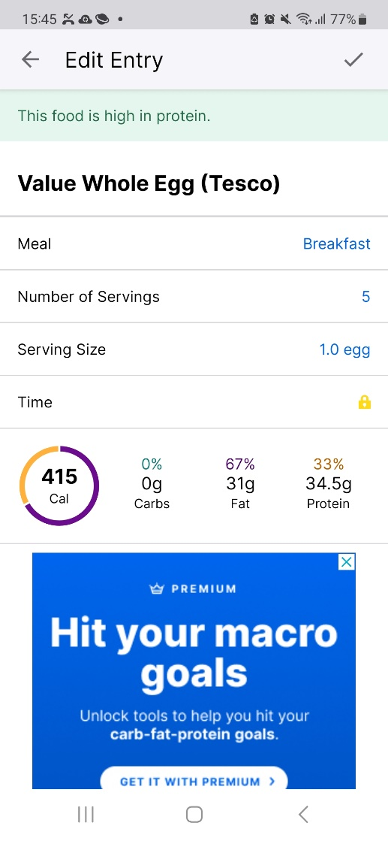

**Similarity** is clear within the dashboard of the app, with app icons having the same style and appearance. App icons are highlighted in blue with a white coloured icon to keep the style consistent throughout the app and In line with company branding. Add food options within the food diary all appear similar as they have the same font style and colour, and are placed in the same position beneath the logged food item. Colour throughout the app appears to be consistent however when user navigates to the newsfeed section it visually feels duller, as it lacks the colour blue other interfaces have throughout. There is inconsistency and I recommend a consistent colour theme within all tabs to create visual uniformity.

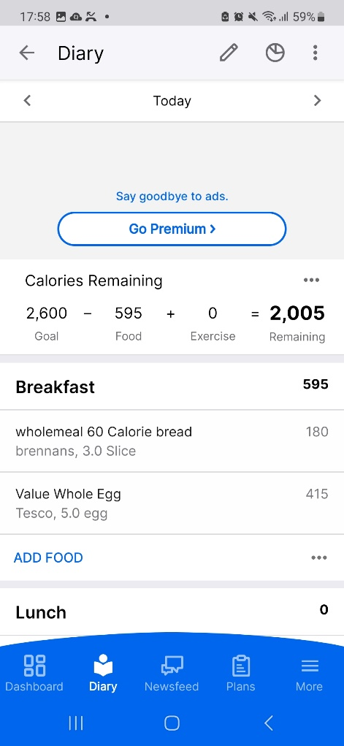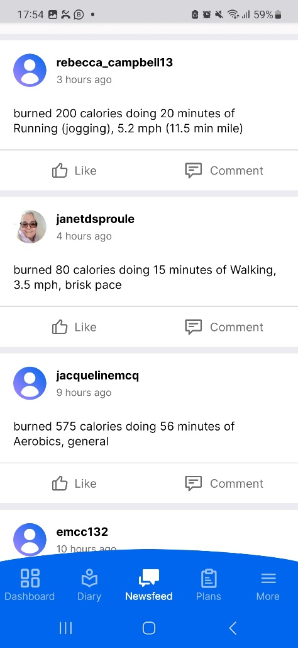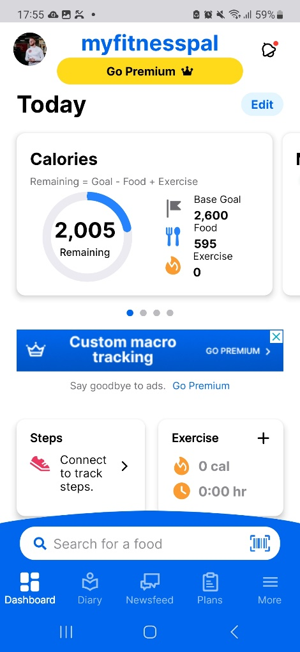

Newsfeed visually feels duller. Less icons, coloured text and style comparatively.

Clear similarity in dashboard and diary sections with consistent colours, text font and styles used.

It applies **closure** connecting elements visually throughout the app, like linking food entries to specific meals (lunch, dinner, snack etc.) or grouping work out details within the food entry log at the bottom to keep everything connected visually. Continuity is used creating smooth and continuous flows in the app’s layout, especially in the presentation of daily logs and progress tracking. Navigation within features is typically horizontal, in the diary users can switch to the next or previous day, check their nutrition targets and select an item.

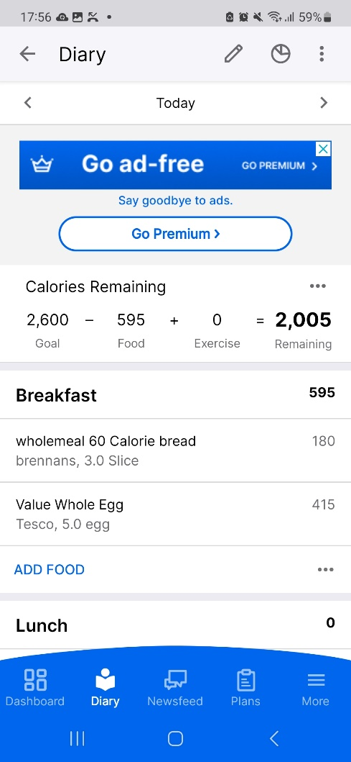

Horizontal navigation used here to allow users to switch to the next or previous day.

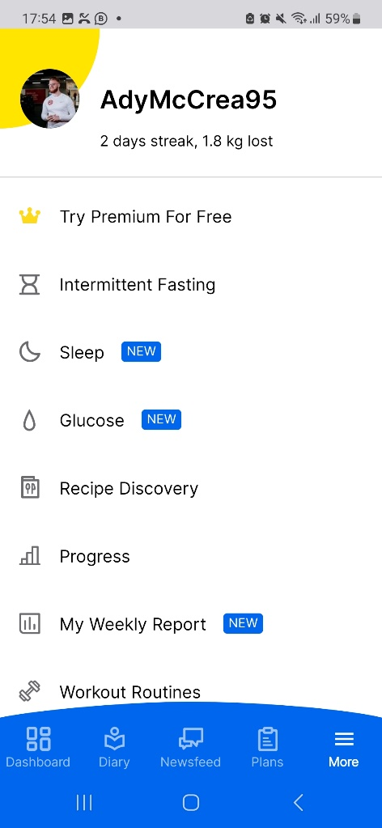

Vertical navigation primarily used for main navigation tab. Data is displayed horizontally so users can scroll up or down to navigate to the selected section.

**Symmetry and order** are achieved by attempting to organise the app structure in a balanced and organised way, trying to provide a sense of order and clarity, which I feel is poorly executed as it feels more chaotic than orderly. The tested users found it difficult to navigate through the app, and commented it was too busy and didn’t feel organised. Menu layouts and interfaces could be more organised and less busy to prevent confusion and indecision. Creating more symmetry and order could benefit the user experience, using the principle ‘less is more’.

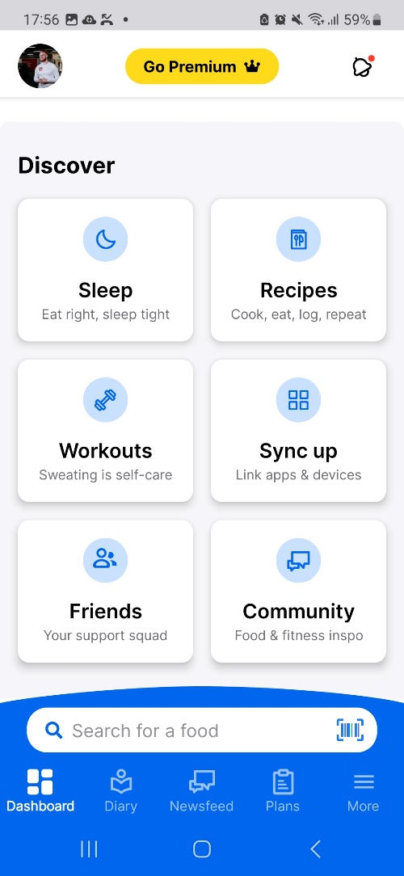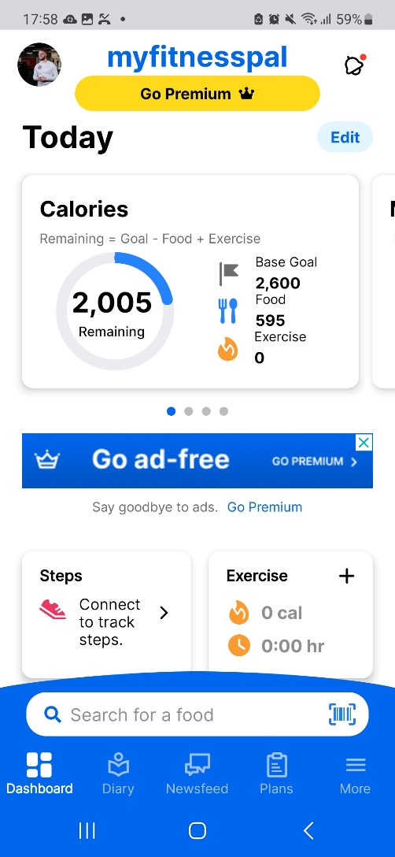

*\*Same interface*

Inconsistent structure, varying sizes of grouped data feels unorganised and more chaotic. Users found finding information difficult and the app challenging to navigate.

The **figure/ground** principle is used throughout the navigation features of the app. There is a clear distinction between foreground and background elements, with key information standing out within a blue navigation bar with icons. In other sections such as the food diary, this could be utilized better, as it can be difficult to see key information such as total calorie intake from other information. Colours used could be different or bold text to highlight elements from the background. This could make the apps information easier to find for the user.

There’s a clear **focal point** on the dashboard clearly directing attention to critical actions such as searching for a food or highlight daily calorie intake. More clear focal points could be added in the diary section to direct more attention to critical actions like adding meals or viewing daily nutritional targets.

The MyFitnessPal app adheres well to the **common fate** principle, elements that are situated inside the same area are seen as ‘grouped’. Items are grouped together by physical barriers and borders especially on the dashboard. Calories, Steps, Exercise and Weight Progress are all grouped to keep different elements unified within the larger group.

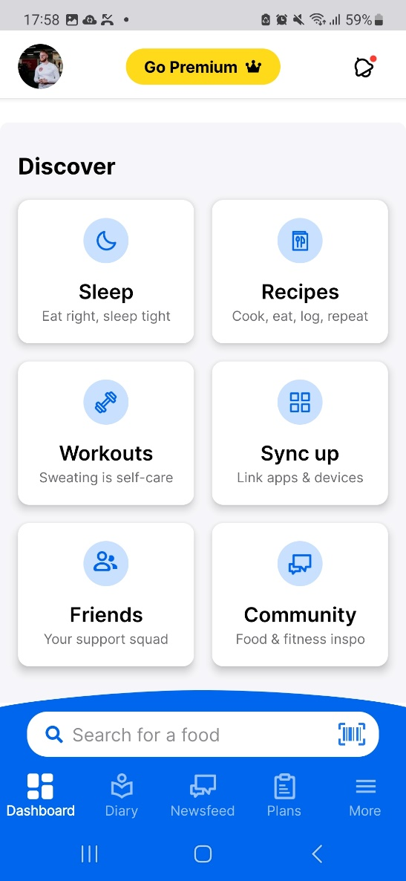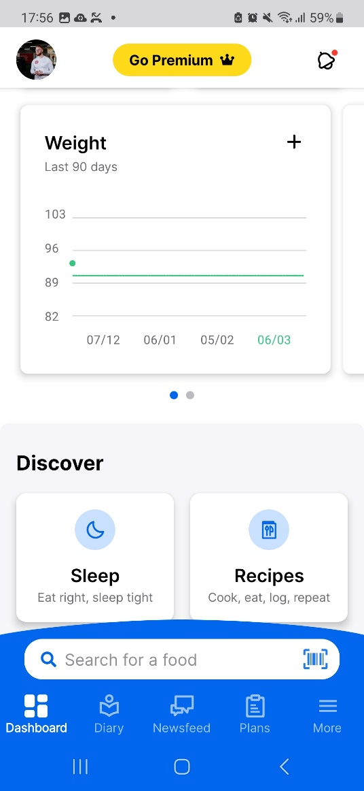

Elements situated inside the same area are grouped, keeping different elements unified within the larger group.

## Visual Structure

Visual structure refers to the arrangement and organization of visual elements within a design, composition, or any visual presentation. It encompasses how different elements are positioned, grouped, and interact with each other to form a cohesive and meaningful whole.

A structured text layout is visible as all page formatting is consistent and similar. MyFitnessPal uses clear headings and categories to organize different sections of the app, such as the diary, newsfeed and dashboard.

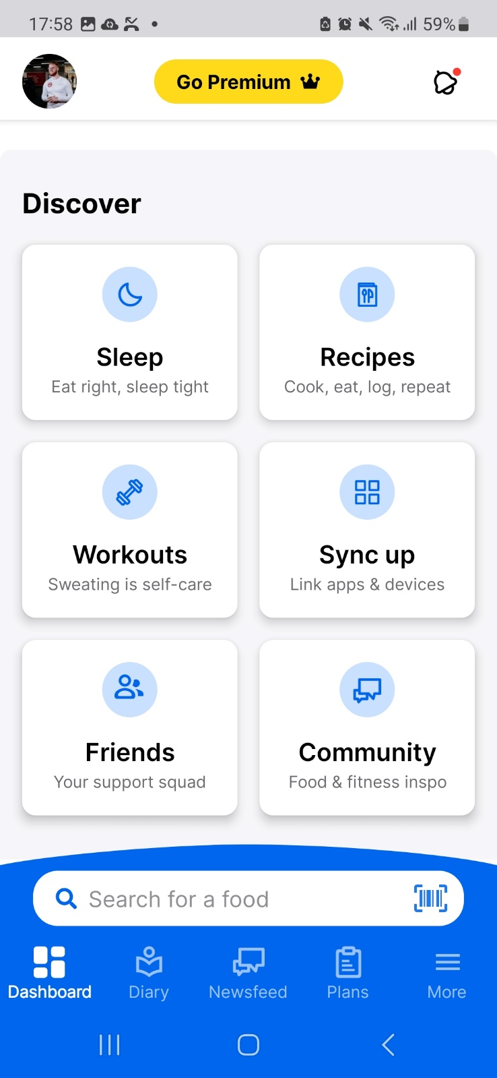

A structured text layout involves a consistent use of typography, including font styles, sizes and colours. MyFitnessPal employs a distinct font for headers, subheadings, and body text to create a visually organized and appealing hierarchy.

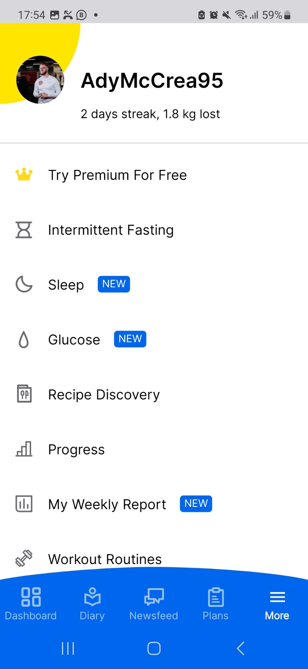

Consistent use of font styles, sizes and colours.

To enhance readability and organisation, the app utilizes lists for presenting information such as searched food items, food servings and exercise routines in a clear and concise manner.

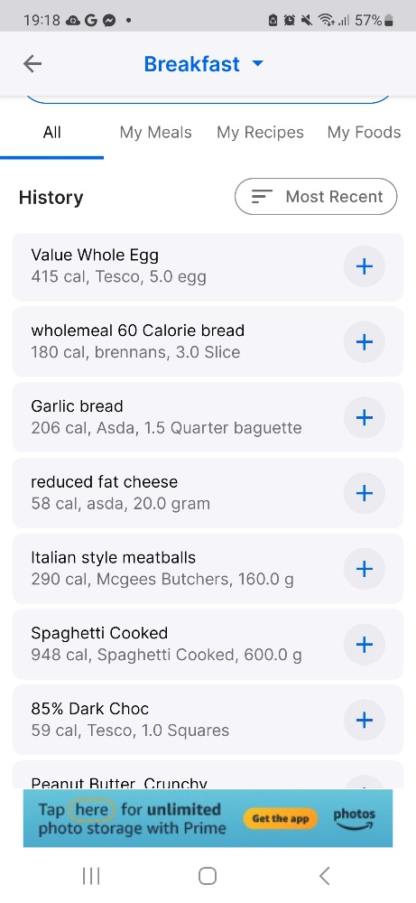

Use of lists when searching or adding a food item makes it easier to digest and navigate through information.

A structured text layout benefits from the use of grids and tables. The app within its nutritional information interface utilizes a table to display the macronutrient breakdown of the day for the user, creating a systematic and organized way to present the data to the user.

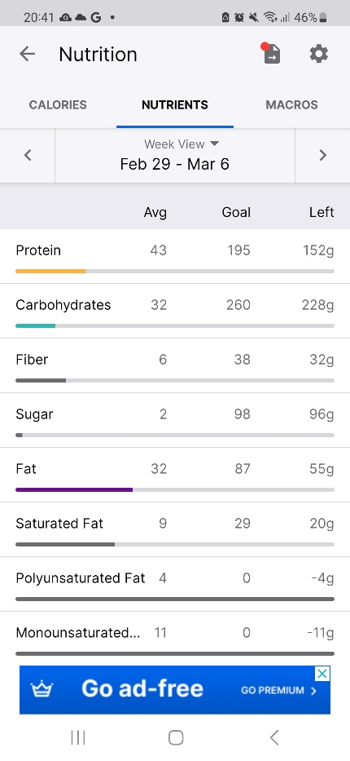

Structured used of a table to display nutritional macronutrient breakdown. Very clear, organised and systematic.

The app uses consistent spaces between sections and elements contributing to a clean and organised visual structure. It uses colour and contrast to highlight important information such as calorie counts, nutritional values, progress indicators which all contribute to a more structured and easier to understand layout.

Use of interactive elements such as buttons, links and icons are strategically placed within the text layout to try to guide users to perform specific actions, like adding meals or logging workouts. I feel MyFitnessPal doesn’t particularly execute this very well as the user feedback indicated. Improvements could be made which I discuss in my conclusion.

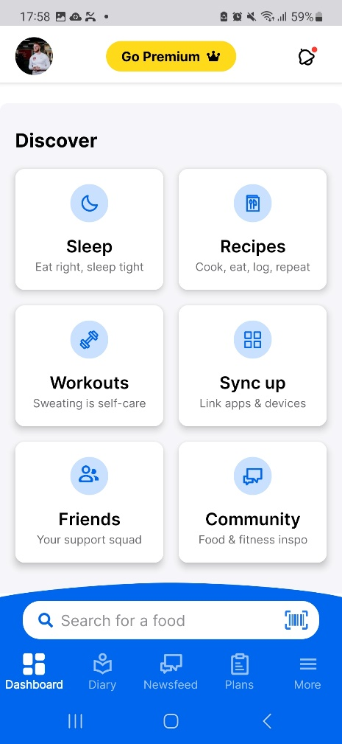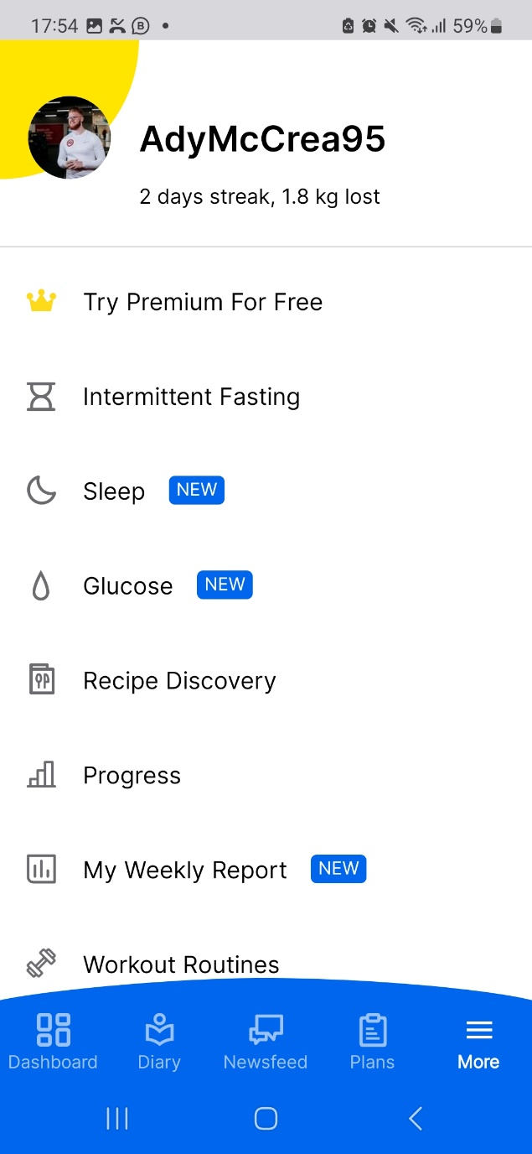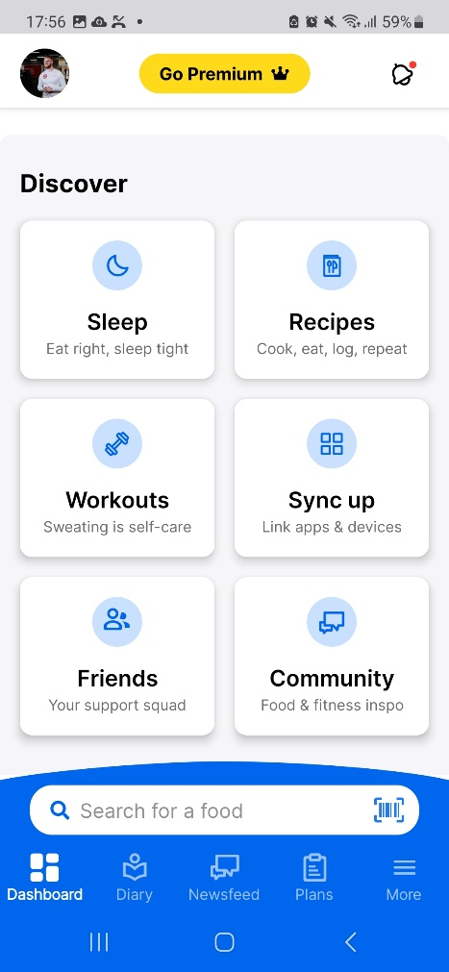

Use of icons throughout the app guide the users to perform certain tasks and actions.

The app also attempts to employ a clear and structured navigation system, of which should make it easy for users to move between different sections of the app to access the information they need. However, users found it challenging to navigate through the app and difficult to find the information they need. Improvements could be made.

## Visual Hierarchy

Visual hierarchy is also a crucial design principle that involves organising and prioritising visual elements within a layout to guide users through content and convey the relative importance of different pieces of information. It plays a significant role in ensuring that users can quickly and easily understand and interact with the content.

MyFitnessPal incorporates some of these aspects, but not very well, and more could be added. The use of icons is present within the app but often doesn’t stand out amongst other data. For instance, a prominent “add” icon may guide users to input a new food item emphasizing its importance, rather than the existing “search” bar which feels generic.



Add icon could have been incorporated to stand out amongst the other elements prompting user to use the feature to start adding a food item.

The placement of elements on screen influences their perceived importance and immediately you will notice a prominent advertisement placement within the middle of the screen on the main dashboard interface. It draws the eye towards the ad rather than the key information that ensures the user can quickly and easily use the app. Icons seem to be misplaced and don’t feel structured or congruent with user eye movement or line of vision.

Buttons, icons and important text could be made larger and more prominent to attract the users’ attention. Key buttons or critical information could be made larger in size to make it more accessible. Instead, it feels as much data as possible is cramped into one area, causing overwhelm and potential procrastination in concise decision making.

## Message Visibility

A crucial aspect of any user design interface is ensuring that important messages, alert, or notifications are easily noticeable by users. In the context of MyFitnessPal, effective message visibility helps users stay informed about their progress, goals, or any relevant updates.

Important messages, alerts, or notifications are presented with a contrasting colour to help them stand out against the background. The use of a red number icon is used to notify the user of a new message or alert. This helps them draw immediate attention to critical information allowing them to take action swiftly on that task.

Icons and symbols can serve as visual cues to convey specific meanings. MyFitnessPal uses a bell icon at the top right-hand corner of the interface to make important alerts that enhance message visibility. The red dot is also placed next to the bell to notify the user of a new notification.

Messages and notifications are placed at the top of the screen, in a prominent position within the user interface. This ensures that users are more likely to notice them, however the icons could be larger because it’s difficult to see the icon at first glance. Making it larger would ensure user’s do not miss a critical piece of information. Unread messages are highlighted in blue to confirm which messages have been read or unread.

Users can customize how the receive and view messages which I feel enhances their experience. There are preferences within the settings tab that allows the user to modify when notifications are pushed. It displays the notification options in a list format with confirm boxes depending on whether you want to activate or deactivate a setting.

Including messages in the main dashboard could capture user attention and allow them to communicate with fellow app users more effectively. Messages are only found by tapping the bell icon and selecting messages which can be confusing when trying to navigate to find your inbox or create a message.

When a user reads a notification, it simply disappears and the user is not informed when a task is completed. A success message could be shown immediately after you complete a task to confirm to the user that their action has been successful.

Search bars do not handle misspelling and entry of non-existent food items. A message could be added to prompt the user of the most accurate way to search for a food item and offer suggestions of what to type. Also, an auto-fill feature would save the user time for searching a food item.

## Conclusion

The majority of users found the MyFitnessPal app to not be well organised, easy to navigate and find information. It seems to have a higher than usual technical entry level requirement to fully utilise all the app’s features. Those with greater technical ability achieved greater success using the app. The app didn’t seem to cater to an older audience with perhaps less technical competency and poorer eye sight. Icons and text were small and interfaces were overflowing with data. MyFitnessPal users expect an app that is easy to use with a fun to use interface whist allowing them to keep a record of their nutrition, helping them reach their goals in the process. Executing all the suggestions and working with users is a sure way to guarantee a more enjoyable experience for all no matter the technical competency. The testing process gave a lot of constructive feedback and data to improve the usability of the app. However, it should be acknowledged that the test size limited to just 5 people. A bigger sample size would result in more reliable results.