In my project I will be looking at a new potential location for a restaurant in Toronto. I will be analysing the area to identify the most popular restaurants and identify a gap in the market. If the area is saturated with too much of a cuisine then it will be tough for a new restaurant to survive, therefore we will be deciding what cuisine after analysing the data.

This would be helpful to anyone who wants to open a restaurants in future as this document will analyse the area and the restaurant market providing information on competitions.

The information for Toronto was obtained through the Wikipedia, which we scraped through and built a data frame. I will clean it and use Foursquare location data to obtain the latitude and longitude for each point.

To build the data frame I took the following steps of installing BeautifulSoup4 and importing necessary program

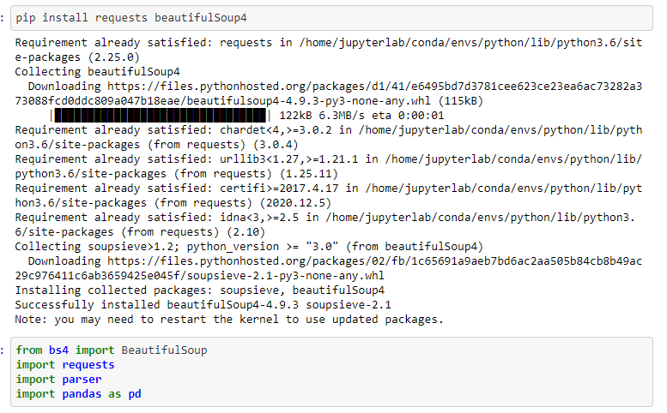

We will use the following URL to download the data

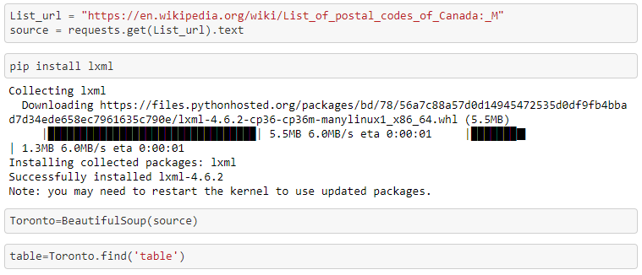

I then structed it and cleaned it for analyse

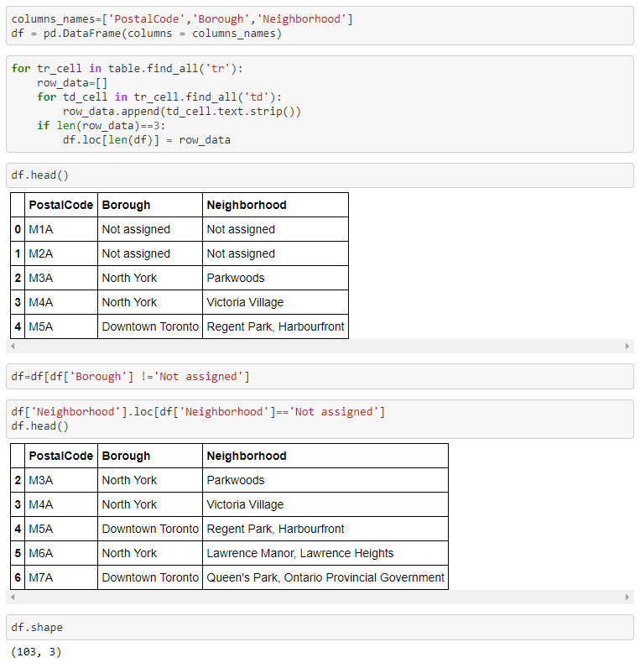

My next step was to download the latitude and longitude to each postal code area and add them to the table.

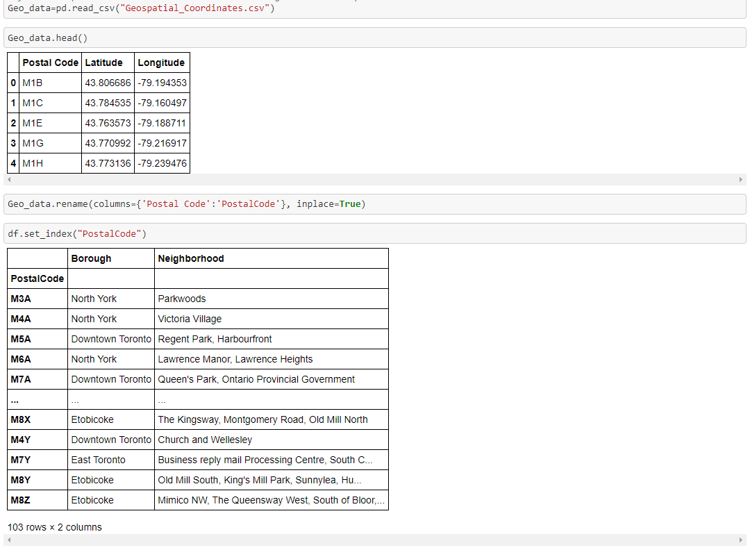

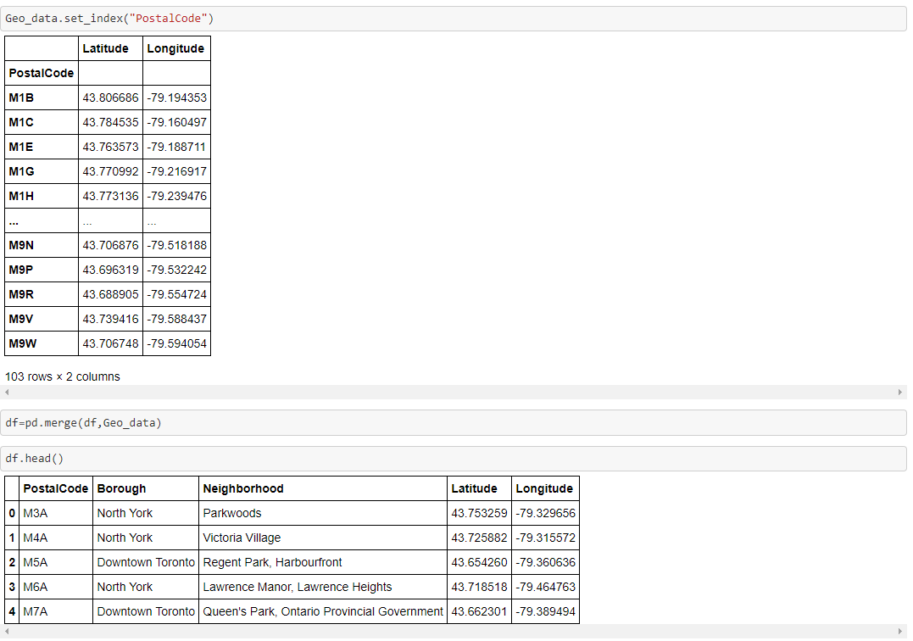

I then added my foursquare detail



My next step was to find venues and point of interest around Toronto

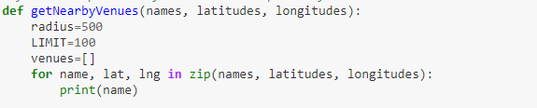

create the API request URL

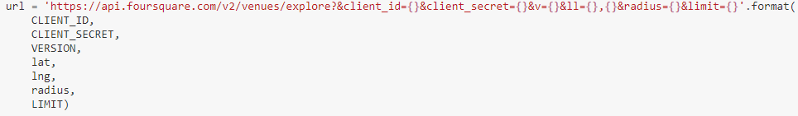

make the GET request



return only relevant information for each nearby venue

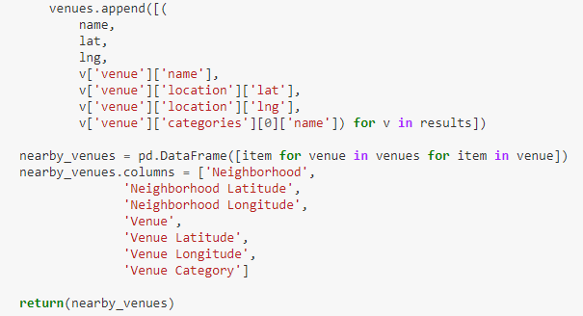



I then created a list of unique venue categories

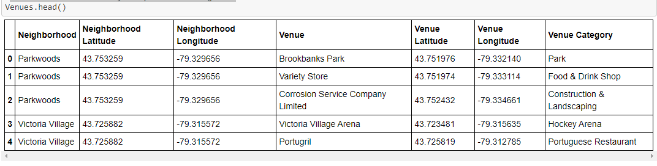

This provided 271 unique categories

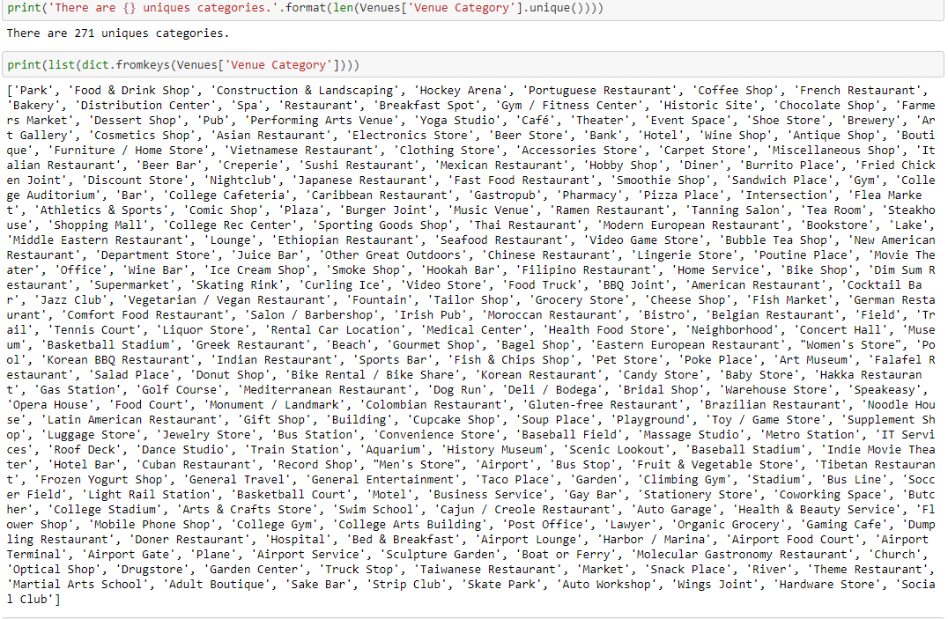

I then filtered for restaurants which gave me 485 rows of places.

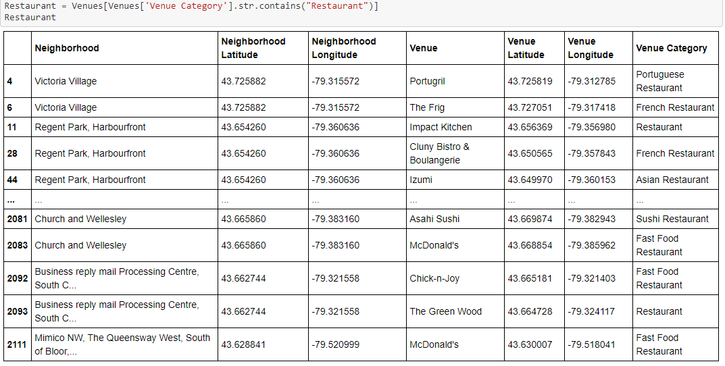

Out of which only 12 had be categorised as an Indian restaurants

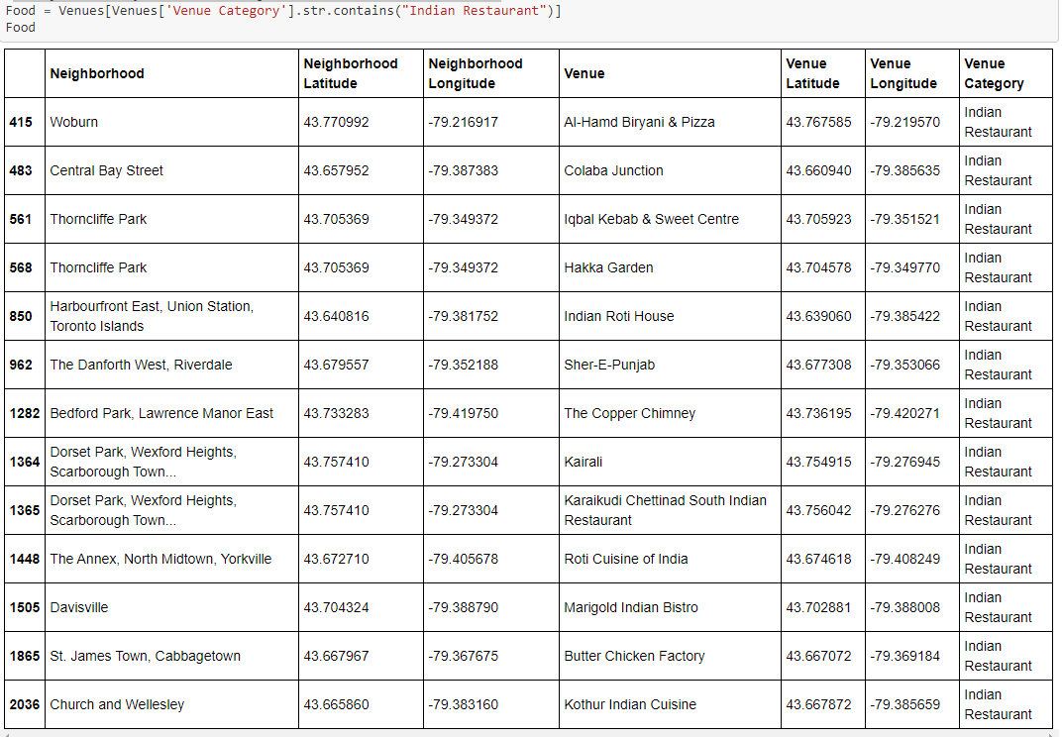

We will now have a look at these restaurants on a map to see the spread across Toronto

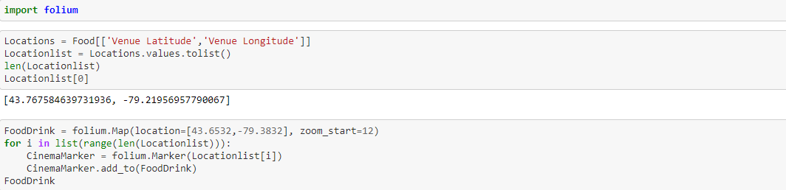

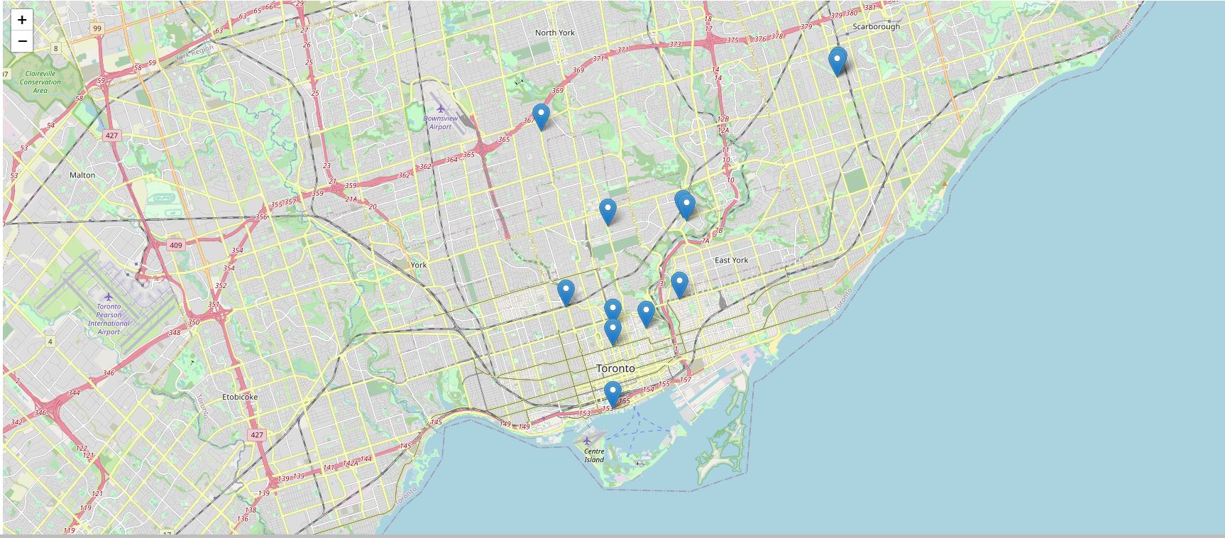



Looking at the map we can see a small cluster of Indian restaurants near central Toronto

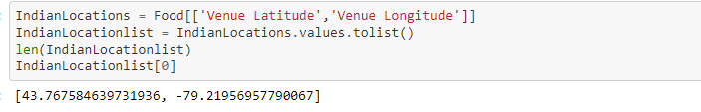

We will now look at delivery area of each restaurant to see which area is untouched.

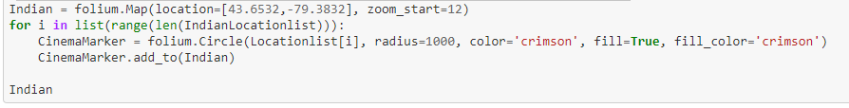

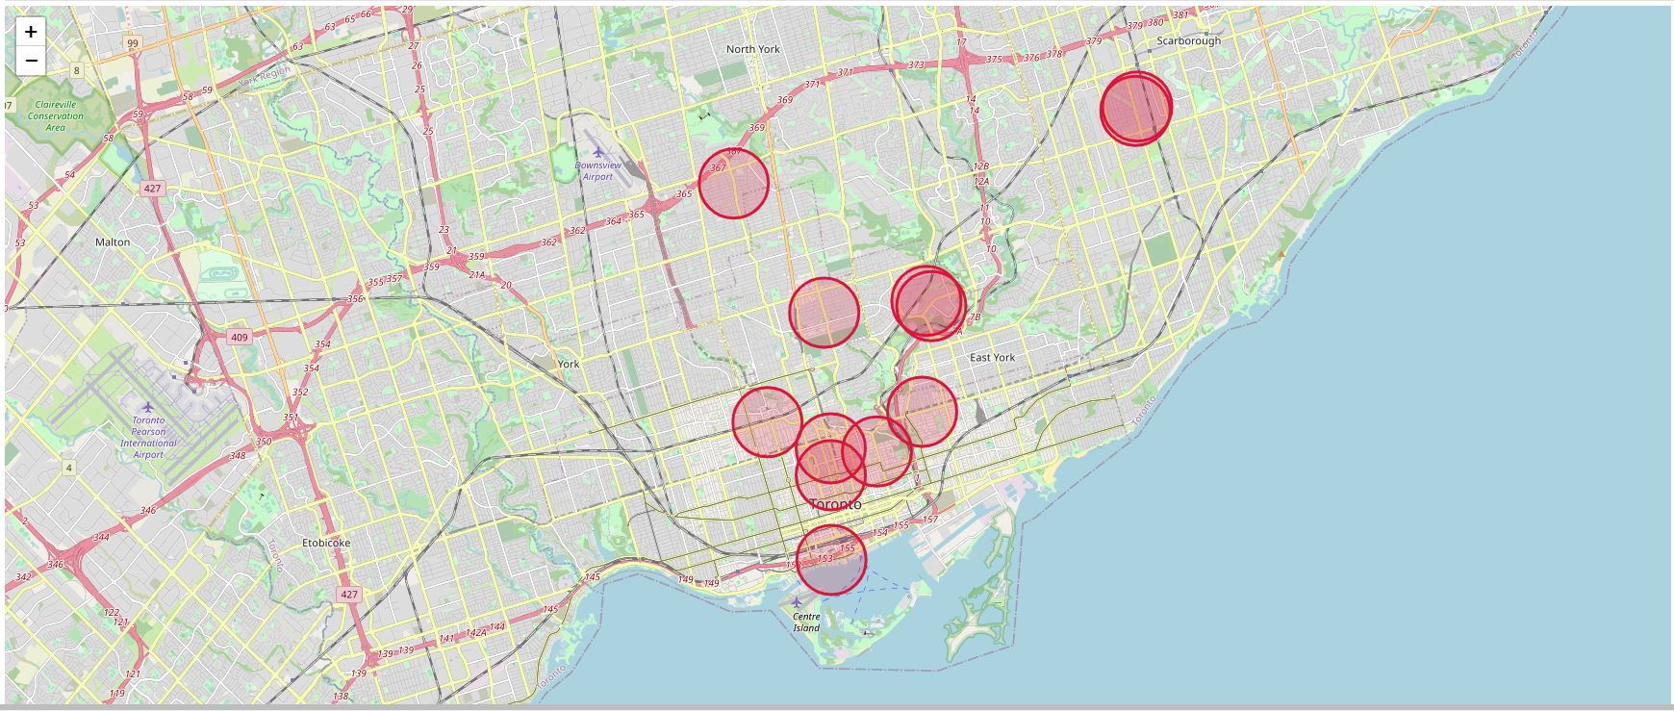

Looking at the map above I would suggest the best location for a new Indian restaurant is in York as there is no competition for a radius of 1000 and would be able to target untouched consumers.