Results

 | P1 (diluted) | P1 (spun) | P2 (diluted) | P2 (spun) | CDS (diluted) | CDS (spun) | R1 (diluted) | R1 (spun) | T1 (diluted) | T1 (spun)
Blue | 5 | 6 | 26 | 43 | 5 | 44 | 0 | 3 | 0 | 7
White | 0 | 0 | 0 | 0 | 248 | 524 | 67 | 140 | 18 | 40
Table 5 – colony count and colour of competent cells according to parts.

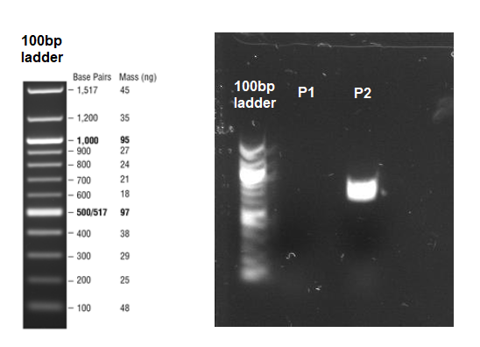

Figure 1 – gel electrophoresis banding of two PCR products (promoters P1 and P2) against NEB 100bp ladder.

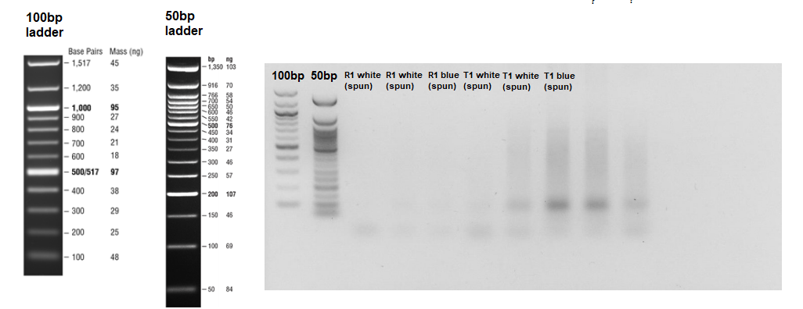
Figure 2 – gel electrophoresis banding of 8 colony PCR parts (2x white RBS R1; 1x blue RBS R1; 2x white terminator T1; 1x T1 blue terminator T1) – TBC!

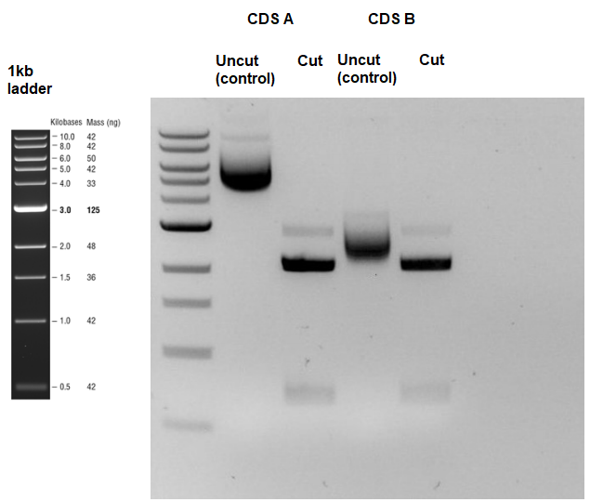
Figure 3 – gel electrophoresis showing digested GFP coding sequences (CDS A and CDS B) against uncut controls.

Figure 4 – showing relative fluorescence of constructs 1-24 (see Appendix Table 1) and a negative control.

