Introduction

The ability to create a library of DNA can be very useful for a variety of purposes, for example to assess gene function, to produce recombinant proteins, or even for gene therapy. Starting from traditional gene assembly using recombinant DNA in plasmid constructs, various DNA construction methods have been developed, such as BioBricks, Golden Gate, and Molecular Cloning (Engler, Kandzia, & Marillonnet, 2008; Røkke et al., 2014; Weber et al., 2011). These assembly methods address issues inherent in DNA construct design and methodology, such as gene pathway engineering, the need for standardisation of parts, and limitations based on the size of the assembled construct. As synthetic biology aims to replicate the design → build → test feedback loop and standardisation used by true engineering disciplines, there exists a need to develop assembly methods focused on overcoming the limitations of DNA construct design and methods in order to more easily and efficiently create new constructs, or amend existing ones.
This report describes the process, methods and results of DNA construction using Molecular Cloning (“MoClo”) described by Weber et al (2011). It was chosen for the following reasons: it is an iteration of Golden Gate design, which itself uses directional assembly of multiple DNA parts in a single-step reaction. It uses Type IIS (TIIS) restriction endonucleases, which cut outside of their recognition sites, and due to the overhanging nature of the resulting DNA overhands can be used in a restriction-ligation reaction to chain standardised DNA parts together in a particular order. MoClo is based on creating “Level 0” plasmids that contain a single DNA part such as promoters, ribosome binding sites (RBS), coding sequences (CDS) and terminators, using the TIIS restriction enzyme Bbsl. These are then used in a restriction-ligation reaction to create “Level 1” transcriptional units that contain a whole genetic construct, using TIIS Bba1 restriction enzyme (i.e. a directional DNA sequence inserted into a host which allows the gene to be expressed). Level 1 constructs can then again be added to a further restriction-ligation reaction to create Level 2 multigene constructs, which is useful for building metabolic pathways.
This report describes only the generation of Level 0 and Level 1 constructs as displayed in Figure 1. The end goal of this experiment is to achieve the introduction of Level 1 constructs which express a green flourescent reporter protein (GFP) in Escherichia coli (E. Coli) competent cells. GFP expression can be used as a method of ascertaining the successful insertion of Level 1 constructs into the cell. A total of 24 expression cassettes was made across several laboratory groups, with each group using 2 promoters, one RBS, 1 terminator and 1 GFP reporter CDS.

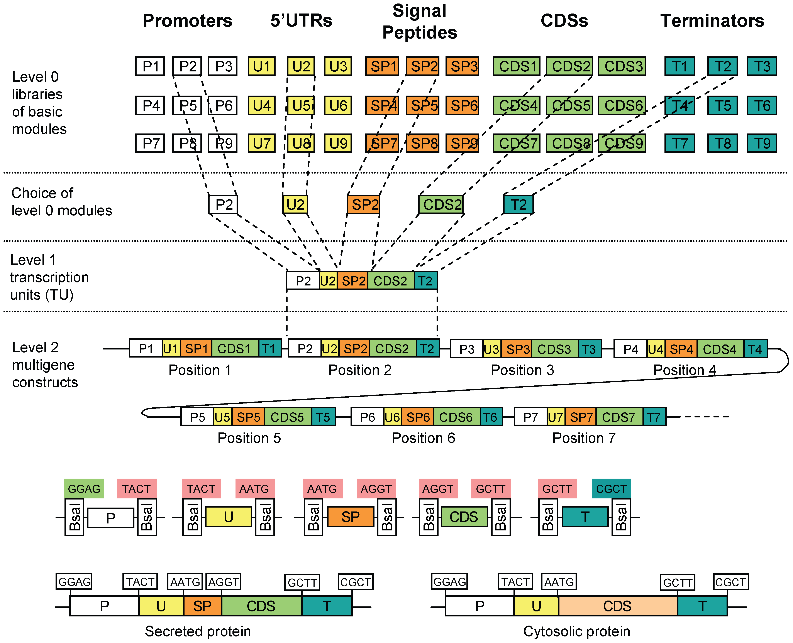
Figure 1. Molecular Cloning - a diagrammatic representation of how genetic parts are ligated together in a restriction-ligation reaction to form Level 0 constructs, which are then again restriction-ligated together into Level 1 constructs, which can then again be used to create Level 2 multigene constructs. Adapted from (Weber et al., 2011).⁠

