|  |  |  |  |  |  |  |  |  |
| --- | --- | --- | --- | --- | --- | --- | --- | --- |
| Input size | IS | | MS | | QS | | HS | |
|  | CPU time  (ms) | Memory  (KB) | CPU time  (ms) | Memory  (KB) | CPU time  (ms) | Memory  (KB) | CPU time  (ms) | Memory  (KB) |
| 4000.case2 | 0 | 12500 | 1 | 12500 | 0 | 12500 | 0 | 12500 |
| 4000.case3 | 15.998 | 12500 | 1 | 12500 | 0 | 12500 | 1 | 12500 |
| 4000.case1 | 7.999 | 12500 | 1 | 12500 | 1 | 12500 | 1 | 12500 |
| 16000.case2 | 0 | 12648 | 5 | 12648 | 1 | 12648 | 2 | 12648 |
| 16000.case3 | 241.964 | 12648 | 4 | 12648 | 1 | 12648 | 2 | 12648 |
| 16000.case1 | 120.981 | 12648 | 6.999 | 12648 | 2 | 12648 | 3 | 12648 |
| 32000.case2 | 0 | 12648 | 8.999 | 12648 | 1 | 12648 | 4.999 | 12648 |
| 32000.case3 | 780.881 | 12648 | 9.999 | 12648 | 1 | 12648 | 4.999 | 12648 |
| 32000.case1 | 480.927 | 12648 | 12.998 | 12648 | 8.999 | 12648 | 7.999 | 12648 |
| 1000000.case2 | 2.999 | 18668 | 298.953 | 20524 | 68.989 | 18668 | 198.97 | 18668 |
| 1000000.case3 | 567890 | 18668 | 278.958 | 20524 | 68.99 | 18668 | 207.968 | 18668 |
| 1000000.case1 | 283712 | 18668 | 337.949 | 20524 | 202.969 | 18668 | 315.952 | 18668 |

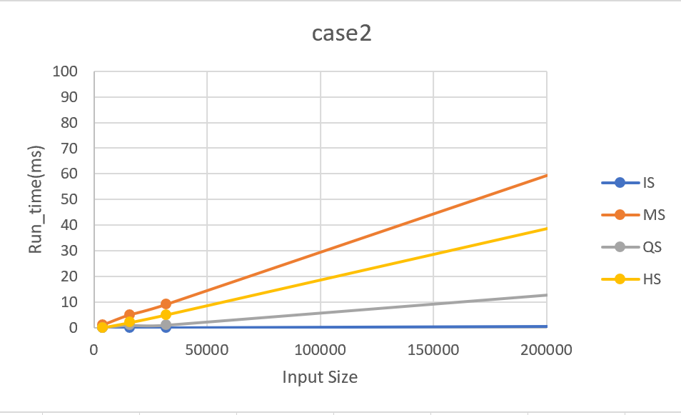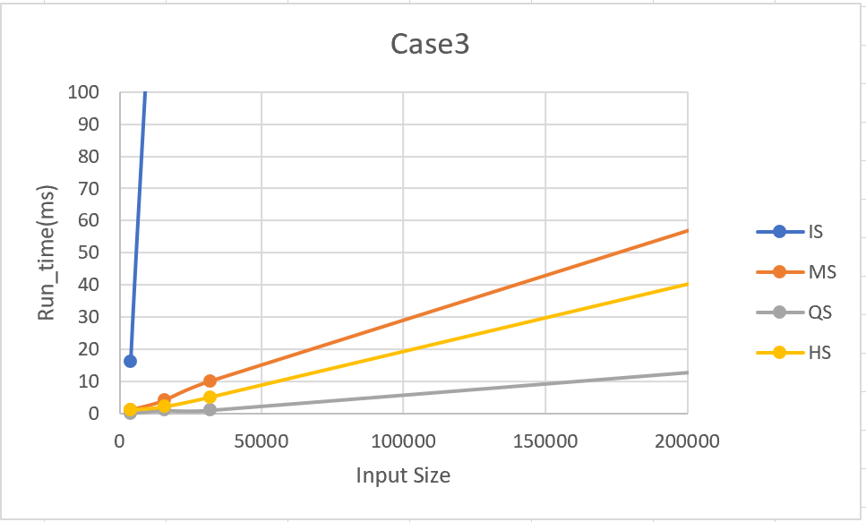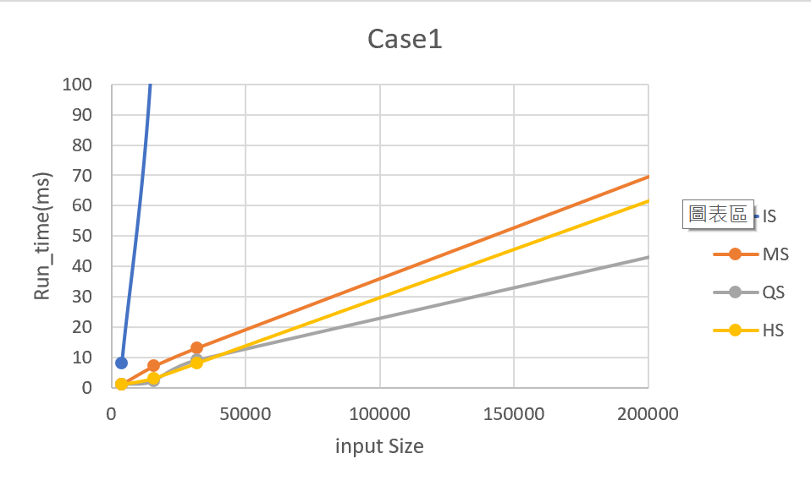

分析:

Case2為sorted array，對insertion sort而言是best case，複雜度為O(n)，因此速度最快，Merge sort因為步驟較繁雜，還要慢慢創subarray，因此時間較久。

Case1為random，因此Insertion Sort最慢，Quick_sort步驟最少，較快。

Case3為reversed order，所以Insertion Sort跑了很久(將近十分鐘)，而Quick Sort依然是最快的。