Report

Name: 陳柏豪

Student ID: b07902068

Result of 100 iterations:

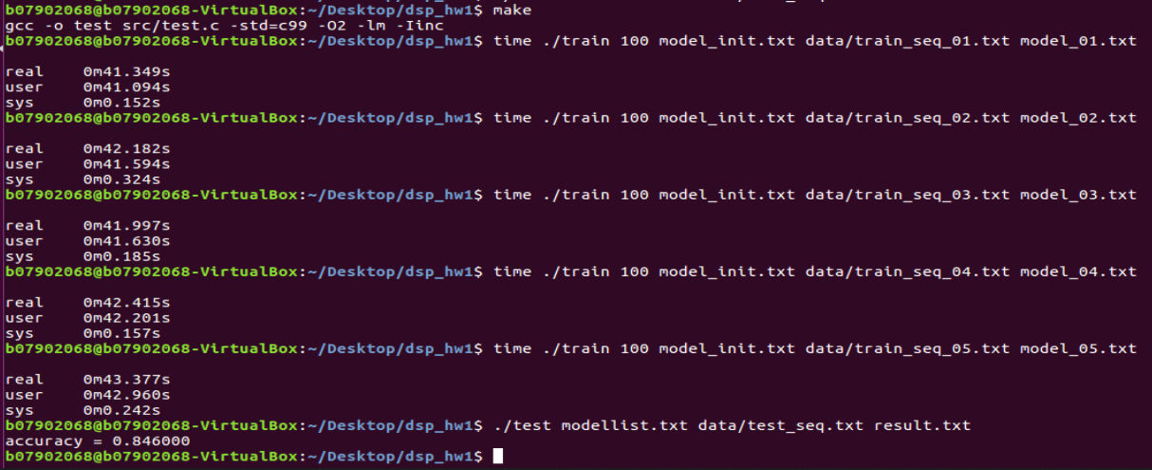

When calculating $γ_{t}\left(i\right), ϵ_{t}\left(i, j\right)$, or updating $a_{ij}, b_{j}(k)$ of the hmm model, a value will be used as denominators of many entries, therefore, values used as denominators can be calculated first and stored, rather than recalculated many times for different entries. In this way, the execution time can be reduced.