Research

This sector of this document will contain research carrying answers and questions about how the use of digital solutions have met user needs in the energy sector of industries, including:

- how hardware and software are used within the context of the industry

- newly emerging technologies

- how digital solutions could be used to meet different user needs

- the industry-specific guidelines and regulations you will need to follow.

First, we must understand what digitalisation means. Digitalisation refers to the incorporation of digital technologies within a sector. In this sense, using technologies to improve or upgrade certain sectors is called Digitalisation.

How Hardware and Software are used within the energy sector.

Digitalisation has helped obtained various technologies (old and new), to help improve work efficiency in the energy sector. Here are some ways hardware and software are being used in this sector.

In an article, [Role of software in the energy transition](https://codibly.com/blog/articles/software-in-the-energy-transition), It emphasises on how each year the energy sector becomes more dependent on the newest technological achievements, stating it is transforming more into a software business, as the innovative technology solutions shape the landscape of the energy and utilities expanding capabilities. With its increasing role in the energy business, software has to answer its biggest challenge – the energy transition.

In another article on [powermag.com](https://www.powermag.com/software-hardware-innovation-all-needed-to-upgrade-the-power-grid/), it emphasises on how hardware and software are being used in the energy sector, saying; “Software, Hardware, Innovation All Needed to Upgrade the Power Grid”.

Enhancing the transmission and distribution of electricity is a priority to ensure a reliable and resilient power supply, as demand increases and grid challenges mount.

Providing more electricity to meet growing global demand for power has put a spotlight not only on adding more generation to the grid, primarily through construction of new power plants, but on improvements to the grid itself. Enhancements to support power grid reliability include investments for a variety of technologies, such as battery energy storage systems (BESS), advanced transmission lines, smart grid infrastructure, and distributed generation. Upgrades also focus on improved grid monitoring and control systems that allow for better and faster response to fluctuations in demand and disruptions caused by weather, equipment, or other issues.

“Needed enhancements span across condition monitoring, advanced data analytics, fire mitigation, and improved system control mechanisms,” said John Russell, senior director, Solution Consulting at [AspenTech](https://www.aspentech.com/en/), a provider of software and services for the process industries.

Bennett added, “Ensuring transmission, distribution, and generation assets are equipped with IoT sensors for real-time data collection, monitoring, and reporting capabilities has become a core focus over the past few years as well. These sensors provide operators with actionable insights into system performance and potential issues, allowing them to leverage both cloud and on-premises data to uncover complex insights, correlations, and predictions.”

Thomas L. Keefe, vice chair and U.S. Power, Utilities & Renewables Sector leader for [Deloitte](https://www2.deloitte.com/us/en.html), said, “Increasing visibility and control through advanced grid technologies” is a major part of increasing grid reliability. “Sensors embedded throughout the network, including smart meters, automated control systems, and advanced monitoring tools, can provide real-time data on energy flow, equipment health, and grid stability,” said Keefe. “Analysing sensor data can allow operators to anticipate equipment failures before they happen, preventing outages, enhancing the utilization of existing resources, and ultimately increasing grid reliability.”

This article contains the words of various individuals who work in the energy sector speaking about the hardware and software being used in the energy sector and how they work.

New emerging technologies in the energy sector

From an article, [NAVRTIS-Emerging Technology Trends in the Energy Sector](https://www.navartisglobal.com/blog/2024/12/emerging-technology-trends-in-the-energy-sector#:~:text=The%20energy%20sector%20is%20rapidly%20evolving%2C%20with%20cutting-edge,reshaping%20how%20energy%20is%20generated%2C%20distributed%20and%20consumed.), it say; The energy sector is rapidly evolving, with cutting-edge technologies driving sustainability, efficiency and resilience...

From breakthroughs in renewable energy systems and storage to the rise of AI and smart grids, these innovations are reshaping how energy is generated, distributed and consumed. Dive into the latest trends powering the future of energy. The article also shows key technologies that are reshaping the energy sector.

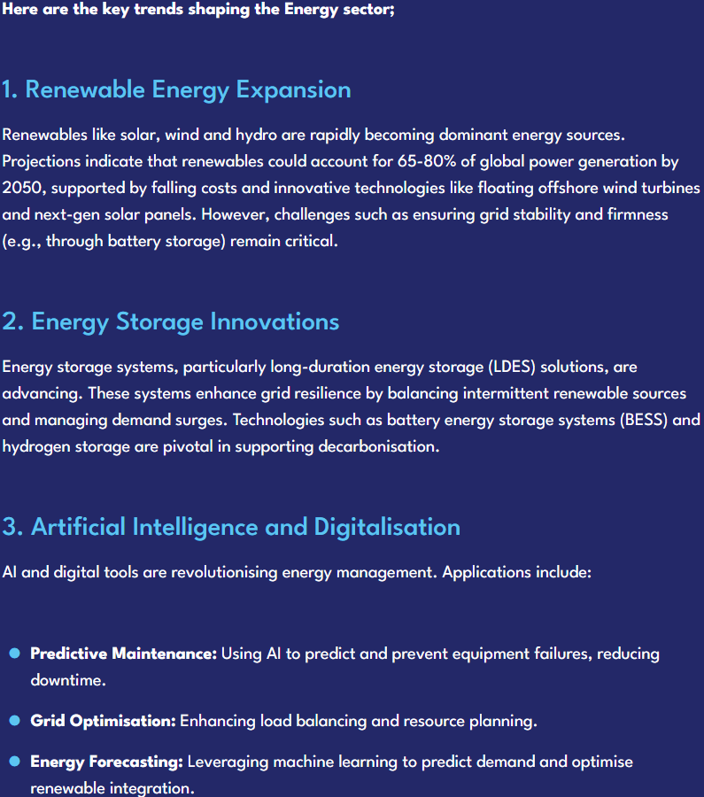

For more information and other emerging technologies listed on this article and a screenshot from it, the link is available in the document.

On another article on [energydigital.com](https://energydigital.com/top10/top-10-emerging-technologies), it talks about *Top 10: Emerging Technologies*.

It starts by saying; **From EV infrastructure & renewable energy storage to smart grid management & predictive analysis, here are 10 technologies impacting the energy industry**

There’s no doubt technology has played — and continues to play — a significant role in the pursuit of more sustainable energy, decarbonisation and the removal of harmful emissions.

It has been [key to reshaping the energy landscape](https://energydigital.com/articles/apples-commitment-to-clean-energy-and-water-investment) when it comes to production and consumption, whether it be the advancement in solar technology or the potential of small modular nuclear reactors promising clean and efficient energy, innovation in technology is instigating major change across the breadth of the sector.

For more information on the *Top 10: Emerging Technologies* on this article research, visit [energydigital.com](https://energydigital.com/top10/top-10-emerging-technologies).

How digital solutions are used to meet the needs of different users within the energy sector

From a [UK Parliament Post](https://post.parliament.uk/research-briefings/post-pn-0655/) , In the UK, the incorporation of digital technologies in the energy sector can support progress towards key UK objectives such as achieving Net Zero emissions targets. It can also transform current methods of energy generation, transmission, regulation, and trading. This parliament post carries an overview containing key digital technologies and their main applications in the energy sector, also providing potential benefits to using these technologies and recent developments in this area.

In the past decade there has been an increased use in the energy sector, including the use of digital sensors in electricity networks for supply monitoring and installation of smart meters for analysing consumers’ demand. Digitalisation can help to support decarbonisation of the energy sector as the UK seeks to achieve Net Zero emissions by 2050, by enabling more widespread use of renewable energy sources. Digital technologies can improve the flexibility and efficiency of energy systems by helping supply to better match demand. Digitalisation can help support energy systems decentralisation (where power generation uses small-scale assets closer to the consumption site) and enables different energy systems to be connected together (such as electricity transport, and renewables) leading to improved efficiency as well as greater consumer choice and improved services.

Technologies such as the Internet-of-Things (IoT) and Artificial Intelligence (AI), as well as Distributed Ledger Technology (DLT) (which is in earlier stages of being applied in the energy sector) have the potential to significantly change the way that the energy system operates. These technologies have a number of benefits, including the capability to make energy systems more connected, sustainable, and reliable. They can support improved analysis of energy sector data and can also allow deeper penetration of renewables.

On another report, [DNV article on digital transformation of the energy sector](https://www.dnv.com/article/digital-transformation-of-the-energy-sector/), It says that the UK is on a journey of change as Novel digital technologies, such as digital twins and artificial intelligence (AI), are starting to become embedded into organisational ways of working, driving unprecedented levels of transformation. These technologies are riding the wave of fourth industrial revolution, and the prevalence of data that is now being collated and warehoused at scales never seen before. Multiple industry verticals are now looking at how this data to solve challenges, improve efficiency and monitor performance.

The energy sector is at the centre of this. Where, there is collective belief that achieving net-zero emissions by 2050 is only possible through digitalising and connecting the UK’s energy system via smart data-driven systems. To reduce carbon emissions and move towards greater electrification of the UK's energy system, increased collaboration among energy stakeholders is essential. Digitalization plays a crucial role in achieving net zero cost-effectively amidst volatility, uncertainty, and complexity.

From a blog on [User research in government](https://userresearch.blog.gov.uk/2015/05/28/we-need-to-talk-about-user-needs/), It is talk understanding user needs and how to satisfy them, not just in the energy sector but as a whole. Understanding user needs saves money, as this enables better service design which results in greater digital take up, higher compliance, more effective policy outcomes, fewer user errors and inaccuracies, reduced failure demand and, overall, makes your service better value and cheaper to run.

These article, post and blog also carry explanation and thoughts with the continuation of integration Internet of Things (IoT). And various other digital technologies. For more information regarding this research and how obtained, the links have been provided.

The industry-specific guidelines and regulations that need to be followed

The energy sector is subject to a wide range of legal considerations, including environmental regulations, health and safety laws, and energy policies. These legal frameworks aim to protect the environment, ensure public health and safety, and promote sustainable energy practices. Corporations in the energy sector must navigate these legal requirements to maintain compliance. This involves understanding and interpreting complex laws, obtaining permits and licenses, conducting environmental impact assessments, and implementing appropriate risk management strategies. Legal considerations also extend to contractual agreements, [intellectual property](https://michaeledwards.uk/intellectual-property/) rights, and international trade laws, as the energy sector often involves collaborations and transactions across borders.

In the energy sector, compliance is of utmost importance for corporations due to the potential environmental and social impacts of their operations. Non-compliance can result in legal penalties, reputational damage, and financial losses. Compliance ensures that corporations operate responsibly, minimise their environmental footprint, and meet the expectations of stakeholders, including governments, communities, and investors. It involves monitoring and reporting on various aspects, such as emissions, waste management, and safety protocols.

These are some regulations and guidelines the energy sector has to comply with.

**Environmental Compliance:**

Environmental compliance is of utmost importance in the energy sector. It ensures that energy companies adhere to laws and regulations that are designed to protect the environment and promote sustainability. There are various laws and regulations related to environmental compliance in the energy sector. These include laws and regulations pertaining to air and water pollution, waste management, and renewable energy. For example, there are strict limits on the amount of pollutants that can be emitted into the air or discharged into water bodies. Energy companies are also required to properly manage and dispose of their waste, including hazardous materials. The potential consequences of non-compliance with environmental regulations can be severe. Energy companies that fail to comply may face legal penalties, fines, and even criminal charges. Non-compliance can also result in reputational damage, as companies may be seen as irresponsible or environmentally harmful. Moreover, non-compliance can lead to environmental damage, such as pollution of air and water, which can have long-lasting effects on ecosystems and human health.

**Health and Safety Compliance:**

Health and safety regulations in the energy sector are crucial for ensuring the well-being of workers and the prevention of accidents and injuries. These regulations cover a wide range of areas, including the handling and storage of hazardous materials, the maintenance of equipment and machinery, and the implementation of safety protocols in various work environments. Workplace safety is a top priority in the energy sector, as it involves working with potentially dangerous substances and equipment. Hazard identification plays a crucial role in preventing accidents and injuries. Energy companies must conduct regular risk assessments to identify potential hazards and implement appropriate control measures to mitigate the risks. Corporations have legal obligations to ensure the safety of their employees in the energy sector. These obligations are outlined in various laws and regulations, such as occupational health and safety acts and environmental protection acts. Energy companies must comply with these legal requirements to avoid penalties and legal consequences.

**Data Privacy and Security Compliance:**

Data privacy and security are of utmost importance in the energy sector. With the increasing digitisation and interconnectedness of energy systems, there is a growing need to protect sensitive data and ensure the security of critical infrastructure. This includes safeguarding customer information, trade secrets, and operational data from unauthorised access, theft, or misuse. Data privacy and security measures help to maintain the trust of customers, investors, and regulatory bodies, and also mitigate the risk of financial loss, reputational damage, and legal liabilities. The energy sector is subject to various laws and regulations related to data protection and cybersecurity. These include industry-specific regulations such as the North American Electric Reliability Corporation (NERC) Critical Infrastructure Protection (CIP) standards in the United States, which aim to ensure the reliability and security of the electric grid. Additionally, general data protection laws like the European Union’s General Data Protection Regulation (GDPR) apply to energy companies that handle personal data of EU citizens. Cybersecurity regulations, such as the Cybersecurity Act in the United States, require energy companies to implement robust security measures and report any cybersecurity incidents. Data breaches in the energy sector can have severe consequences, both financially and operationally. A data breach can result in the unauthorised access or theft of sensitive information, such as customer data, intellectual property, or operational details. This can lead to financial losses, reputational damage, and legal liabilities. In the energy sector, data breaches can also pose significant risks to the security and reliability of critical infrastructure. For example, a cyberattack on a power grid could disrupt electricity supply, causing widespread outages and potentially compromising public safety. Energy companies may also face legal liabilities if they fail to adequately protect customer data or comply with [data protection regulations](https://michaeledwards.uk/data-protection-and-privacy/). It is crucial for energy companies to invest in robust data privacy and security measures to mitigate these risks and ensure the resilience of their operations.

The information on these regulations were acquired from [energy-sector-compliance-legal-considerations-for-corporations](https://michaeledwards.uk/energy-sector-compliance-legal-considerations-for-corporations/). If more information is needed, the link has been provided.

Proposal

What comes after this could be seen as part of the research made but will be used as a start of this proposal. It is to show where the idea for this proposal has come from.

Like Rolsa Technologies, there are other companies that offer the same services, but with this research, we hope to see what these companies go and improve that for Rolsa Technologies. A particular company has been sighted, known as [myenergi](https://www.myenergi.com/).

This website/app offers services to help its consumers (both personal and business) monitor, maximise and manage their energy from anywhere. as it is said on their website. It is confirmed that they do indeed as they say. With ideas from the [myenergi](https://www.myenergi.com/) web-app, we strive to obtain a similar yet more improved website for our client, Rolsa Technologies to carry out their business.

Another website/app discovered is [ev.energy](https://www.ev.energy/en-gb/drivers). as said on their website, offering its users/consumers various services from electric vehicle charging to solar installation.

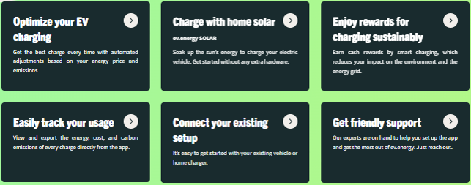

Performing similar tasks as [myenergi](https://www.myenergi.com/), they both have the same plans as Rolsa Technologies and can easily be seen as competition in the marketing aspect.

Introduction

This proposal presents a detailed approach for developing a bespoke digital solution to meet the diverse needs of Rolsa Technologies, a forward-thinking company specializing in renewable energy solutions such as solar panel installations, electric vehicle (EV) charging stations, and smart home energy management systems. Central to this proposal is the goal to enhance customer interactions, knowledge, and engagement with sustainable energy technologies.

Business Context

As Rolsa Technologies operates in the green technology sector, it faces increasing competition from both startups and established companies alike. Today’s consumers are not only interested in high-quality products but are also keen to understand how these technologies can reduce their carbon footprint. Recent market studies conducted by Rolsa Technologies indicate that customers express a need for a unified digital platform that provides comprehensive information about green energy products and services. Furthermore, as the global emphasis on sustainability continues to intensify, demonstrating corporate responsibility through digital engagement can significantly enhance brand loyalty. Thus, developing a digital solution that can effectively provide information, facilitate scheduling for consultations, and promote energy-saving practices is vital for Rolsa Technologies’ continued growth and success.

Functional and Non-Functional Requirements

Functional Requirements:

1. User Account Registration and Management: Users should have the ability to create, access, and manage their accounts securely. Account features include profile management and history logs of consultations and services.

2. Information Database: A comprehensive database providing updated information on green energy products available in the market, along with educational content on how these products work and their benefits.

3. Carbon Footprint Calculator: This tool will allow customers to input data regarding their energy consumption and receive insights into their carbon emissions, along with personalized recommendations for improvement.

4. Scheduling System: A robust scheduling feature that allows customers to book consultations for installations or maintenance services, integrated with a calendar system that sends reminders and notifications.

5. Customer Support: A customer service module offering live chat, email support, and an FAQ section to assist users with inquiries about the platform or Rolsa Technologies' services.

6. Accessibility Features: The platform should adhere to Web Content Accessibility Guidelines (WCAG) to accommodate users with disabilities, ensuring everyone can navigate the system without barriers.

Non-Functional Requirements:

1. **Usability:** The system must be easy to use, with an intuitive interface and clear navigation paths to enhance the user experience.

2. **Performance:** The application should load quickly, with minimal downtime, and be able to handle a high volume of users simultaneously.

3. **Security:** Due to the sensitive nature of user data, the platform must comply with GDPR regulations, incorporating encryption for data storage and secure authentication measures.

4. **Scalability:** The system should be designed to accommodate future growth, with the capability to integrate additional features or modules as needed.

5. **Responsiveness:** The solution should function seamlessly across various devices, including desktops, tablets, and mobile phones.

Problem Decomposition

Implementing the functional and non-functional requirements involves addressing several key challenges:

- **Account Security:** Implementing advanced security measures, including two-factor authentication and stringent password policies, to protect user data.

- **Database Management:** Creating a reliable and scalable database that updates in real-time to house product information, user inputs for the carbon footprint calculator, and service appointments.

- **User Experience Design:** Applying user-centred design principles when developing the interface to ensure it meets the needs of a diverse audience, including individuals with varying levels of tech-savviness.

- **Integration of Services:** Ensuring seamless integration between the scheduling system, notification services, and customer support channels to facilitate smooth user interactions.

Key Performance Indicators (KPIs) and User Acceptance Criteria

To evaluate the success of the digital solution, a set of key performance indicators (KPIs) will be established:

1. **User Engagement:** Measuring daily active users, session duration, and feature usage analytics to assess how effectively users are interacting with the platform.

2. **Conversion Rates:** Tracking how many users transition from account creation to consultations or purchases, evaluating the effectiveness of the scheduling system.

3. **Customer Satisfaction:** Utilizing surveys and feedback forms to gauge user satisfaction levels, aiming for high net promoter scores (NPS) and low customer support inquiry rates.

4. **Error Rates:** Monitoring the frequency of errors or failures in the application to maintain a high level of reliability and improve the user experience.

5. **Compliance Reports:** Regular audits to ensure ongoing compliance with GDPR and other relevant legislation.

Description of the Proposed Solution

The digital solution will be built as a responsive web application that prioritizes user experience and accessibility. It will feature a clean, modern design that encapsulates Rolsa Technologies’ brand ethos of innovation and sustainability. Upon logging into their account, users will access a dashboard displaying personalized recommendations based on their energy usage patterns.

Moreover, users will have access to a rich repository of educational content, including articles, videos, and tutorials on green energy practices. The carbon footprint calculator will be interactive and visually driven, providing users with a clear understanding of their impact and efficient steps to mitigate it.

The integrated scheduling system will utilize calendar integration to enable reminders for appointments, making the process straightforward for users and enhancing their experience with Rolsa Technologies.

Justification of Recommended Solution

**How the recommended solution meets the needs of the client and users**

This solution is tailored to meet Rolsa Technologies' objectives while addressing user needs effectively. By offering a seamless platform that combines education, practical tools, and service facilitation, the solution positions Rolsa Technologies as a thought leader in the green technology space.

**How potential risks will be mitigated**

Potential risks, such as data breaches, will be mitigated through robust encryption and regular security audits, along with user education on maintaining account security.

**How relevant regulatory guidelines and legal requirements, in relation to software development and the energy sector, will be addressed**

Engagement with legal advisors throughout the development process will ensure compliance with all regulatory guidelines, particularly those related to data privacy and consumer protection in the energy sector.

Conclusion

In summary, this comprehensive digital solution not only strengthens Rolsa Technologies' market position but also equips users with the knowledge and tools needed to engage positively with their energy consumption. By fostering a culture of sustainability and transparency, this platform can significantly enhance customer loyalty, drive business growth, and contribute to a greener future.