# FastQC report (via Python)

# Sample SRR6175552

## summary

Total Sequences 11624915

PASS Basic Statistics

PASS Per base sequence quality

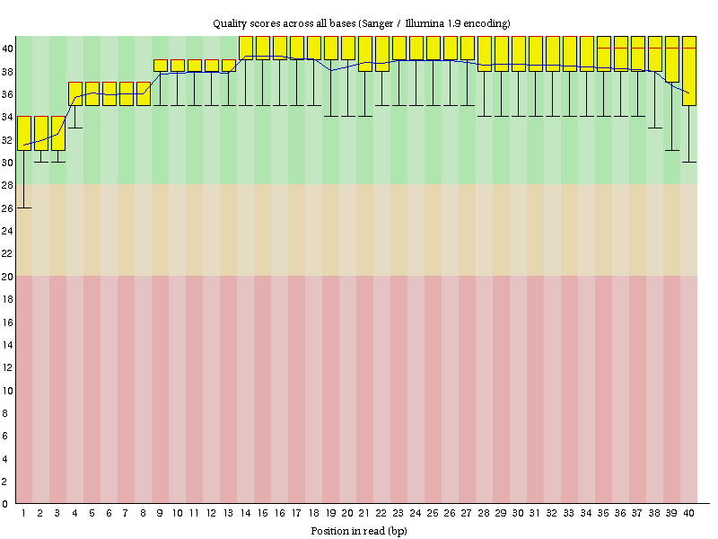

# Sample SRR6175552

## summary

Total Sequences 11437524

PASS Basic Statistics

PASS Per base sequence quality

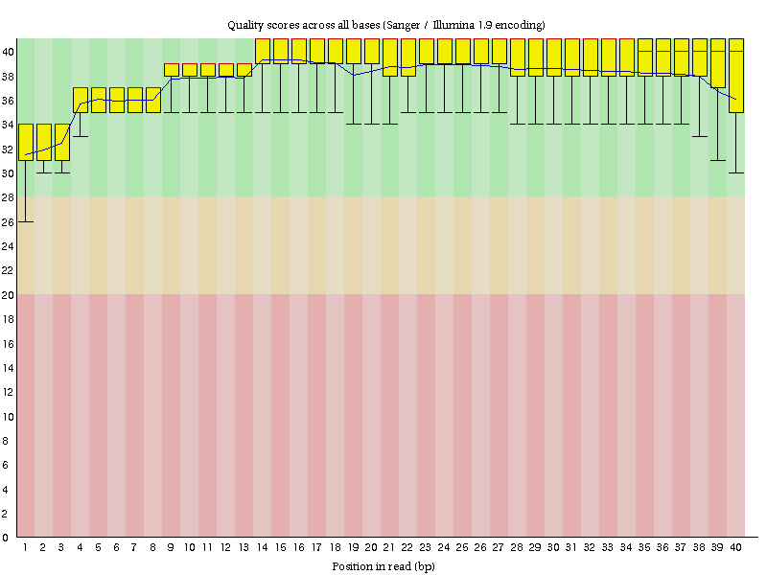

# Sample SRR6175552

## summary

Total Sequences 10698443

PASS Basic Statistics

PASS Per base sequence quality

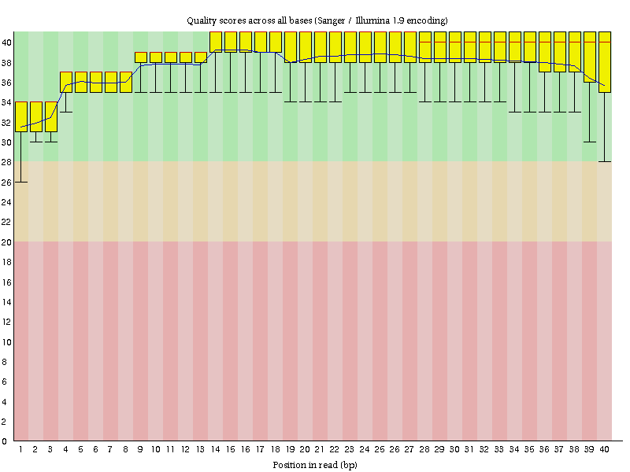

# Sample SRR6175552

## summary

Total Sequences 9578977

PASS Basic Statistics

PASS Per base sequence quality

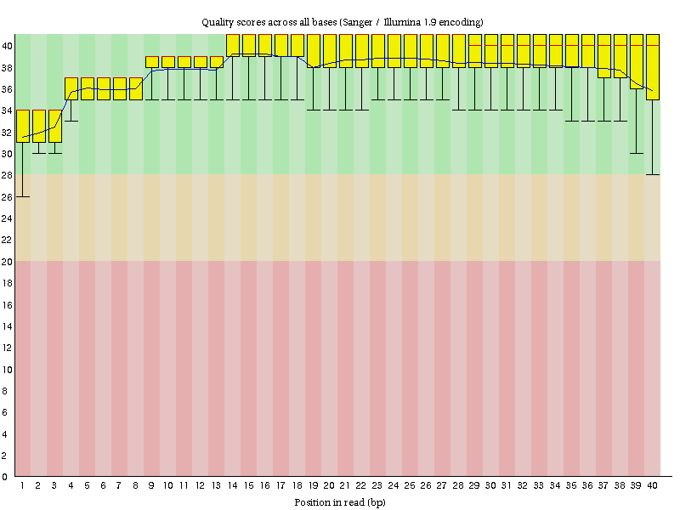

# Sample SRR6175552

## summary

Total Sequences 10607636

PASS Basic Statistics

PASS Per base sequence quality

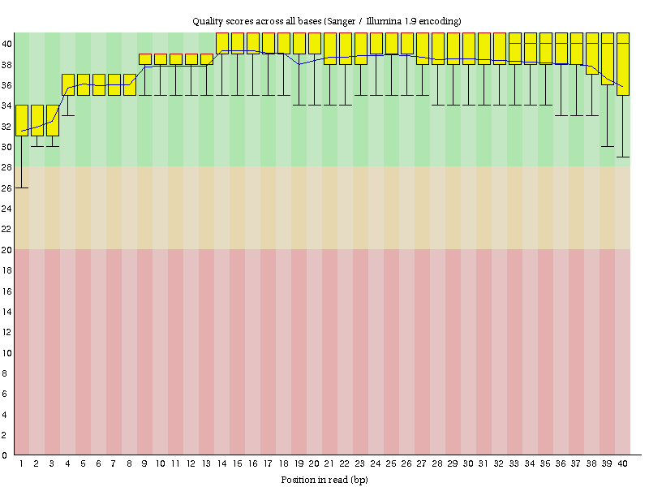

# Sample SRR6175552

## summary

Total Sequences 10417383

PASS Basic Statistics

PASS Per base sequence quality

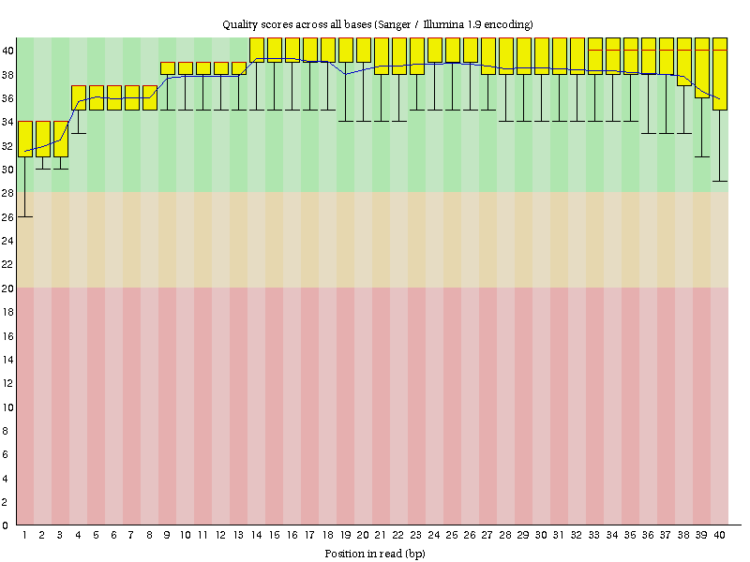

# Sample SRR6175552

## summary

Total Sequences 10510958

PASS Basic Statistics

PASS Per base sequence quality

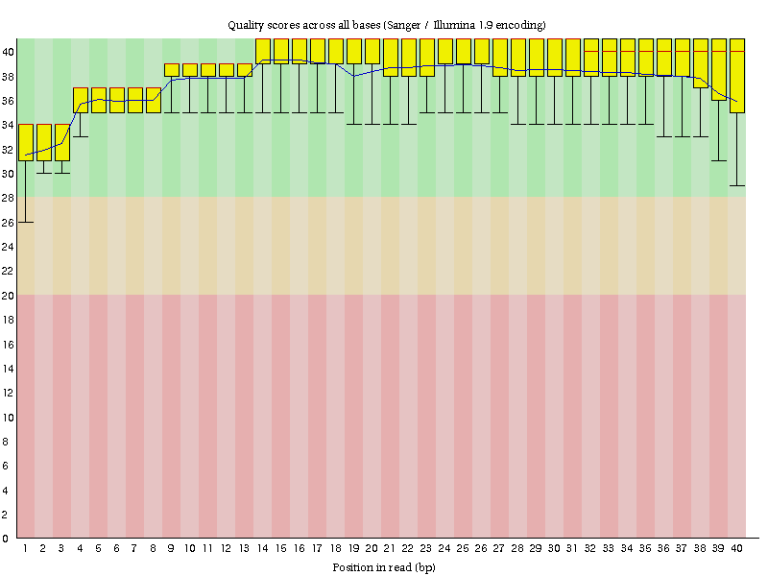

# Sample SRR6175552

## summary

Total Sequences 12780882

PASS Basic Statistics

PASS Per base sequence quality

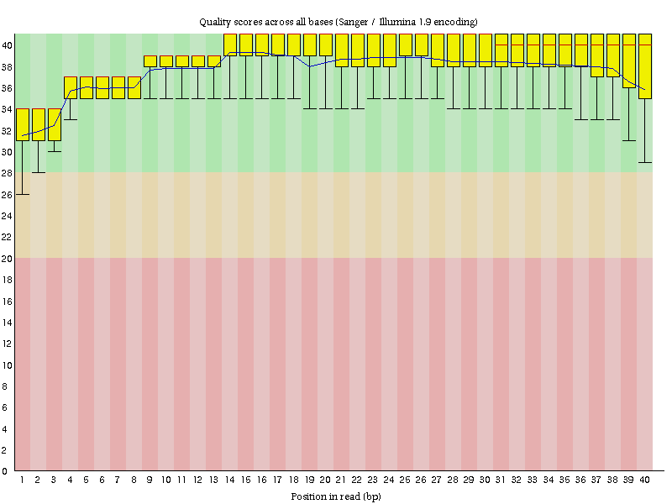

# Sample SRR6175552

## summary

Total Sequences 9892037

PASS Basic Statistics

PASS Per base sequence quality

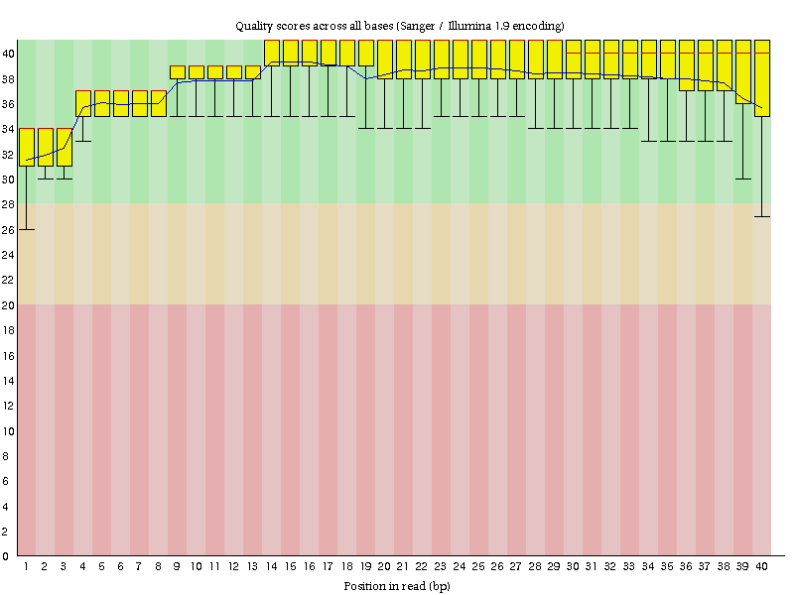

# Sample SRR6175552

## summary

Total Sequences 10202002

PASS Basic Statistics

PASS Per base sequence quality

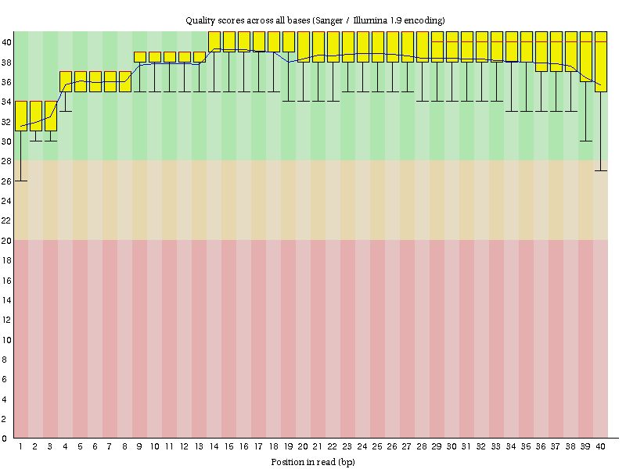

# Sample SRR6175552

## summary

Total Sequences 10785193

PASS Basic Statistics

PASS Per base sequence quality

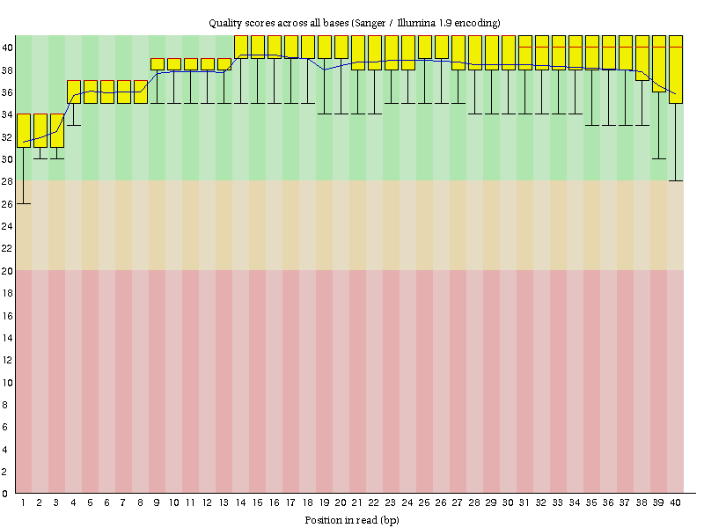

# Sample SRR6175552

## summary

Total Sequences 1376257

PASS Basic Statistics

PASS Per base sequence quality

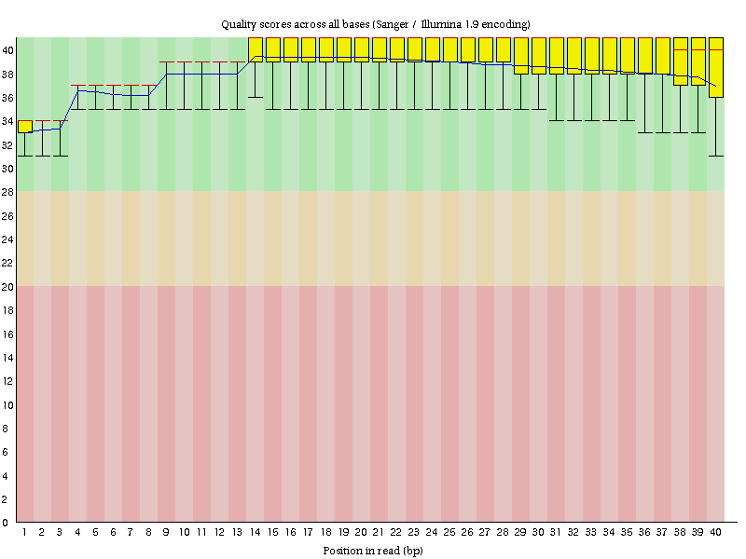

# Sample SRR6175552

## summary

Total Sequences 9662772

PASS Basic Statistics

PASS Per base sequence quality

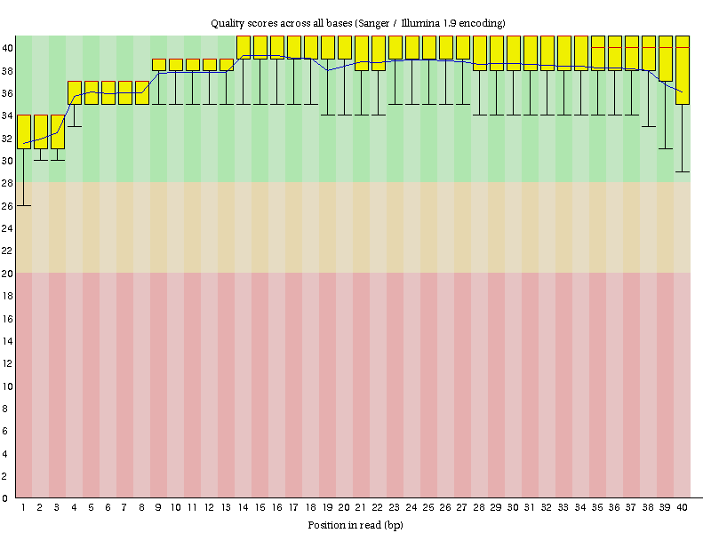

# Sample SRR6175552

## summary

Total Sequences 10526325

PASS Basic Statistics

PASS Per base sequence quality

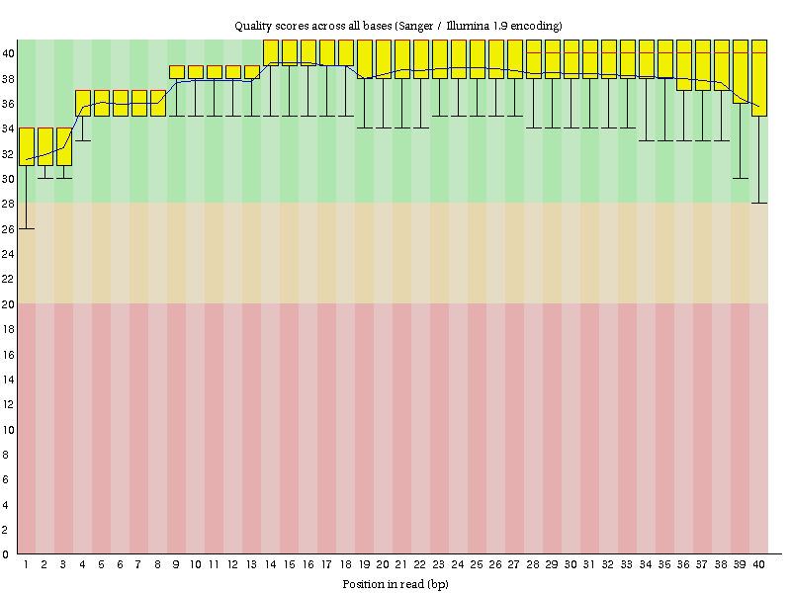

# Sample SRR6175552

## summary

Total Sequences 9766773

PASS Basic Statistics

PASS Per base sequence quality

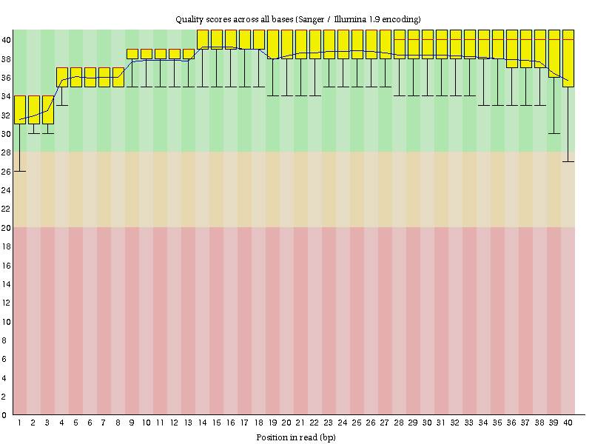

# Sample SRR6175552

## summary

Total Sequences 10671031

PASS Basic Statistics

PASS Per base sequence quality

