A PROJECT ON

“FLIGHT FARE PREDICTION”
SUBMITTED IN
PARTIAL FULFILLMENT OF THE REQUIREMENT FOR THE COURSE OF
DIPLOMA IN BIG DATA ANALYSIS



SUNBEAM INSTITUTE OF INFORMATION TECHNOLOGY, PUNE
Submitted by:

Mr. Shekhar R Drakshe (80650)

&

Mr. Rushikesh Kumavat (80510)

Mr.Nitin Kudale Mrs.Manisha Hingne Centre Coordinator Course Coordinator



CERTIFICATE

This is to certify that the project work under the title ‘Flight Fare Prediction’ is done by Mr. Shekhar Drakshe & Mr. Rushikesh Kumavat in partial fulfillment of the requirement for award of Diploma in Big Data Analysis Course.

Mr. Aniket P Mrs. Manisha Hingne
Project Guide Course Coordinator

Date:

ACKNOWLEDGEMENT

A project usually falls short of its expectation unless aided and guided by the right persons at the right time. We avail this opportunity to express our deep sense of gratitude towards Mr. Nitin Kudale (Centre Coordinator, SIIT, Pune) and Mrs. Manisha Hingne (Course Coordinator, SIIT ,Pune) and Project Guide Mr. Aniket P.
We are deeply indebted and grateful to them for their guidance, encouragement and deep concern for our project. Without their critical evaluation and suggestions at every stage of the project, this project could never have reached its present form.
Last but not the least we thank the entire faculty and the staff members of Sunbeam Institute of Information Technology, Pune for their support.

Mr. Shekhar R Drakshe
DBDA Sept 2023 Batch, SIIT Pune

Mr. Rushikesh Kumavat
DBDA Sept 2023 Batch, SIIT Pune

TABLE OF CONTENTS

- Introduction
  - Introduction And Objectives
  - Why this problem needs To be Solved?
  - Dataset Information

Problem Definition and Algorithm
  - Problem Definition
  - Algorithm Definition

3. Experimental Evaluation
  - Methodology / Model
  - Exploratory Data Analysis

4. Results and Discussion

5. GUI

6. GitHub link

7.Future Work and Conclusion
7.1 Future Work
7.2 Conclusion

1. Introduction

1.1 Introduction and Objectives

The ticketing system is to buy the ticket many days before the flight takes off to avoid the effects of the most extreme fees. Air routes usually do not agree with this procedure. Airlines can reduce costs at times when they need to build a market and when tickets are less affordable. They can maximize costs, so the price may depend on various factors. In order to predict the costs, this business uses AI to show the ways of the tickets after some time. All groups are free to adjust the price of their tickets at any moment. An explorer can save cash by booking the lowest cost flight. People who have travelled frequently by plane are aware of the fluctuations in prices.

Airlines use comprehensive Revenue Management principles to implement distinctive rating systems. As a result, the evaluation system changes the fee depending on the time, season and holidays to change the header or footer on the following pages. The ultimate goal of airways is to make a profit while the customer seeks the minimum rate. Customers usually try to buy a ticket well in advance of the departure date to avoid the increase in ticket prices as the date approaches. But in reality, it is not. A customer may end up paying more than they should for the same location.

1.2 Why this problem needs to be solved?
This project aims to predict flight prices for different flights using the machine learning model. The user receives the expected values, and using these as a guide, they can choose whether to purchase tickets.

In the current scenario, airlines are trying to manipulate ticket prices to maximize their profits. Many people frequently take flights, so they are aware of the optimum times to get affordable tickets. But there are also many people who have no experience while booking tickets and they end up falling into the trap of discounts from the companies where they actually end up spending more than they should have. By providing clients with the information they need to order tickets at the proper moment, the suggested system can help them save millions of rupees.

The proposed problem statement is “Flight fare prediction."
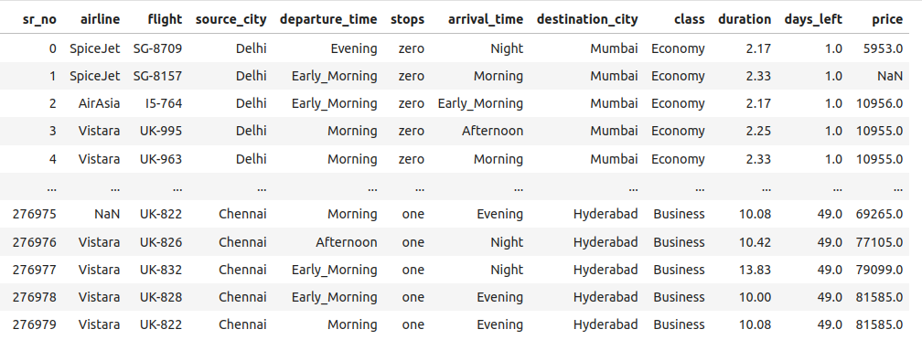
1.3 Dataset Information

flight_fare_dataset.csv

The dataset had 12 columns.

Airline : this column had all the types of airlines like Indigo, Jet Airways, Air India, and many more.

Flight number : flight number of various airlines.

Source_city: This column holds the name of the place from where the passenger’s journey will start.

Departure_time : Departure time is when the passenger will start his journey(viz. Morning, afternoon, evening, night)

Total_Stops: This will let us know in how many places flights will stop there for the flight in the whole journey.

Arrival_Time: Arrival time is when the passenger will reach his/her destination.

Destination_city : This column holds the name of the place to where passengers wanted to travel.

Class : Whether the passenger wants to opt for economy or business class.

Duration: Duration is the whole period that a flight will take to complete its journey from source to destination.

Price: Price of the flight for a complete journey including all the expenses before onboarding. This is the dependent variable and the main objective of predicting the value for the passengers for future journey.

2. Problem Definition and Algorithm

2.1 Problem Definition

The problem is quite straightforward. The Flight Fare Prediction project harnesses the power of machine learning to forecast airfare prices, enabling travelers to make informed decisions and plan their journeys more efficiently. By analyzing extensive historical flight data, the project seeks to uncover patterns and relationships among various factors influencing ticket prices. This includes considerations such as departure and arrival locations, times, airlines and number of stops.

2.2 Algorithm Definition

Linear regression : is one of the very basic forms of machine learning where we train a model to predict the behaviour of your data based on some variables. In the case of linear regression as you can see the name suggests linear that means the two variables which are on the x-axis and y-axis should be linearly correlated.

Ridge Regression : Ridge regression is a model tuning method that is used to analyse any data that suffers from multicollinearity. This method performs L2 regularization. When the issue of multicollinearity occurs, least-squares are unbiased, and variances are large, this results in predicted values to be far away from the actual values.

Lasso Regression : Lasso regression is a regularization technique. It is used over regression methods for a more accurate prediction. This model uses shrinkage. Shrinkage is where data values are shrunk towards a central point as the mean. The lasso procedure encourages simple, sparse models (i.e. models with fewer parameters). This particular type of regression is well-suited for models showing high levels of multicollinearity or when you want to automate certain parts of model selection, like variable selection/parameter elimination.Lasso Regression uses L1 regularization technique,It is used when we have more number of features because it automatically performs feature selection.

Random forest : is a Supervised Machine Learning Algorithm that is used widely in Classification and Regression problems. It builds decision trees on different samples and takes their majority vote for classification and average in case of regression. One of the most important features of the Random Forest Algorithm is that it can handle the data set containing continuous variables as in the case of regression and categorical variables as in the case of classification. It performs better results for classification problems.

Decision Tree : algorithm belongs to the family of supervised learning algorithms. Unlike other supervised learning algorithms, the decision tree algorithm can be used for solving regression and classification problems too. The goal of using a Decision Tree is to create a training model that can use to predict the class or value of the target variable by learning simple decision rules inferred from prior data(training data).In Decision Trees, for predicting a class label for a record we start from the root of the tree. We compare the values of the root attribute with the record’s attribute. On the basis of comparison, we follow the branch corresponding to that value and jump to the next node.

XGBoost : or extreme gradient boosting is one of the well-known gradient boosting techniques (ensemble) having enhanced performance and speed in tree- based (sequential decision trees) machine learning algorithms. XGBoost was created by Tianqi Chen and initially maintained by the Distributed (Deep) Machine Learning Community (DMLC) group. It is the most common algorithm used for applied machine learning in competitions and has gained popularity through winning solutions in structured and tabular data. It is open- source software. Earlier only python and R packages were built for XGBoost but now it has extended to Java, Scala, Julia and other languages as well.

MAE (Mean Absolute Error)
Mean Absolute Error is basically the sum of average of the absolute difference between the predicted and actual values.
MAE = 1/n[∑(y-ý)]
y = actual output values,
ý = predicted output values
n = Total number of data points
Lesser the value of MAE the better the performance of your model.

MSE (Mean Square Error)
Mean Square Error squares the difference of actual and predicted output values before summing them all instead of using the absolute value.
MSE = 1/n[∑(y-ý)2]
y=actual output values
ý=predicted output values
n = Total number of data points
MSE punishes big errors as we are squaring the errors. Lower the value of MSE the better the performance of the model.

RMSE (Root Mean Square Error)
RMSE is measured by taking the square root of the average of the squared difference between the prediction and the actual value.
RMSE = √1/n[∑(y-ý)2]
y=actual output values
ý=predicted output values
n = Total number of data points
RMSE is greater than MAE and lesser the value of RMSE between different model the better the performance of that model. It helps you to understand how well the independent
variable adjusted with the variance in your model. The value of R-square lies between 0 to 1. The closer its value to one, the better your model is when comparing with other model
values.

3. Experimental Evaluation

3.1 Methodology
The objective of this project is to predict the flight fare when the customer provides the required information.

Loading in raw data
df= pd.read_csv('flight_fare_dataset.csv')

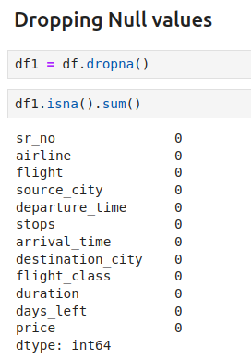
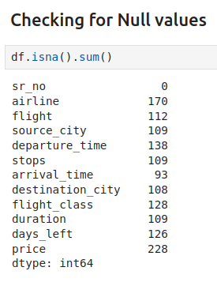
Exploratory data analysis
df.rename(columns = {'class':'flight_class'}, inplace = True)

Checking for Null values
df.isna().sum()

Dropping Null values
df1 = df.dropna()
df1.isna().sum()
df1.drop(['sr_no',"flight","duration"], axis=1, inplace=True)
df1.to_csv('cleaned_dataset.csv')
df["airline"].unique()

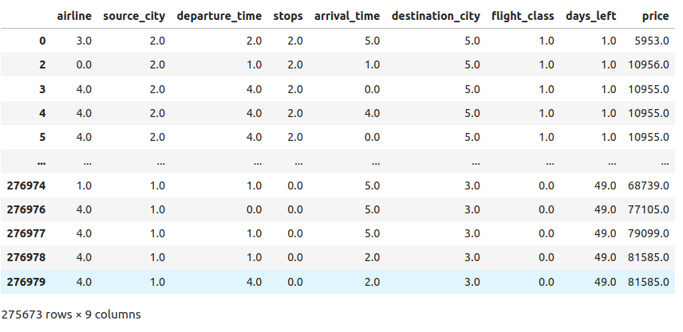
Label Encoding
from sklearn.preprocessing import OrdinalEncoder
enc = OrdinalEncoder()
df1[['airline','source_city','departure_time','stops','arrival_time','destination_city','flight_class']] = enc.fit_transform(df1[['airline','source_city','departure_time','stops','arrival_time','destination_city','flight_class']])
with open('LabelEncode.pkl', 'wb') as file:
pickle.dump(enc, file)

df1["source_city"].value_counts()

Flow Diagram
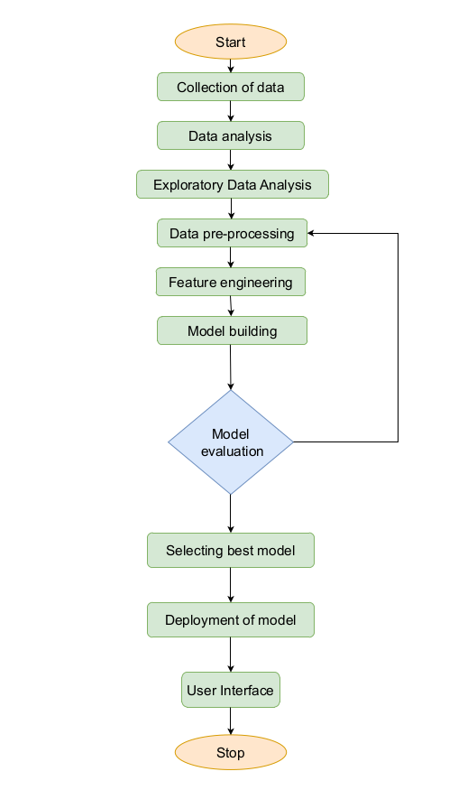

Fig 1 : Flowchart

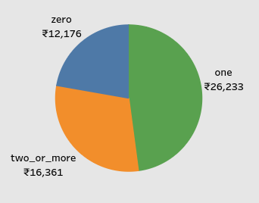
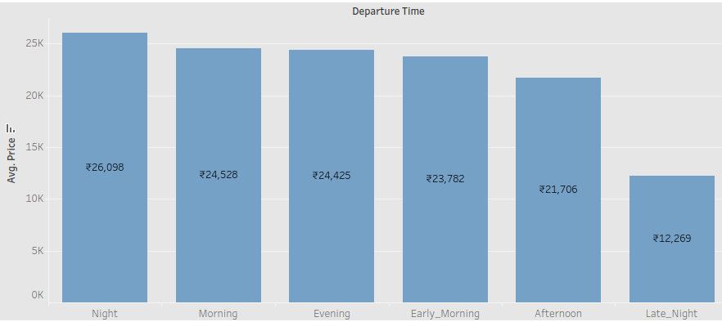
3.2 Exploratory Data Analysis

Fig 2 : Bar-chart showing Avg price vs Departure time

Fig 2 represents the average price of the flight during the different time periods of the day. This will help the customers to book the flight accordingly.

Fig 3 : Pie-chart showing Avg price vs Number of stops

Fig 3 represents the average price of the flight with respect to the number of stops during the entire journey of the customer.

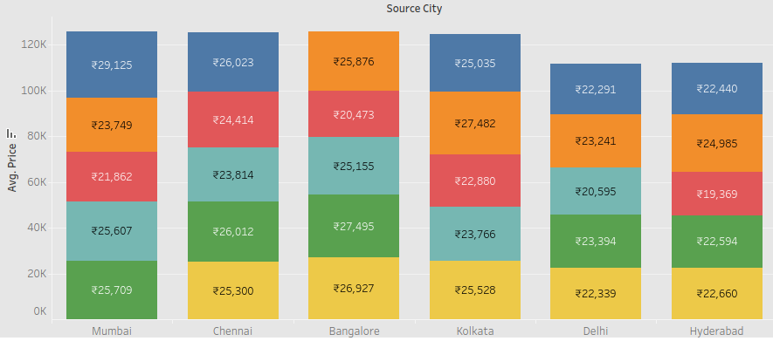

Fig 4 : Bar-chart showing Avg price from Source city vs Destination city

Fig 4 represents the average price of the flight from the source city to the different locations. This chart provides the actual comparison to the customer where he can plan his journey accordingly.
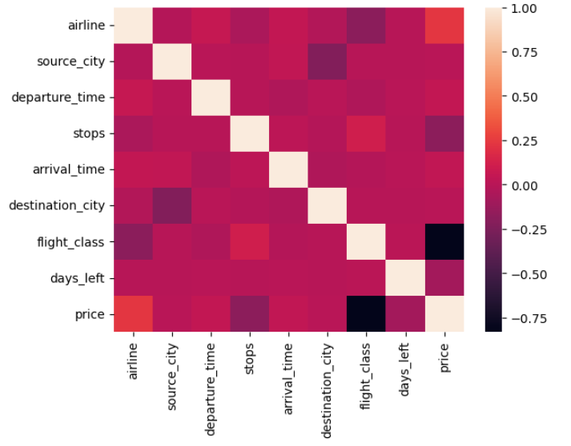

Fig 5 : Heat map showing the co-relation between the different features of the dataset

4. Results and Discussion

The accuracy and dependability of the fare forecasts are often taken into account while evaluating the outcomes of the Flight Fare Prediction System. Metrics like mean absolute error (MAE), root mean square error (RMSE), and percentage error can be used to assess the system's performance. The algorithms used, the quantity of the dataset, and the accuracy and completeness of the historical flight data can all affect the outcomes. Low mistake rates and fare estimates that closely match the real ticket pricing are the system's ultimate goals. Comparing anticipated fares to actual fares for a set of test flights is one way to assess the system's performance, as is examining the performance over a range of dates and routes. The outcomes should show how well the system generates precise fares.

5. GUI

GUI is made using Flask framework. Flask is a micro web framework written in Python. It is classified as a microframework because it does not require particular tools or libraries. It has no database abstraction layer, form validation, or any other components where pre-existing third-party libraries provide common functions. However, Flask supports extensions that can add application features as if they were implemented in Flask itself. Extensions exist for object-relational mappers, form validation, upload handling, various open authentication technologies and several common framework related tools

6. GitHub link

https://github.com/B1-80650/Flight-Fare-Prediction.git

7. Conclusion

On the dataset, Machine Learning methods are employed to forecast the dynamic flight pricing. This provides the expected airfare values to get a flight ticket at the lowest possible price. We began with a summary of airline pricing policies, which involves periodic ticket price adjustments based on internal and external factors. We described how customers and airlines interact to determine dynamic ticket costs. We imported the data set and performed exploratory data analysis to predict the outcome. We converted all text data types into numerical datatype as machine learning is the study of computer algorithms. We dropped the columns which are of no use and handled the categorical data. The training and test datasets have been split. This strategy will be utilized to prevent data leaking, and the model will be fitted using the Random Forest Regressor, Model precision is determined by the R-squared values calculated by the procedure. Future predictions will be more accurate if additional data, such as the present availability of seats, can be available. Finally, we have outlined the complete method of projecting airline ticket prices and provided evidence of our projections based on prior patterns.

