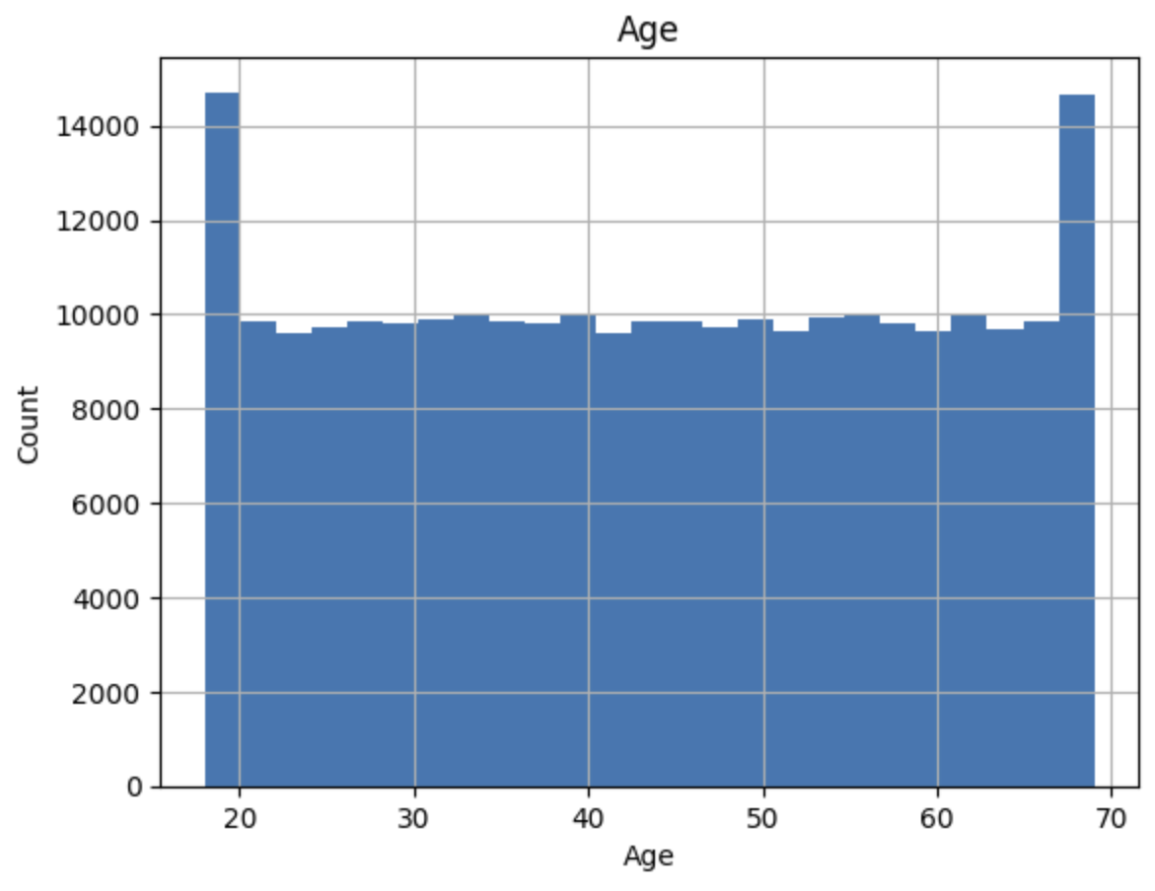

Insights from the Histogram:
- Age Distribution:
  - The histogram shows that the dataset contains age values ranging from around 18 to 70.
  - There are peaks in the number of individuals at the lower and upper ends of the age range (around 18-20 and 65-70). This suggests that there are more individuals at these age ranges in the dataset.
  - The counts are relatively uniform across the middle age ranges, indicating a relatively even distribution of ages between 20 and 65.
- Data Balance:
  - The relatively uniform distribution in the middle age ranges suggests that the dataset is balanced in terms of the number of individuals in each age group within this range.
  - The peaks at the ends may require further investigation to understand why there are more individuals at these specific age ranges.
- Potential Data Issues:
  - The spikes at the lower and upper ends of the age range might suggest potential data collection or entry anomalies, or they could reflect actual population characteristics. Further analysis might be necessary to determine the cause.

Next Steps:
- Further Investigation: To understand why there are spikes at the lower and upper ends of the age range, you might want to explore additional features in the dataset (e.g., employment type, loan amount, etc.) for these age groups.
- Feature Engineering: If the spikes are determined to be meaningful, consider creating age-related features or age groups that can help the prediction model.
- Model Considerations: Ensure that the model is not biased towards the age distribution and is fairly representing all age groups.

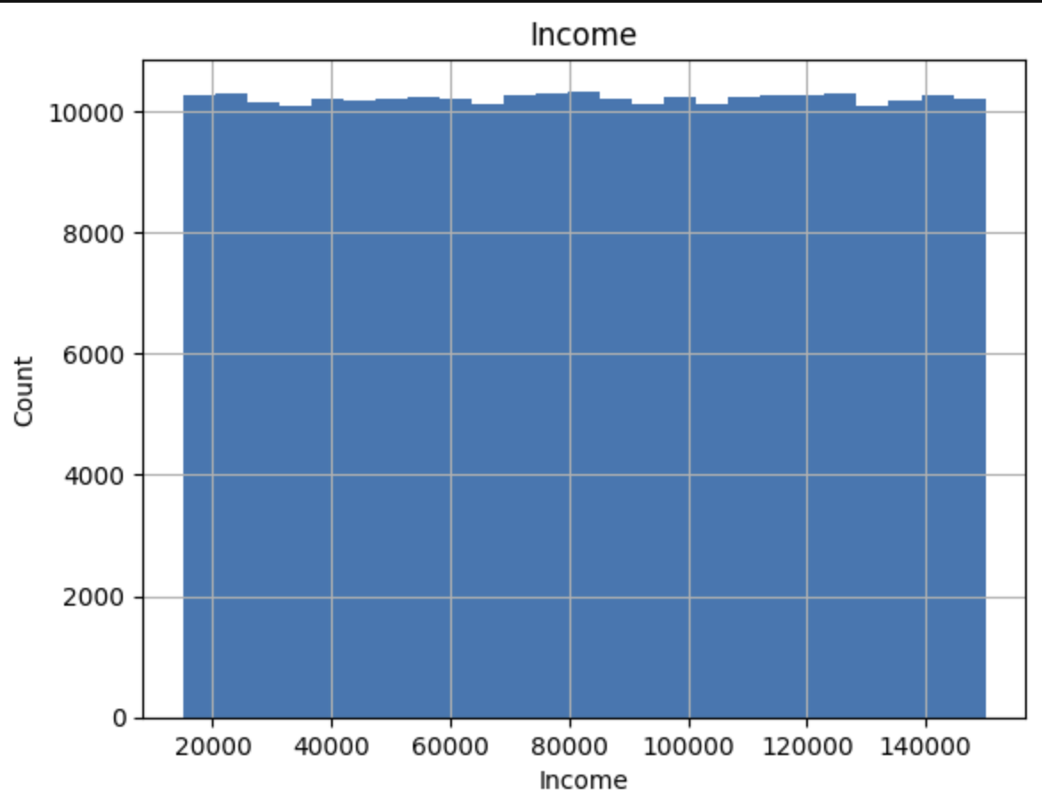

Insights from the Histogram:
- Uniform Distribution:
  - The income distribution is relatively uniform across the range, which suggests that the dataset includes individuals with a wide range of income levels.
  - There are no significant peaks or dips in the distribution, indicating that no particular income range is overrepresented or underrepresented.
- Range of Income:
  - The incomes in the dataset range from approximately 20,000 to 140,000.
  - This wide range of income values suggests diversity in the financial backgrounds of the individuals in the dataset.

Implications for Analysis:
- Balanced Representation: The uniform distribution indicates a balanced representation of different income levels, which is good for model training as it reduces the risk of bias towards any particular income group.
- Feature Engineering: Since income is uniformly distributed, you might consider creating income brackets or categories (e.g., low, medium, high) for more granular analysis and feature engineering.
- Model Training: The diversity in income levels can help the model learn better by exposing it to a variety of financial situations.

Additional Steps:
- Correlation Analysis: Perform correlation analysis between income and other features to see how income interacts with other variables in the dataset.
- Impact on Default: Investigate how different income levels affect the likelihood of loan default by analyzing the default rate across income brackets.

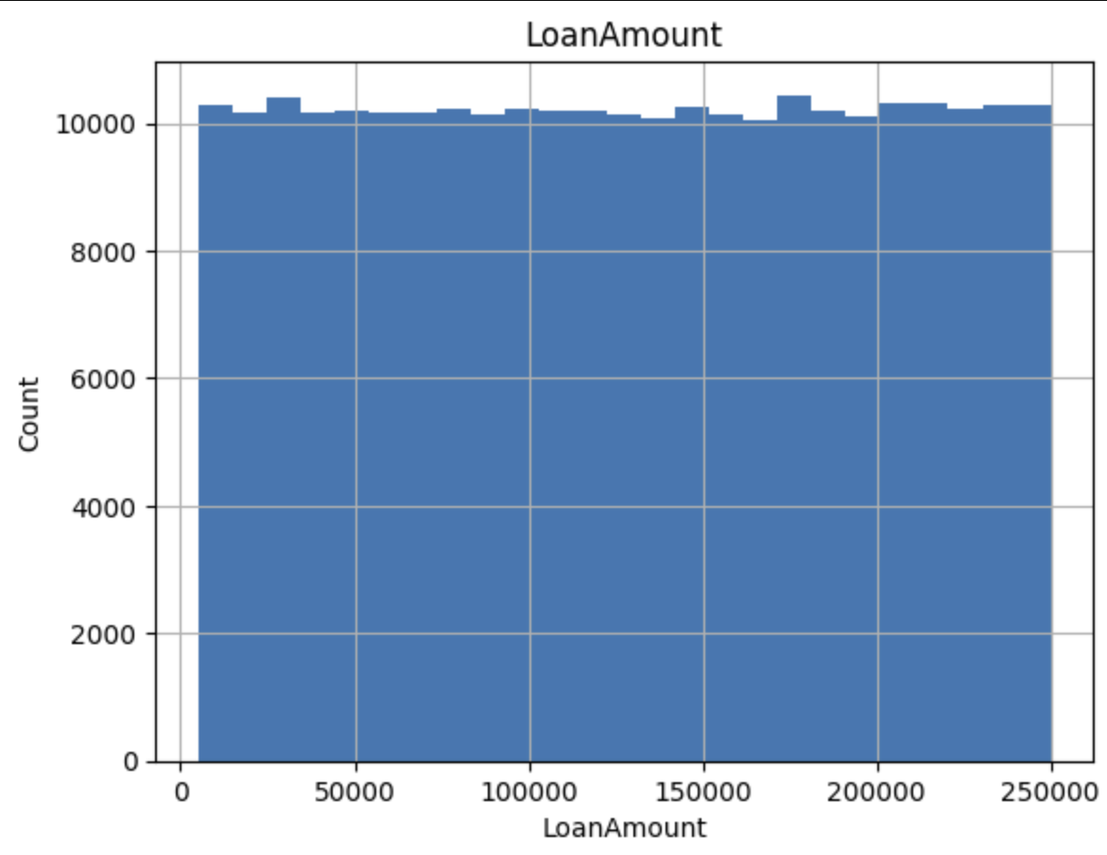

Insights from the Histogram:
- Uniform Distribution:
  - The loan amount distribution is relatively uniform across the range.
  - This indicates that loans of various amounts are well-represented in the dataset.
- Range of Loan Amounts:
  - The loan amounts in the dataset range from approximately 0 to 250,000.
  - This wide range suggests that the dataset includes loans of different sizes, catering to various financial needs and capabilities of the borrowers.

Implications for Analysis:
- Balanced Representation: The uniform distribution indicates a balanced representation of different loan amounts, which is beneficial for training a machine learning model as it reduces the risk of bias towards any particular loan amount range.
- Feature Engineering: Given the uniform distribution, you might consider creating loan amount brackets or categories (e.g., small, medium, large loans) for more granular analysis and feature engineering.
- Model Training: The diversity in loan amounts can help the model learn better by exposing it to a variety of financial scenarios.

Additional Steps:
- Correlation Analysis: Perform correlation analysis between loan amount and other features to understand how loan amount interacts with other variables in the dataset.
- Impact on Default: Investigate how different loan amounts affect the likelihood of loan default by analyzing the default rate across different loan amount brackets.
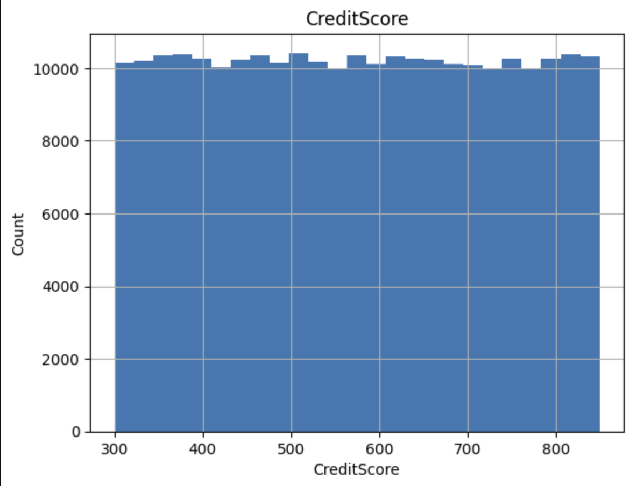

Insights from the Histogram:
- Uniform Distribution:
  - The credit score distribution is relatively uniform across the range from 300 to 850.
  - There are no significant peaks or dips in the distribution, indicating that credit scores of various levels are well-represented in the dataset.
- Range of Credit Scores:
  - The credit scores in the dataset range from approximately 300 to 850.
  - This wide range suggests that the dataset includes individuals with varying levels of creditworthiness, from poor to excellent credit scores.

Implications for Analysis:
- Balanced Representation: The uniform distribution indicates a balanced representation of different credit score levels, which is beneficial for training a machine learning model as it reduces the risk of bias towards any particular credit score range.
- Feature Engineering: Given the uniform distribution, you might consider creating credit score categories (e.g., poor, fair, good, very good, excellent) for more granular analysis and feature engineering.
- Model Training: The diversity in credit scores can help the model learn better by exposing it to a variety of creditworthiness scenarios.

Additional Steps:
- Correlation Analysis: Perform correlation analysis between credit score and other features to understand how credit score interacts with other variables in the dataset.
- Impact on Default: Investigate how different credit score levels affect the likelihood of loan default by analyzing the default rate across different credit score categories.
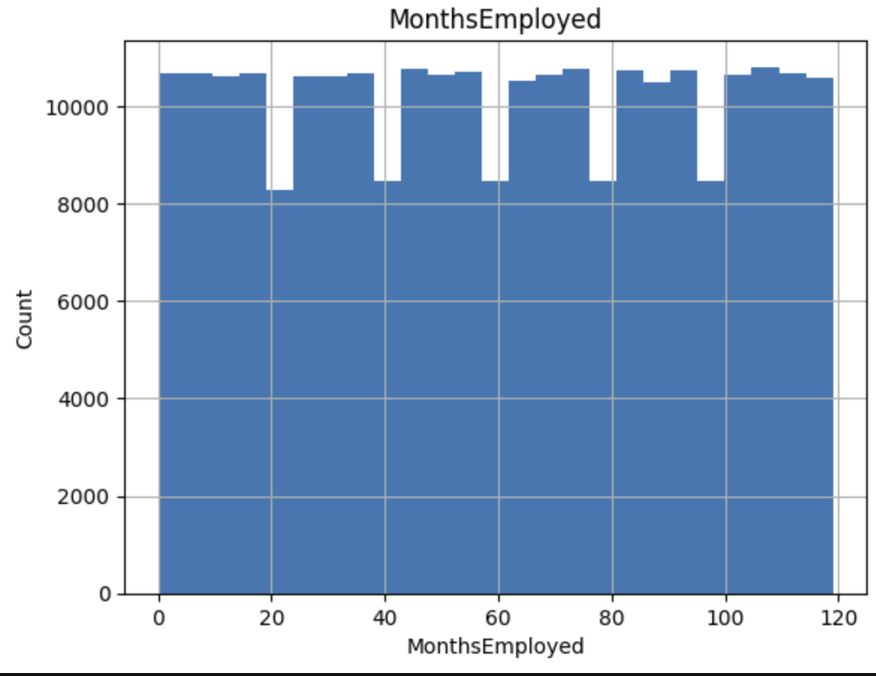

Insights from the Histogram:
- Uniform Distribution with Gaps:
  - The distribution of months employed appears to be relatively uniform across the range, with some periodic dips.
  - These gaps or dips might indicate data collection intervals or missing data for certain periods.
- Range of Employment Duration:
  - The employment duration in the dataset ranges from 0 to 120 months (approximately 10 years).
  - This wide range suggests that the dataset includes individuals with varying lengths of employment, from newly employed to those with long-term employment.

Implications for Analysis:
- Balanced Representation: The relatively uniform distribution indicates a balanced representation of different employment durations, which is beneficial for training a machine learning model as it reduces the risk of bias towards any particular employment duration.
- Feature Engineering: Given the uniform distribution, you might consider creating employment duration categories (e.g., short-term, medium-term, long-term) for more granular analysis and feature engineering.
- Model Training: The diversity in employment durations can help the model learn better by exposing it to various employment scenarios.

Additional Steps:
- Investigate Gaps: Further investigation is needed to understand the reasons for the periodic dips in the distribution. This could involve checking for missing data or data collection intervals.
- Correlation Analysis: Perform correlation analysis between months employed and other features to understand how employment duration interacts with other variables in the dataset.
- Impact on Default: Investigate how different employment durations affect the likelihood of loan default by analyzing the default rate across different employment duration brackets.

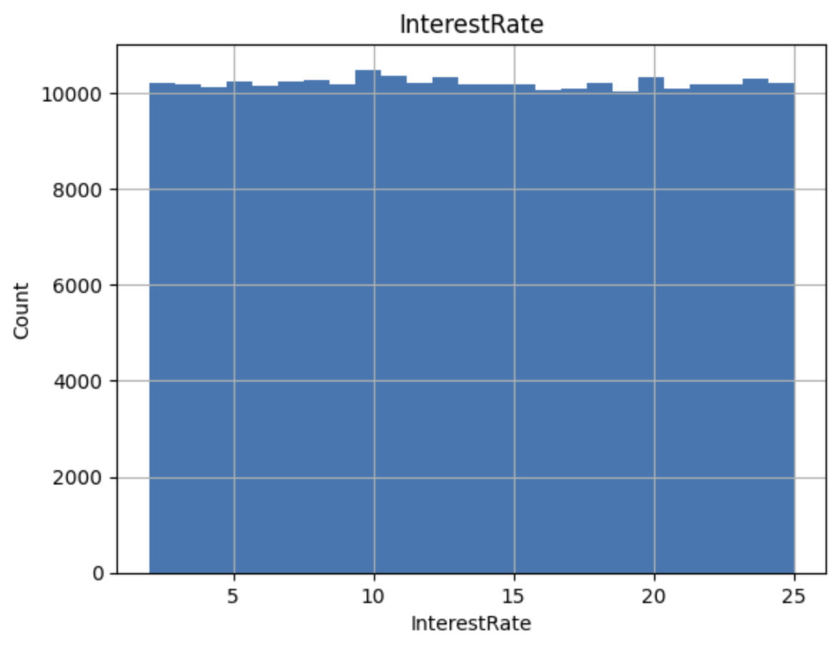

Insights from the Histogram:
- Uniform Distribution:
  - The interest rate distribution is relatively uniform across the range from approximately 0% to 25%.
  - There are no significant peaks or dips in the distribution, indicating that interest rates of various levels are well-represented in the dataset.
- Range of Interest Rates:
  - The interest rates in the dataset range from approximately 0% to 25%.
  - This wide range suggests that the dataset includes loans with varying interest rates, reflecting different lending terms and borrower risk profiles.

Implications for Analysis:
- Balanced Representation: The uniform distribution indicates a balanced representation of different interest rate levels, which is beneficial for training a machine learning model as it reduces the risk of bias towards any particular interest rate range.
- Feature Engineering: Given the uniform distribution, you might consider creating interest rate categories (e.g., low, medium, high) for more granular analysis and feature engineering.
- Model Training: The diversity in interest rates can help the model learn better by exposing it to a variety of lending scenarios.

Additional Steps:
- Correlation Analysis: Perform correlation analysis between interest rate and other features to understand how interest rate interacts with other variables in the dataset.
- Impact on Default: Investigate how different interest rate levels affect the likelihood of loan default by analyzing the default rate across different interest rate categories.

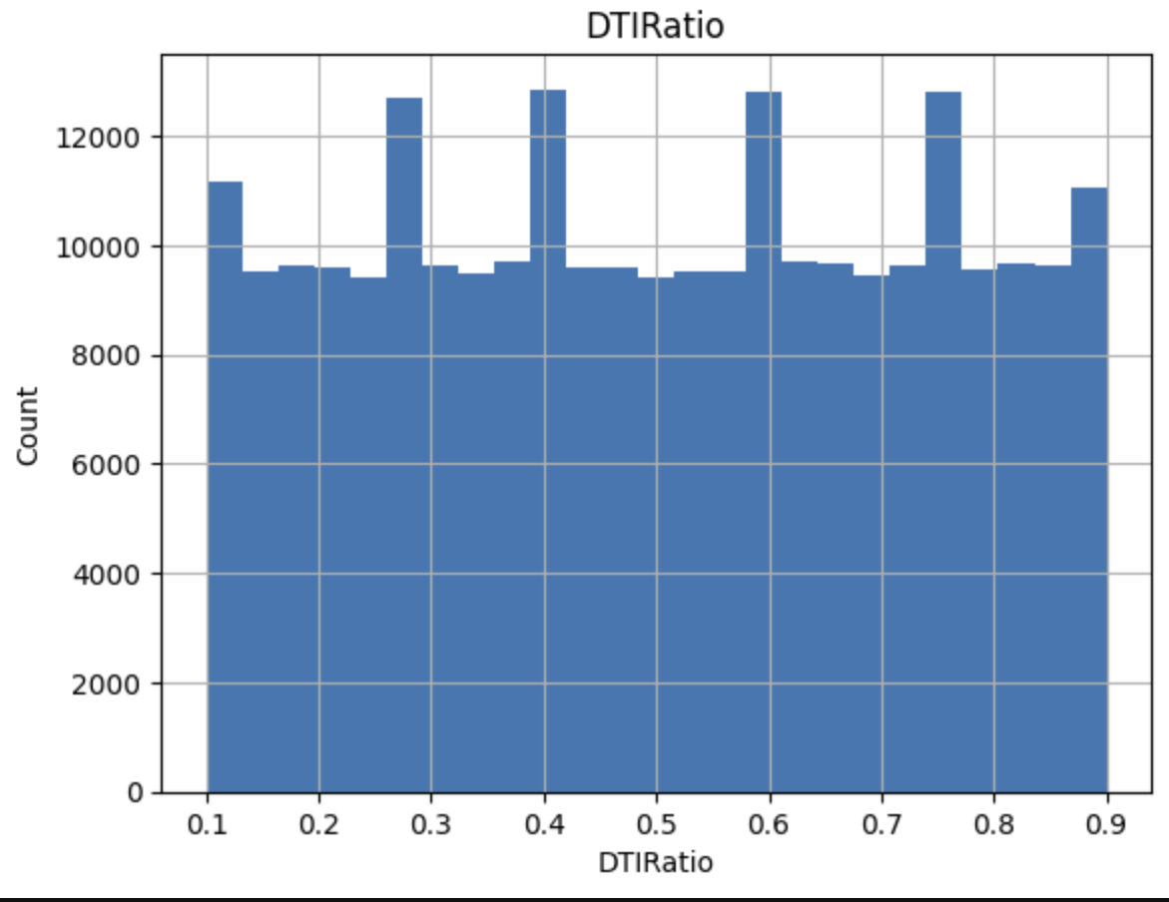

Insights from the Histogram:
- Mostly Uniform Distribution with Periodic Peaks:
  - The DTI ratio distribution is mostly uniform across the range from approximately 0.1 to 0.9.
  - There are periodic peaks in the distribution, indicating that certain DTI ratios are more common than others.
- Range of DTI Ratios:
  - The DTI ratios in the dataset range from approximately 0.1 to 0.9.
  - This wide range suggests that the dataset includes individuals with varying levels of debt relative to their income, reflecting different financial situations.

Implications for Analysis:
- Balanced Representation: The mostly uniform distribution indicates a balanced representation of different DTI ratio levels, which is beneficial for training a machine learning model as it reduces the risk of bias towards any particular DTI ratio range.
- Feature Engineering: Given the mostly uniform distribution with some peaks, you might consider creating DTI ratio categories (e.g., low, medium, high) for more granular analysis and feature engineering.
- Model Training: The diversity in DTI ratios can help the model learn better by exposing it to a variety of financial situations.

Additional Steps:
- Investigate Peaks: Further investigation is needed to understand the reasons for the periodic peaks in the distribution. This could involve checking for common DTI ratios used in lending policies or financial thresholds.
- Correlation Analysis: Perform correlation analysis between DTI ratio and other features to understand how DTI ratio interacts with other variables in the dataset.
- Impact on Default: Investigate how different DTI ratio levels affect the likelihood of loan default by analyzing the default rate across different DTI ratio categories.

Reasons for Log Transformation:
1. Normalization of Data:
- Log transformation helps to normalize the data, especially when the data is skewed or has a long tail. It compresses the range of the data, making it closer to a normal distribution.
2. Handling Large Ranges:
- When dealing with data that spans several orders of magnitude, log transformation can reduce the impact of extreme values and make the data easier to work with.
3. Stabilizing Variance:
- Log transformation can stabilize the variance of a dataset, which is important for many statistical techniques that assume homoscedasticity (constant variance).
4. Linearizing Relationships:
- In some cases, log transformation can linearize relationships between variables, making it easier to apply linear models and interpret coefficients.
5. Reducing Skewness:
- Log transformation can reduce the skewness of a dataset, making the data more symmetric and improving the performance of statistical models.

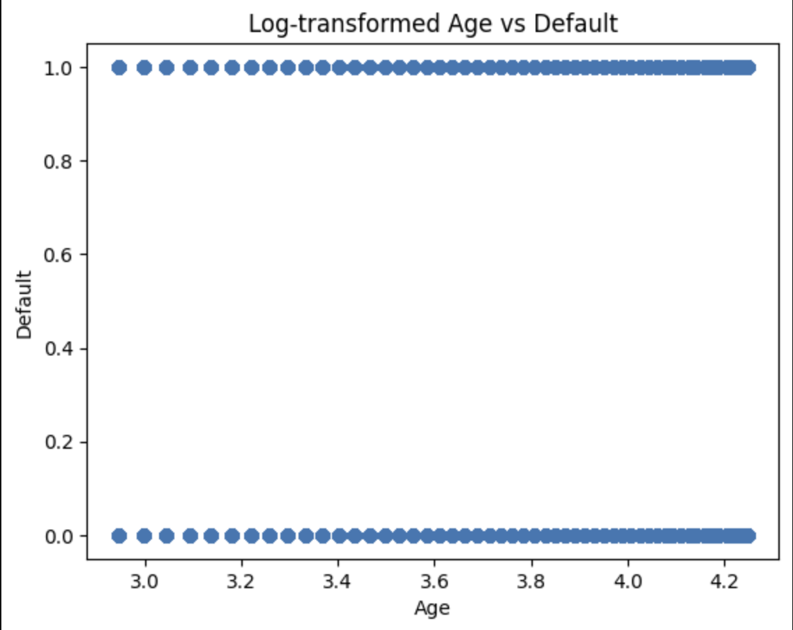

Explanation of the Graph:
- Log-Transformed Age:
  - The x-axis represents the log-transformed values of the "Age" feature.
  - Log transformation is used to normalize the data, especially if the original data has a wide range or is skewed.
- Default Variable:
  - The y-axis represents the "Default" variable, which is binary (0 or 1).
  - 0 indicates that the loan was not defaulted, and 1 indicates that the loan was defaulted.

Insights:
- Binary Default Values:
  - The "Default" variable is correctly represented as binary (0 and 1), unlike the previous plot where it appeared to be continuous.
  - There are two distinct horizontal lines in the plot: one at y=0 and another at y=1.
- Distribution Across Age:
  - The points are scattered along two lines corresponding to the default statuses (0 and 1).
  - The log-transformed age values range from approximately 3.0 to 4.2, which corresponds to the age range in the dataset.
- Lack of Clear Pattern:
  - The scatter plot does not show a clear pattern or correlation between the log-transformed "Age" and the "Default" status.
  - This suggests that age, when log-transformed, does not have a strong predictive relationship with whether a loan is defaulted or not.

Conclusion:
- The scatter plot indicates that there is no strong or obvious relationship between the log-transformed age of the individuals and their loan default status. Age might not be a significant predictor of loan default in this dataset.

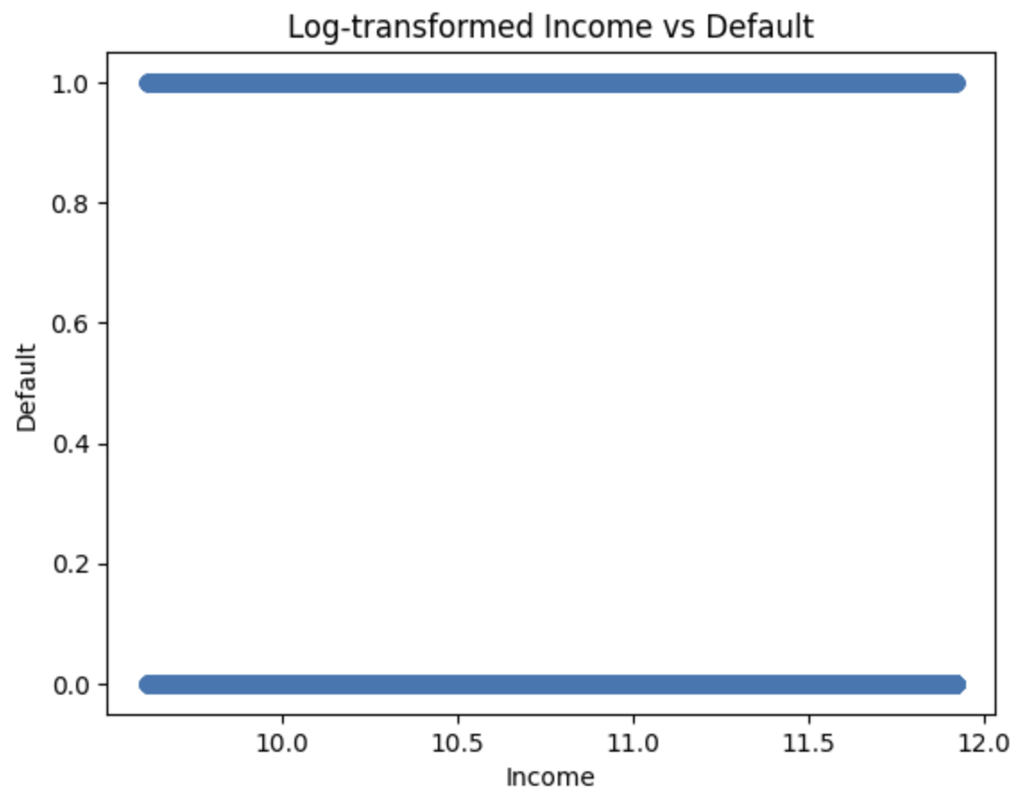

Explanation of the Graph:
- Log-Transformed Income:
  - The x-axis represents the log-transformed values of the "Income" feature.
  - Log transformation is used to normalize the data, especially if the original data has a wide range or is skewed.
- Default Variable:
  - The y-axis represents the "Default" variable, which is binary (0 or 1).
  - 0 indicates that the loan was not defaulted, and 1 indicates that the loan was defaulted.

Insights:
- Binary Default Values:
  - The "Default" variable is correctly represented as binary (0 and 1).
  - There are two distinct horizontal lines in the plot: one at y=0 and another at y=1, corresponding to the non-defaulted and defaulted loans, respectively.
- Distribution Across Income:
  - The log-transformed income values range from approximately 10 to 12, which corresponds to the income range in the dataset after log transformation.
  - The points are scattered along the two lines for default statuses (0 and 1) across the entire range of log-transformed income values.
- Lack of Clear Pattern:
  - Similar to the previous plot, there is no clear pattern or correlation between the log-transformed "Income" and the "Default" status.
  - This suggests that income, when log-transformed, does not have a strong predictive relationship with whether a loan is defaulted or not.

Conclusion:
- The scatter plot indicates that there is no strong or obvious relationship between the log-transformed income of the individuals and their loan default status. Income might not be a significant predictor of loan default in this dataset.
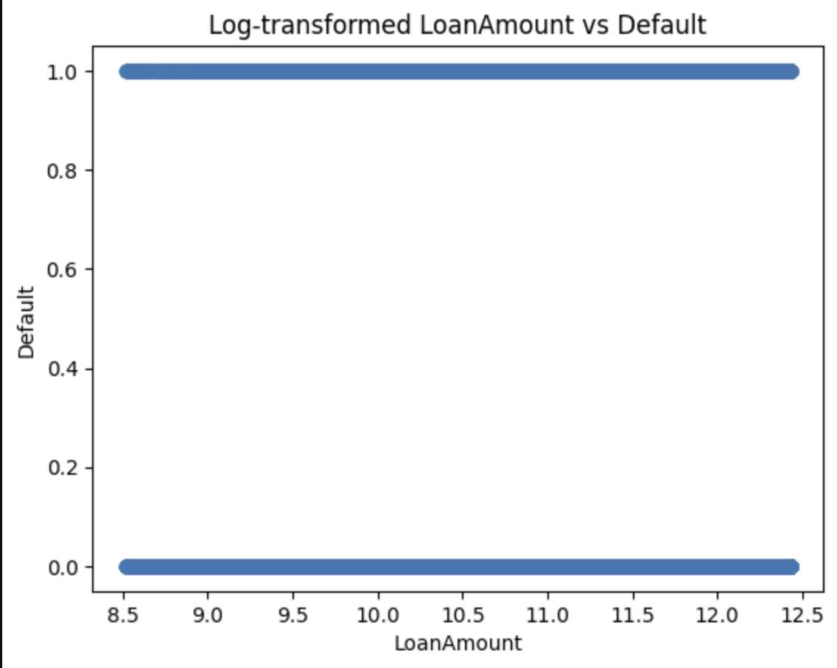

Explanation of the Graph:
- Log-Transformed Loan Amount:
  - The x-axis represents the log-transformed values of the "Loan Amount" feature.
  - Log transformation is used to normalize the data, especially if the original data has a wide range or is skewed.
- Default Variable:
  - The y-axis represents the "Default" variable, which is binary (0 or 1).
  - 0 indicates that the loan was not defaulted, and 1 indicates that the loan was defaulted.

Insights:
- Binary Default Values:
  - The "Default" variable is correctly represented as binary (0 and 1).
  - There are two distinct horizontal lines in the plot: one at y=0 and another at y=1, corresponding to the non-defaulted and defaulted loans, respectively.
- Distribution Across Loan Amount:
  - The log-transformed loan amount values range from approximately 8.5 to 12.5, which corresponds to the loan amount range in the dataset after log transformation.
  - The points are scattered along the two lines for default statuses (0 and 1) across the entire range of log-transformed loan amount values.
- Lack of Clear Pattern:
  - Similar to the previous plots, there is no clear pattern or correlation between the log-transformed "Loan Amount" and the "Default" status.
  - This suggests that loan amount, when log-transformed, does not have a strong predictive relationship with whether a loan is defaulted or not.

Conclusion:
- The scatter plot indicates that there is no strong or obvious relationship between the log-transformed loan amount of the individuals and their loan default status. Loan amount might not be a significant predictor of loan default in this dataset.

