1.Created Resource-Group in azure portal.

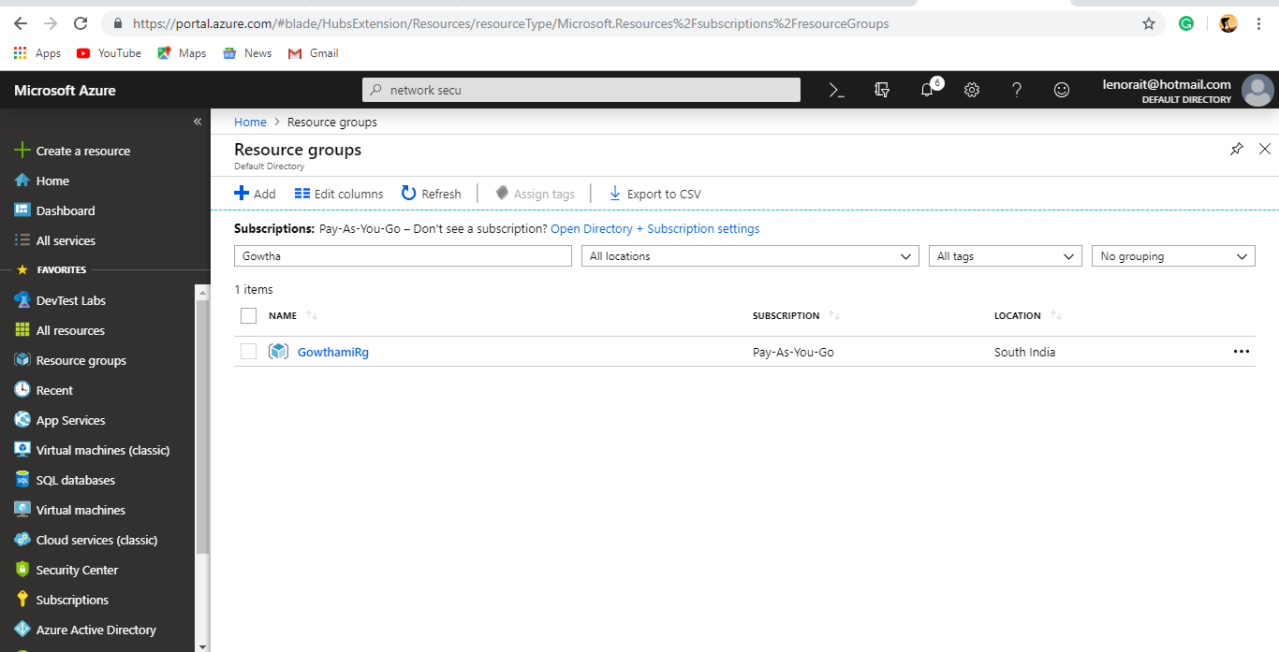

2.Created Virtual Network in Azure portal.

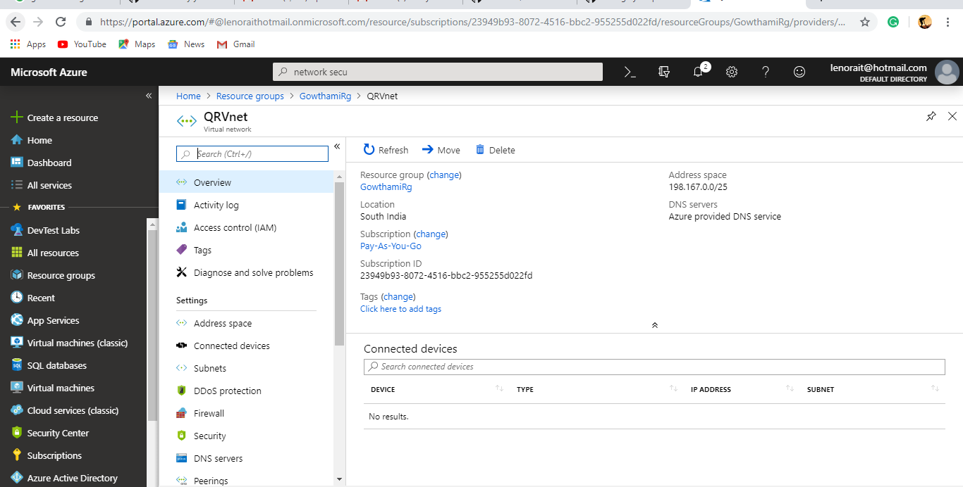

3.Created Network Security group added subnets (frontend, backend).

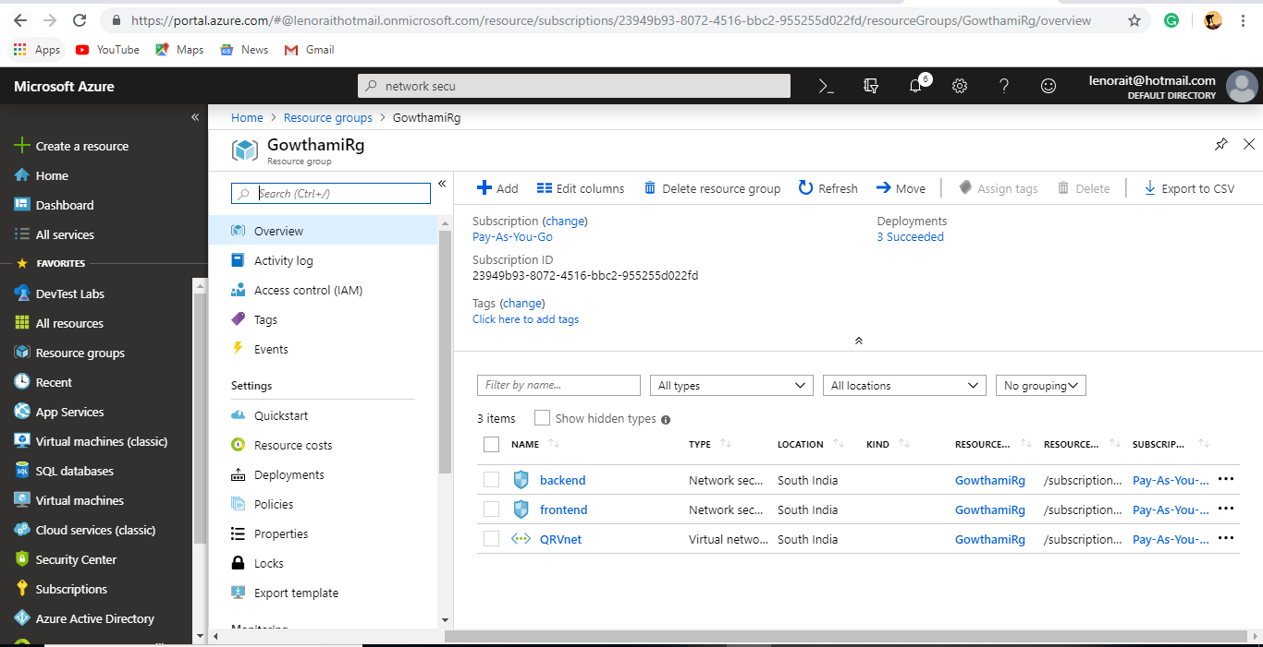

4.Added In-bound rules in subnet1(frontend).

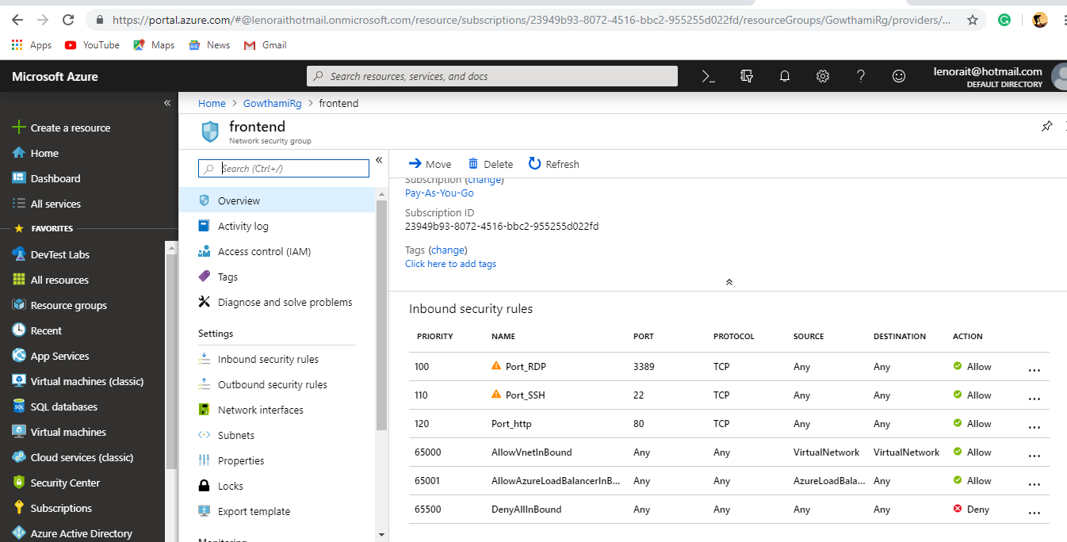

5.Added out-bound rules in subnet1(frontend).

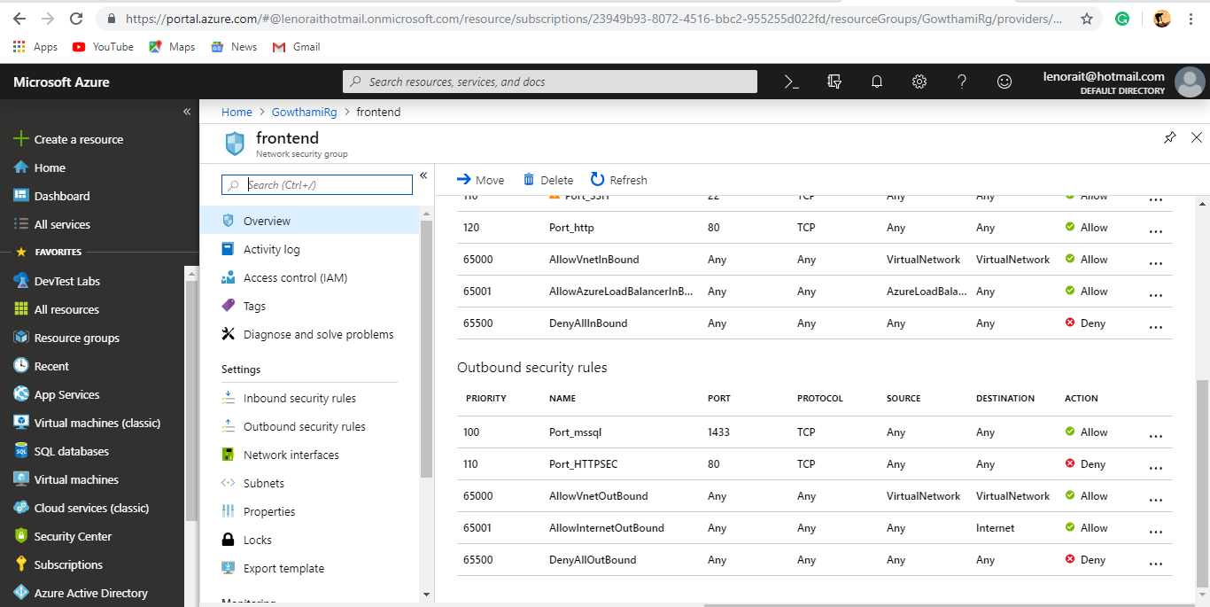

6.Added in-bound rules in subnet2(backend).

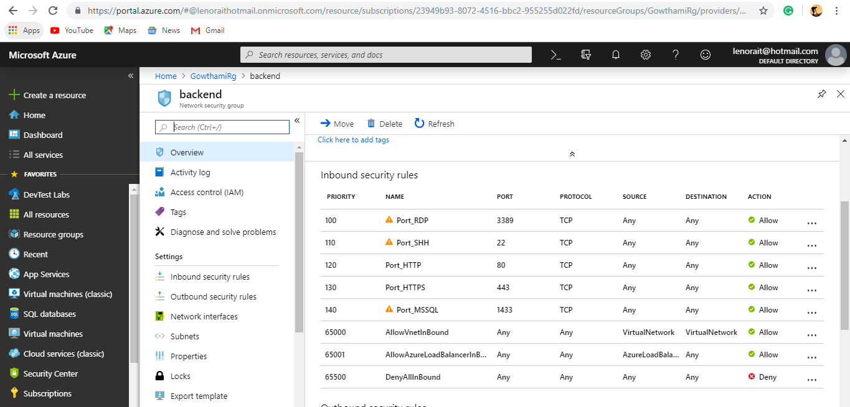

7.Added out-bound rules in subnet2(backend).

