Shopping Navigation — Object-Oriented Software Design Report
Shopping Navigation is a smart grocery-shopping companion. It is an Android app (Kotlin + Jetpack Compose) that helps a user plan a shopping list, scan receipts to track a budget, find nearby stores, and finally navigate inside the store to each product using the phone camera. The in-store camera guidance is powered by a small Python vision backend that runs an object detector, an OCR engine, and a vision-language model to turn each photo into a “move / ask / arrived” instruction.
Hardware: an Android smartphone (camera + GPS + screen) and a backend server (CPU or optional GPU) that runs the vision models. Software: the Android app talks over HTTP to the vision backend and to cloud services (OCR, an AI assistant, and a maps service).
This report documents four representative functions of the system: (1) Manage Shopping List, (2) Scan Receipt & Track Budget, (3) Find Nearby Stores, and (4) In-Store Visual Navigation. Diagrams use a simple notation: a box is the system boundary, rounded shapes are use cases, lines join actors to use cases, and dashed arrows mean «include» (always part of) or «extend» (optional).

Chapter 4 — Glossary
Term | Definition (explanation) | Notes
Shopping Navigation | The whole system: an Android shopping app plus a vision backend for in-store navigation. | App + backend.
Shopping app | The Android frontend the user interacts with. | Kotlin / Jetpack Compose.
Shopping item | One thing to buy: name, quantity, price, checked state. | Core list entry.
Shopping list | A dated collection of shopping items. | Status: in-progress / done.
Budget | The user’s monthly spending limit, compared against purchases. | Drives the budget view.
Receipt scan | Photographing a receipt so the app extracts its line items. | Uses OCR + an AI parser.
OCR | Optical Character Recognition — reading text from an image. | For receipts, labels, signs.
AI assistant | The cloud AI service that parses receipts and answers questions. | Returns structured data / text.
Nearby store | A shop near the user’s GPS location. | From the maps service.
Maps service | The cloud service that returns nearby places. | Needs location permission.
In-store navigation | Camera-based, turn-by-turn guidance to a product inside a store. | App + vision backend.
Vision backend | The Python server that analyses each photo and decides the next step. | FastAPI.
Object detection | Finding named objects (e.g. “milk”) in a photo. | Open-vocabulary detector.
Vision-language model (VLM) | A model that reads an image + text and returns the next action. | Hosted by the backend.
Topological map | A graph of visited places (nodes) and the moves between them (edges). | Built as the user walks.
Goal | The product/place the user is looking for. | e.g. “find the milk”.
Action | The backend’s reply each turn: MOVE, ASK, or ARRIVED. | Drives the on-screen guidance.
Arrival gate | A check that confirms ARRIVED only with real evidence; otherwise asks the user to confirm. | Prevents false arrivals.
Actor | A person or external service that interacts with the system. | User, OCR, AI, maps, backend.
Use case | A unit of useful behaviour for an actor. | Rounded shape in the diagrams.

Chapter 5 — Use Case Diagrams

Function 1 — Manage Shopping List
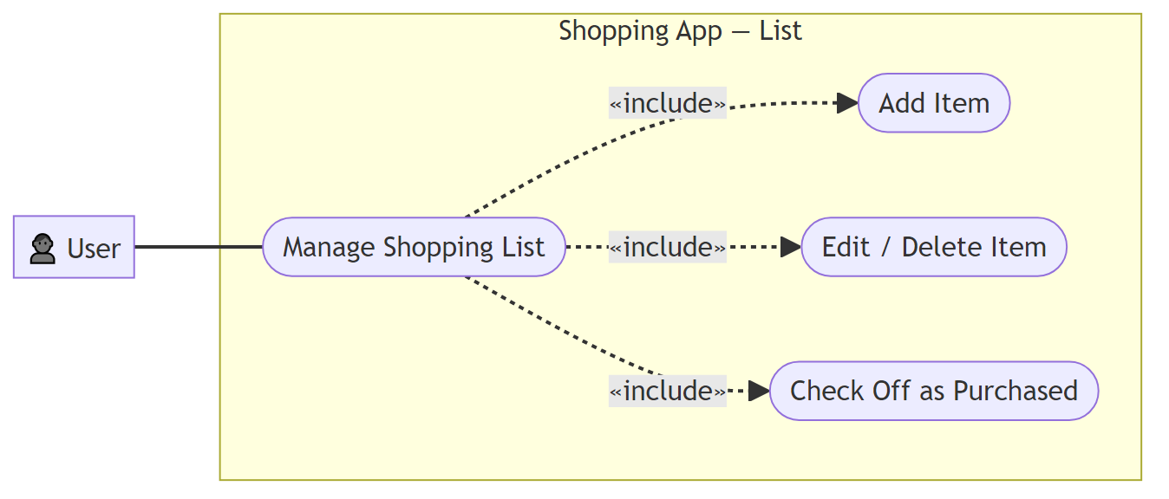
diagram

Function 2 — Scan Receipt & Track Budget
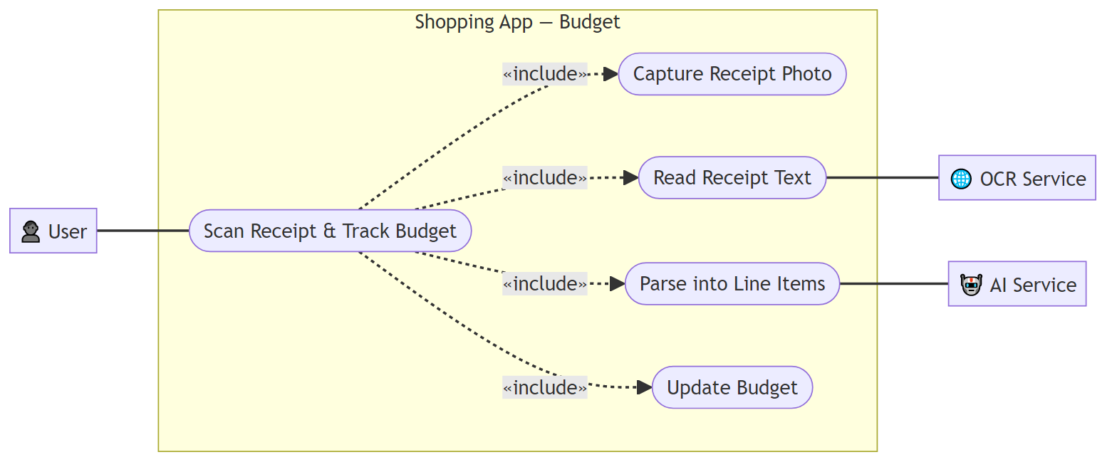
diagram

Function 3 — Find Nearby Stores
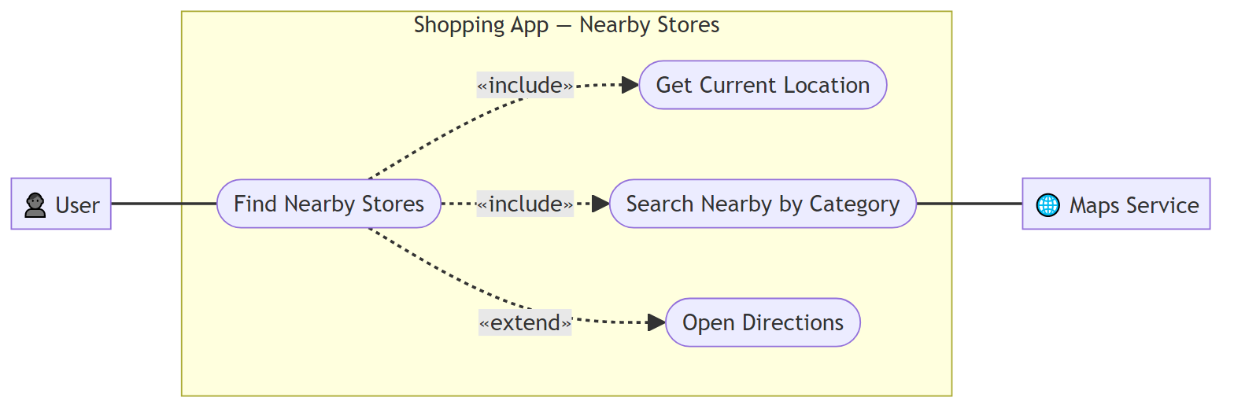
diagram

Function 4 — In-Store Visual Navigation
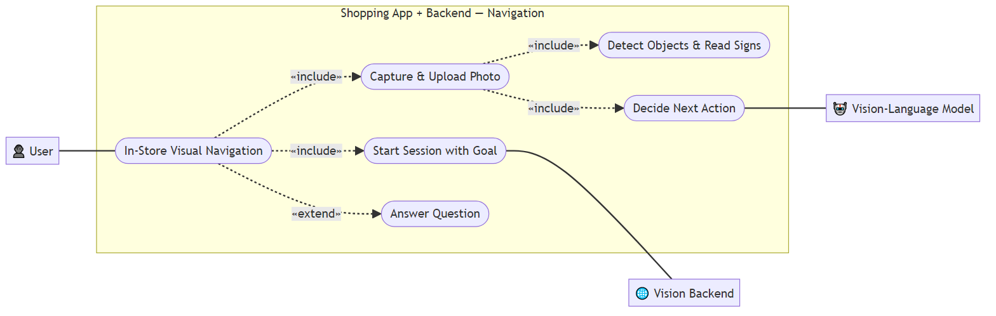
diagram

Chapter 6 — Use Case Descriptions

Function 1 — Manage Shopping List
Field | Content
Actors | User
Precondition | The list screen is open.
Postcondition | The item exists; when checked it counts toward spending.
Normal scenario: (1) the user enters an item name (and optional quantity and price); (2) the system creates the item and auto-categorises it; (3) it appears in the list; (4) when the user checks it off, it is marked purchased and counts toward the budget.
Exception — empty name: the user confirms with a blank name; the system rejects the entry and keeps the dialog open.
Exception — edit/delete: the user edits a field or deletes the item; the system updates or removes it and refreshes totals.

Function 2 — Scan Receipt & Track Budget
Field | Content
Actors | User; OCR Service; AI Service
Precondition | The budget screen is open.
Postcondition | Parsed items are added; spending and remaining budget update.
Normal scenario: (1) the user provides a receipt photo; (2) the system sends it to the OCR service and receives the text; (3) it sends the text to the AI service to parse into line items; (4) the items are added and total spent, remaining budget, and spending-by-category are recomputed; (5) the updated summary is shown.
Exception — unreadable receipt: OCR returns no usable text; the system reports it could not read the receipt and adds nothing.
Exception — parsing fails: the AI returns invalid data; the system reports a parsing failure and adds nothing.

Function 3 — Find Nearby Stores
Field | Content
Actors | User; Maps Service
Precondition | Location permission is granted.
Postcondition | A ranked list of nearby stores is shown.
Normal scenario: (1) the system reads the current GPS location; (2) the user picks a store category; (3) the system queries the maps service; (4) results (name, distance, rating) are listed; (5) the user taps a store to open directions.
Exception — permission denied: location permission is missing; the system explains why it is needed and offers to open settings; no search runs.
Exception — no results: the service returns nothing; the system shows an empty state suggesting a wider radius or another category.

Function 4 — In-Store Visual Navigation
Field | Content
Actors | User; Vision Backend; Vision-Language Model
Precondition | The backend is reachable.
Postcondition | The user is guided turn-by-turn until arrival.
Normal scenario: (1) the user enters a goal; (2) the app starts a session and the backend turns the goal into objects to detect; (3) the user captures a photo and the app uploads it; (4) the backend detects objects and reads signs; (5) it asks the model for the next action and returns MOVE with guidance; (6) the user walks and repeats until ARRIVED.
Exception — clarification needed: the action is ASK; the user answers and the backend re-decides with the answer.
Exception — arrival without evidence: the model says ARRIVED but no goal object/sign is detected; the arrival gate downgrades it to a confirm question.
Exception — backend/model error: a call fails or returns unparseable output; the backend replies with a safe “walk forward and try again” instruction.

Chapter 7 — Activity Diagrams

Function 1 — Manage Shopping List
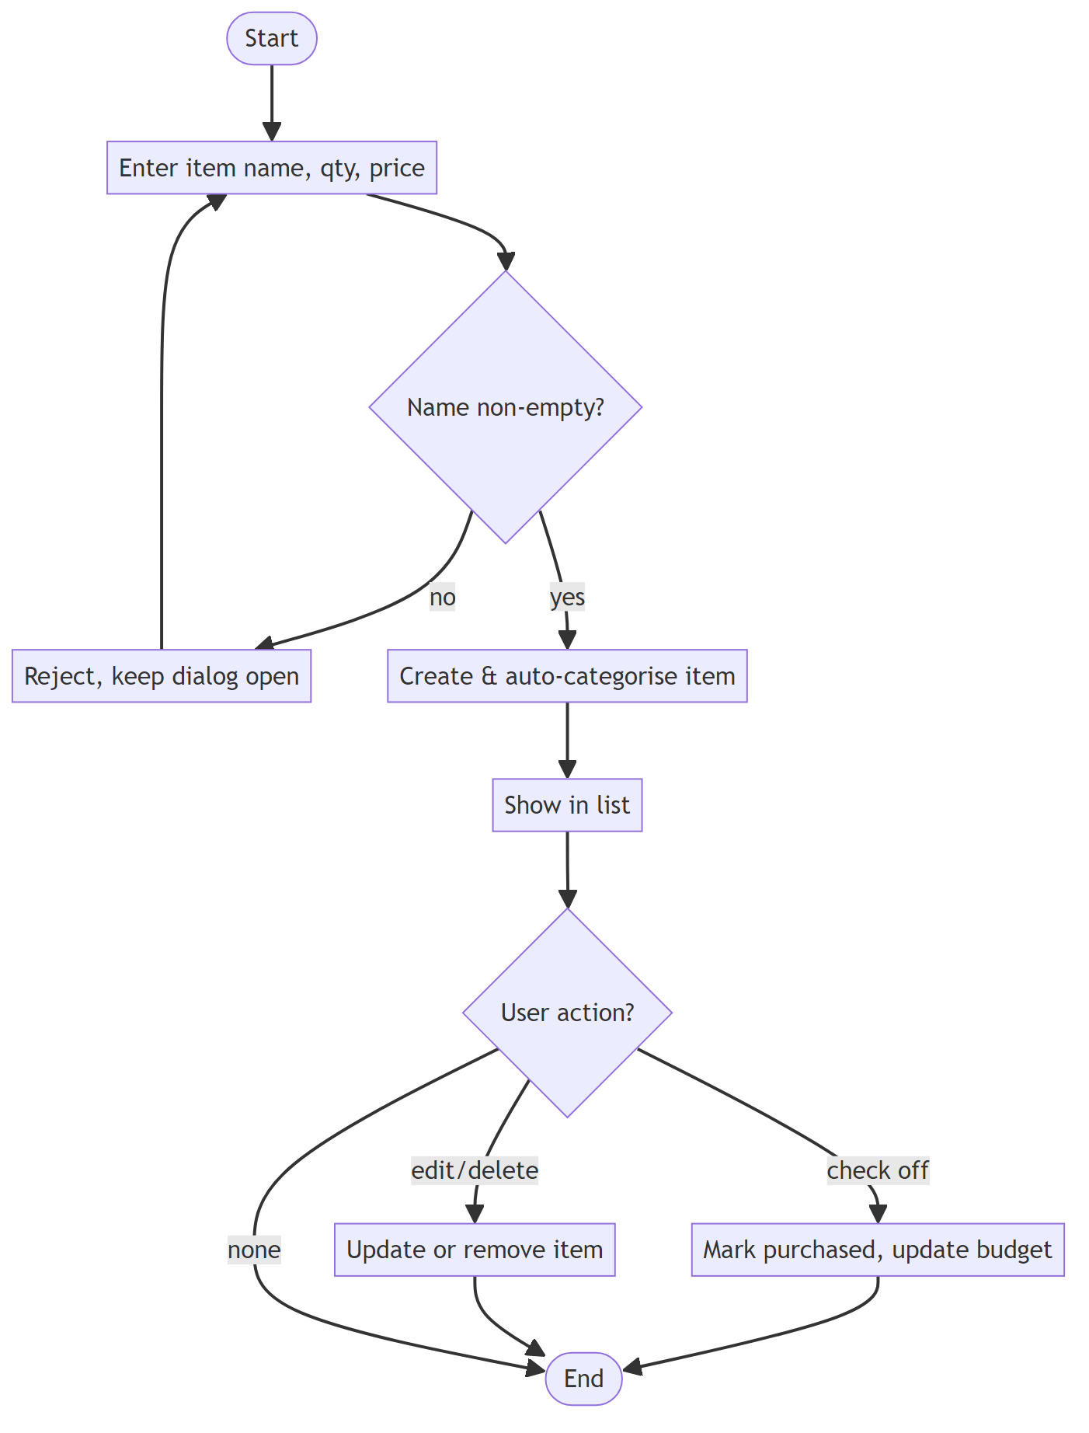
diagram

Function 2 — Scan Receipt & Track Budget
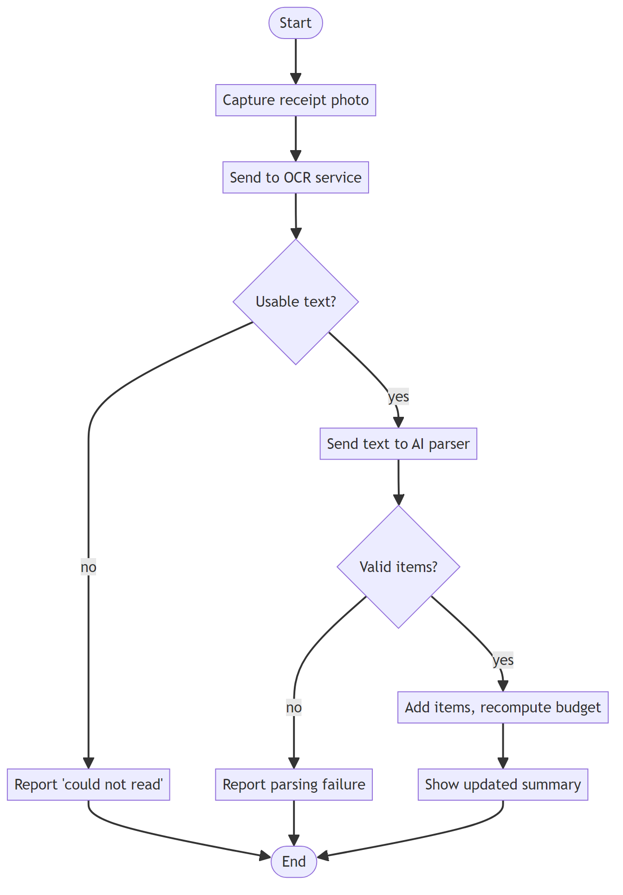
diagram

Function 3 — Find Nearby Stores
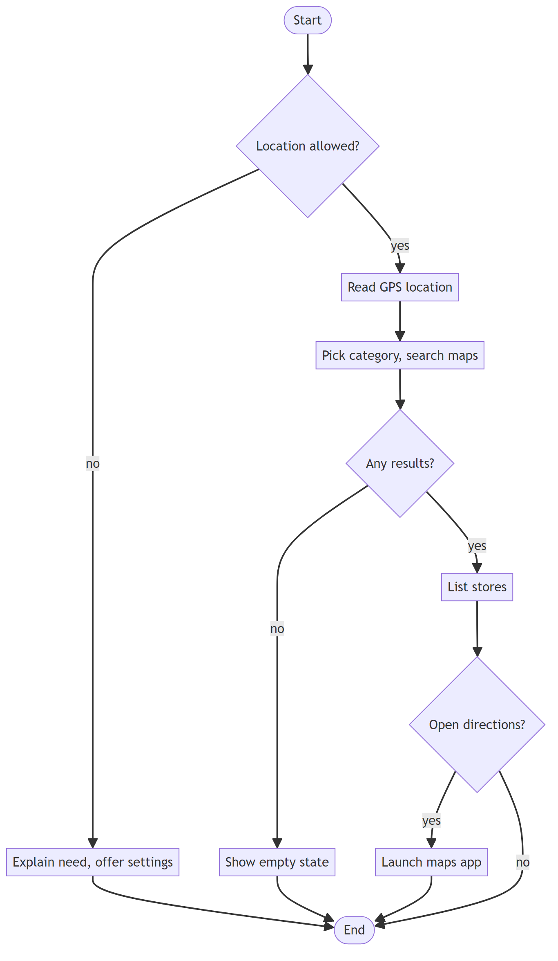
diagram

Function 4 — In-Store Visual Navigation
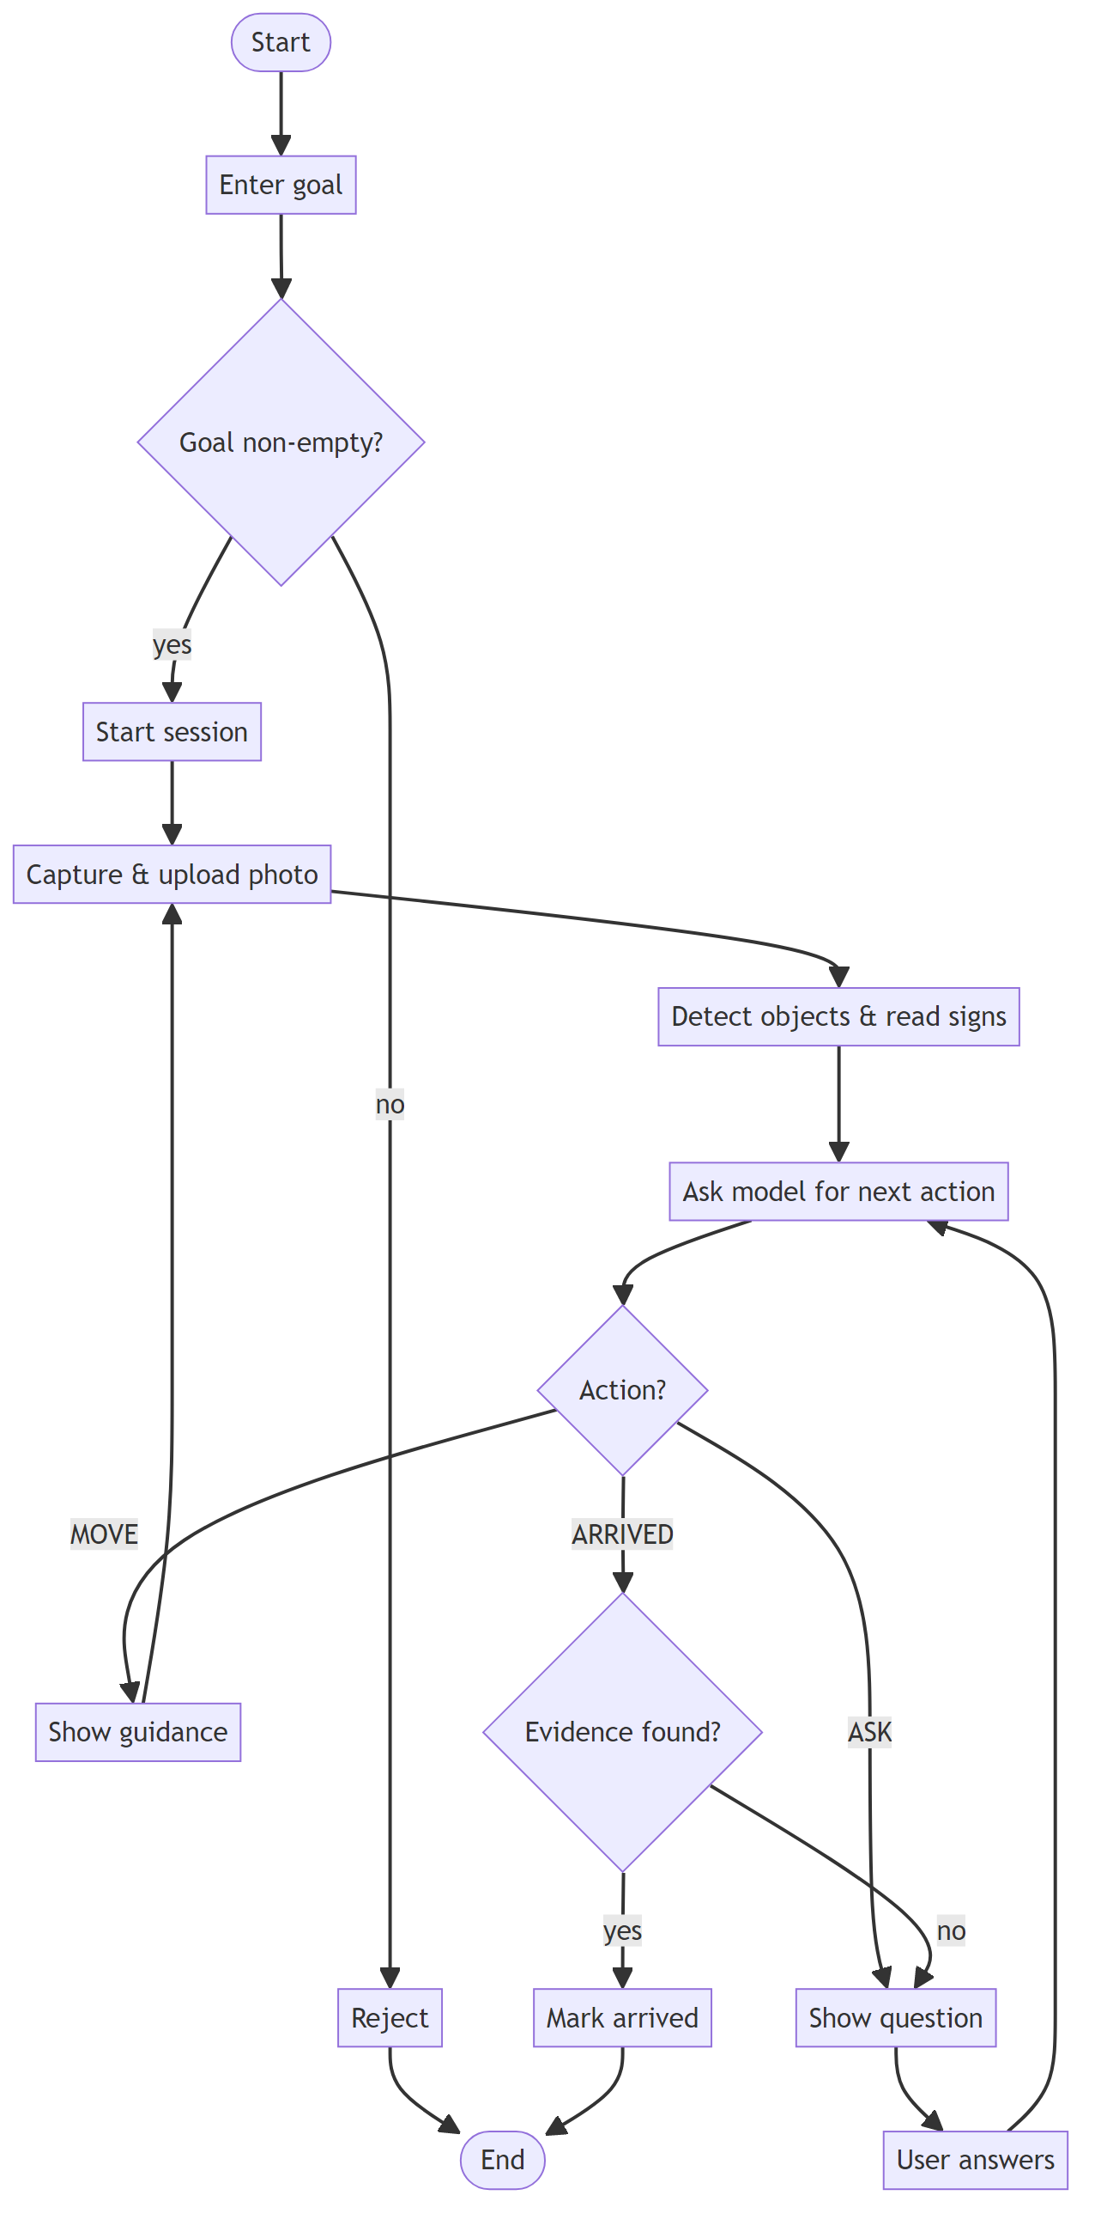
diagram

Chapter 8 — Class Diagram
A simplified class diagram of the whole system: the Android client (left) and the vision backend (right), joined by NavigatorApi → NavigationServer over HTTP.
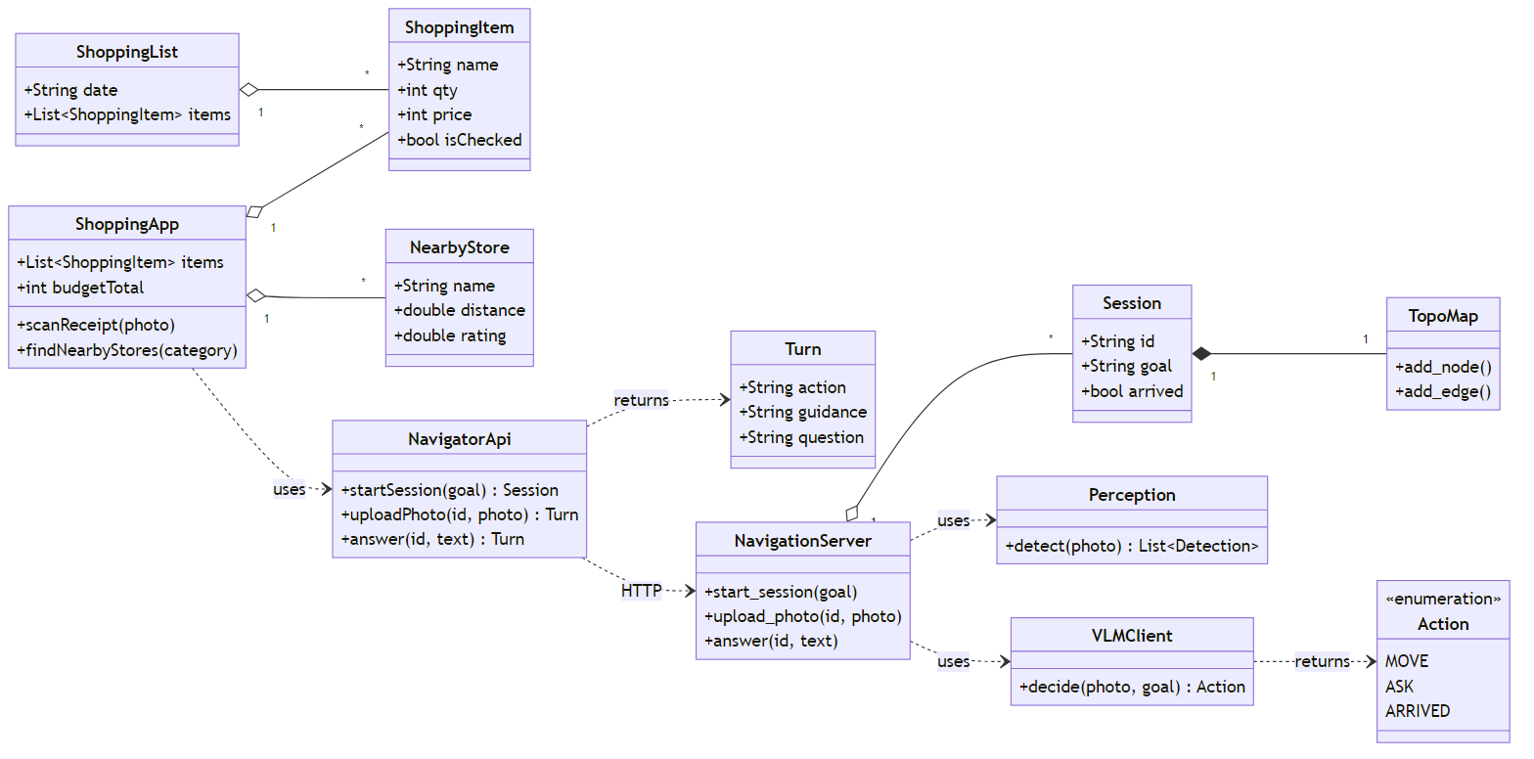
diagram

