**Kathmandu Bernhardt College**

(Affiliated to Tribhuvan University)



A Project Proposal

On

**“Game using JavaScript”**

**Submitted by**

Bishwas Shrestha

Sandip Bhandari

Karim Gopali

**Submitted to**

Department of BCA

Bernhardt College

Bafal, Kathmandu, Nepal

**December 2020**

Table of Contents

1. Introduction 3

2.History 3

3. Studying existing game 4

4.Gameplay 4

5.Problem statement 4

6.Methodology 4

Expected Output 5

6.Limitation 6

7.Improvement 6

# 1. Introduction

The project title is called Cave Escape, and is based on the 2000s arcade mobile game. Similar game was released for android on 2013 and gained a popularity on 2014 and also topped the chart on the google play store and as well as the app store. Now, In the market there are many games which require high graphics and a more reliable pc but we introduce you the simple flappy game that gives the experience on playing on a big screen with more FPS. This game category is arcade. Our game concept is simple and fun in which you start just with a click and help the bat escape the cave without hitting to an object.

Maybe all the people could not afford the high specs pc so here is the simple, addictive competitive.

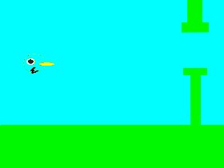

*Figure 1: 2000s flappy by waste stomach*

# 2.History

The history of this game goes back to the 2000's. Flappy bird 2000, a project made by Wasteful Stomach. It was not so popular at that time due to insufficient techs but probably gained widespread recognition when it was shipped as standard on Android mobile phones in the late 2013's.

# 3. Studying existing game

While studying the existing game created in late 2000s by wasteful Stomach team, we discovered that there was no audio or the score features and the canvas size were too small for the better game play. They had some extra features like they could customize the character. Waste Stomach didn’t include a pause button and the levels was not enough. So, keeping those things in consideration we plan to create a remastered version for low spec pc users.

# 4.Gameplay

The game involves controlling a character up or down and avoid the obstacles. When you get the egg, you will get a 150 points bonus. Every time the character gets the egg the 1+point is added to your score. The player loses when the bird touches the obstacles or the ground the final score is displayed.

You can control the character by using up arrow or the bottom arrow on the keyboard.

# 5.Problem statement

The Problem is to design the character and add the animations which provides the following functionalities:

* When the character touches the lava, it burns and when the player taps the buttons to fly the character, the character needs an animation to look aesthetic.
* When character touches an obstacle or touches the lava/ground the game is over.

The objects are ordered and the space between the obstacles are given by the programmer

# 6.Methodology

We have to think about how the game will be, set up the requirement.

* The programming language we used in the project JavaScript.
* HTML5 and Bootstrap will be used for the content display and titles.
* The textures are photoshopped using adobe photoshop CC 2019 as per their resolutions.
* Used the canvas html element for the main game display.

# Expected Output

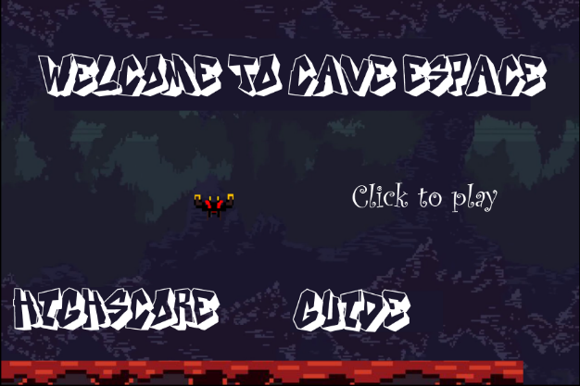

*Figure 1: Main Menu*

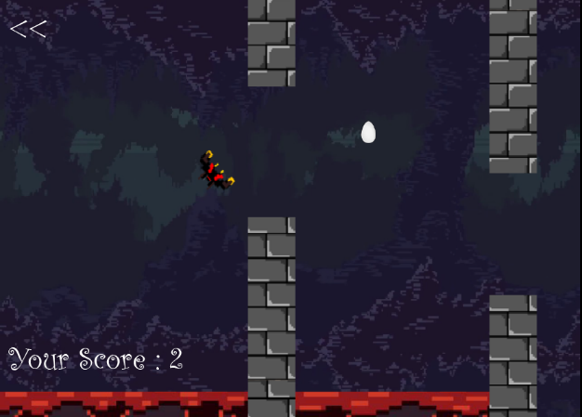

Figure 2: Gameplay

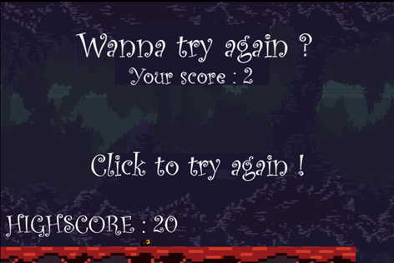

Figure 3: Game Over

# 6.Limitation

* Not an online game.
* Need a no copywrite audios.
* Web browser is needed.

# 7.Improvement

The changes/improvement from old flappy game:

* We will extend overall levels.
* Main menu contains features like high-score, guide and audio.
* Added BGM and IGM
* Implementing pause and play features.
* Add animations and audio effects as the character touches obstacles.
* Resolution improvement.
* Added score boost ups.

# 8.Refrences

<https://www.youtube.com/watch?v=bI6e6qjJ8JQ>

<http://pixelartmaker.com/art/559c053d4ec5f1d> (textures)

<https://wallpapercave.com/pixel-art-wallpapers> (background)