Tic Tac Toe
Artificial Intellegence
Assignment - 2

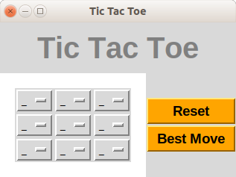

Submited By: Chetan Prakash Meena (B16CS006)

Mentor: Dr Gaurav Harit
Department of Computer Science and Engineering
Indian Institute of Technology, Jodhpur

Special Features:
- Have both Console and Graphics user interface, console is far much better than graphics as its has more functionality than graphics.
- Popup screens for displaying various messages.
- Different functionality for Tic Tac Toe Board like:
  - Clear whole Board or Reset Board
  - Make Best Move
- Automatically finds best move for Computer

Heuristic:
No Heuristic is used but instead MinMax Algorithm is used for finding best move.

Preview:
Figure 1: Board in Start of game
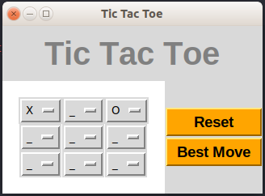Figure 2: Board in middle of game
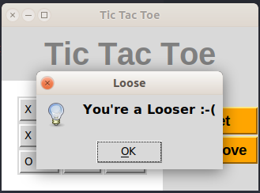Figure 3: Result

