**Artificial Intelligence**

**Video Player Using Face Detection And Recognition**

Abhinav Suthar (B16CS001) Chetan Prakash Meena (B16CS006)

Mentor : Dr. Chiranjoy Chattopadhyay

*Department of Computer Science and Engineering*

*Indian Institute of Technology, Jodhpur*

**Motivation:**

* We want to learn about Face Detection and Recognition technique and Python.
* We also want to make an application which can be control by faces and eyes.

**Objective:**

* To make an Artificial Intelligence Video Player which is controlled by facial expressions.
* On closing eye video should be stopped and again on opening eye video should be started.
* Video should be stopped if no face is detected for a time.

**Challenges/Research Issues:**

* Both Programming language and Face detection techniques are new for us.
* Using Python packages is little bit challenging.
* Linking Video Player, Face Detection Techniques and Python is also difficult.

**Methodology/Algorithm:**

1. From a snapshot of web cam, identifies faces using Viola-Jones algorithm for face detection.
2. Check whether eyes in the identified face is open or close using Viola-Jones algorithm.
3. If face is detected ask for file to play else stop the video or program
4. If eyes detected then play the video else pause the video.
5. We are also using Face Recognition techniques.

**Results:**

* Application work well for face but some it doesn’t work for eyes due to lack of light intensity.
* The below image shows the outcome of application.

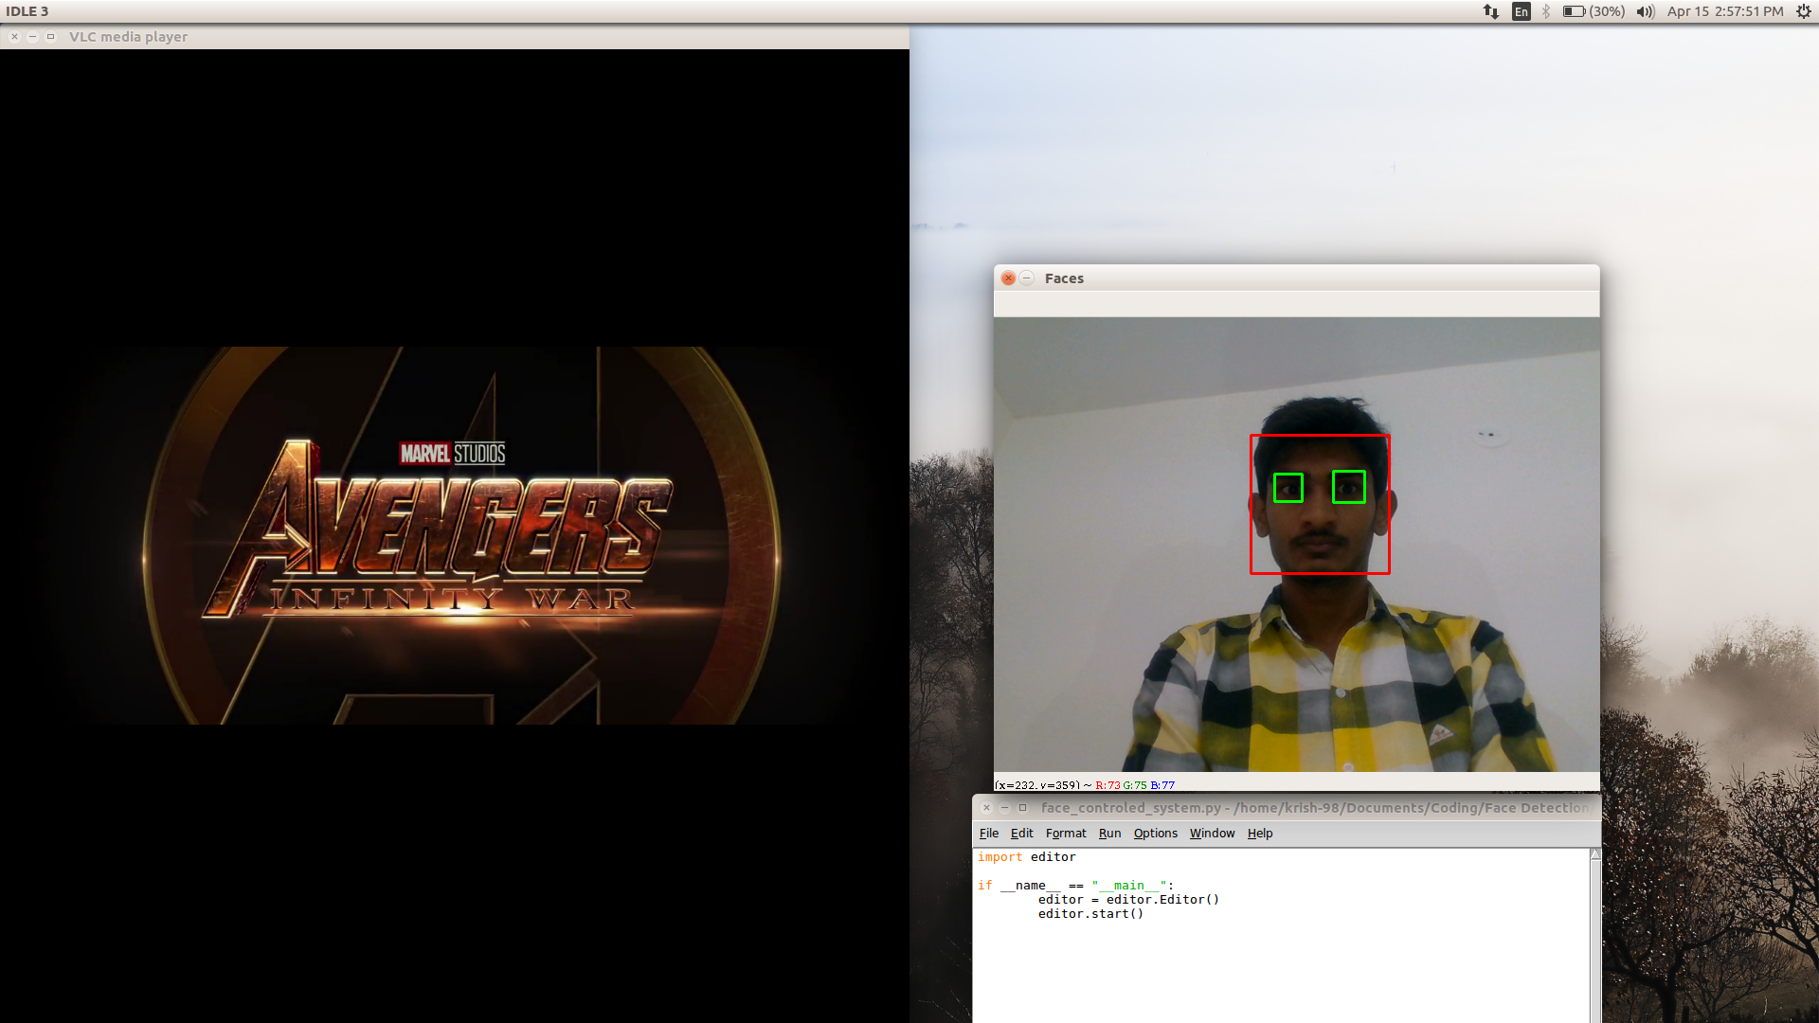

**Conclusion:**

* Through this project we learn a new programming language(little bit).
* We also learn about Viola-Jones algorithm for Face Detection.
* Some basic methods of many python packages like cv2, vlc, os, etc.

**References:**

1. P. Viola, M. J. Jones, “Robust Real-Time Face Detection”, International Journal of Computer Vision 57(2), 137–154, 2004.
2. Python Programming URL : <https://classroom.udacity.com/courses/ud1110>
3. Stack Overflow URL : <https://stackoverflow.com/questions/38279632/viola-jones-in-python-with-opencv-detection-mouth-and-nose>

Date: Mentor’s signature