Artificial Intelligence Video Player Using Face Detection And Recognition



Abhinav Suthar (B16CS001) Chetan Prakash Meena (B16CS006)

Mentor : Dr. Chiranjoy Chattopadhyay
Department of Computer Science and Engineering
Indian Institute of Technology, Jodhpur

1. Motivation:

In this modern era, every people and every thing are going towards smartness and intellegence. Almost everythings are automatically control and required minimal efforts of humans. Recently a new smartphone is released which is control by our face. So we thought that can we also make such an application for our laptops and we decide to make a such an application. This application can become very useful for us as it involve a very little interference between person and keyboard/mouse and it pause the video as soon as we close our eyes or move or face from screen.

2. Objective:

The objective of this project is to make an application which will control by the face and eyes of the person like :
- Pause video when person close his both eyes.
- Play video when person’s eyes are open.
- Stop video when there is no person in front of the camera.
- Resume video when person open his eye.
- Next video when previous video is finished.
- Resume video from previous position, if person wants to resume his previous video.
- Close the application when person is not came in front of camera for a long interval.

3. Challenges/Research Issues:

- The most diffcult challange is to learn basics of a completely new programming language(Python) and implementation of its packages because none of us is familiar with it.
- Another is to detect a face in an image. After getting suggestion from our mentor and google matarial we came to know about Viola-Jones algorithm for face detection.
- Above algorithm work pretty well with faces but for eyes it is not accurate. Here it became a problem to us as it detect mouth as an eye, small gap aside the Iris it again detects eye. So to solve these problem we give only upper half image of face, and to overcome other situation we calculate the average range of ratio of size of face to size of eye [3,6] and assume only those square as eyes for which the ratio lie in listed range.
- Above challenges are not much difficult as this one, we have to run a video using python and we have no idea about it, we google it but cant’t find much useful stuffs. So we decide to show frame one by one to convert it into video but the major issue is of audio. So we again start googling it.
- Another big issue is to run video parallelly becuase without it we cant pause video in middle until play function returns.
- After solving both, we have to link both file into a single file and use them combinedly.
- Another challenge is to become familair with opencv, PIL, List, Dictionary.

4. Methodology/Algorithm:
We are using Viola Jones method for face detection. It is available in OpenCV library. The goal is to distinguish faces from non-faces. For eye detection we are using same face detection technique but with different classifiers.
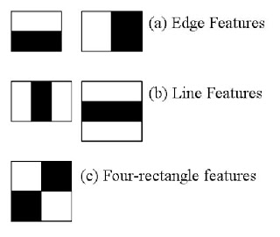
The algorithm has four stages:
- Haar Feature selecation
- Creating an Integral Image
- Adaboost Training
- Cascading Classifiers

4.1. Process : Image Pre-processing

- First of all it take an colored image from camera then convert it into gray.

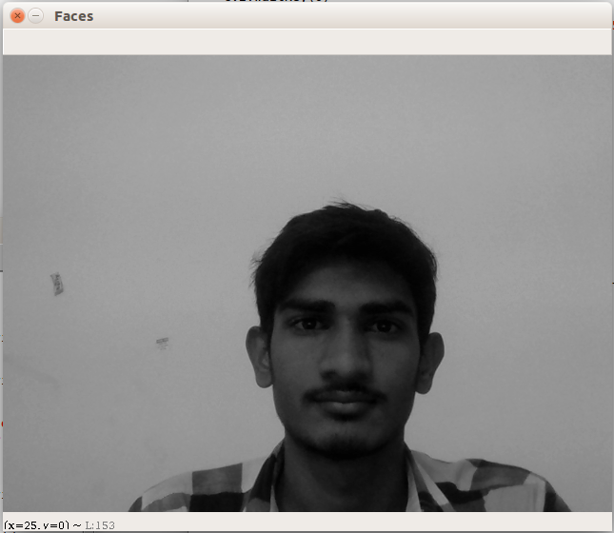


4.2. Process : Faces and eyes detection

- We use Viola-Jones algorithm for face detection, but we cant use it by making ourself, we use inbult function of opencv.

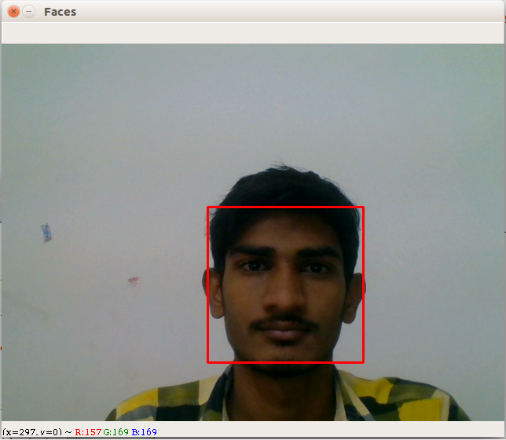
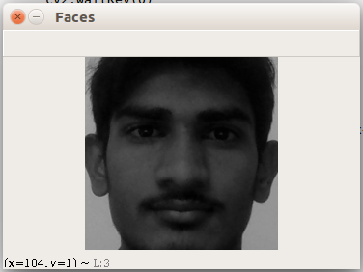

- But as we already know this classifier is not detecting eyes with accuracy.
- Now we save only those image which consist of only false.
- So we take only upper half portion of face to detect eyes and also face to eye size ratio between interval [3,6]

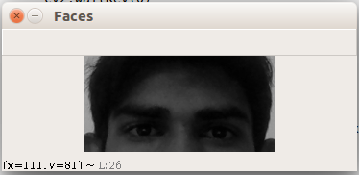
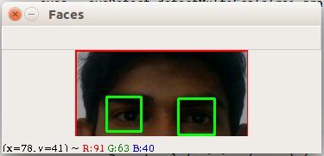

- Now here is our final face detected image

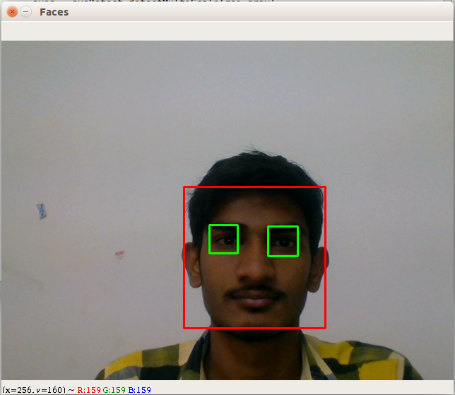

4.3. Process : Playback control

- Detect face for every frame of video input by webcam



- On successful detection of the face and eyes, play the video

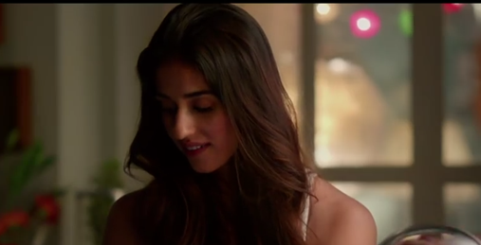

- On closing of eyes, video pauses

- When no face is detected, video player is closed

5. Result:

The application capture an image from webcam and process it and play/pause/ resume/ stop according with a great accuracy.

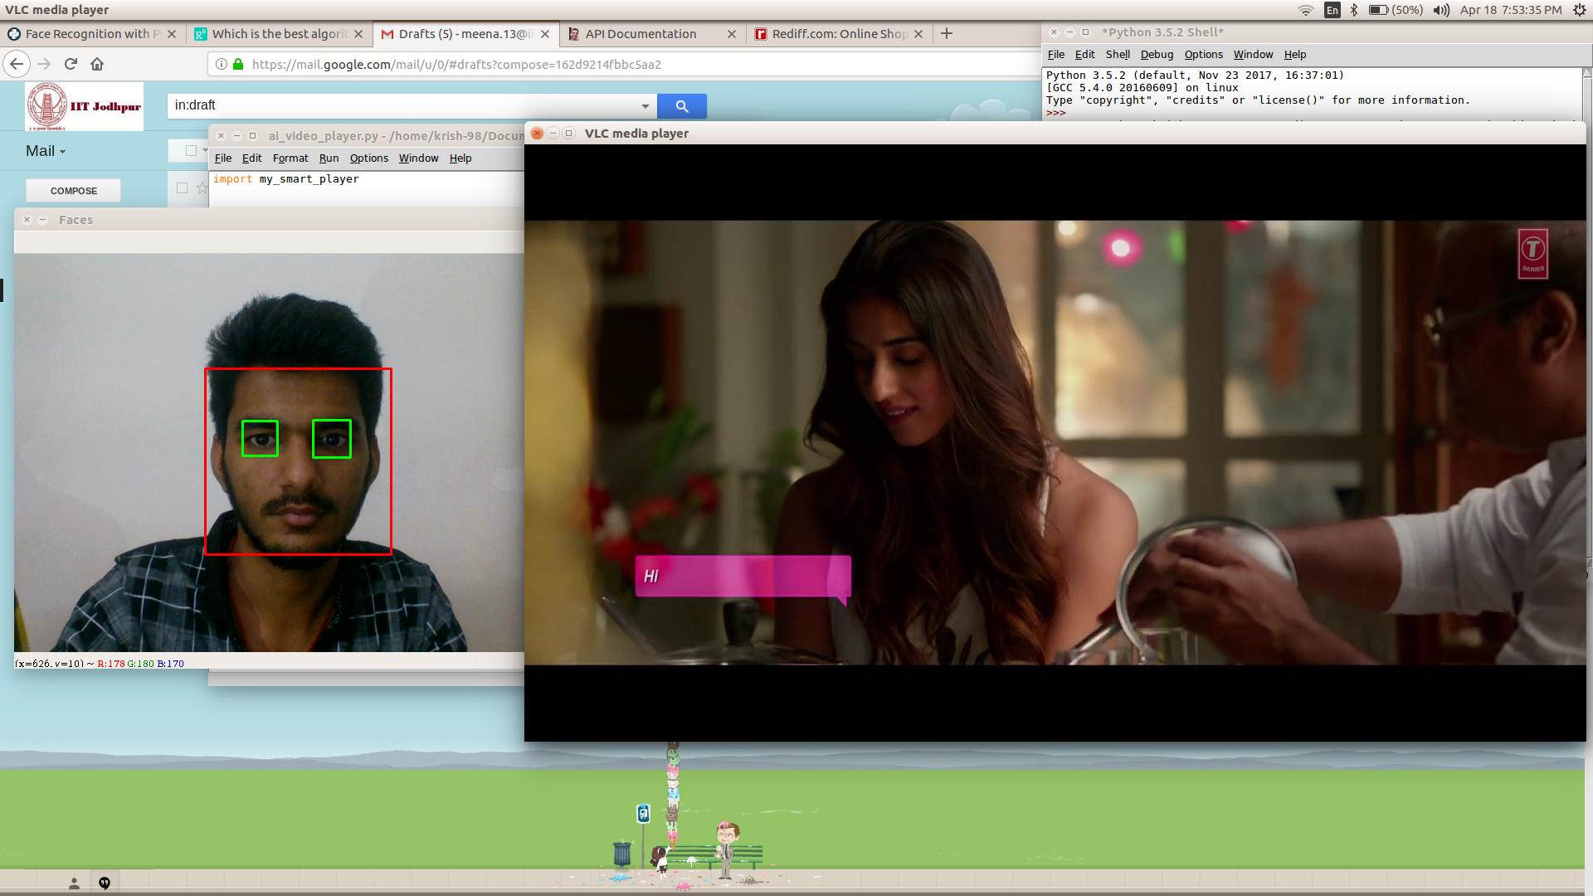

6. Conclusion:

Video player do his work very well and also face detection is pretty good but eyes detection is not showing good result but if we take an image in bright light then eyes detection accuracy increase with a great extent.

7. References:

- P. Viola, M. J. Jones, “Robust Real-Time Face Detection”, International Journal of Computer Vision 57(2), 137–154, 2004.
- Python Programming URL : https://classroom.udacity.com/courses/ud1110
- Stack Overflow URL : https://stackoverflow.com/questions/38279632/viola-jones-in-python-with-opencv-detection-mouth-and-nose

