

Project

Semester 2 / Year 2020

COURSE : Digital Media Marketing

COURSE CODE : BTIS3063

LECTURER : Ms Chan Ler-Kuan

**Assignment Instructions:**

1. Project assignment will contribute 30% to your final grade
2. This is a group assignment.
3. A team should consist of minimum five (5) students
4. Register your project title at the destinated file.

# Submission Instructions:

1. Group project must be submitted **LATEST** by: **1 Sept 2020, 4pm**
2. Your report should not exceed 10 pages including cover page, table of content and references list and marking scheme.
3. ~~Submit the hardcopy to your lecturer. The hardcopy should include the printout of your work and marking scheme.~~
4. If any assignment is submitted after the deadline, 50% deducted from the total assignment marks.
5. Marks will also be deducted for not adhering to the instructions

# Rubric for Project

|  |  |  |  |  |
| --- | --- | --- | --- | --- |
| Criteria | Requires Revision to Meet Requirements  (0 - 2 marks) | Meets Minimum Requirements  (3 - 4 marks) | Exceeds Requirements  (5 marks) | **Marks** |
| Content | Content is unclear, inaccurate  Incomplete support for the central purpose, arguments or goals are weak or poorly discussed | Present clear and appropriate information that adequately supports the central purpose, arguments or goals of the project | Presents balanced, significant and valid information that clearly and convincingly supports the central purpose, arguments or goals of the project. |  |
| Volume | 0 – 10% increase in volume | 10 – 50% growth in volume | More than 50% growth in volume |  |
| Reach | 0 – 10% increase in reach | 10 – 50% growth in reach | More than 50% growth in reach |  |
| Engagement | 0 – 10% growth in engagement | 10 – 50% growth in engagement | More than 50% growth in engagement |  |
| Influence | 0 – 10% growth in influence | 10 – 50% growth in influence | More than 50% growth in influence |  |
| Grammar and Spelling | * More errors in punctuation and capitalization | * Some errors in punctuation and capitalisation | * Punctuation and capitalization are correct |  |
| Multimedia | * No multimedia and image elements | * Apply some multimedia elements * Image need improvement | * Good use of multimedia * Image in good ratio and resolution |  |
| Structure / Text Formatting | * Lack of tidiness * Lack of colour coordination * Weakly organised * Not adhering instructions. | * Average user-friendliness and tidiness * Some technical or structure errors * Well organized but need improvement * Partially adhering instructions | * Good user-friendliness and tidiness * No technical or structure errors * Well organised * Adhering instructions. |  |
|  |  |  | **Calculation** | **_____ / 20 *15** |

Once your team has completed all the tasks, prepare a technical report. Your report should contain the following.

|  |  |  |
| --- | --- | --- |
| **No** | **Title** | **Description** |
| 1 | Summary | Summary of the project |
| 2 | Research analysis | * Industry research * Keyword/ phrase research * Post title research * Hashtag research * Platform research |
| 3 | Strategy | What is the strategy plan? |
| 4 | Schedule | How do you schedule it? |
| 5 | Result | Result from platform |
| 6 | Conclusion | What lessons have your team learned? |

# 1) Summary

# 2) Research analysis

**Industry research**

There are several competitors online learning platform which are similar with Academe in Malaysia. These competitors have different unique features.

OpenLearning



OpenLearning is an online learning platform that goes beyond content delivery to focus on community, connectedness, and learner engagement.

**Keyword/ phrase research**

The keyword is important to us. Because it can help search engines identify the topics that your content covers. The search engines will be using an algorithm for analyzing the keywords that are used throughout a given piece of content. So, it can match the content that will best answer.

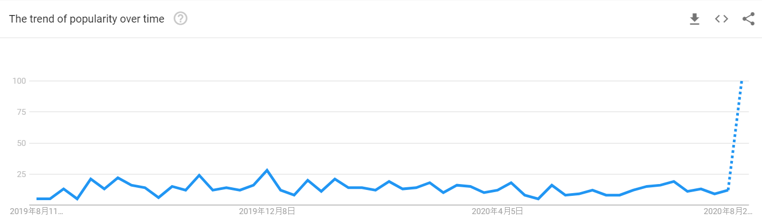

This picture will show the hold world people that search academe in average result. In here we can see the highest result is in December have 28-point that research result. The lowest result is in September and April just have 5-point research result.

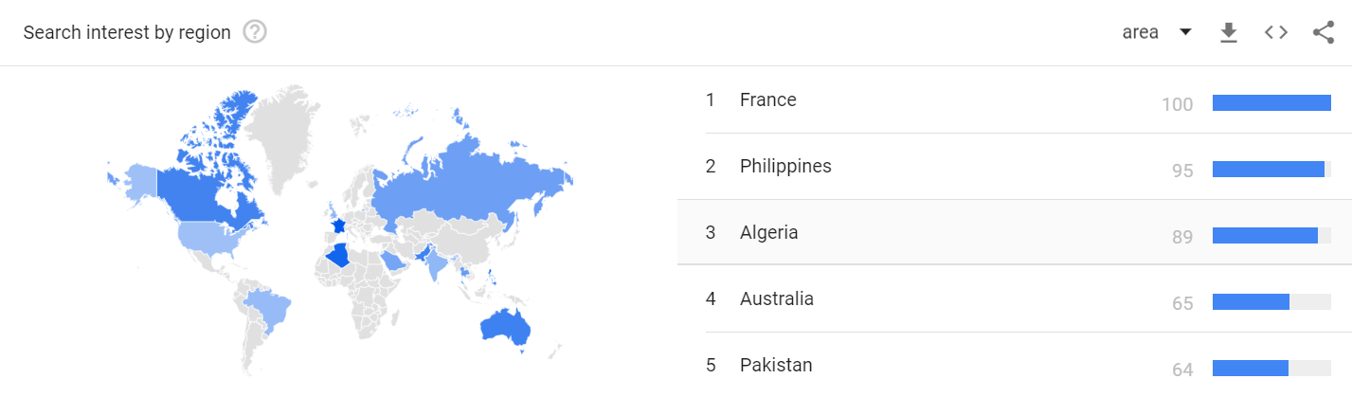

In this picture we can know the France country many people will search the academe. This is a good situation because knowledge is power, a country need to upgrade the people in the country also need the knowledge.

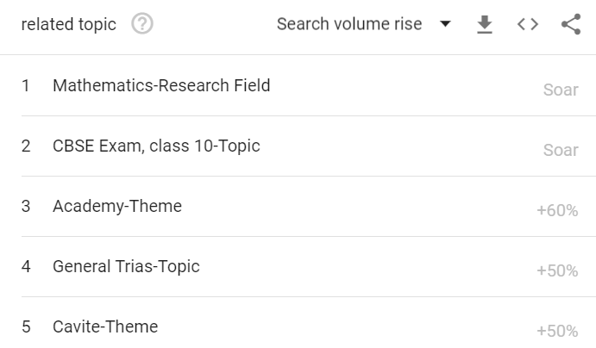

In this picture we can know the people that search topic for academe most of the topic is mathematic. Because the math is use in everywhere, so the math is most important than another subject.

**Post title research**

Before we look at how to title a research paper, let’s look at a research title example that illustrates why a good research paper should have a strong title. When you are searching for a research study on a topic, you probably notice that articles with interesting, descriptive research titles draw you in. By contrast, research paper titles that are not descriptive are usually passed over, even though they may be good research papers with interesting content. This shows the importance of coming up with a good title for your research paper when drafting your own manuscript.

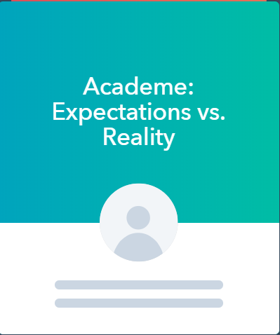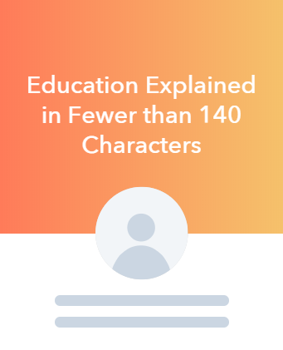

Those are the post title example that given by <https://www.hubspot.com/blog-topic-generator>

**Hashtag research**

To increase your social media presence as they make your content viewable by anyone who has an interest in your hashtag as it goes beyond just your followers. Hashtags can help you build a customer and joining the conversation about what’s trending.

The best hashtag of academe result as shown as below:

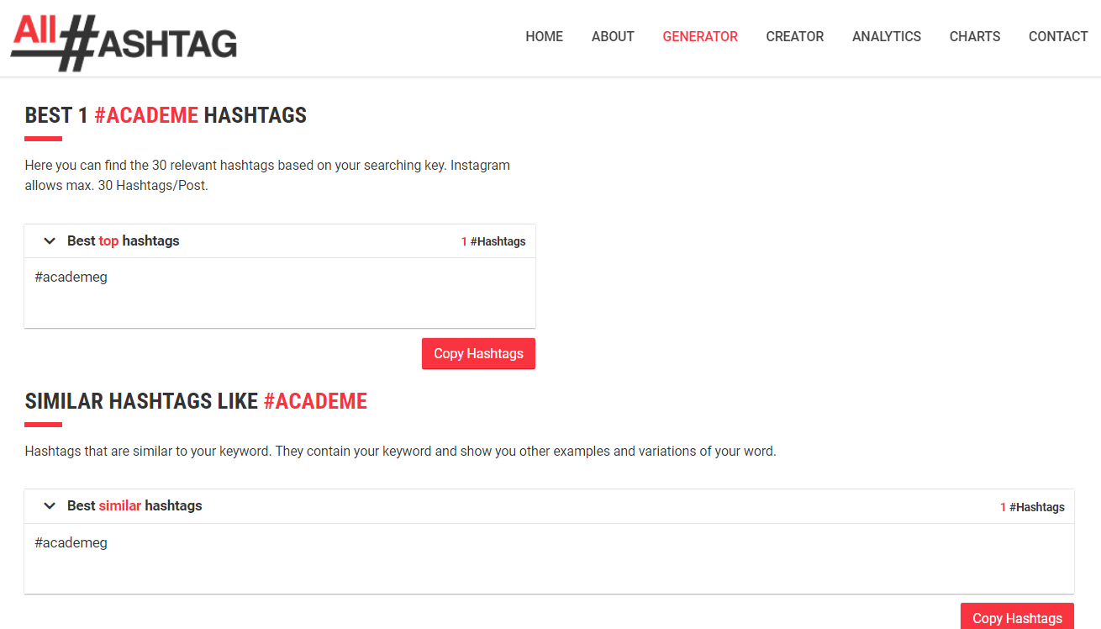

The best hashtag of education result as shown as below:

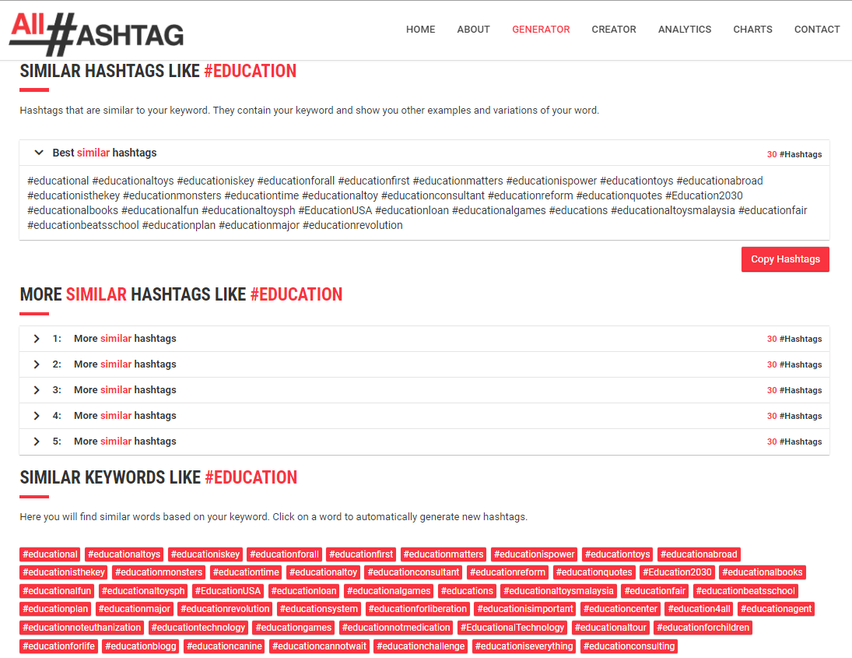

**Platform research**

# 3) Strategy

In the past few years, social media has completely changed the Internet. In fact, it changed the whole world and also changed the field of marketing. A social media strategy is a summary of everything you plan to achieve on social media and hope to achieve.

Social media makes it easier to display products and brands, and it can increase digital media exposure. In addition, social media can reduce marketing costs, because many social media are free. Here is how we build a social media strategy.

Step 1: Choose relevant and realistic social media marketing goal

The first step, we want to create a strategy is to establish our objective and goals. This because most significant problem faced by many businesses engaged in social media is, they have never spent the time to set relevant and realistic social media marketing goals. Without goals, you have no way to measure and return on investment. The goal will guide our actions and ensure it lead to real business results.

Step 2: Research and Know all most relevant metrics

Take today’s social media demographics as an example. A lot of information about the audience our need to know to influence the social media marketing strategy has been publicly released and who the audience is and what they want to see on social media is the key. These numbers directly indicate which network the brand should use and the type of content to be published. Use social media dashboards to outline who is following you and how they interact with you on each channel.

Step 3: Determine what media is the social media audience

No matter what product you sell, your social media strategy should be data-driven. Social media can focus on reaching, natural and paid likes, and hashtag performance. Social media followers can’t help achieve our goals, it’s meaningless. In most cases, you want your social media followers to be similar to the target customers. This is especially important if you sell products to geographically different markets. In this case, you don’t want people to have many followers in regions and countries where people cannot buy your products. Effective social media marketing strategies are rooted in numbers. That is, these numbers need to be placed in an environment that can be traced back to your original goal.

Step 4: Know Competition

Competitors are already using social media and conducting competitive analysis. Please take a moment to research the competition and analyze their methods before you start publishing content.

For example, maybe one of your competitors dominates Instagram, but invests very little energy on Twitter or LinkedIn. You may want to focus on networks with underserved audiences instead of trying to win fans from supporters. And pay attention to their business positioning on social media so that you can do similar or deliberately different things to stand out.

If you don’t have any direct competitors, just try to find a few accounts similar to your industry. Similarly, you can use our social media strategy templates to track your findings.

Step 5: Set up accounts and improve profile

Once you’ve determined the networks to follow, you can create a profile or improve an existing profile to align it with your strategy. All major social media channels can be set up for free, and most channels can be easily set up from their homepage. Make sure to fill in all profile fields and include keywords people use to search for your company. Use consistent branding (logos, images, etc.) across the web to easily identify you.

While all of these social media platforms can be accessed through a web browser, Instagram are both primarily mobile apps. All other major networks also have mobile app versions that are worth downloading so that you can access your channels on the go.

Step 6: Find inspiration

Can draw inspiration from other companies with strong social skills. For example: social media success stories, case studies can provide valuable insights that you can apply to your social media plans. There are also examples of award-winning accounts and campaigns with the highest-ranking brands in their social media games.

Consistency also helps keep your content brand image. You can also ask your followers what they want from you. Just make sure you follow and deliver on their requirements.

Step 7: Create a social media content calendar

Sharing great content is essential, but making appropriate plans to share the most impactful time is equally important. Set your release schedule, Your social media content calendar lists the date and time you will post the content type on each channel. This is the ideal place to plan all your social media activities-from image and link sharing to blog posts and videos. It includes the content of your daily postings and social media activities.

Determine the right combination of content. Make sure that your calendar reflects the task descriptions you have assigned to each social profile so that everything you post can be used to support your business goals.

# 4) Schedule

Below has shown the schedule of posting in social media platform (Facebook) on July.

|  |  |  |  |  |  |  |  |
| --- | --- | --- | --- | --- | --- | --- | --- |
| Week | Date | Day | Time | Post | Purpose | PIC | Remark |
| 1 | 3 Jul 2020 | Friday | 9:00 | A brand new learning platform | Introduction to the audiences | Ang  Sheng  Yang | Image |
| 1 | 4 Jul 2020 | Saturday | 12:00 | Do you know about Accounting, Information Technology and Arts & Design? | Describe  Accounting, Information Technology and Arts & Design | Ang  Sheng  Yang | Text |
| 1 | 5 Jul 2020 | Sunday | 9:00 | “Excellence is to do a common thing in an uncommon way” ―Booker T. Washington | Motivational quotes | Ang  Sheng  Yang | Text |
| 1 | 6 Jul 2020 | Monday | 18:00 | “I love _____ course!!” | Receive feedbacks from customer | Ang  Sheng  Yang | Text |
| 1 | 7 Jul 2020 | Tuesday | 15:00 | Advantages of online learning | Describe advantages of online learning | Ang  Sheng  Yang | Image |
| 1 | 8 Jul 2020 | Wednesday | 23:00 | What is this symbol belonged to? | Guessing quiz | Ang  Sheng  Yang | Image |
| 1 | 9 Jul 2020 | Thursday | 21:00 | What do you know about academy? | Differences between academy and school | Ang  Sheng  Yang | Video |
| 2 | 10 Jul 2020 | Friday | 12:15 | Stackoverflow is a great place for you to find answer, ask questions for everything coding related!    https://stackoverflow.com/ | Resources recommendation | Ang  Jin Feng | Text |
| 2 | 11 Jul 2020 | Saturday | 12:15 | What does Software Engineers do?  - Information analysis  - Debugging software  - Testing software  -Programming and coding | Introduce what software engineers do | Ang  Jin Feng | Text |
| 2 | 12 Jul 2020 | Sunday | 12:15 | What inspire you to be an artist | Interacting with followers | Ang  Jin Feng | Text |
| 2 | 13 Jul 2020 | Monday | 12:15 | Local Artist that you should definitely check out!  <https://www.instagram.com/eddieputera/?hl=en>  <https://www.deviantart.com/feigiap> | Recommending some artist that might become inspire them. | Ang  Jin Feng | Text |
| 2 | 14 Jul 2020 | Tuesday | 12:15 | A pack of great tools that you can try out for free if you’re a student.  <https://education.github.com/pack> | Recommending great software | Ang  Jin Feng | Text |
| 2 | 15 Jul 2020 | Wednesday | 12:15 | “Amateurs look for inspiration, the rest of us just get up and go to work.” – Chuck Close | Motivation quote | Ang  Jin Feng | Image |
| 2 | 16 Jul 2020 | Thursday | 9:00 | Asking question | Receive answer form customer | Lim  Chiau  Hui | Image |
| 3 | 17 Jul 2020 | Friday | 21:00 | The promotion to everyone. | Early bird has a discount. | Lim  Chiau  Hui | Video |
| 3 | 18 Jul 2020 | Saturday | 12:00 | 7 platform for online learning | learning platform | Lim  Chiau  Hui | Image |
| 3 | 19 Jul 2020 | Sunday | 15:00 | Do you know which one is more expensive than another? | The Cost of Online Education vs physical education | Lim  Chiau  Hui | Image |
| 3 | 20 Jul 2020 | Monday | 18:00 | The compare of the Online education VS Traditional  education | Online VS Traditional | Lim  Chiau  Hui | Image |
| 3 | 21 Jul 2020 | Tuesday | 12:00 | 5-reason online learning more effective | The Effective learning at online | Lim  Chiau  Hui | Image |
| 3 | 22 Jul 2020 | Wednesday | 23:00 | Develop Your Online Learning Skills and Get More from Your Online Classes | Online Learning Skills and Get More from Your Online Classes | Lim  Chiau  Hui | Image |
| 3 | 23 Jul 2020 | Thursday | 12:00 | How can you ensure you are getting out of your comfort zone more regularly? | Overcome comfort zone and start giving yourself a little push. | Jasmine Poh Fong Lin | Text |
| 4 | 24 Jul 2020 | Friday | 21:30 | How The 8 Design Principles Should Be Applied To Learning  <https://elearningindustry.com/how-apply-design-principles-to-online-learning> | Learn to apply principles of design to learning. | Jasmine Poh Fong Lin | Text |
| 4 | 25 Jul 2020 | Saturday | 08:30 | “Success is no accident. It is hard work, perseverance, learning, studying, sacrifice and most of all, love of what you are doing or learning to do.” – Pele | Motivational Quote | Jasmine Poh Fong Lin | Text |
| 4 | 26 Jul 2020 | Sunday | 22:00 | Create beautiful visual content, import your existing PowerPoint slides, get access to premium images and icons, PDF export, and offline access.  [www.prezi.com](http://www.prezi.com/) | A great presentation software should be known by the educators and learners. | Jasmine Poh Fong Lin | Text |
| 4 | 27 Jul 2020 | Monday | 11:00 | Types of eLearning | Differentiate between  asynchronous and synchronous | Jasmine Poh Fong Lin | Image |
| 4 | 28 Jul 2020 | Tuesday | 19:30 | Characteristics of Adult Learners | To raise self-awareness, self-improvement | Jasmine Poh Fong Lin | Image |
| 4 | 29 Jul 2020 | Wednesday | 8:00 | Best University in Malaysia | Introducing Malaysia's top 10 universities | Chiam Bak Seng | Text, Image |
| 4 | 29 Jul 2020 | Wednesday | 20:00 | Top 20 Course in Malaysia | Introducing Malaysia’s top 20 course | Chiam Bak Seng | Image |
| 4 | 30 Jul 2020 | Thursday | 8:00 | How to Focus on Study | Improve Study efficiency | Chiam Bak Seng | Image |
| 4 | 30 Jul 2020 | Thursday | 20:00 | Best ways to Decrease Stress from Studying | Relieve the Pressure after Study | Chiam Bak Seng | Image |
| 4 | 31 Jul 2020 | Friday | 8:00 | How to Study Smart no Hard | Improve Learning efficiency | Chiam Bak Seng | Text,  Image |
| 4 | 31 Jul 2020 | Friday | 20:00 | Hello Cannot | Use the latest fashion trends to attract followers | Chiam Bak Seng | Image |

# 5) Result

In our social media (Facebook) of the life time, the total number of people who have liked our page got 10 people like. Engagement refers to the daily number of people who engaged to our page. Engagement includes any click on created posts or stories by the users. The video post, “What do you know about academy?” at 9/7/2020 has the best engagement because it has total of 6 people engaged the post on July.

Through this posting, we know that there are more people watched the video than other posted photos or texts. It is very important that allow the contents from our page or about your page to be viewed by the people in every day. This includes posts, check-ins, ads, social information from people who interact with our page. Although the daily engagement rate of our page has resulted in little rise and fall, but the number of people had any contents from page is rising continuously in the observation of 28 days. In the 28 days, the number of people who had any contents from our page or about our page enter their screen through unpaid distribution also growth up. This includes posts, stories, check-ins, social information from people who interact with our page. According to our 28-day observation, the number of our indicators continues to increase. For 28 days, we have posted every day by using the planned strategy.

# 6) Conclusion

The title of our group is ‘Academe’, and we use social media platform promote us. Through this experience, our group learned that digital media marketing is an efficient way to attract viewers. Now everyone has a mobile phone with internet access. Children and young people spend their free time on social media platform, while elderly people use social media platform to search information and read latest news. We should use this opportunity to promote our products because there are many social media platforms are free to be used and last forever as well as they provide huge amount of viewers. Thus, this is an opportunity for free online advertising and it should not be wasted.

‘Academe’ is an educational academic language which contains a lot of various content. We must determine and target the viewers before start promoting. Young people and students are the targeted audience because they are more related to our products, which mean their lives are likely more relevant with our products so it could attract their attention and increase curiosity. Besides, we must make sure that the content we want to share is legal, and each post cannot involve copyrighted or trademarked products of others. If we use related products made by others, we must list out their trademarks and sources.

Our group believes that we have achieved our goals, and we believe that the key to succeed is to share what we have learned together in a division of labour, and we also use the lessons taught by teachers and apply it to real projects. Our purpose is to promote the meaning of ‘academic’ and all about ‘academic’ to public.

This small project is set to be completed in 4 weeks. Therefore, we draw up a complete detailed timetable and then update our feed by posting the contents according to the timetable. The timetable must include the date, time, content, purpose, picture and remark of the feed to be posted.

In the first week, we used some questionnaire and answer methods to attract viewers. We also use this time to introduce our products and benefits, so that people gradually become familiar with us and our products.

In the second week, we began to introduce our products in depth. We use motivation quotes to attract viewers' attention and inspire everyone's desire to work hard and work smart. We understood the needs of the viewers and try to meet their requirements after receiving replies from the viewer via questionnaires.

In the third week, we used gifts and promotions to attract viewers and arouse everyone's greedy desire. We use a short video to introduce our products, and then attract customers with an early bird discount. We also let viewers understand that online education is better than traditional methods through comparison, and let customers understand our products more thoroughly.

In the fourth week, we felt that we had successfully introduced the word ‘academe’ to every viewer, and we could begin to attract viewers to become our customers. In addition, we are continuing to update our feed by posting about our product information on social media platform. We also use pictures to share information, because we found that viewers are easier to be attracted by pictures and it is easier to understand. We also make viewers continue to pay attention to our products through modern popular trending topics which make sense among people.

In conclusion, we must analyse our products thoroughly before starting a project. We can use the social media platform to promote our products, and we can also use it to make profits. Thank you teacher for giving us the opportunity to do this project, let us understand that Digital Media Marketing will become a new trend in the future.

**~End of Project ~**