SOUTHERN UNIVERSITY COLLEGE

ACADEMIC YEAR 2020

TEST 1

**BTIS3063 DIGITAL MEDIA MARKETING**

DATE: 1 July 2020 TIME:

BACHELOR OF SOFTWARE ENGINEERING (HONS)

YEAR ONE / TWO / THREE

Name: Lam Wei Chun (B180279C)

**Instruction to Candidates:**

Answer **ALL** questions. All questions carry equal marks.

Answer ALL questions in Word format.

Save it as Microsoft word format (DOCX)

Name it as Test1__BTIS3063_2020B_<studentID>. For instance: *Test1_BTIS3063_2020B_B111111C*

Submit through destinated Microsoft Teams’ assignment section.

Mc Donald Digital Marketing Case Study

Social media has become a primary tool of marketing for businesses in the 21st century. More and more of them from all industries are flocking to the social media platforms to market their brand and products. They are actively publishing content, engaging their audience in discussions and in this way growing their customer base and engaging the existing customers. Social media has also proved highly effective in terms of marketing and is helping brands reach millions of fans and customers. They do not need to spend a fortune either. It is helping them manage their customer relationships in several new ways. From fun to food and fashion, brands from all industries and even tech industry are actively engaging on social media and connecting with their followers in real time. McDonald’s is the leading fast food brand of the world. It is mainly managed by its franchisees. The company operates across more than a hundred countries. Its number of restaurants has grown higher than 37K. The QSR brand sells a uniform menu globally except for minor regional variations to suit the local taste and preferences. However, the company also focuses on marketing and promotions to reach its target audience. Apart from the other channels of advertising, McDonald’s uses social media for marketing and promotions. Let’s have a look at how it has utilised each of the major social media channels for marketing, promotions and customer engagement.

**Facebook:**

With more than 78.5 Million followers, the Facebook page of McDonald’s looks quite popular. A very high number of marketers and brands use Facebook. After all it is the leading social media platform with the highest number of users. As the largest social media website, Facebook boasts of more than 2.2 Billion monthly active users. No company or marketer will find a bigger base of users and customers accessible on any other platform on the entire web. It is why Facebook is at the core of the social media strategy of most marketers. The level of user engagement on both Facebook and Instagram can be quite high. However, brands must still refrain from using these platforms too aggressively for they can end up spoiling users’ taste and their own image as well. McDonald’s has used Facebook mainly for promotions. However, they are not using it solely for promotions. McDonald’s also uses it to some extent to address customer service related issues and people’s complaints. The social media reps of the company respond to people’s recommendations or complaints as required. Overall, the number of views, likes, shares and comments on each posts shows an impressive level of engagement.

It is good to engage with your fans by occasionally responding to their concerns. McDonald’s is doing well in this area. People do often bring their grudges and complaints. However, the trick lies in engaging them successfully and giving them genuine and practical responses that minimise dissatisfaction. Facebook can be an attractive platform to tackle your customer’s complaints. These discussions help you gain critical insights which will help you with making your marketing more effective. McDonald’s does not use the platform too aggressively for promotions. The number of posts is generally limited to no more than one a day. Still most of them receive likes in hundreds or a few thousands. While Facebook must not be used as a total marketing solution, it can still help you fill some important gaps in your marketing strategy. McDonald’s promotes mainly the freshest deals and new arrivals in its Facebook account. Apart from its main account, McDonald’s also has an India account with more than 1.7 million followers. Overall, it has used Facebook effectively for creating excitement and user engagement.

**Instagram:-**

For the fun, food and fashion brands, Insta is also a very attractive platform to market their business and promote their products or services. You are going to find a large and relevant audience on Insta as well. However, the audience size of Insta is much smaller as compared to Facebook and still it is a great option for video marketing and sharing images. McDonalds has got 3.3million followers on Insta and has made around 500 posts including videos and images. However, the main focus of the brand is promotions on this social media platform. It does not use Insta for discussions or to address customer issues.  Mostly, it is promotional videos or images which either promote new deals or items on the menu. However, the response from customers is still very good and the level of engagement impressive. McDonald’s uses most of these social media platforms sparingly in order to avoid a mess which can happen due to too much promotional content. This is a good practice. Even on Twitter it does not send too many tweets and generally sends just one a day. It has adopted this practice on nearly all of its social media accounts including Insta. while this helps at staying connected with users, it also helps maintaining the right image in the eyes of users.

**Twitter:**

Twitter is also a social media platform that attracts marketers in very large numbers. It has got some attractive features that are quite suited to real time marketing and interaction. Serve exciting news in real time to keep your fans engaged and feeling hungry. The reason that a large number of marketers flock to Twitter is because they find it most suitable for real time content distribution.  McDonald’s has more than 3.5 million followers on Twitter which is a large fan base for a fast food brand. Most of its rivals including KFC, Subway, Burger King and Wendy’s have fewer. Like the other platforms, McDonald’s uses this one too sparingly with number of tweets remaining limited to one a day and 5 to 7 a week. It has used Twitter also mainly for promotions and to churn excitement around new products and deals. Reps sometimes respond to comments but their level of interaction with users is much limited compared to Facebook. However, the number of retweets, likes and comments on each of its tweets shows impressive engagement.

**YouTube:-**

It’s an era of video marketing and brands from all industries promote their products and services using videos. Apart from being the largest video sharing platform, YouTube also boasts of a very large audience which is around 1.9 Billion month active users a month.  However, it seems McDonald’s is not trying to exploit this opportunity to its fullest. The number of followers of McDonald’s on YouTube is a little less than 400K. However, the number of videos uploaded by McDonalds is even less than 50. Some of these videos have been very popular and have received more than a million views. Most of them are promotional videos promoting the items on McDonald’s menu. Some of them are related to branding. McDonald’s can use videos more regularly to actively engage users. In this area, it must follow the brands like Coca Cola, Pepsi, Starbucks or even Nike which use videos more regularly to promote their brand. Video content has become an essential part of your marketing strategy in this era and you can use them to generate excitement as well as to drive user engagement and customer loyalty higher.

**Linked In:**

Linked In is mainly the social media platform for professionals. However, it is also a social media platform with a large user base that allows businesses to build profiles, connect with prospective candidates and a larger audience. Many businesses use it for branding as well and to stay connected with an educated and skilled audience made up of working professionals. Even as a platform related mainly to employment, Linked In offers some great opportunities or branding as well as marketing. You would like to project a strong and impressive image as an employer before a large pool of talented people if you want to attract the right talent. You can also share new and exciting things about your workplace and work culture as well as new employment opportunities with your group of followers. While Linked In may not offer as large an audience as Facebook, Twitter or Insta, businesses can still benefit a lot from the opportunities it offers for both marketing and hiring.

McDonald’s is using an attractive strategy to exploit all the benefits that Linked In offers. Number of McDonald’s followers on Linked In is a little higher than 650 K. It actively engages its audience on a wide range of topics that most often include opportunities for work and collaboration on other issues. Apart from it, the company also uses Linked In to attract attention towards other issues and ignite discussions on topics like supply chain sustainability and Corporate social responsibility. Linked In is also its favourite platform for sharing best practices and generate excitement around the company’s business policies as well as employment programs. High number of likes which usually runs in hundreds and tens of comments on each post show impressive engagement.  McDonald’s also does not let any opportunity go to showcase the success of its employment and training programs through Linked In.

**Conclusion:**

Social media is now a very important tool of marketing for most brands including big and small. Several of them are using it actively for customer service and for addressing customer complaints as well. Social media channels like Facebook, twitter and Instagram have also been proved to be very effective for promotions to churn excitement and ignite discussions. the insists generated from popular reactions canals be very useful in terms of designing marketing strategy. McDonald’s is a leading fast food brand with presence in more than 100 countries. It is mostly run by franchisees. However, the brand has used social media with skill to connect with its customers and to engage its fan base. It has the largest base of followers on Facebook. However, it uses most of these channels for only promotions apart from Facebook through which it also likes to address customers’ complaints. Its YouTube account however, seems to be lacking activity. The brand should follow a better video marketing strategy. In this regard it can seek inspiration from other major brands like Coca Cola and Pepsi. Otherwise its social media strategy is relatively impressive and effective. However, the level of engagement in case McDonald’s likes to increase it can be driven higher through active interaction and discussions.

Source adopted from <https://notesmatic.com/2019/01/mcdonalds-social-media-strategy/> on 26 June 2020

1. Refer to the Mc Donald digital marketing case study above and relevant sources.
2. Summarize the main tactic tools used by McDonald in the context of RACE.

(20 marks)

|  |  |
| --- | --- |
| Criteria | Main tactic tools Summarize |
| Reach | * Apart from the other channels of advertising, McDonald’s uses social media for marketing and promotions. * Apart from its main account, McDonald’s also has an India account with more than 1.7 million followers. * McDonalds has got 3.3million followers on Instagram and has made around 500 posts including videos and images. * McDonald’s has more than 3.5 million followers on Twitter which is a large fan base for a fast food brand. * Number of McDonald’s followers on Linked In is a little higher than 650 K. |
| Act | * McDonald’s has used Facebook mainly for promotions. However, they are not using it solely for promotions. McDonald’s also uses it to some extent to address customer service related issues and people’s complaints. * McDonald’s has used Instagram to focus of the brand is promotions on this social media platform. It does not use Instagram for discussions or to address customer issues. * McDonald’s has used Twitter also mainly for promotions and to churn excitement around new products and deals. Reps sometimes respond to comments but their level of interaction with users is much limited compared to Facebook. * The number of followers of McDonald’s on YouTube is a little less than 400K. It seems McDonald’s is not trying to exploit this opportunity to its fullest. |
| Convert | * McDonald’s promotes mainly the freshest deals and new arrivals in its Facebook account. * McDonalds does not use Instagram for discussions or to address customer issues.  Mostly, it is promotional videos or images which either promote new deals or items on the menu. * McDonalds has used Twitter also mainly for promotions and to churn excitement around new products and deals. * Most of them are promotional videos promoting the items on McDonald’s menu in YouTube |
| Engage | * McDonald’s also uses it to some extent to address customer service related issues and people’s complaints. * The social media reps of the company respond to people’s recommendations or complaints as required. * McDonalds use the trick lies in engaging them successfully and giving them genuine and practical responses that minimise dissatisfaction. * McDonald’s also does not let any opportunity go to showcase the success of its employment and training programs through Linked In. |

1. Measure McDonald’s customer lifecycle by using the RACE. (5 marks)

|  |  |
| --- | --- |
| Criteria | Measurement |
| Reach | Unique visitors |
| Act | Time on site |
| Convert | Revenue / profit |
| Engage | Loyalty |

TOTAL: 25 marks

1. Refer to the Mc Donald digital marketing case study above and relevant sources.
2. Provide each P from marketing mix with TWO (2) examples from Mc Donald case study. (21 marks)

|  |  |
| --- | --- |
| Marketing Mix | Examples |
| Product | * McDonalds includes certain aspects of its product such as packaging, desirability, looks etc. This consists of both tangible and non-tangible aspects of the product and services. McDonalds has purposely kept its product depth and product width limited. * McDonalds had first studied the behavior of the Malaysian customer and provided a totally different menu as compared to its menu offered in International market. * McDonald’s Malaysia is the first Malaysian Fast Food Restaurant to be recognized by the Halal Department of Islamic Development (JAKIM). This recognition ensures that we comply with the Halal standards and regulations set by JAKIM. |
| Price | * McDonald Corporations usually set the price based on the potential customers’ income level, or how much are they willing to pay for the products. * McDonalds has certain value pricing and bundling strategies such as happy meal, combo meal, family meal, happy price menu, and other to increase overall sales of the product. * For example, McDonald is selling Mc-Value meal and Happy meal in cheaper price which included everything, this can help customer save their money and increase more customer to dine in. |
| Place | * They are built or open in retail area’s like shopping malls due to a trend of all Malaysian who loves to shop in malls. They also open in some rural area’s however KFC has more restaurants in the rural area. * In some strategic places, McDonalds also opens in several local gas station such as PETRONAS. They open an express café that serve some popular products. * This can satisfy the hunger of consumers such as, working executives on-the-go and motorist. |
| Promotion | * The promotional activities adopted by the McDonald helps to communicate efficiently with the target customers. * McDonalds corporate used advertising, personal selling, sales promotion, public relations, and direct marketing and became world’s largest leading Burger Empire. These five promotion tools are used by McDonalds to integrate marketing communication program which allows McDonalds to access the communication channels clearly, consistently and easily transfers messages and product to the target audiences. |
| People | * McDonald's understands the importance of both its employees and its customers. It understands the fact that a happy employee can serve well and result in a happy customer. McDonald continuously does Internal Marketing because if the internal marketing is effective it will automatically lead to in the success of external marketing. * Internal marketing includes hiring, training and motivating employees. In this way they can easily serve customers and the result will be the smiling faces of the customers. * The level of importance has to be placed in the following order (the more important people are at the top):  1. Customers 2. Front line employees 3. Middle level managers 4. Front line managers |
| Physical Evidence | * The physical evidence appearance affects not only the impression outsiders have of a business but all the way that business functions * Staff Members * Location and appearance * Buildings Maintenance * Interior * McDonalds focuses on clean and hygienic interiors of is outlets and at the same time the exteriors are attractive and the fast food joint maintains a proper decorum at its joints. |
| Process | * Food Producing Transparent to customers * New method of packaging & distribution * Invented most Efficient cooking equipment * Customer are invited to check the ingredients used in food * It allows customer to enter the area where the process takes place to have a Clearview of what they are consuming |

1. What impacts do apps, widgets & QR codes have on marketing mix?

* Apps – can be install on mobile devices
* Widget – Display news headlines, clocks, or games on their webpages.
* Photo - Photos are easier to remember and follow than fonts.
* QR codes – QR codes to promote their companies and offer customer discounts.

(4 marks)

TOTAL: 25 marks

1. Refer to the Mc Donald digital marketing case study above and relevant sources.
2. FIVE (5) tools for assessing your online marketplace (5 marks)

* similarweb.com
* alexa.com
* [semrush.com](http://www.semrush.com)
* woorank.com
* sitechecker.pro/traffic-checker

1. Using the 5 tools mentioned on 3(a) analyse McDonald digital marketing (20 marks)

|  |  |
| --- | --- |
| Tools (1 mark each) | Explanation (1point = 1 mark) |
| similarweb.com | * For the past 6 months, McDonald has a total 197.36m visit. * Average visit duration is below 2 minutes.      * Facebook.com has the highest social media referral (96.56%) |
| alexa.com | * Mcdonalds.com.my has ranked second in percentage overall site traffic (59%)      * For the past 90 Days, McDonald has a total 205363 in global internet engagement. * Average visit duration is below 2 minutes. |
| [semrush.com](https://www.semrush.com/analytics/traffic/) | * In SemRush, that show has 1.2M visits in May 2020. * The visit duration also increases 8.47% in 05:20 minutes. * The Bounce Rate decreases 5.66% in 53.11%. |
| [woorank.com](http://www.woorank.com) | * In woorank, the Traffic Estimations of level is high. * The McDonold.com.my is 205363th most visited website in the world * The McDonold.com.my is 1358th most visited website in Malaysia. |
| sitechecker.pro/ traffic-checker | * In sitechecker, the overall visits per month is 353987 * The average visit duration is below 2 minutes.      * The highest traffic by sources is direct to mcdonalds.com.my |

TOTAL: 25 marks

1. Refer to the Mc Donald digital marketing case study above and relevant sources. All images or media used in this question must be open source and free of copy right.
2. Assume that Mc Donald is introducing plant-based meat burger in Malaysia. Refer to Ansoff matrix, which strategy will be the most suitable to apply in Malaysia market? (1 marks)
   * + Product development strategy
3. Provide situation analysis on 4(a). (5 marks)
   * + **Goal performance (SSs)** - Today McDonalds is the California world’s largest fast food chain serving 47million customers daily. McDonalds is now one of the most valuable brands globally, worth more than $25 billion.
     + **Customer insight** - Quick and simple ordering means happy customers, and revolving customers are the core of every restaurant business.
     + **E-marketplace SWOT**

|  |  |
| --- | --- |
| Strength   * Strong Brand * Customer Intimacy * Product innovation * Supplier Integration | Weakness   * Low depth and width of product |
| Opportunity   * Expand into Tier 2 and Tier 3 cities * Entry into breakfast category. | Threat   * Changing customer lifestyle and taste * Increased competition from local fast food outlets like Jumbo King. |

* + - **Brand perception**

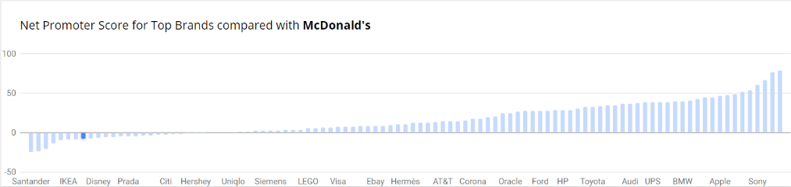

1. McDonald’s has a net promoter score of -8. (Customer Guru, 2020)
   * + **Internal capabilities and resource**
2. brand image
3. food variety and quality
4. global presence
5. customer service
6. Economies of scale
7. Illustrate a Facebook page banner for the plant-based meat burger. (5 marks)

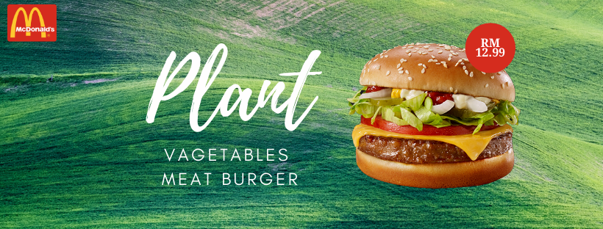

1. Illustrate an Instagram post for the plant-based meat burger campaign.

(5 marks)

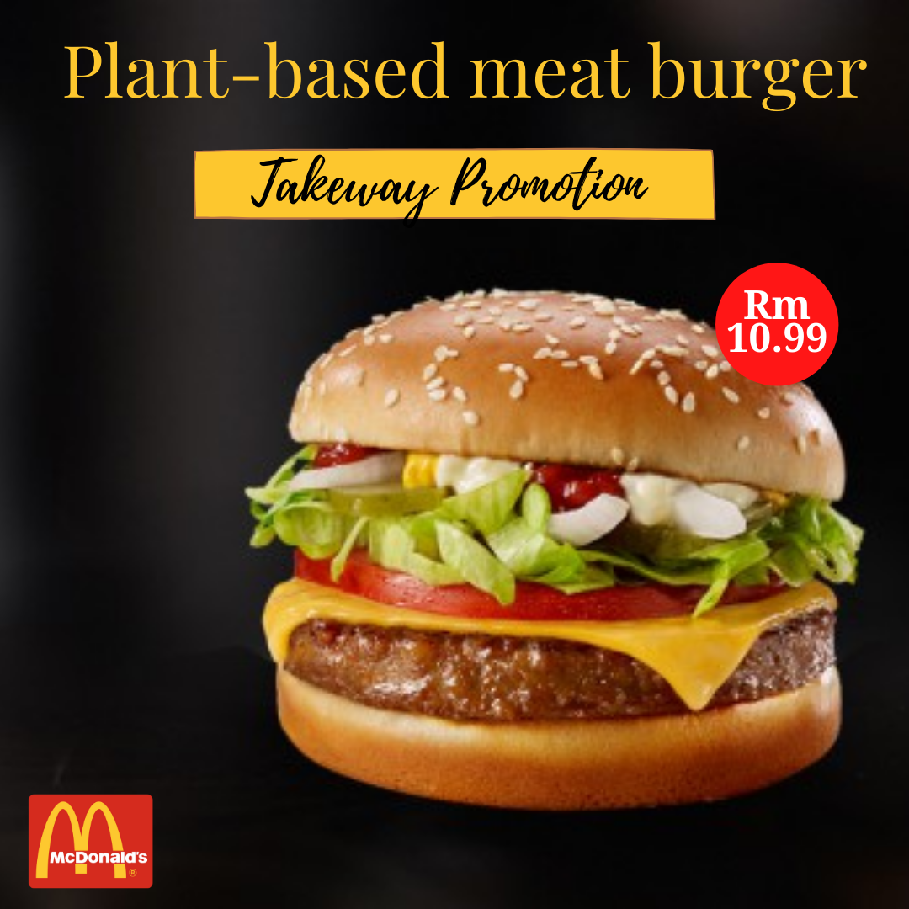

1. Explain the selected strategy on 4(a). (5 marks)
   * + In business and engineering, new product development (NPD) is the term used to describe the complete process of bringing a new product or service to market.
     + There are two parallel paths involved in the NPD process:
       1. one involves the idea generation, product design, and detail engineering
       2. the other involves market research and marketing analysis.
     + Companies typically see new product development as the first stage in generating and commercializing new products within the overall strategic process of product life cycle management used to maintain or grow their market share.
     + McDonalds is always within the fast-food industry, but frequently markets new burgers. Frequently, when a firm creates new products, it can gain new customers for these products. Hence, new product development can be a crucial business development strategy for firms to stay competitive.
     + McDonalds are always enhancing their existing product along with it; they also try to introduce new and new products so that they can easily survive in market.
2. Propose the most suitable pricing strategy for plant-based meat burger.

(1 mark)

* Bundling

1. Explain your pricing strategy mentioned in 4(f). (3 marks)

* Combine several services or products as a sale package
* It’s important to say that this strategy works well for services too, not just products.
* Example: Microsoft Office 365, Sling TV and AirAsia

TOTAL: 25 marks

______________________0000_____________________

# References

Canva. (2020). *Canva*. Retrieved from Canva: https://www.canva.com/folder/all-designs

Customer Guru. (2020). *MCDONALD'S NET PROMOTER SCORE 2020 BENCHMARKS*. Retrieved from Customer Guru: https://customer.guru/net-promoter-score/mcdonald-s

McDonald. (2020). *McDonald*. Retrieved from McDonald: https://www.slideshare.net/AdityaBetala1/7ps-of-m-cdonalds

Slideshare. (2020). *mcdonalds marketing strategies*. Retrieved from Slideshare: https://www.slideshare.net/pridhavale/mcdonalds-marketing-strategies