University Content Management System

Wei Chun Lam

Department of Computer Science, Southern University College

hiew MOI sim

Department of Computer Science, Southern University College

# ABSTRACT

# The University Content Management System is a web-based system that allows Dean and Lecturers to track, manage and store university documents and reduce paper usage. Admin can manage university data such as staff, student, program, etc. Lecturer can put teaching materials on the system so that students can watch and download them at any time. Lecturer can also develop teaching plans and assessments so that students can browse it. Dean can use this system to check whether Lecturer's teaching methods meet official government requirements. Lecturer also needs to be a moderator for review other Lecturer courses, such as whether the assessment level of the course meets and give some other opinions. Lecturer can also take student attendance about the course through this system. Students also need to store the examination papers reviewed by Lecturer by taking photos, so that the university does not need to store student examination papers in paper documents.

Keywords - **University Content Management System, University Data, teaching materials.**

1. **INTRODUCTION**

Nowadays, with the rapid development of technology to the high-tech era, we have also begun to gradually accept the paper documents change to use electronic documents for storage. In the past, there are still many colleges that use paper to store information. Of course, there will be no problems at the beginning, but as time slowly builds up, the problems will become very apparent such as waste space, difficult searching, and other. Therefore, to effectively manage the growing paper documents, a paper-based document management system is needed. Since we are hooked on smartphones, tablets, etc., these devices now play an important role in electronic documents. It turns out that books are gradually being replaced by electronic teaching materials such as CD or USB. Therefore, University Content management system is essential for university colleges.

1. **UNIVERSITY CONTENT MANAGEMENT SYSTEM**

The University Content management system is a storing document system which is developed for Dean, head of department (HOD), Lecturers and Students. The University Content management system is a web-based system and it is accessed by the internet connection to receive, track, manage and store documents and reduce paper. So, the University Content management system will focus on Five target user such as the Admin, Dean, HOD, Lecturer and Student.

There is no doubt that paper document cannot be replaced in completely. However, the University Content management system can effectively, properly create, share, organize and store information. This can help paper-based documents solve problems facing them. The most important thing is to reduce paper documents. Most paper documents are Assignments, Test, Quiz and Final exam questions of some courses, which can be replaced by system archives. The system can also let lecturer put the teaching materials on the system, so that students can download and quote for free anytime, anywhere. Lecturers can also put teaching plans on the system so that students can follow or track. Dean and HOD can easily monitor lecturer and student performance.

In this system got five target, the following is the listing of target task.

**Admin**

* Add, view, edit and delete the University data details.

**Lecturer**

* Staff can edit own personal data in own portal.
* Add, view, edit and delete the course portfolio.
* Assign students in own course.
* Add the teaching plan about the course.
* Upload the assessment question in image to system.
* Search keyword for question using by OCR.
* Store the course materials such as Lecture Note.
* Download the course materials in Zip Files or Single File.
* Review specified of courses.
* Generate the QR code for student take attendance himself.
* Scan the QR code for take attendance.

**HOD**

* Can done all the task of lecturer
* Can view the faculty data (portfolio, lecturer CV, syllabus) based on department.

**Dean**

* Can done all the task of lecturer
* Assign the lecturer to be a moderator of specify courses.
* Generate the E-Portfolio Form
* Store the faculty materials such as activities and other.

**Student**

* Student can submit the assessment in image that marked by lecturer.
* Search keyword for question using by OCR.
* Download the course materials in Zip Files or Single File.
* Student can edit own personal data in own portal.

1. **LITERATURE REVIEW**

In this part, I am going to explore the products related to my project that have been conducted by other academic previously. University Content Management System an online system or software which is used to manage content of university. It helps in administration and tracking. In this regard, I explored two system of research paper related to my project, which are Content Management System(CMS) and Document management system (DMS).

At first, I thought there was no difference between the two systems, which may cause confusion when it comes to the number of solutions, especially when the boundaries between solutions are not well defined. Document Management Systems (DMS) and Content Management Systems (CMS) [3] offer similar features, but they also have some key differences. Generally, a DMS works to help create, track, and store digitized documents. These systems retain, classify, and protect electronic data. In addition to this, a DMS supports collaboration, versioning, and workflows. However, a CMS creates and manages different kinds of digital content, besides more traditional documents. Rather than solely managing PDFs, Excel files, or Word files, a CMS can manage web pages, images, flash files, and records.

Table 1: Differences of CMS and DMS [1].

|  |  |
| --- | --- |
| **Content Management System** | **Document management system** |
| A DMS manages structured data and is focused on documents in the traditional sense in such formats as Word, PDF, PowerPoint, Excel, etc. | A CMS, on the other hand, can handle both structured data and unstructured data, such as web content (HTML and PDF files) and digital assets (images and audio and video files). |
| The key purposes of a DMS are regulatory compliance and workflow management. | The key purposes of a CMS are storage, retrieval and publishing of content. |
| DMS applications have advanced imaging and scanning capabilities, such as optical character recognition (OCR), handprint character recognition (HCR), optical mark recognition (OMR) and more. | CMS tools usually don’t support those functions. |

In this regard, our university colleges do not have a more complete Content Management System [6][7]. So, I will use some of the functions of these two management systems to build a more complete University Content Management System. Many photos and documentation will be stored in this system, I will use scanning capabilities, such as optical character recognition (OCR) to help the lecturers and students to find some relevant information. This system will also store some course materials in PDFs, Excel files, or Word files.

1. **METHODOLOGY**

**4.1 Laravel**



Figure 1: Logo of Laravel

Laravel [9] is a free and open source PHP Web framework created by Taylor Otwell , designed to implement the MVC architecture of Web software , and as an alternative to CodeIgniter . Since Laravel has been developed for a long time, it has many discussions and solutions, so it makes it easier for me to develop University Content management system. Moreover, my system is a web-based system that will require PHP for server-side scripting.

**4.2 MySQL**



Figure 2: Logo of MySQL

MySQL [5] is an open-source relational database management system (RDBMS). Its name is a combination of "My", the name of co-founder Michael Widenius's daughter, and "SQL", the abbreviation for Structured Query Language.

MySQL is free and open-source software under the terms of the GNU General Public License, and is also available under a variety of proprietary licenses. Since it is free and open source, I will use MySQL as my database because its development technology is relatively mature and more familiar to me.

**4.3 Iterative model**

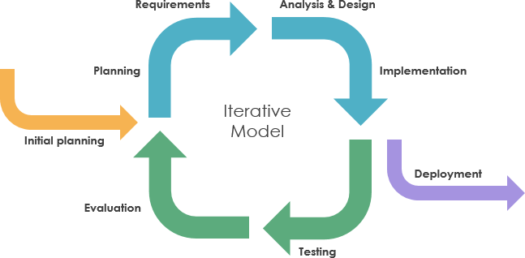

Figure 3: Iterative model

Since I am not familiar with the requirements of University Content Management System, so I will use the iterative model to develop the system. According to the iterative model [2], an iterative life cycle model does not start with a full specification of requirements. In this model, the development begins by specifying and implementing just part of the software, which is then reviewed in order to identify further requirements. Moreover, in iterative model, the iterative process starts with a simple implementation of a small set of the software requirements, which iteratively enhances the evolving versions until the complete system is implemented and ready to be deployed. Each release of Iterative Model is developed in a specific and fixed time period, which is called iteration.

The process of Iterative Model is cyclic, unlike the more traditional models that focus on a rigorous step-by-step process of development. So, the iterative model is suitable to make changes in requirements when I have misunderstood the requirements of the University Content Management System. In this process, once the initial planning is complete, a handful of phases are repeated again and again, with the completion of each cycle incrementally improving and iterating on the software. Other phases of the iterative model are described below:

1. **Planning Phase:** This is the first stage of the iterative model, where proper planning is done by the team, which helps them in mapping out the specifications documents, establish software or hardware requirements and generally prepare for the upcoming stages of the cycle.
2. **Analysis and Design Phase:** Once the planning is complete for the cycle, an analysis is performed to point out the appropriate business logic, database models and to know any other requirements of this particular stage. Moreover, the design stage also occurs in this phase of iterative model, where the technical requirements are established that will be utilized in order to meet the need of analysis stage.
3. **Implementation Phase:** This is the third and the most important phase of the iterative model. Here, the actual implementation and coding process is executed. All planning, specification, and design documents up to this point are coded and implemented into this initial iteration of the project.
4. **Testing Phase:** After the current build iteration is coded and implemented, testing is initiated in the cycle to identify and locate any potential bugs or issues that may have been in the software.
5. **Evaluation Phase:** The final phase of the Iterative life cycle is the evaluation phase, where the entire team along with the client, examine the status of the project and validate whether it is as per the suggested requirements.
6. **RESULT**

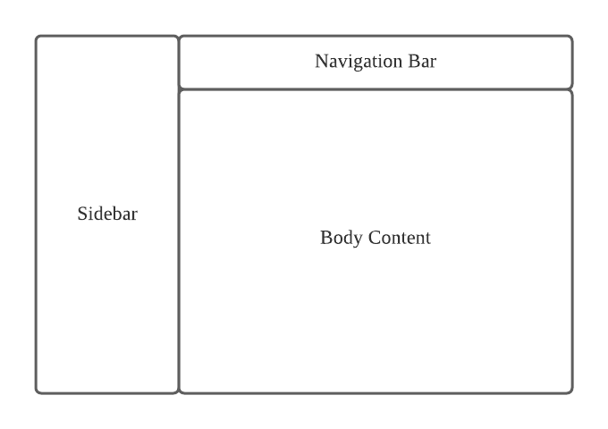

Figure 4: Interface Design Content

In University Content management system, the web-based system for user is designed by using HTML 5 and CSS. In this web-based system, it consists of three parts, which are sidebar, navigation bar and the body content.

For the Navigation bar, it is placed above of the body content of the system. It contains the user setting and it is saw easily.

For the sidebar, it is placed on the left hand side of the screen of the system. It consists of buttons for selections to the modules. The corresponding page will display in body content when the button is clicked.

For the body content, it displays the data. It also contains few buttons to allow user performs the functions. The layout is shown as below.

Next, I will show the results of my work, although my work is not yet finished. The following is the panel function I have now.

1. Admin Panel

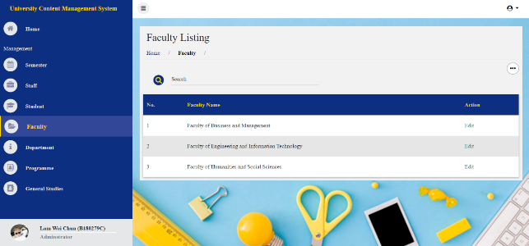

Figure 5: Admin Panel Interface Design

The webpage after design. Above the content page also provide the “Title” which indicates the current page's location. The corresponding page will display in content block when button is clicked. Data table or form will be displayed when the button is clicked. Admin mainly manages university data [8], such as faculty, department, program, subject, staff, and student.

1. Dean Panel

The dean has the same function as the lecturer, they can manage the course, such as assign student in the course, put the lecture note to system, write down the teaching plan, assessment, final exam and attendance, etc.

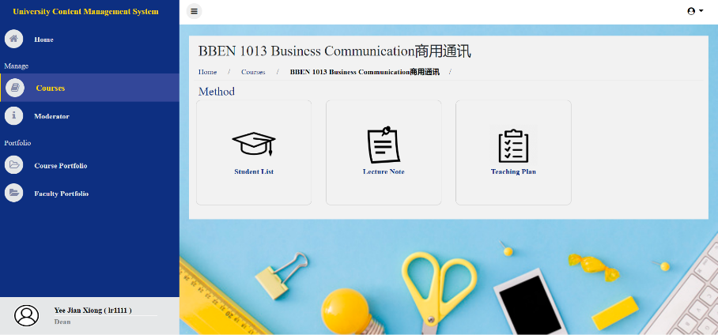

Figure 6: Course function in dean

But dean has some other functions, such as faculty portfolio and so on. Faculty Portfolio is to store some faculty affairs, such as activities and events, etc. It is not related to course, so this function is only available on dean.

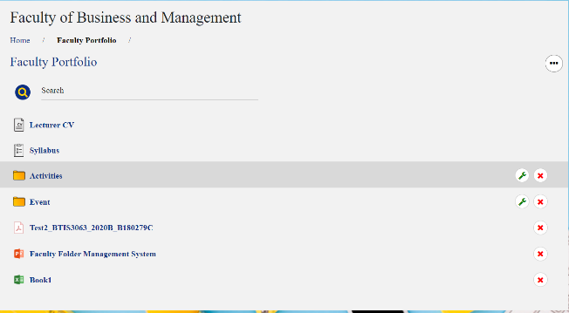

Figure 7: Faculty Portfolio function

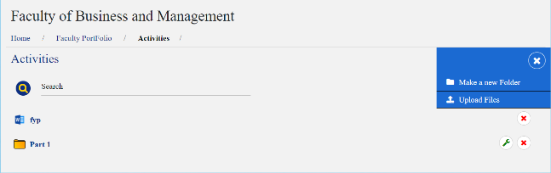

Figure 8: After Click the folder, access into folder.

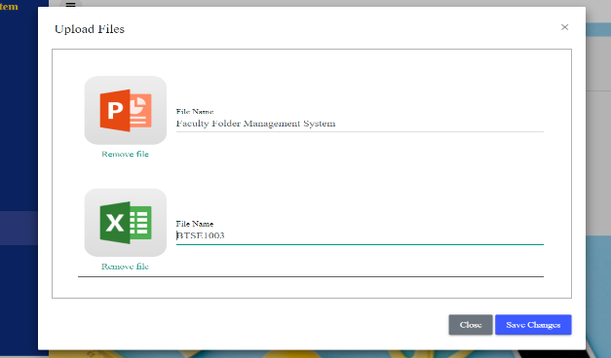

Figure 9: Click Upload Files, pop up the upload form.

As mentioned above, the way I store the faculty materials in portfolio will be similar to the window file exploder, which is to put the files in the designated folder. The files can be modified to the desired name when they are uploaded. Other similar functions are stored in this way, such as Lecture Note.

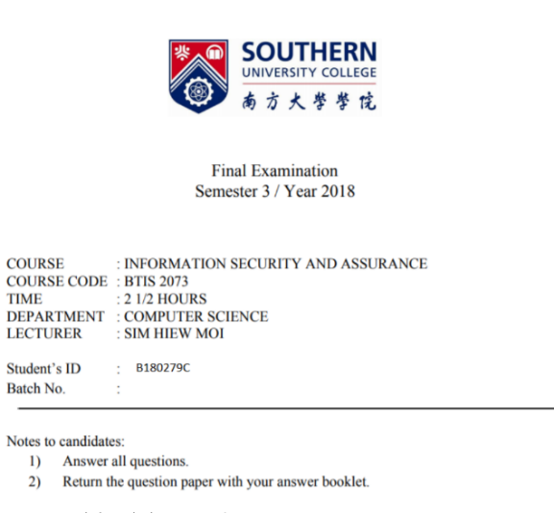

Figure 10: Image of Testing OCR.

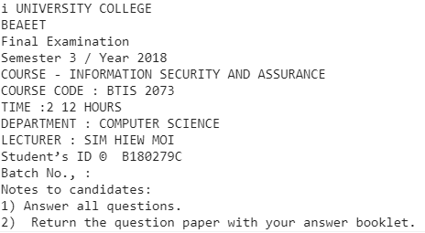

Figure 11: Testing OCR function.

As mentioned above, I haven't fully developed this feature yet. This feature allows me to detect the words on the photo, so that teachers can search for related materials such as exam questions and so on. In terms of assessment, I let the lecturers store them in the form of photos. I used tesseract.js [4] to perform this function.

1. **CONCLUSIONS**

According to the main goal of the project's university content management system, the system can reduce the paper documents in the university. There are many exam questions and homework submitted by the students in the university, which takes up space and is very difficult to search. The system can solve these problems well.

Other goal of the project's university content management system, the system can enable university teachers and students to easily perform daily actions such as take attendance and so on. Teachers can also upload teaching materials to the system so that students can download materials anytime and anywhere via the Internet.

Later, the mobile version should be added during development. As the speed of smart phones continues to increase and smart phones have become part of our daily lives. Therefore, the general portability of smart phones made me consider porting to the android platform. Therefore, students can use it anywhere.

Overall this still is not a complete system but it still has lots and lots of improvement that I can do in the future to make this an even better system.

**REFERENCES**

[1] aiim. (23 Sep, 2019). *Document Management vs. Content Management: What's the Difference?* Retrieved from Document Management vs. Content Management: What's the Difference?: https://info.aiim.org/aiim-blog/document-management-vs-content-management-whats-the-difference

[2] Andrew Powell-Morse. (15 December, 2016). *Iterative Model: What Is It And When Should You Use It?* Retrieved from airbrake: https://airbrake.io/blog/sdlc/iterative-model

[3] cmswire. (July, 2018). *How Document Management and Content Management Differ*. Retrieved from How Document Management and Content Management Differ: https://www.cmswire.com/information-management/how-document-management-and-content-management-differ/

[4] jeromewu. (2020). *Tesseract.js*. Retrieved from Tesseract.js: https://tesseract.projectnaptha.com/

[5] Oracle Corporation. (May, 1995). *MySQL*. Retrieved from MySQL: https://www.mysql.com/

[6] researchgate. (2016). *researchgate*. Retrieved from WEB CONTENT MANAGEMENT SYSTEM: https://www.researchgate.net/publication/299438184_WEB_CONTENT_MANAGEMENT_SYSTEM

[7] Sarwati Rahayu. (2017). *A Systematic Literature Review of Web Content Management*. Retrieved from A Systematic Literature Review of Web Content Management: http://oaji.net/articles/2017/1948-1537277581.pdf

[8] Southern Univerisity Colloge. (2020). *Faculty of Engineering and Information Technology*. Retrieved from Faculty of Engineering and Information Technology: https://www.southern.edu.my/feit/en/

[9] Taylor Otwell. (June , 2011). *Laravel*. Retrieved from Laravel : https://laravel.com/