# Result

From July 9th to August 1st, we have been using the planned strategy to publish our posts in these 24 days. The following is the total number of people who liked our page during the 24 days.

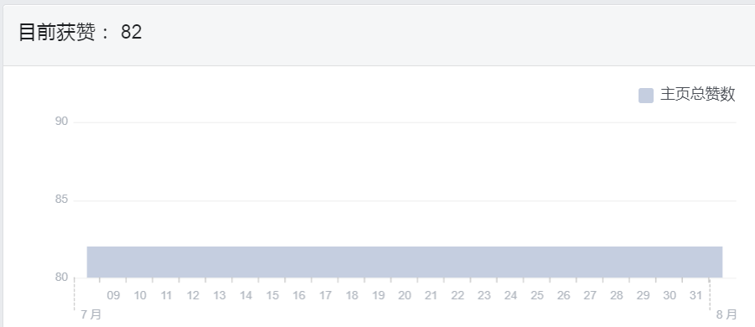

Unfortunately, our posts did not attract more people to like our page. After removing our team member, the total number of people who liked our page in the past 24 days has not changed. However, this does not mean that our posts are useless. Under our execution plan, there is still a significant difference in the number of posts reached. The number of posts reached is the number of users who have seen any of our posts at least once. The following is the number of posts reached from June to July.

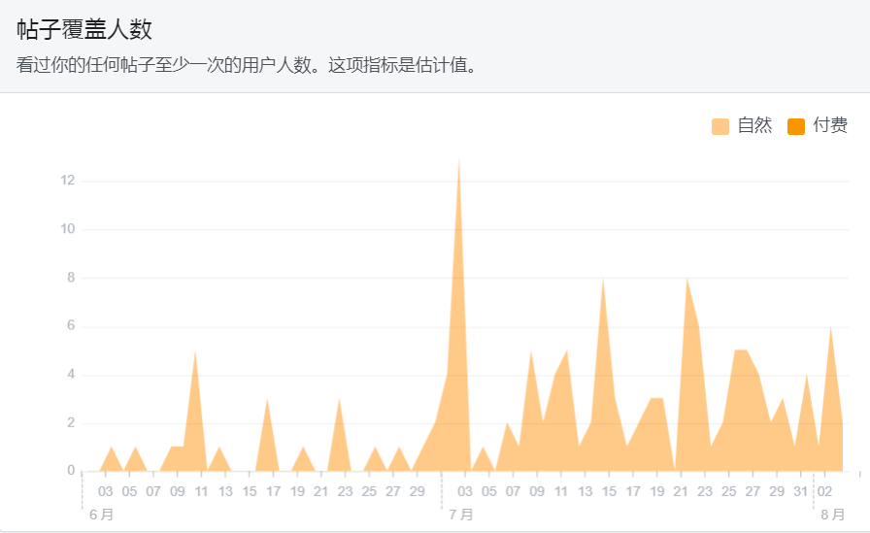

From this indicator, we can see that in June, the number of people watching posts was not very large. Excluding the time period in early July, the reason why the number of people watching posts suddenly increased at that time was because we and other teammates joined in and caused it to increase rapidly. Only after watching July 9th can it be regarded as our achievement. Under our implementation plan, the number of people watching posts has increased a bit more than before. Especially between July 21 and 23, the number of people watching the posts during this period reached more than 8. This allows us to find that some tips and simple knowledge posts are more attractive to watch than other posts that introduce and explain the confinement centers. Fortunately, in our plan, we also post many posts about some knowledge that during the confinement period, which allowed us to maintain a good number of viewers in late July.

In the end, our results were not very satisfactory. The reason may be that the strategy of our plan is not very good, such as no video, etc. After all, the number of people watching the video is more than other published photos or texts. But from 24 days of observation, our plan is still helpful. For example, the number of people watching any content on the page is increasing.